KISTIE_STORE
Project Screen Guide
User Interface Documentation
─────────────────────────────
A Kampala-based retail fashion platform built around carefully selected clothing brands
from Turkey, the UK, and the USA, with worldwide shipping.
April 2026

Responsive Design & Screen Size Compatibility
Kistie_Store is built as a responsive web application, meaning the layout automatically adapts to different screen sizes — from mobile phones to desktop monitors. Below is a summary of how each major screen size is supported:
Device | Screen Width | Layout Behaviour | Key Changes
Mobile (Phone) | ≤ 576px | Single-column stack, hamburger nav | Full-width cards, stacked buttons, compact navbar
Tablet | 577px – 991px | 2-column product grid, condensed nav | Side-by-side cards, readable typography
Laptop / Desktop | 992px – 1400px | 3–4 column grid, full navbar | Multi-column catalog, hero banner visible
Wide Screen | > 1400px | Centred max-width container | Content constrained to ~1200px, generous whitespace
The screenshots in this document were captured on a standard desktop browser (1440px wide). On mobile devices, product cards stack vertically, the navigation collapses into a menu, and buttons resize to full width for easy tap targets.

1. Home Page
Route: /
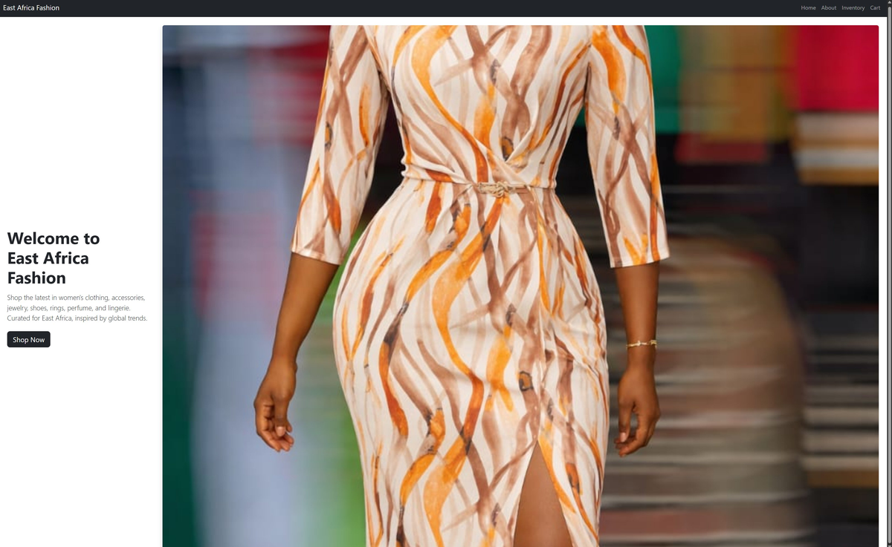
Figure 1: Home Page

Screen Description
The landing page of Kistie_Store. It showcases the store's value proposition — premium imported fashion from Turkey, UK & USA — with a hero banner, product stats (85 items, 1 collection, worldwide shipping), shop-by-style categories (Workwear, Occasion, Power Sets, Statement Dresses), and a "New In" product grid. Each product card shows EU sizing options, an Add to Cart button, and a WhatsApp quick-order button.

User Actions
- Click Shop Now or Order on WhatsApp in the hero to start browsing or order directly.
- Browse style categories (Workwear, Occasion, Power Sets, Statement Dresses) to filter products.
- Click Add to Cart on any product card to add it to your order.
- Click WhatsApp on a product card to open a direct WhatsApp chat for that item.
- Use the top navigation bar (Home, About, Contact, Catalog, Inventory, Cart, Order) to move between pages.
- Toggle Dark mode or switch the Ocean theme from the top-right controls.

2. About Page
Route: /about
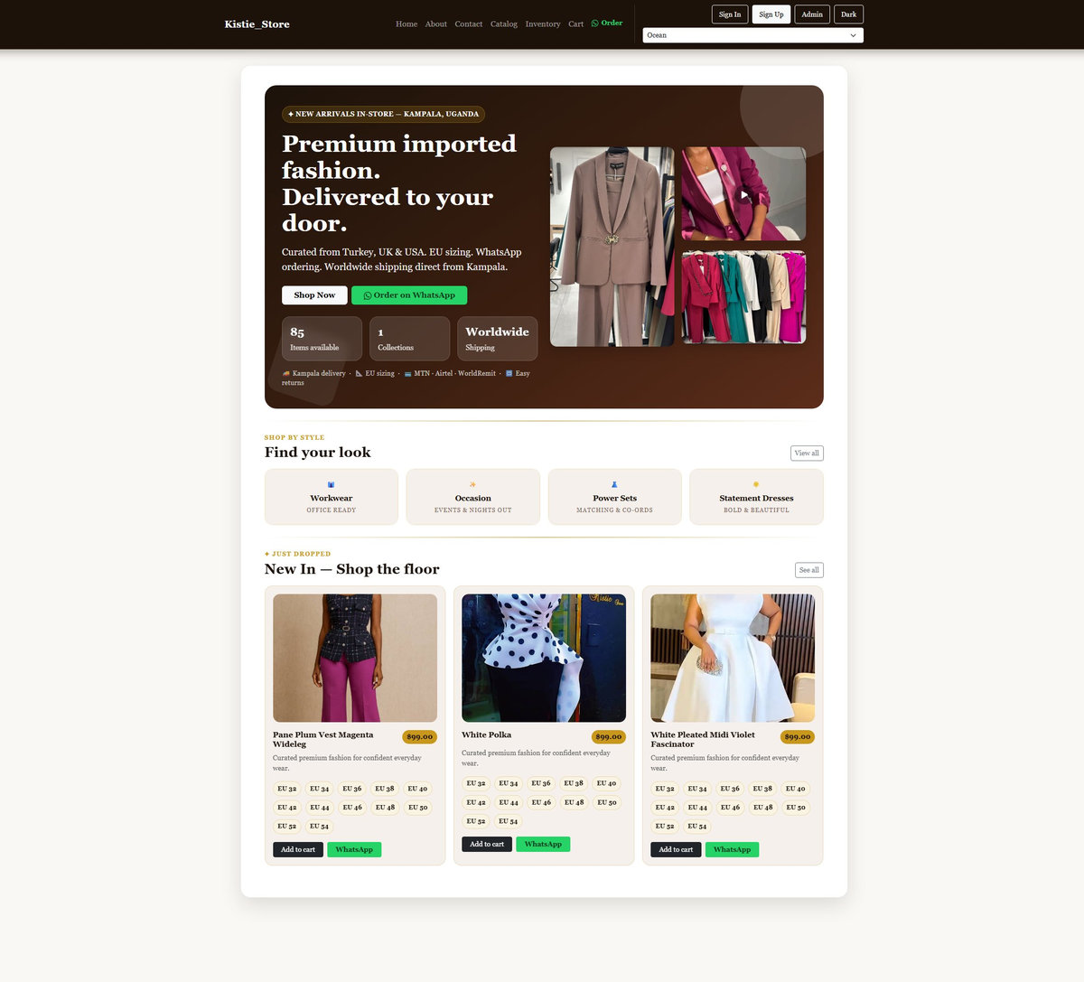
Figure 2: About Page

Screen Description
Presents the brand story, mission, vision, and ethos of Kistie_Store. It includes brand imagery (photos and a video thumbnail), contact details, and two call-to-action buttons linking to the inventory and the contact/inquiry form.

User Actions
- Read the store's Ethos, Vision, and Mission statements.
- View brand imagery — photos and a video that represent the store's style.
- Click Shop Kistie_Store Inventory to go directly to the product inventory.
- Click Send an Inquiry to navigate to the contact page and submit a question.
- Use the WhatsApp link in Contact & Location to reach the store team directly.

3. Contact Page
Route: /contact
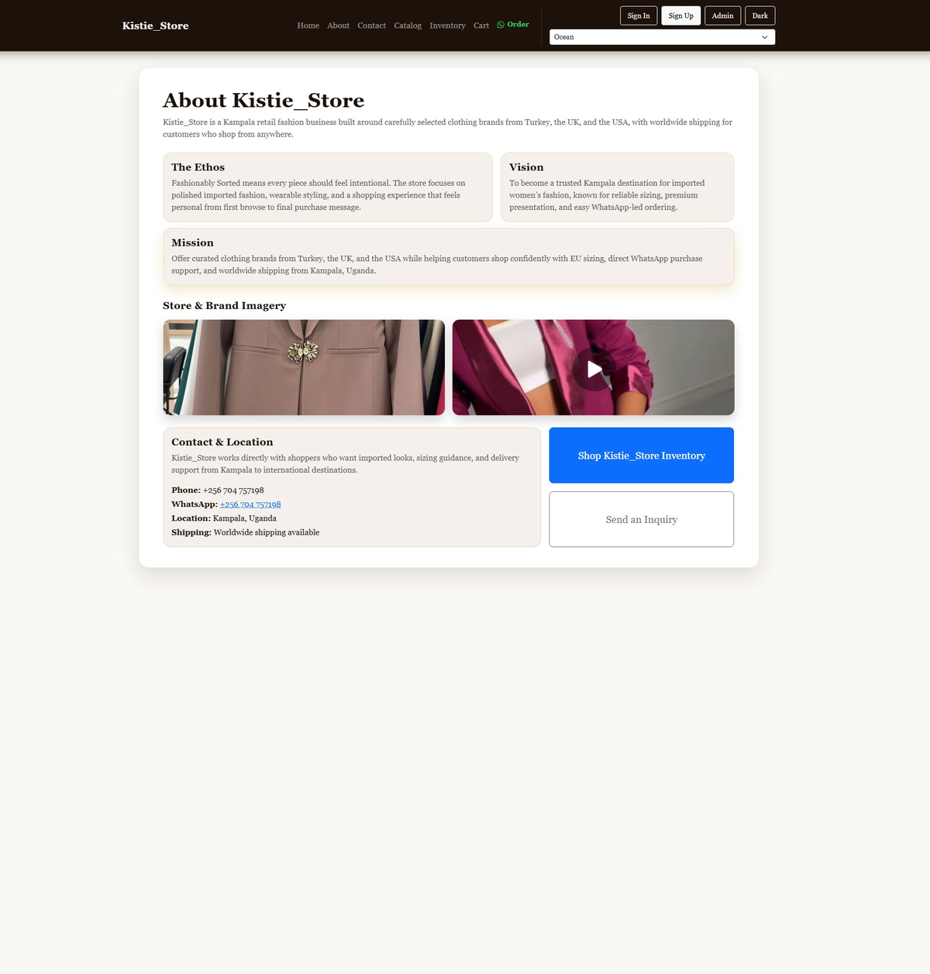
Figure 3: Contact Page

Screen Description
A dual-panel contact page. The left panel shows direct store contact details (WhatsApp, phone, location in Kampala, Uganda, and worldwide shipping info). The right panel provides a store inquiry form with Name, Email, Subject, and Message fields.

User Actions
- Click the WhatsApp link (+256 704 757198) to open a chat directly with the store.
- Fill in the Name, Email, Subject, and Message fields and click Send Store Inquiry to submit a message.
- Use the phone number for direct calls.
- Note worldwide delivery availability on this page.

4. Catalog Page
Route: /catalog
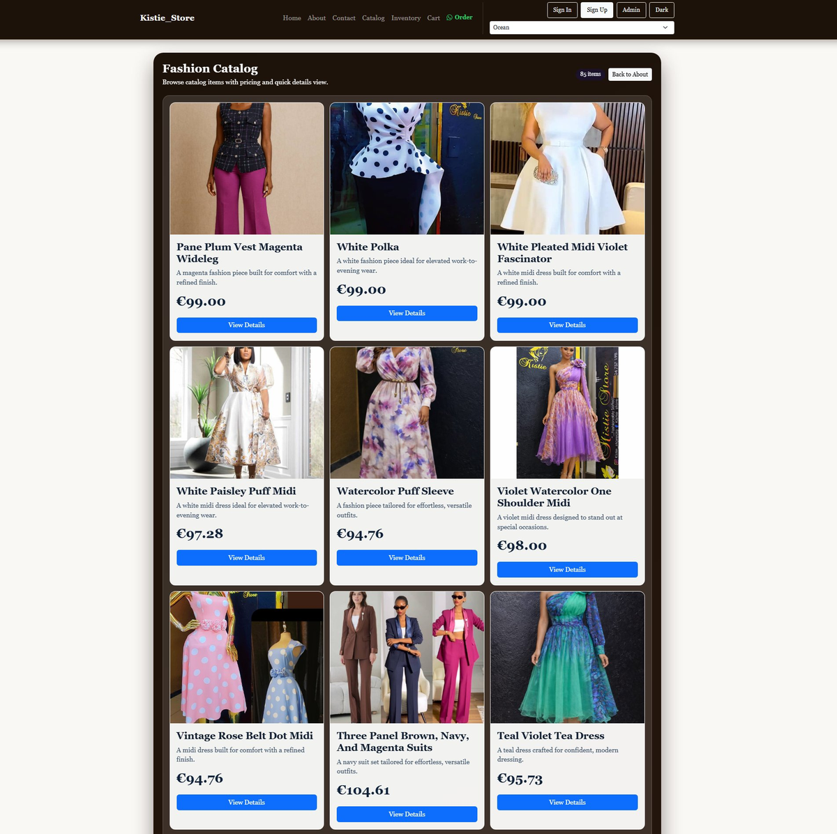
Figure 4: Catalog Page

Screen Description
A browsable fashion catalog grid showing all 85 items. Each card displays a product photo, name, short description, price in EUR, and a View Details button. Items include dresses, suits, midi dresses, and co-ord sets.

User Actions
- Scroll through the 85-item catalog grid to browse all available products.
- Click View Details on any card to see the full product detail page.
- Use Back to About in the top-right to return to the About page.
- Navigate to Inventory for purchase-ready product cards with Add to Cart functionality.

5. Inventory Page
Route: /inventory
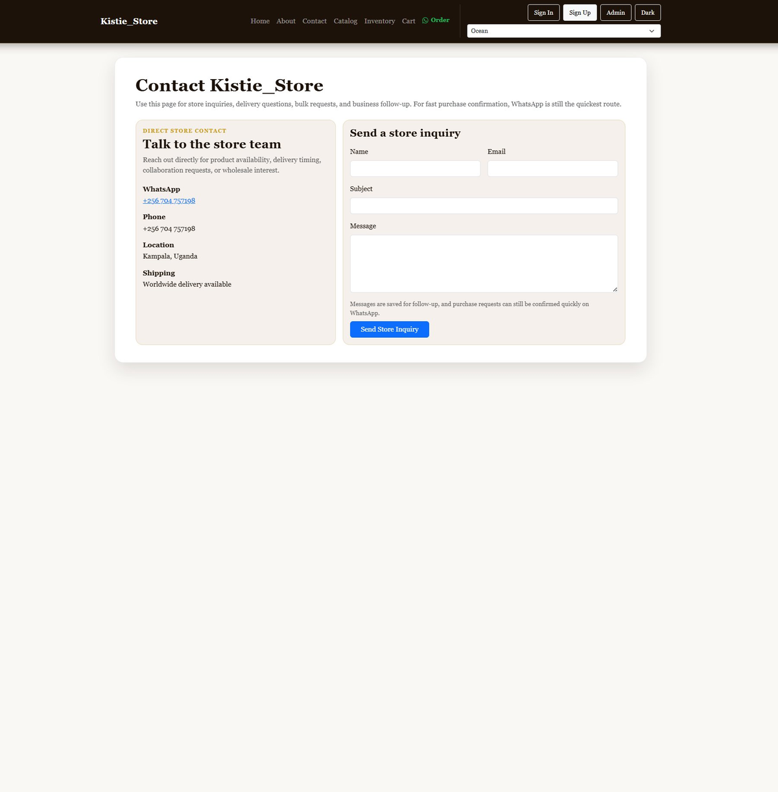
Figure 5: Inventory Page

Screen Description
The purchase-ready product listing page. Items show stock status, sale/original price in the selected currency, EU size selector, quantity input, and an Add to Cart button. Users can also choose their purchase currency and payment method at the top.

User Actions
- Select Purchase Currency (USD, EUR, KES, UGX) — prices refresh automatically using live exchange rates.
- Select Payment Method (MTN Mobile Money, Airtel Money, Pesapal) before adding items.
- Choose EU size from the dropdown on each product card.
- Set the quantity for each item.
- Click Add to Cart to add the item to your current order.
- Navigate to Cart in the navbar to review and pay.

6. Cart / Checkout Page
Route: /cart
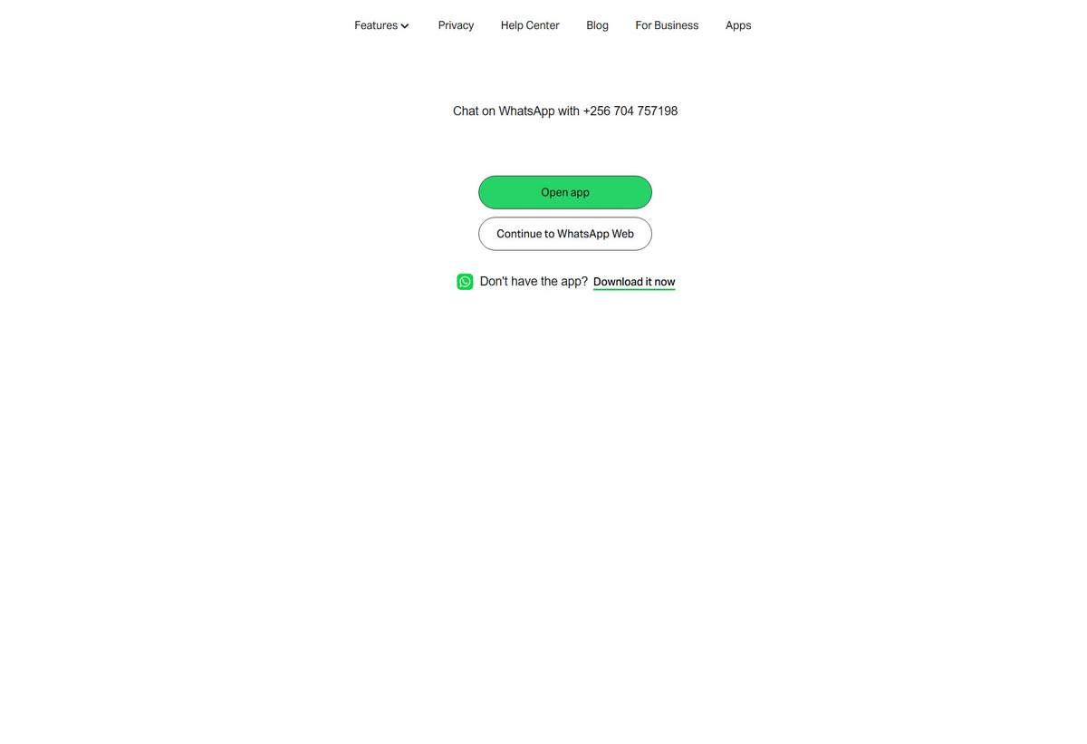
Figure 6: Cart / Checkout Page

Screen Description
The shopping cart and checkout page. Users review their selected items here, choose a currency and payment method, and apply settings before paying. The empty-cart state shown here displays 'Your cart is empty.' with currency (USD) and payment method (MTN) dropdowns ready.

User Actions
- Review all items in your cart (name, unit price, quantity, line total).
- Change Currency (USD, EUR, KES, UGX) — totals update instantly.
- Choose a Payment Method (MTN, Airtel, Pesapal) and click Apply Checkout Settings.
- Click Pay Now to submit the order and receive a payment confirmation or reference number.
- Return to Inventory to continue shopping if the cart is empty.

7. WhatsApp Order Page
Route: WhatsApp (wa.me link via Order button)
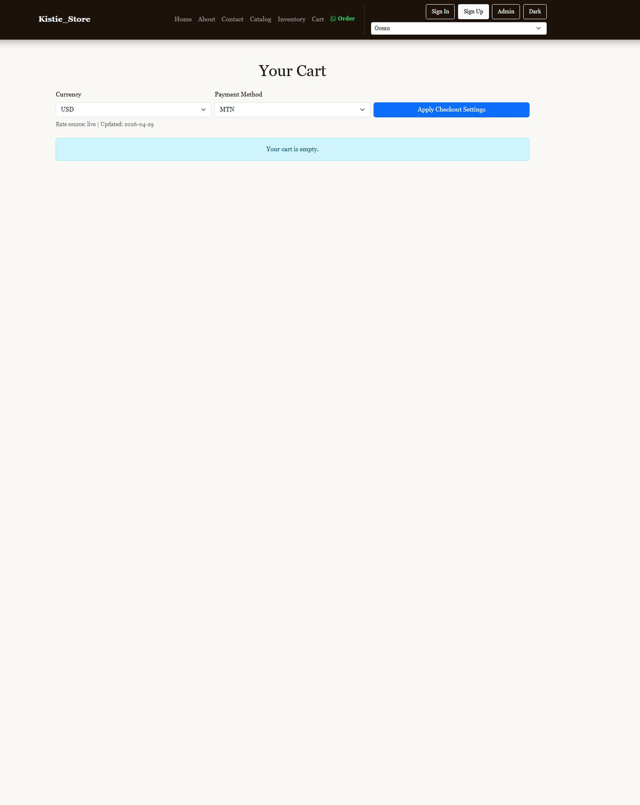
Figure 7: WhatsApp Order Page

Screen Description
Clicking the Order (WhatsApp) link in the navigation opens WhatsApp's web redirect page, prompting users to chat with +256 704 757198. This is the store's primary fast-order channel for confirming purchases without going through the full cart flow.

User Actions
- Click Open app to launch WhatsApp desktop or mobile app and start a chat.
- Click Continue to WhatsApp Web to open a browser-based WhatsApp chat.
- Click Download it now if WhatsApp is not yet installed.

8. Django Admin Panel
Route: http://127.0.0.1:8000/admin/
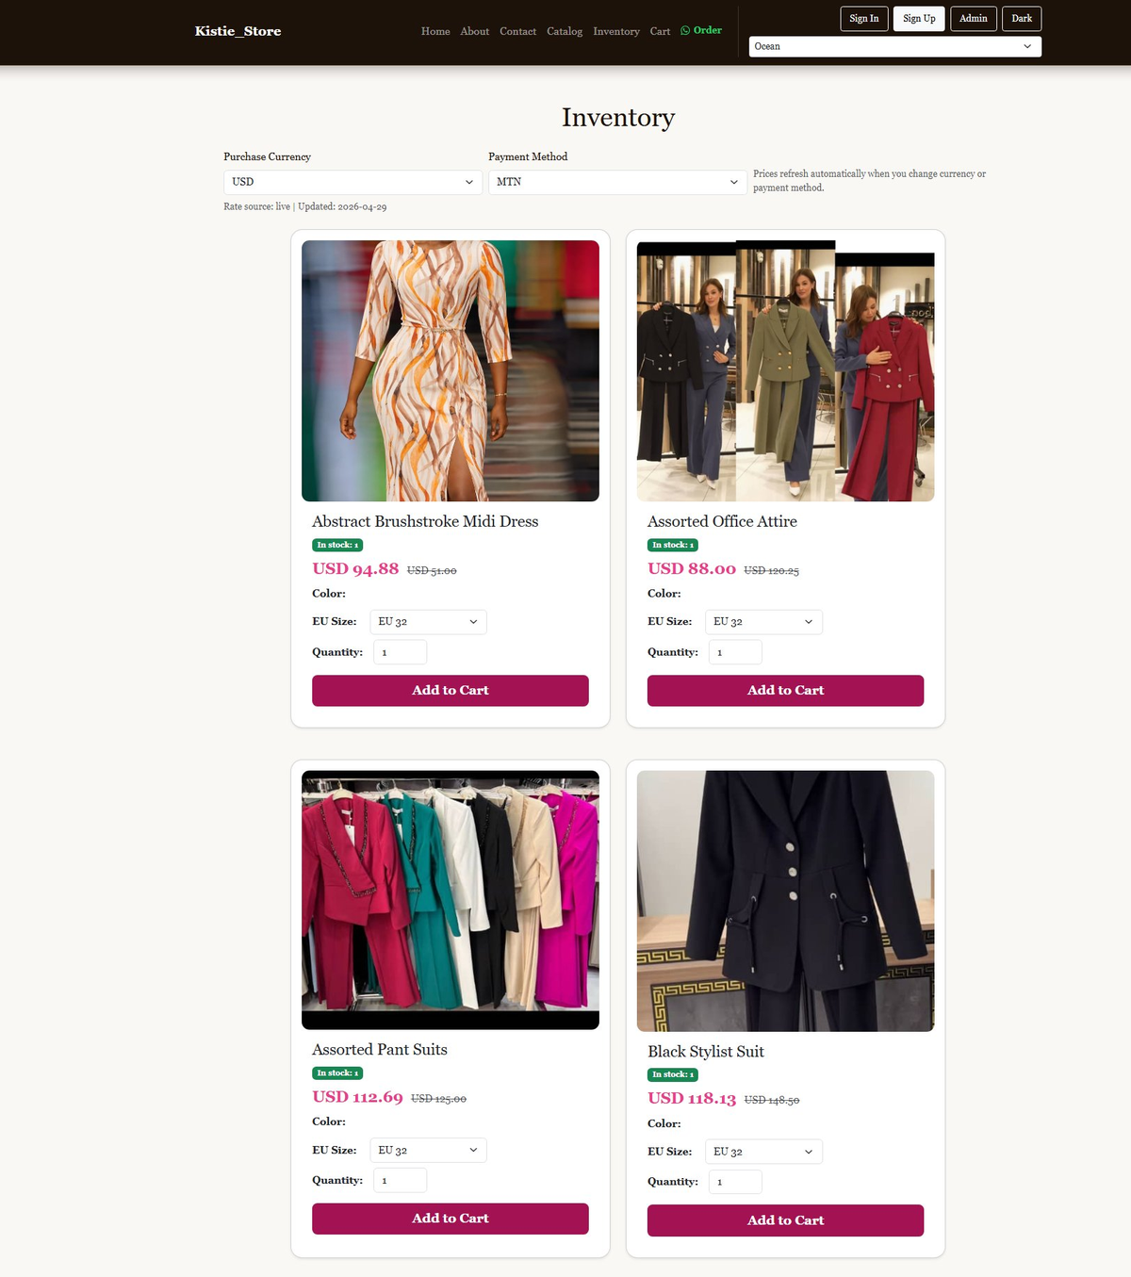
Figure 8: Django Admin Panel

Screen Description
The backend administration interface powered by Django Admin. Accessible only to superusers, it allows full management of the store's data: products, categories, inventory, orders, contact inquiries, and user accounts.

User Actions
- Log in with superuser credentials to access the admin dashboard.
- Manage Products — add, edit, or delete products including name, price, category, stock level, and images.
- Manage Categories — create and organise product categories.
- View and update Carts / Orders — see all customer orders and update their status (e.g. Pending → Payment Confirmed).
- Read Contact Inquiries submitted via the contact form.
- Manage Users / Groups — create or edit shopper accounts and staff permissions.

