Name:____________________________________ Section:_______________ Date:_______________________

Lab 8: Macroparasite Aggregation + Host Behavioral Effects

For today’s lab, we’re going to be dissecting two common species of marsh snails (*Ilyanassa obsoleta* and *Melampus bidentatus*) to measure their trematode infection burden. We know that parasite infection status can affect host body condition, physiology, and behavior, and as such are going to investigate whether body size or locomotion changes as a function of infection status for *I. obsoleta*.

**Safety:**

**In addition to general lab safety protocols we follow every lab, we need to be aware of the following potential hazards:**   
 Whenever working with the snails or the seawater they’re contained in, always wear nitrile gloves. Although prevalence is generally quite low in the South East (Blakeslee et al., 2012), I. obsoleta is a known intermediate host of the trematode *Austrobilharzia variglandis,* the cercidiae of which is known to cause Cercarial Dermatitis (aka “Swimmer’s Itch”) in humans.   
  
 Additionally, when cracking snail shells for dissection, you MUST wear some form of eye protection. We have a few pairs of glasses available for folks to use; if there’s not a pair available wait until there is. There is the potential for shards of shell to be ejected as you crack it, and you don’t want any of these to end up in your eyes.

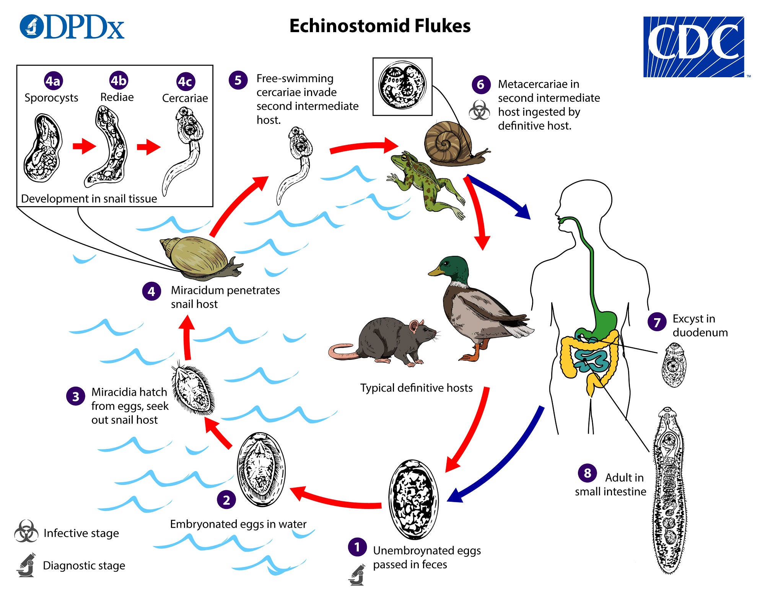

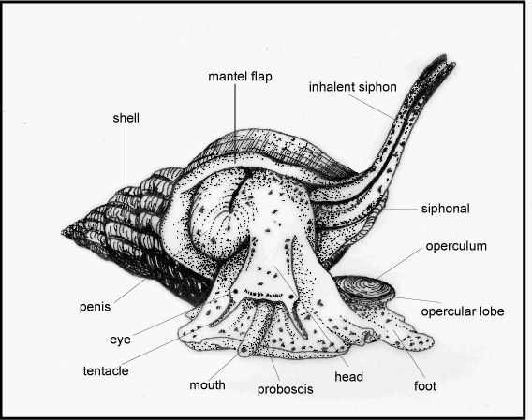

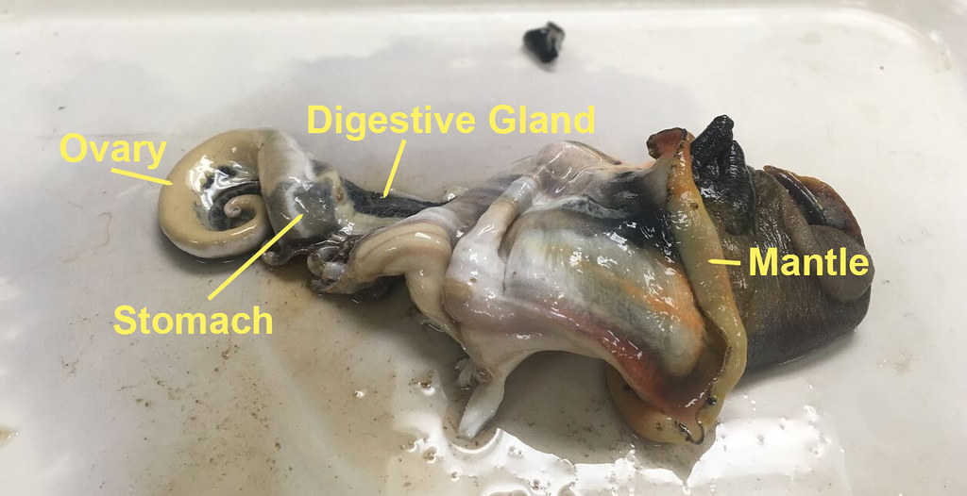

**Protocol:**

For *I. obsoleta:*

1. Grab two specimens from the container and place them into a weigh boat. Record their wet weights, as well as the shell height (1), shell width (2), and aperture height (4) using calipers. Record your data in the table below.

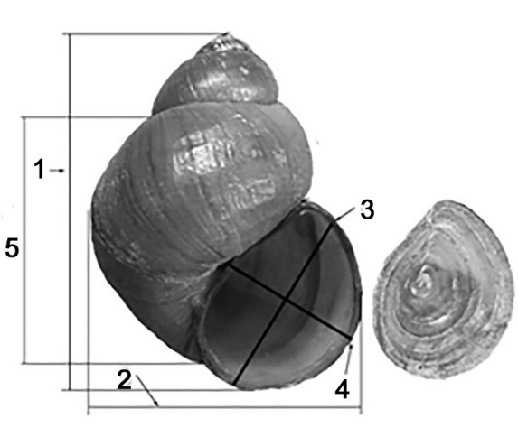

|  |  |  |  |  |
| --- | --- | --- | --- | --- |
| Specimen | Weight | Shell height | Shell width | Aperture H. |
|  |  |  |  |  |
|  |  |  |  |  |
|  |  |  |  |  |
|  |  |  |  |  |

2. Once you’ve taken the morphometric metrics of your two specimens, conduct the movement trial.

1. Retrieve an arena and ruler from the lab bench, and using a sharpie, mark the midpoint of the arena from the outside.
2. After allowing ~60s for the sharpie to dry, fill the arena with seawater.
3. Cut a roughly half-inch square of bait, and place it in the middle of the arena.
4. Ready a stopwatch, and then place one snail on each far end of the arena.
5. Record how long it takes each snail to 1) start moving, and 2) reach the bait. Record for a maximum of 12 minutes; if snails have not reached the bait at this time mark “NA” in the appropriate time column. Record your data below **in seconds** (e.g., if it took the snail 5 minutes and 12 seconds to reach the bait, record 312 seconds).

|  |  |  |  |  |
| --- | --- | --- | --- | --- |
| Specimen | Time to move (Trial 1) | Time to reach bait (Trial 1) | Time to move (Trial 2) | Time to reach bait (Trial 2) |
|  |  |  |  |  |
|  |  |  |  |  |
|  |  |  |  |  |
|  |  |  |  |  |

3. Prepare for dissection

1. First, place each of your specimens in their own weight boat. Pour a few mm of DI water into the bottom, and look at it under the dissecting scope. Look for movement of possible cercariae; the bright lights of the dissecting scope’s light source may encourage some to emerge. If you see any, use a pipette to place a drop of liquid onto a microscope slide, cover gently with a coverslip so you can examine it under the compound microscope.
2. Once you’ve screened for initial infection, you need to euthanize your snails for dissection. We’ll be using a two step process. First, place your snails in a 5% ethanol solution and allow them to remain until movement stops (~5 minutes). This sedates the snails, but does not kill them. Then, remove the snails from the 5% solution and move them to a 70% solution, allowing them to remain for 2 minutes. The snails should now be ready for dissection

4. Screen for trematode parasites

1. Wearing safety glasses, use a hammer to gently crack the shells of the specimens, taking care to try not to smash the soft body.
2. Rinse the smashed specimen with DI water; then use forceps to gently remove the curled body from the interior of the shell.
3. Look at the gonad regions under the dissecting scope; health tissue should be a bright orange, while infected tissues may be more white, yellow, or grey.
4. Using forceps, pull off the gonadal tissue and place it on a microscope slide. Gently squash with a coverslip; if the slide is too dry, you may add a drop or two of DI water.
5. Look at the gonads under your dissecting scope and look for evidence of cercariae, metacercariae, or rediae.
6. Once you inspect the gonads, create another wet mount of the mantle region and once again inspect for evidence of infection.

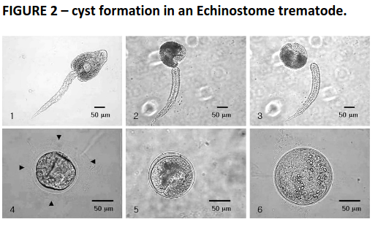

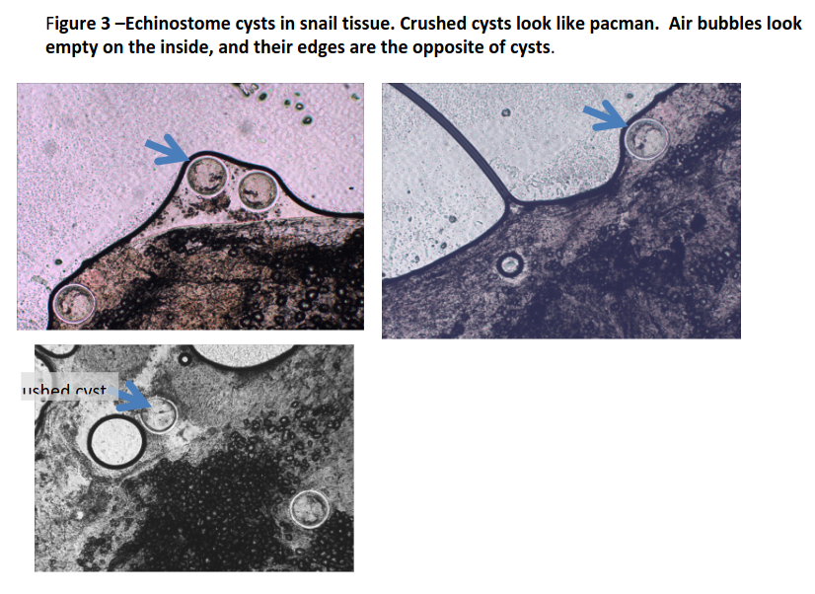

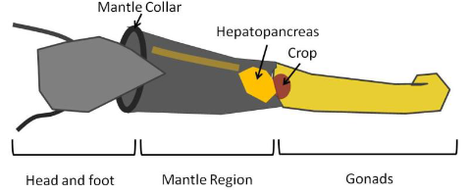

Record the infection status of each of your specimens below:

**Gonads**

|  |  |  |  |  |
| --- | --- | --- | --- | --- |
| Specimen | Cercaria # | Cercaria Type | Cyst # | Cyst Type |
| 1. |  |  |  |  |
| 2. |  |  |  |  |
| 3. |  |  |  |  |
| 4. |  |  |  |  |

**Mantle**

|  |  |  |  |  |
| --- | --- | --- | --- | --- |
| Specimen | Cercaria # | Cercaria Type | Cyst # | Cyst Type |
| 1. |  |  |  |  |
| 2. |  |  |  |  |
| 3. |  |  |  |  |
| 4. |  |  |  |  |

Once you’ve completed the dissection process for 4 *I. obsoleta* individuals, repeat the steps above for 2 *M*. *bidentatus* individuals, **skipping the movement trial.** Record your data below.

|  |  |  |  |  |
| --- | --- | --- | --- | --- |
| Specimen | Weight | Shell height | Shell width | Aperture H. |
|  |  |  |  |  |
|  |  |  |  |  |

**Gonads**

|  |  |  |  |  |
| --- | --- | --- | --- | --- |
| Specimen | Cercaria # | Cercaria Type | Cyst # | Cyst Type |
|  |  |  |  |  |
|  |  |  |  |  |

**Mantle**

|  |  |  |  |  |
| --- | --- | --- | --- | --- |
| Specimen | Cercaria # | Cercaria Type | Cyst # | Cyst Type |
|  |  |  |  |  |
|  |  |  |  |  |

Once you’ve completed your data collection add your data to the class dataset using the google drive link below:

<https://docs.google.com/spreadsheets/d/1Mgp9G9JVpcFpzuOwhxpNo8i35Hu0emulRDJYYVtuHjE/edit?usp=sharing>

**Followup Questions:**

1. The following diagram represents a compartmental model of Fish-borne zoonotic trematodes with the potential to infect humans in aquaculture setting (ex. *Clonorchis sinensis*). If well parameterized, we can use models like these to investigate the effects of potential disease control strategies. For the following intervention strategies listed below, what parameter or state variables would you change to reflect them?
   1. A one-time, widespread chemotherapy treatment of all human hosts
   2. Administration of regular molluscicide treatments to kill snails
   3. Implementation of a longer quarantine period between fish generations.

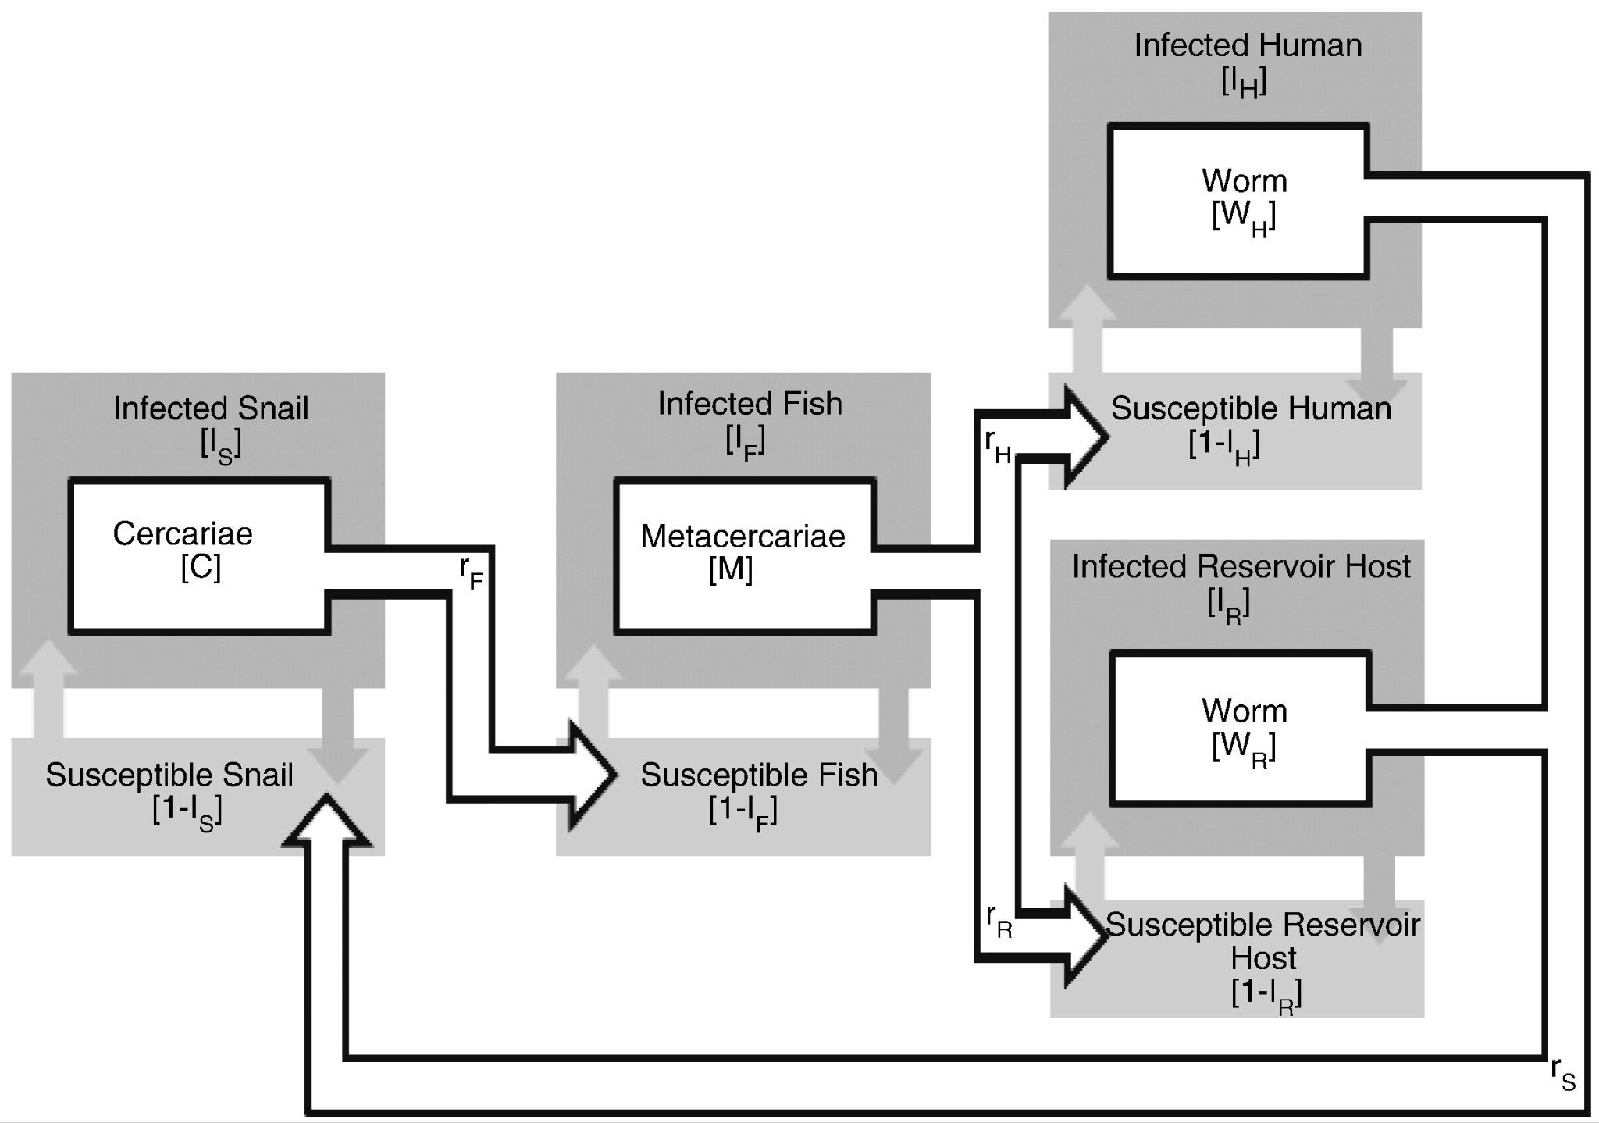

1. The two graphs below are based on mesocosm experiments on the trematode parasite *Renicola roscovita* infection and the common cockle (*Cerastoderma edule*). As temperature increases, do these data lead you to expect higher or lower disease prevalence in cockles? Do the two graphs lead you to the same or different conclusions? If different, how would you go about testing the outcome?

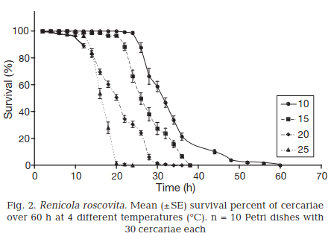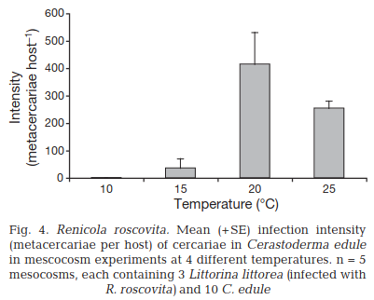

1. Find an example of invertebrate host behavioral modification as a result of trematode infection in the primary literature. Describe the behavior and the evidence the paper used to associate it with infection. Does this seem to be a sickness behavior on the part of the host, or behavioral manipulation on the part of the parasite? Explain why.

(Hint: some potentially useful keywords for your search might be “**behavior**”, “**trematode**”, and whatever your marine invert of choice is, “**snail**”, “**crab**”, “**clam**”, etc. Google scholar and web of science are your friends!).