Name:____________________________________ Section:_______________ Date:_______________________

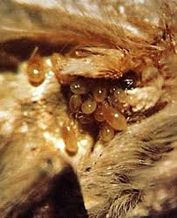Worksheet 11: Moths & Mites

**Moth Ear Mites**

**The who:** True mites(superorder: Acariforme), which live colonially inside the “ears” (tympanal organs) of certain species of moths.

3 NA species in genus *Dicrocheles*: 1) *phalaenodectes* – widespread in North America, infects one ear only, burrows through tympanum, probably deafening moth in that ear. Common in SC

2) *scedastes* – until 1974, known from Old World only; 1974-now, east coast of US, too; infects both ears, but often doesn’t pierce tympanum, effect on hearing totally unknown. Seems to have showed up in 1975 in SC

3) *hippeoides* – known only from one colony in one moth found in Baton Rouge, LA – in one ear, but never found again, no information at all.

**The how:**

Female jumps off a flower onto moth, moves to ear(s), lays eggs, colony forms – generation time 5-6 days, colonies may last “a couple weeks or longer”.

A single female can lay up to 80 eggs, multiple females can inhabit same colony, so colonies can be big.

They are haplodiploid, with very few males (~7%) in each colony; the males live entirely in the tympanic air sacs. Apparently don’t leave the moth.

Mature females move to collar/mouthparts of the moth, then jump off to flower. Treat says that some floral odors attract the mites, but they do not drink nectar.

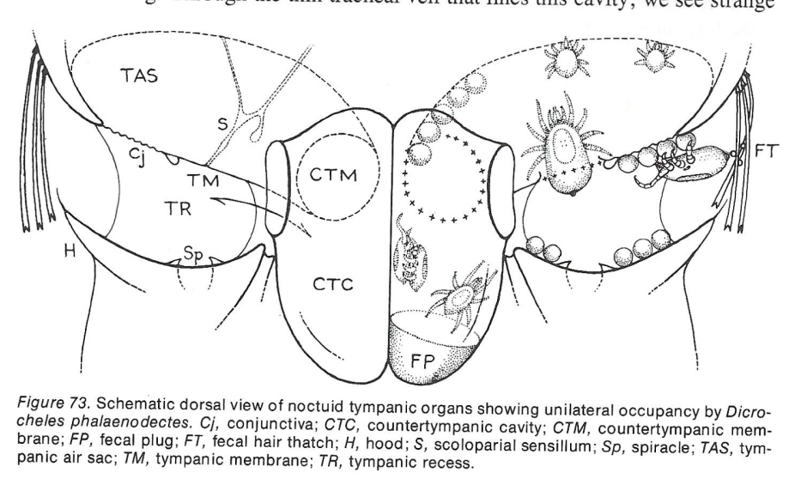

Moth Ears: Found behind their wings, these consist of a membrane (tympanum) stretched across an air sac, as well as associated sensory neurons to detect its vibration. These allow moths to detect sounds, chief among which is the ultrasonic echolocation calls of bats (potentially helping them avoid predators. Tympanal organs have evolved multiple times in the moth phylogeny; *Dicrocheles* mites can only colonize certain structures. As far as we know, *Dicrocheles* have only been found in moths in the family Noctuidae (owlet moths).

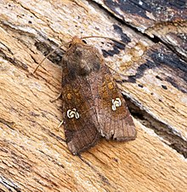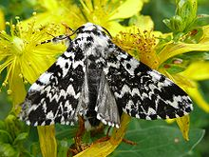

In noctuids, the organs themselves are on the sides of the body located near the underside of the wing. In many species, there is a “furry” cover protecting the opening that needs to be peeled back before the inside of the organ.

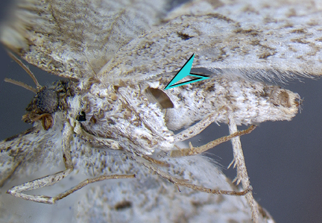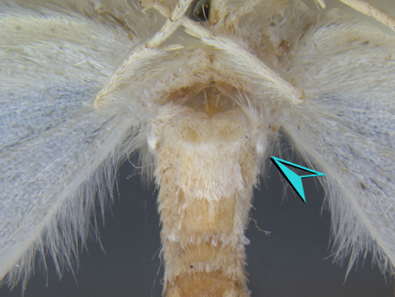

Once you’re able to look inside the tympanal membrane, active colonies of mites should be fairly easy to detect. There’ll normally be adults, feces, eggs, and nymphs in large enough abundance that they should be fairly easy to see. (Photo below credit to Eric LoPresti, moth mite expert).

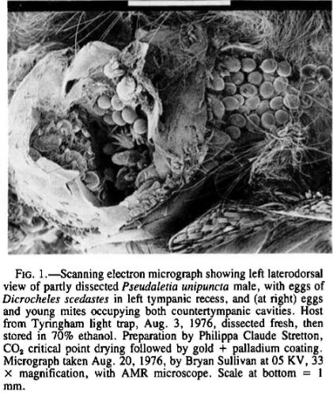

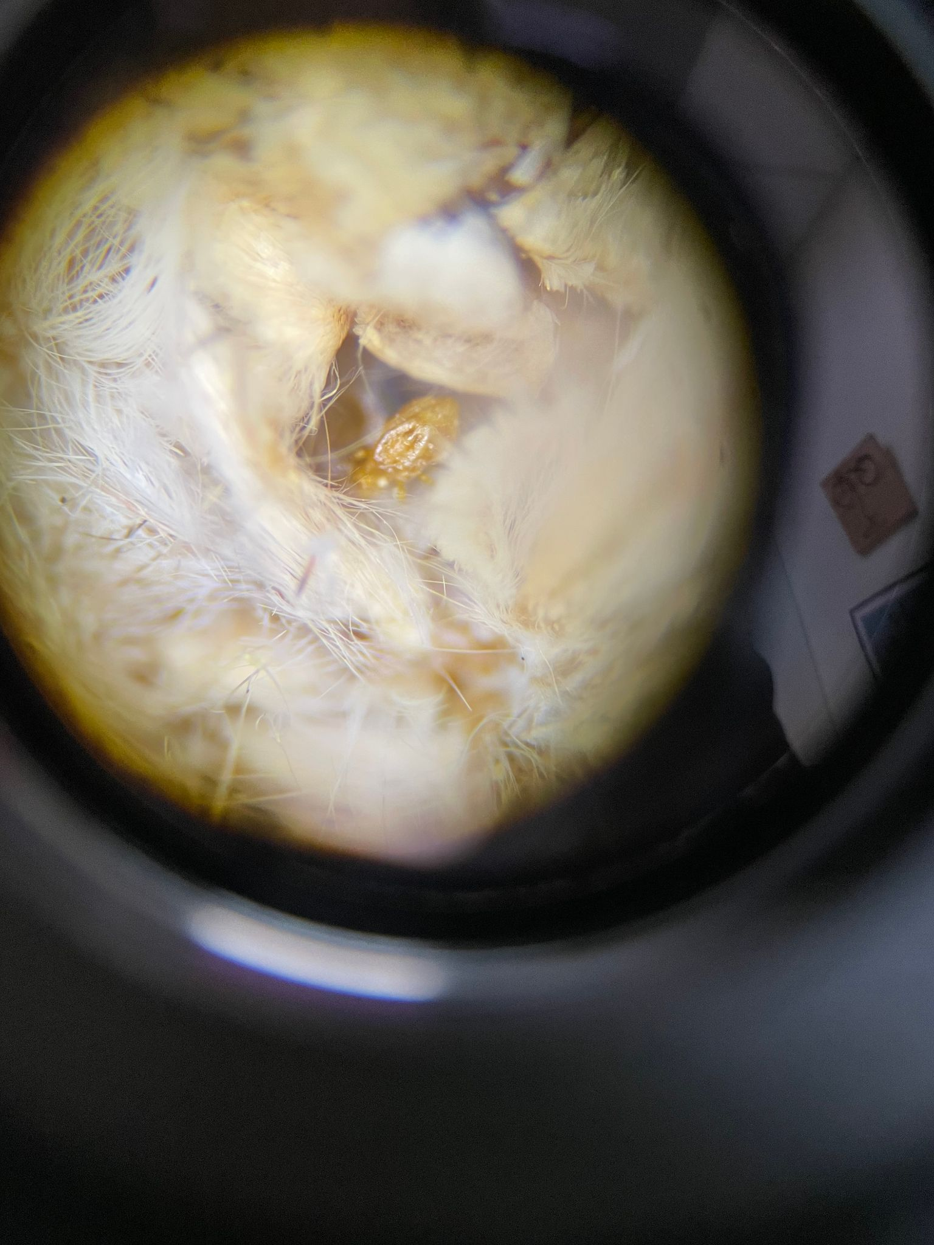

This week’s lab:

We already have records of ear mites in some moth species present in hundreds of specimens of moths in genera *Leucania* and *Mythimna* from 2023 (&2024) & 100+ from 1965-1976. However, we know very little about the mites’ overall host range or its overall prevalence in SC, much less how these may vary across time, species, and habitat.  
  
To try and answer these questions, we’re going to be screening for *Dicrocheles* infection in a variety of noctuidae that have very few or no records of prior infection. These specimens were all collected by the Lo Presti lab in 2023, and are all members of Noctuidae.

1. Specimens are organize by container; each container represents a unique species-location-date combniation. MAKE SURE to keep these separate, and to keep track of which sample you’re working with at a time!
2. It’s easiest to look inside the ears with the moth mounted on a piece of foam. Cut a foam square, and use an insect pin to affix the moth to the side
3. The wings will often be in the way; pinning them up above the moth’s head is often easiest
4. Look inside the tympanic recess; infected moths should have visible adult and larval mites, as well as lots of feces
5. Make sure to check both ears, as the most common species will only infect one!
6. Repeat this step for each individual in your sample. You’ll want to count the total number of individuals, as well as the total number of infections in each ear.
7. Once you’ve completed a sample, record your data on the class sheet here: <https://docs.google.com/spreadsheets/d/15fGXo2lI94ObHqJ2nkPTXJZ-DN7WwpiPB4BXRftuaq8/edit?usp=sharing>
8. Mark the label with a check mark, and then set the screened sample aside.

Assessment:

Contribute to the class dataset (6pts)

Q1. Define the following terms *sensu* [Poulin et al., 2011](https://doi.org/10.1016/j.pt.2011.05.003). Describe how you could measure them in our *Dicrocheles* system.

1. Basis specificity
2. Structural Specificity
3. Phylogenetic Specificity

Q2. (2pt) One of the most exciting things about this research system is how little we know about it! Below, come up with **two** research questions you could answer in this system. Provide a hypothesis for these questions, and describe how you could test that hypothesis:

1. Research Question 1:  
     
   Hypothesis:  
     
     
   Experimental Approach:
2. Research Question 2:  
     
   Hypothesis:  
     
     
   Experimental Approach:

Q3. (1pt) Moths ultimately don’t live that long, so for these mite species to survive adult females must find and infect new hosts. What are some possible ways for this to occur in the field? How might their mode of transmission influence their host specificity?