Name:____________________________________ Section:_______________ Date:_______________________

Lab 4: Parasite Aggregation + Host Immune Response

The melanization response is one of the major innate immunity pathways insects have for responding to parasites. Today, we’ll be quantifying the pathogen burdens of horned passalus beetles (*Odontotaenius disjunctus*), and seeing if those burdens relate to the measured strength of their melanization response.

Over the course of this lab, you’ll be filling out your data alongside the rest of the class on this shared google sheet: [Lab4_ClassData531L_Spring24](https://docs.google.com/spreadsheets/d/1ER1ef_kRh-LoONk0ulre4hJjswyKGd42hZBpUiOsv8w/edit?usp=sharing). We have ~22 beetles total to process. That leaves most students processing 2 beetles, but if you’re not very excited about the dissection or other parts you can only do one beetle. For each beetle, you’ll follow the entire processing protocol described below.

**Part 1: Morphometrics + Mite Burden**

1. After taking your beetle, start by taking its morphometrics. Use a scale to weigh the beetle, and record it on the datasheet. Additionally, use calipers to determine its length pronotum and elytra at their longest points.

**Q1. Write the two length measurements and mass of your beetle(s) below:**

1. After sizing and weighing your beetle you’ll want to calculate its mite burden. This can partially be done with the naked eye, using insect pins and fine forceps to remove mites. You’re looking for small, round bumps/spots, often in the joints and crevices of the underside of the pronotum, forelegs, and head. After picking off all the mites you can see with your naked eye, give your beetle a look under the dissecting scope to make sure there are none you missed. You can also use this time to take a better look at the mites themselves under the scope.

**Q2. Write the number of mites your beetle(s) has below:**

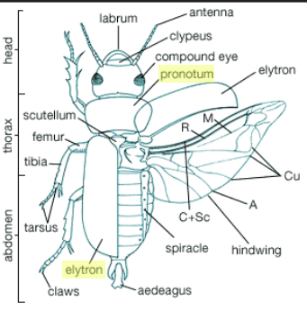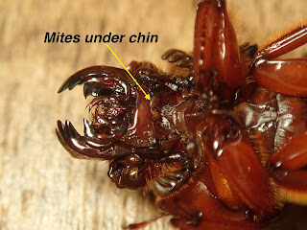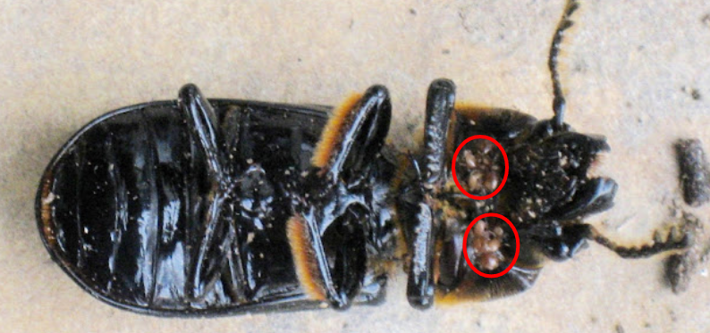

**Part 2: Melanization Assay**

1. Once you’ve calculated your beetle’s mite burden, you’re going to go ahead and perform a melanization assay. To prepare for this assay, use a sharpie marker to label a piece of filter paper near the edge with your beetle’s ID number. Then, place the filter paper flat inside of a petri dish, touching one of the edges.
2. Thoroughly wet the labeled filter paper with 25mL of the assay solution (2mg/mL of L-DOPA in 10mM sodium phosphate buffer). Place the edge of the petri dish opposite the paper on a spacer to give it a slight tilt, causing excess solution to drop to the side of the petri dish.
3. Once you have your assay setup prepared, bring your beetle up to the instructor, and they will help you drill a hole in the pronotum using a dremel from which you can extract enough hemolymph to sample. Using a micropipette, extract 10 microlitres of hemolymph from the beetle and gently deposit it onto your filter prepared filter paper. Repeat this process 4 times for four replicate samples, taking care to ensure the droplets do not touch each other.

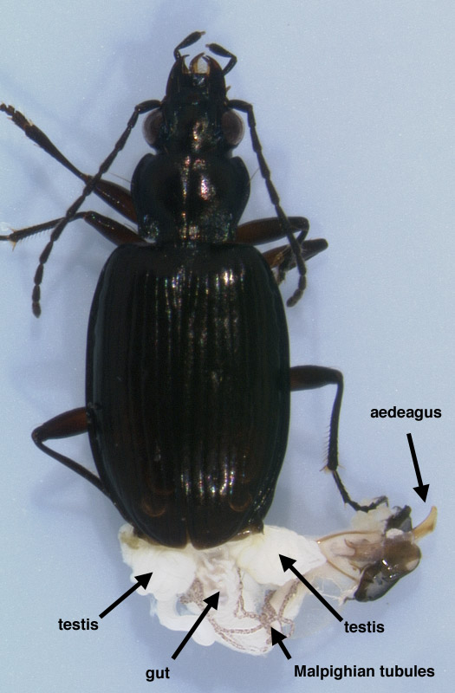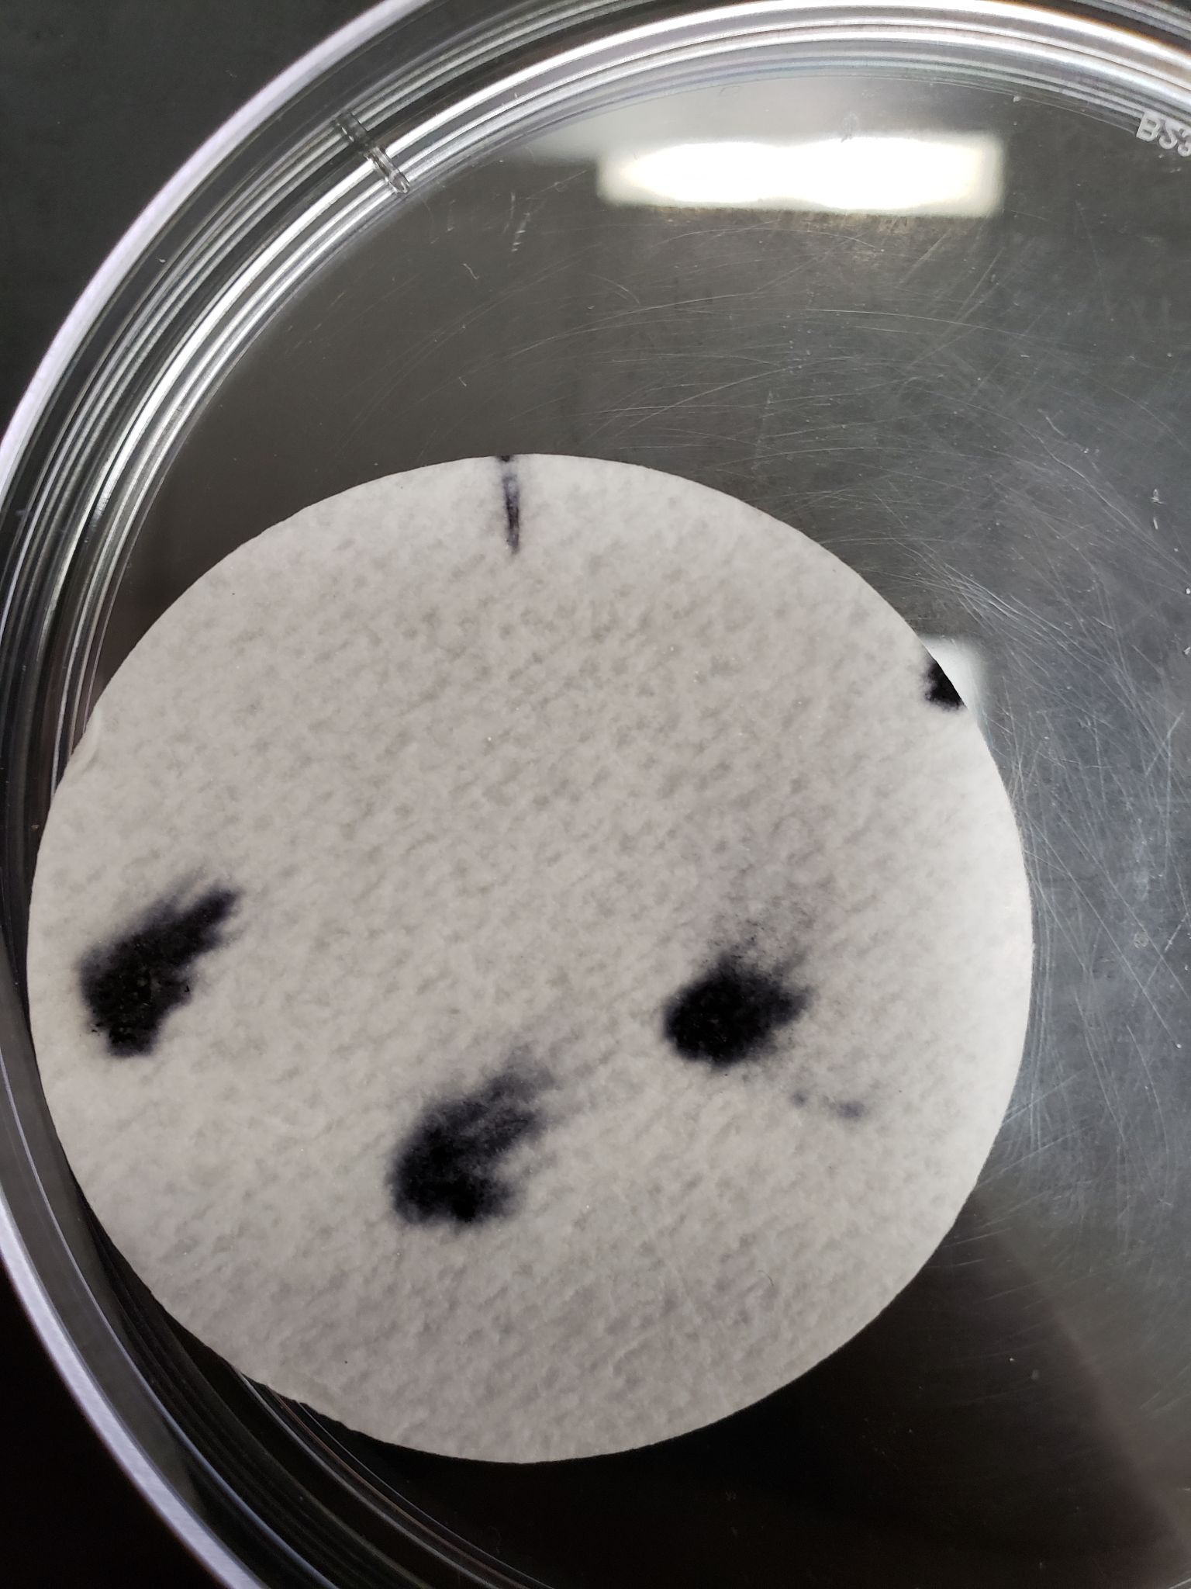

1. Allow the setup to sit for 30 minutes, during which time the droplets should darken as phenol oxidase in the insect's hemolymph catalyzes the conversion of L-DOPA into melanin. Once thirty minutes have elapsed, remove the filter paper from the petri dish using forceps, and place into a clean petri dish lined with a paper towel to dry.
2. Give the dried sample to your instructor. After the lab, they will scan the dried samples, and calculate the absorbance values of each sample using the photo software ImageJ and fill in the absorbance values of each on the data sheet.

**Part 3: Dissection + Calculation of Nematode Burden**

1. Once you’ve started the melanization assay, you can get started with your dissection. Place your beetle into a jar of 70% ethanol, and allow it to remain for at least 3 minutes. Once this time has elapsed, remove to a clean petri dish using forceps.
2. With the dorsal-side of the beetle facing upwards, remove the elytra of the beetle using forceps and insect pins.
3. Once the elytra is removed, flip the beetle to the ventral side, and remove the ventral abdominal sterna to expose the hemocoel. Parasitic nematodes of the species *Chondronema passali* live inside the hemocoel. Use your insect pin and forceps to search for these nematodes, which may often move. Use 70% ethanol to rinse the insides of the beetle as needed. You may find it helpful to remove individual worms from the organism and place them into the petri dish, as they become difficult to count when tangled together. Make sure to look carefully around the hemocoel so that you’re not missing any nematodes.
4. Use the following scale to rank the infection intensity of your specimens.

**Q3: Write the nematode infection intensity of your specimens below:**

| # of Nematodes | Intensity Value |
| --- | --- |
| 0 parasites | 0 |
| 1-5 parasites | 1 |
| 6-10 parasites | 2 |
| 11-100 parasites | 3 |
| 101+ parasites | 4 |

1. Finally, determine the sex of your specimen and notate it on the datasheet. Males can be identified by the presence of an aedeagus, which is used for transfer of sperm during reproduction. Your instructor will help you identify this structure.

**Q4: Write two (or more) hypotheses below for the effect of 1) mite burden, and 2) nematode burden on measured strength of phenol oxidase activity.**

**Q5: Following the lab, your instructor will send you the outputs of three glms, for each, answer the following: (HINT: look at the glm section of the powerpoint from last week for help!)**

1. What is the predictor variable
2. What is the response variable
3. How do you interpret the results of that model

**Q6. Which model of the three best fits our data? Why?**

**Q7: Given the outputs of our data, is your hypothesis supported or not?**

**Citations:**

Bibbs, Christopher S., Hodges, Amanda C., Baldwin, Rebecca W. (2010, December). *Horned Passalus*. Featured Creatures: Department of Entomology and Nematology. <https://entnemdept.ufl.edu/creatures/misc/beetles/horned_passalus.htm>

Calderon, L., & Davis, A. K. (2016). Observations of Steinernema nematode and Tachinid fly parasites in horned passalus beetles, Odontotaenius disjunctus, from Georgia, USA. *Comparative Parasitology*, *83*(2), 265-268.

Davis, A. K., Ladd, R. R., Smith, F., & Shattuck, A. (2023). Sex-specific effects of a parasite on stress-induced freezing behavior in a natural beetle-nematode system. *Plos one*, *18*(3), e0281149.

González‐Santoyo, I., & Córdoba‐Aguilar, A. (2012). Phenoloxidase: a key component of the insect immune system. Entomologia Experimentalis et Applicata, 142(1), 1-16.

Nakhleh, J., El Moussawi, L., & Osta, M. A. (2017). The melanization response in insect immunity. *Advances in insect physiology*, *52*, 83-109.

Sorrentino, R. P., Small, C. N., & Govind, S. (2002). Quantitative analysis of phenol oxidase activity in insect hemolymph. Biotechniques, 32(4), 815-823.