Pre-Processing !! Lots of it !!

1. Plot SST timeseries data to find on-colony positions

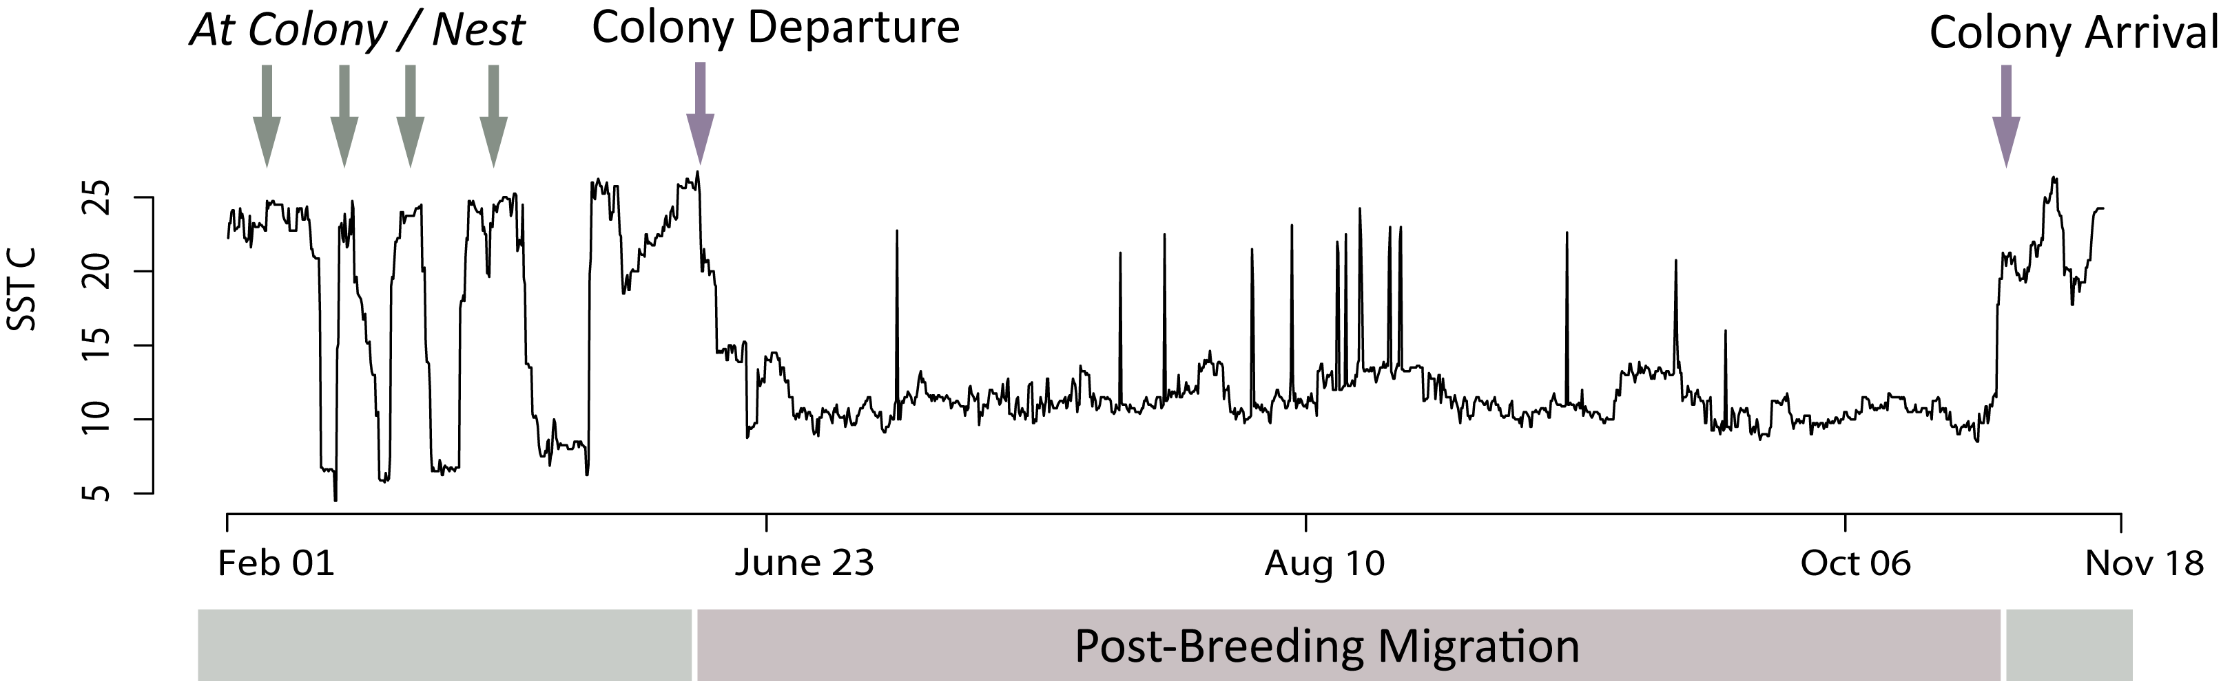

1.a. Script to identify Colony Fixes: *01_SGAT_process_flag_start_end_SST.R*

1.b. End product:

*Either*

1. 1 file with birdid, startdate, enddate

*Or*

1. A list with each bird as a component of the list, and under each bird the rows of when bird was on colony.

These dates are used to:

1. fix colony locations in trip estimation in SGAT. (This is done in a later step).

xp <- threshold.path(prs$Twilight, prs$Rise, zenith = 95, unfold = TRUE)

x0 <- xp$x

x0[x0[, 1] < 0, 1] <- x0[x0[, 1] < 0, 1] + 360

x0[1, 1:2] <- start x0[nrow(x0), 1:2] <- end

fixedx <- c( rep(FALSE, nrow(x0) )

**fixedx** is a logical index, the same length as x0 (which are the original locations estimated from light data). Fixedx starts off as all FALSE values, giving trip estimation freedom to estimate positions for every point. Where positions are known (i.e. on the colony), you can insert TRUE values, and at those points where fixedx is TRUE, the model will be constrained to the colony positions.

Something like:

fixedx[which(path1$time==date[i])]<- TRUE

x0[fixedx,1] <- lon.home # fix with colony longitude

x0[fixedx,2] <- lat.home # fix with colony latitude

1. After final MCMC chain estimation … use the start,end dates to truncate full estimation to just the post-breeding chunk.

Pre-Processing !! Lots of it !!

1. Clean Up Twilight Estimations.
   1. For BAS*:* 
      1. *Code 🡪 02_a_SGAT_save_prs_BAS.R*
         1. This is a pretty straightforward script. Plots light data , estimates twilights from light data, and then uses an interactive tool to edit the erroneous twilights.
      2. End Product from BAS tags: **‘prs’** object
   2. For LOTEK
      1. Lotek data is .. a bitch. Sort of. Tags do not give raw light data, so you are relying on tags own algorithm that estimated sunrise/sunset times. Sunrise/sunset times were very very noisy so the following codes plot the sunrise/sunset times and then use a tool (hampel filter + manual fix) to smooth the sunrise/sunset times.
      2. LTD1400:
         1. *Code 🡪 02_b_SGAT_save_LTDldata.R*
      3. LAT2500:
         1. *Code 🡪 02_c_SGAT_save_LATldata.R*
      4. End Product from LOTEK tags: **‘ldata’** object
   3. **‘prs’** and **‘ldata’** can both be treated the same way in the next step
2. Initialize first location estimation from twilight times – & correct for latitude drift during **equinox** periods.
   1. *Code 🡪 03_SGAT_initialize.R*
   2. This is the longest step because it requires manual intervention. Need to manually identify equinox periods and zap overland positions (usually just the kamchatka issue)
   3. Code ingests both prs (from BAS) and ldata (from LOTEK) and calculates path1 from both those data types (i.e. initial location estimation)
   4. Then interp equinox lats
   5. Then fix colony lats (this will require some tweaking of code for how you store your files. Basically it needs dates where bird is on colony, for each bird.

Have separate object with just bird and start/end date of trip 🡪 used in this code and also after final MCMC estimation when want to truncate trip to just non breeding season.

* 1. Build log priors
  2. Choose alpha and beta parameters (alpha – light error, beta – speed gamma dist)
  3. Construct model
  4. Run initial fit from estelle estimator
  5. Check plot and save.

Once all the initial fits are saved, the following step is completely automated, looping through each bird running all the MCMC chains/tripestimations.

1. Run automated portion of SGAT …. MCMC iterations via estelle.metropolis
   1. *Code 🡪 04_SGAT_MCMC_estimate_loop.R*
2. Truncate track to solely post-breeding migration using start/end dates from SST timeseries
   1. *Code 🡪 05_SGAT_Track_Truncate.R*