**Spatial segregation during the non-breeding phase in two species of sympatric North Pacific albatross**

**Introduction**

Laysan albatrosses (*Phoebastria immutabilis*) and Black-footed albatrosses (*P. nigripes*) are two functionally similar sympatric species of seabird that range across the North Pacific. As pelagic birds which exclusively forage in marine environments, their annual cycle is defined by a breeding phase in which they incubate and brood young on land, and a non-breeding phase, when they forage over vast areas of the North Pacific Ocean basin. Due to their vagrant nature and technological limitations outside of the breeding period (e.g., the inability to retrieve archival tags), there is limited data about the foraging ranges and distributional patterns of these albatrosses during the non-breeding phase. This non-breeding phase is a critical time period for both Laysan and Black-footed albatrosses (hereafter, LAAL and BFAL) due to the high energetic costs of molting (Murphy 1996). Mortality due to fisheries bycatch is the primary threat to both LAAL and BFAL, which are currently listed as Near-Threatened by the IUCN (IUCN 2020). On account of this conservation status and their role as indicators of the marine environment (Parsons et al. 2008), there is special concern for monitoring and implementing effective management policies of BFAL and LAAL. The limited information on spatial distributions of these species during the non-breeding period has hindered effective conservation and management efforts to further support their recovery, and thus there is a need to elucidate foraging behaviors and distributional patterns of LAAL and BFAL during this phase.

Most tracking studies of seabirds are conducted during the breeding period, when tags can easily be recovered when birds return to the nest site and considerably fewer studies have examined movement during the non-breeding period (Gutowsky et al. 2014; Mackley et al. 2010; Catry et al. 2011; Hedd et al. 2012; Suryan et al. 2007; Copello et al. 2014; Reid et al. 2013). Studies of North Pacific albatrosses have been limited to single year analysis (Suryan et al. 2006), comparisons of age classes (Gutowsky et al. 2014), sexes (Wearmouth and Sims 2008), and individuals of different species from unknown breeding locations (Fischer et al. 2009). The goal and overall objective of this study is to use data from geolocation tags deployed over multiple years to compare the non-breeding distribution of LAAL and BFAL within and between years. My long-term goal is to further our understanding of what influences where these albatrosses forage during the non-breeding season in order to better inform our conservation efforts for these species.

**Background**

*Breeding phenology and annual cycle*

Laysan and Black-footed albatrosses are distributed throughout the North Pacific Ocean and nest on tropical and sub-tropical islands from Mexico to Japan, though the vast majority nest in the Northwest Hawaiian Islands (Arata et al. 2009). Both species have well-defined and consistent breeding cycles, initiating courtship and nesting in mid-November and subsequently incubating their eggs (incubation, approximately 50 days), then brooding their young after hatch (brooding or guard phase, approximately one month), and finally rearing chicks for several months until chicks fledge (rearing, during which the adult only returns to land to feed the chicks) (approximate total *t* = 165 days for LAAL; *t* = 150 days for BFAL). After this breeding period, fledglings and adults leave the breeding sites and forage from late-July to late-October (non-breeding phase). During this time, birds range widely while foraging in productive waters and molt their feathers before breeding adults return to breeding colonies in late-October (annually for Laysan albatrosses; possibly semi-annually for Black-footed albatrosses) (Arata, Sievert, and Naughton 2009).

*Light level geolocators*

Tagging and tracking methods are important tools used to study the behavioral and foraging patterns of vagile seabird species (Burger and Shaffer 2008; Wakefield et al. 2009; Wilson et al. 2002; Wilson, Weimerskirch, and Lys 1995). While satellite telemetry and other active sensing methods are frequently used to track and analyze the movements of highly mobile species, these devices are often large, costly, may have limited batteries, and collect data over a limited time frame. The development of light level geolocators (also called global location sensors, or GLS tags) in the 1990s and subsequent advancements in miniaturization during the following decade have allowed for passive remote data collection and the ability to study animal behaviors that were previously unobservable (Wilson et al. 1992; Phillips et al. 2004). Light level geolocators record light intensities and time. Data on level of light intensity and the corresponding time allows detection of “twilight events” (sunrise/sunset) as well as the duration of these events. Time of twilight events and date is used to calculate longitude, while the time between and duration of twilight events are used to calculate latitude. In contrast to active sensors such as satellite telemetry tags, which constantly transmit a signal, light level geolocators, hereafter GLS tags, collect data passively and consume small amounts of battery to record data. Thus, they have a markedly long lifespan. These devices have been of particular benefit to marine ornithology and the study of pelagic birds such as BFAL and LAAL, which return to land only to breed. Laysan and Black-footed albatrosses, like most seabirds, show high levels of nesting site fidelity, returning annually to the same locations to breed. By deploying GLS tags during the breeding phase and retrieving the data loggers when individuals return the following season, it is possible to obtain a long time-series of location data from the non-breeding period of LAAL and BFAL’s annual cycle when they are away from land.

*Constraints of central place foraging*

For most pelagic birds, space-limited breeding habitat often leads to sympatric breeding by multiple species, resulting in dense aggregations of breeding pairs that can number in the thousands. Albatrosses access vast areas for foraging when not breeding, spanning entire ocean basins in a single foraging trip (Tickell 2000), limiting competitive interactions between individuals. In contrast, during the breeding phase, they practice central place foraging (foraging from a central location) as they are constrained to return to their nests to regularly incubate, brood, or feed their chicks. As distant foraging trips have high energetic costs, the accessible foraging area becomes highly constricted (Thorne et al. 2016), particularly after chicks hatch when more frequent feeding trips are required (Kappes et al. 2015; Hyrenbach et al. 2006; Conners 2015). Movement constraints during the breeding period results in consumption of shared resources, and competition thus increases while breeding (Kappes et al. 2015; Ashmole 1971; Birt et al. 1987). Organisms with overlapping niches compete for similar resources, and intense competition when resources are scarce selects for mechanisms that facilitate niche divergence or resource partitioning through temporal or spatial segregation (MacArthur 1958); additionally, optimal foraging theory suggests species in competition will exploit resources in the most efficient way (Orians and Pearson 1979). LAAL and BFAL exhibit behaviors that could be described by this framework, such as differential use in foraging habitat (habitat segregation). Reduction in competitive pressure is one reason that these behaviors may occur (Kappes et al. 2015). During the breeding phase, and particularly during brooding, there is strong segregation of core foraging areas between LAAL and BFAL (Conners 2015).

*Non-breeding segregation*

Competition between pelagic avian species and sexes can drive at-sea habitat segregation (Kappes et al. 2015; Hyrenbach, Fernandez, and Anderson 2002; Gutowsky et al. 2014). While many studies have confirmed this behavior of habitat segregation during the breeding period, there is a paucity of information to determine whether spatial segregation occurs during the non-breeding phase. Species that are central place foragers when breeding are freed from the central place after concluding breeding, and presumably return to conditions of lower competition. It is conceivable that habitat segregation seen during breeding may become substantially reduced resulting in greater mixing of distributions, or overlap, between functionally similar species with similar foraging requirements (Kappes et al. 2015, Conners 2015, Pettex et al. 2019). Limited work has suggested that oceanographic features such as seamounts and the North Pacific Transition Zone may act to maintain segregation (Nishizawa et al. 2015). While there is great interest in understanding what drives at-sea distributions of these species, whether that is competition, oceanographic features, or other factors, an important first step is determining if spatial segregation exhibited by LAAL and BFAL occurs outside of the breeding period.

**Objectives and Hypotheses**

My **overall objective** is to assess the degree of overlap in the non-breeding spatial distribution of sympatrically breeding Laysan and Black-footed albatrosses. My specific objectives are to:

(1) determine the distributional range of non-breeding Laysan and Black-footed albatrosses; (2) quantify the degree of non-breeding overlap or segregation between the species within and between years; and (3) quantify the degree of non-breeding overlap or segregation between the species within and between different breeding colonies. These three questions will be answered by testing the following null hypotheses:

1. *H0* : LAAL and BFAL will show no significant spatial segregation in their non-breeding distributions across all years of observations.
2. *H0* : Populations of LAAL and BFAL from separate colonies will show no spatial segregation in their non-breeding distributions (i.e. populations of BFAL and LAAL from separate breeding islands will show similar degrees of overlap).
3. *H0* : LAAL and BFAL will each show no interannual variation in their non-breeding distributions.

**Research Approach**

*Dataset and general approach*

For this study, I will be analyzing two existing datasets of BFAL and LAAL GLS location data from individual adults equipped with a Lotek LTD 2400, Lotek LTD 2500, or BAS MK19 GLS tags (Lotek Wireless, St. John’s, Newfoundland and British Antarctic Survey, Cambridge, UK). Tagging procedures are outlined in Conners (2015). The first data set was collected over six years (2008, 2009, 2010, 2011, 2012, 2013) on Sand Island, Midway Atoll (28.12°N, 177.23°W) in conjunction with San Jose State University, UC Santa Cruz and the NOAA Environmental Research Division. The second data set was collected by UCSC and US Fish and Wildlife staff and volunteers over eight years (2004, 2005, 2006, and 2008, 2009, 2010, 2011, 2012) from the breeding colony at Tern Island in the French Frigate Shoals (23.870°N, 166.284°W). Five years of overlap between the sets is present. Both datasets represent individuals from similarly heterogenous colonies of LAAL and BFAL, and total numbers of tagged individuals were N=71 (BFAL=30, LAAL=41) from Midway over six years and N=136 (BFAL=61, LAAL=75) for Tern Island over eight years.

My overall approach for this study is to process data collected to determine initial location estimates and to apply a movement model in a Bayesian framework to these estimates to generate likely location points (Conners 2015). Then, I will develop kernel density estimations to generate utilization distributions (location density maps). By comparing overlap (and conversely segregation) of utilization distributions (1) between species across all years, (2) between species from separate colony sites, and (3) within species over time, I can test Hypotheses 1, 2, and 3 respectively to determine if segregation is maintained in the non-breeding phase for BFAL and LAAL.

*Movement modeling in a Bayesian framework*

MK19 sensors collected “light profiles”, giving daily time-series of light intensities recorded by the sensor. For these devices, the R package ‘SGAT’ and threshold methodology (see (Lisovski et al. 2020) for reference) will be used to determine twilight events (“twilight annotation”). Lotek LTD sensors use on-board algorithms to generate initial location (latitude/longitude) estimates.

Whether determined by twilight annotation or an on-board algorithm, passive collection of light level data leads to relatively low accuracy of initial latitude and longitude estimates due to technological constraints. Given the low accuracy of these position estimations, modeling is necessary in order determine most likely locations (Sumner, Wotherspoon, and Hindell 2009). The initially determined latitude and longitude will be passed through a Bayesian framework to increase accuracy of tracks using priors and criteria such as sea surface temperature (Shaffer et al. 2005), geolocation estimation uncertainty (Winship et al. 2012), maximum possible travel distance, and presence of land to calculate likely locations and exclude improbable data points. GLS is unable to determine location for approximately two weeks around equinox, as durations between twilight events are too similar to reliably calculate latitude during these time periods. These gaps in data will be interpolated using the movement model used to refine the latitude and longitude data. My movement model will be an adaptation of the model used by Conners (2015), using the metropolis algorithm to approximate my posterior distribution and the mean of the posterior distribution as the most likely trip path.

*Kernel density estimation (KDE)*

Once likely positions are determined from modeling, I will conduct kernel density estimation (KDE) with the ‘ks’, ‘move’, and ‘adehabitatHR’ packages in R to determine utilization distributions (UD) by species, year, and colony site (Worton 1989). KDE is a method that visualizes densities of data points (e.g. 50% UD indicates 50% of all data points are within that contour). Here, I will be adapting methods from Clay et al. (2016) and Kappes et al. (2015). KDE will be applied to post-processed data and compared at the 90% utilization contour.

Preliminary KDE on location data that has been processed in a movement model for individuals tagged on both Tern Island and Midway Atoll between 2008 and 2012 is shown in Figures 1 and 2.

*Spatial overlap indices and randomization*

As with kernel density estimation, my methods for determining a test statistic for spatial overlap and randomization will be adapted from Clay et al. (2016) and Kappes et al. (2015). To test the null hypotheses that no segregation will be observed across my treatments, I will do a permutation test to see if observed overlap in my data is significantly less than what would be expected due to random chance (P-values will represent the proportion of overlaps from the randomized data that is smaller than the overlaps from the observed data). The test statistic for each comparison will be the area of overlap divided by the area of the larger of the two utilization distributions (*HRi,j* = *Ai,j/Ai* ; Kappes et al. 2015, Breed et al. 2006). For each comparison (e.g. to assess whether BFAL and LAAL from Midway overlap in the non-breeding distributions in a given year), I will resample my existing data to create randomized data sets (permuted labels), and calculate the overlap index for each randomized set, testing if the observed overlap is significantly smaller than expected from random. If so, it can be determined that segregation occurred for that comparison. Conclusions will be drawn by assessing the number of significant findings of segregation for each relevant hypothesis.

*Significance*

This proposal seeks to establish whether or not non-breeding spatial segregation consistently occurs in LAAL and BFAL and to contribute an immensely valuable dataset to the literature. If segregation is found in the majority of comparisons, then future work could begin to examine underlying drivers of that segregation. A first step would be examining oceanographic drivers of spatial segregation such as wind patterns or the utilization of the Transition Zone Chlorophyll Front.

This proposal outlines the foundation for several further analyses of the factors shaping spatial distributions. As a major objective is exploratory, the proposed timeline for the research is relatively short. It is anticipated that future work based on the findings of this proposal will extend into 2021.

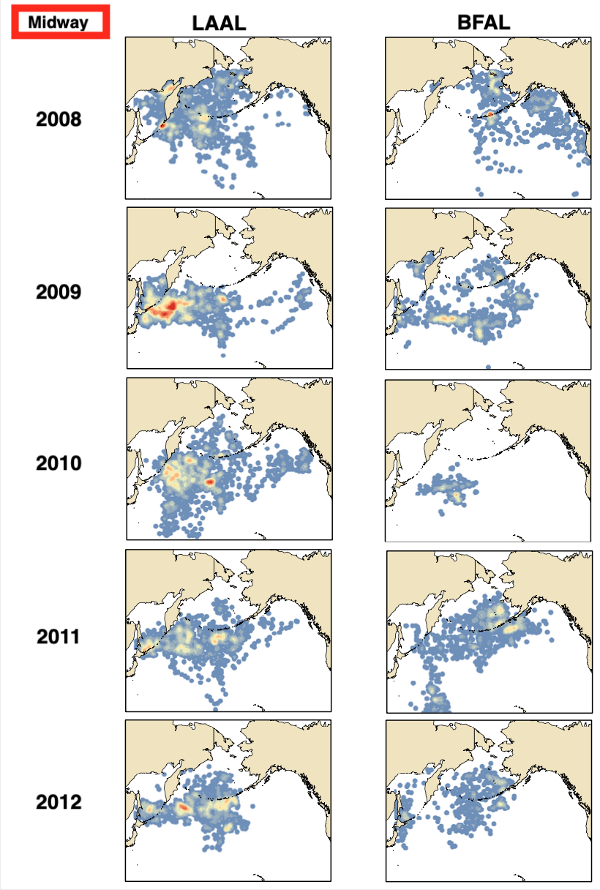

Figure . Yearly aggregate density estimates for modeled tracks of Midway LAAL and BFAL

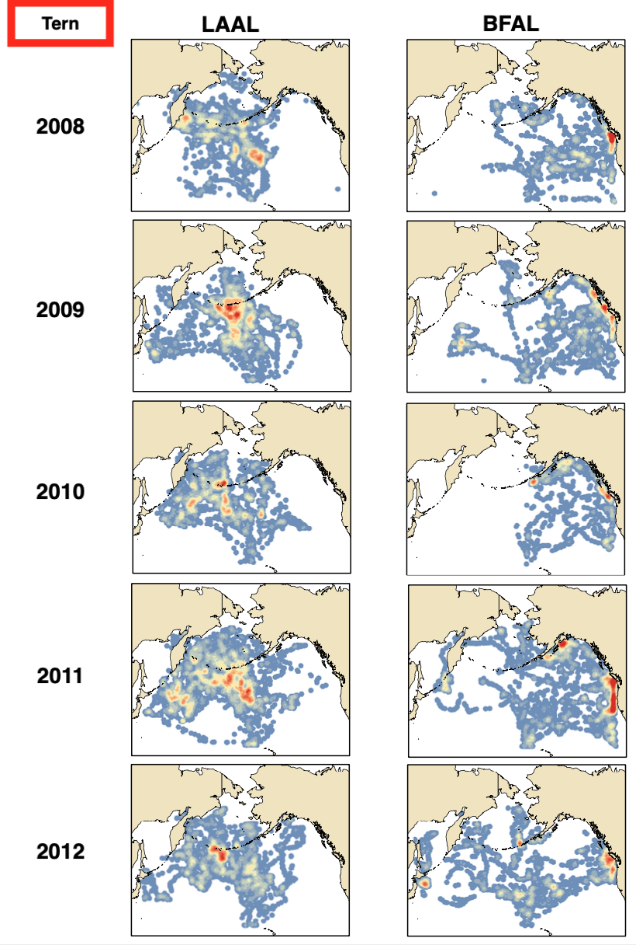

Figure . Yearly aggregate density estimates for modeled tracks of Midway LAAL and BFAL

Works Cited

Arata, J.A., Sievert, P.R., and Naughton, M.B. 2009. “Status Assessment of Laysan and Black-Footed Albatrosses , North Pacific Ocean , 1923 – 2005 Scientific Investigations Report 2009-5131,” 1923–2005. https://pubs.usgs.gov/sir/2009/5131/.

Ashmole, N Philip. 1971. “Seabird Ecology and the Marine Environment.” *Avian Biology* 1: 223–86.

Birt, VL, TP Birt, D Goulet, DK Cairns, and WA Montevecchi. 1987. “Ashmole’s Halo: Direct Evidence for Prey Depletion by a Seabird.” *Marine Ecology Progress Series* 40: 205–8. https://doi.org/10.3354/meps040205.

Breed, Greg A, W.D Bowen, J.I McMillan, and M.L Leonard. 2006. “Sexual Segregation of Seasonal Foraging Habitats in a Non-Migratory Marine Mammal.” *Proceedings of the Royal Society B: Biological Sciences* 273 (1599): 2319–26. https://doi.org/10.1098/rspb.2006.3581.

Burger, Alan E., and Scott A. Shaffer. 2008. “Application of Tracking and Data-Logging Technology in Research and Conservation of Seabirds.” *The Auk* 125 (2): 253–64. https://doi.org/10.1525/auk.2008.1408.

Catry, Paulo, Maria P. Dias, Richard A. Phillips, and José P. Granadeiro. 2011. “Different Means to the Same End: Long-Distance Migrant Seabirds from Two Colonies Differ in Behaviour, Despite Common Wintering Grounds.” Edited by R. Mark Brigham. *PLoS ONE* 6 (10): e26079. https://doi.org/10.1371/journal.pone.0026079.

Clay, Thomas A., Andrea Manica, Peter G. Ryan, Janet R.D. Silk, John P. Croxall, Louise Ireland, and Richard A. Phillips. 2016. “Proximate Drivers of Spatial Segregation in Non-Breeding Albatrosses.” *Scientific Reports* 6 (1): 1–13. https://doi.org/10.1038/srep29932.

Conners, Melinda G. 2015. “Comparative Behavior, Diet, and Post-Breeding Strategies of Two Sympatric North Pacific Albatross Species (Phoebastria Sp.).” UC Santa Cruz. https://doi.org/Conners_ucsc_0036E_10949.

Copello, Sofía, Juan Pablo Seco Pon, and Marco Favero. 2014. “Spatial Overlap of Black-Browed Albatrosses with Longline and Trawl Fisheries in the Patagonian Shelf during the Non-Breeding Season.” *Journal of Sea Research* 89 (May): 44–51. https://doi.org/10.1016/j.seares.2014.02.006.

Fischer, Karen N., Robert M. Suryan, Daniel D. Roby, and Gregory R. Balogh. 2009. “Post-Breeding Season Distribution of Black-Footed and Laysan Albatrosses Satellite-Tagged in Alaska: Inter-Specific Differences in Spatial Overlap with North Pacific Fisheries.” *Biological Conservation* 142 (4): 751–60. https://doi.org/10.1016/j.biocon.2008.12.007.

Gutowsky, Sarah E., Lee F.G. Gutowsky, Ian D. Jonsen, Marty L. Leonard, Maura B. Naughton, Marc D. Romano, and Scott A. Shaffer. 2014. “Daily Activity Budgets Reveal a Quasi-Flightless Stage during Non-Breeding in Hawaiian Albatrosses.” *Movement Ecology* 2 (1): 1–14. https://doi.org/10.1186/s40462-014-0023-4.

Gutowsky, Sarah E, Yann Tremblay, Michelle A Kappes, Elizabeth N Flint, John Klavitter, Leona Laniawe, Dan P Costa, Maura B Naughton, Marc D Romano, and Scott A Shaffer. 2014. “Divergent Post-Breeding Distribution and Habitat Associations of Fledgling and Adult Black-Footed Albatrosses Phoebastria Nigripes in the North Pacific.” *Ibis* 156 (1): 60–72. https://doi.org/10.1111/ibi.12119.

Hedd, A, WA Montevecchi, H Otley, RA Phillips, and DA Fifield. 2012. “Trans-Equatorial Migration and Habitat Use by Sooty Shearwaters Puffinus Griseus from the South Atlantic during the Nonbreeding Season.” *Marine Ecology Progress Series* 449 (March): 277–90. https://doi.org/10.3354/meps09538.

Hyrenbach, K. D., C. Keiper, S. G. Allen, D. G. Ainley, and D. J. Anderson. 2006. “Use of Marine Sanctuaries by Far-Ranging Predators: Commuting Flights to the California Current System by Breeding Hawaiian Albatrosses.” *Fisheries Oceanography* 15 (2): 95–103. https://doi.org/10.1111/j.1365-2419.2005.00350.x.

Hyrenbach, K David, Patricia Fernandez, and David J Anderson. 2002. “Oceanographic Habitats of Two Sympatric North Pacific Albatrosses during the Breeding Season.” *Marine Ecology Progress Series* 233: 283–301. https://www.int-res.com/abstracts/meps/v233/p283-301/.

Kappes, Michelle A., Scott A. Shaffer, Yann Tremblay, David G. Foley, Daniel M. Palacios, Steven J. Bograd, and Daniel P. Costa. 2015. “Reproductive Constraints Influence Habitat Accessibility, Segregation, and Preference of Sympatric Albatross Species.” *Movement Ecology* 3 (1): 1–24. https://doi.org/10.1186/s40462-015-0063-4.

Lisovski, Simeon, Silke Bauer, Martins Briedis, Sarah C. Davidson, Kiran L. Dhanjal‐Adams, Michael T. Hallworth, Julia Karagicheva, et al. 2020. “Light‐level Geolocator Analyses: A User’s Guide.” Edited by Garrett Street. *Journal of Animal Ecology* 89 (1): 221–36. https://doi.org/10.1111/1365-2656.13036.

MacArthur, Robert H. 1958. “Population Ecology of Some Warblers of Northeastern Coniferous Forests.” *Ecology* 39 (4): 599–619. https://doi.org/10.2307/1931600.

Mackley, EK, RA Phillips, JRD Silk, ED Wakefield, V Afanasyev, JW Fox, and RW Furness. 2010. “Free as a Bird? Activity Patterns of Albatrosses during the Nonbreeding Period.” *Marine Ecology Progress Series* 406 (May): 291–303. https://doi.org/10.3354/meps08532.

Murphy, Mary E. 1996. “Energetics and Nutrition of Molt.” In *Avian Energetics and Nutritional Ecology*, 158–98. Springer US. https://doi.org/10.1007/978-1-4613-0425-8_6.

Nishizawa, Bungo, Daisuke Ochi, Hiroshi Minami, Kotaro Yokawa, Sei Ichi Saitoh, and Yutaka Watanuki. 2015. “Habitats of Two Albatross Species during the Non-Breeding Season in the North Pacific Transition Zone.” *Marine Biology* 162 (4): 743–52. https://doi.org/10.1007/s00227-015-2620-1.

Orians, G H, and N E Pearson. 1979. “On the Ecology of Central Place Foraging.” *Analysis of Ecological Systems*, 155–77.

Parsons, Matt, Ian Mitchell, Adam Butler, Norman Ratcliffe, Morten Frederiksen, Simon Foster, and James B. Reid. 2008. “Seabirds as Indicators of the Marine Environment.” *ICES Journal of Marine Science* 65 (8): 1520–26. https://doi.org/10.1093/icesjms/fsn155.

Pettex, Emeline, Charlotte Lambert, Jérôme Fort, Ghislain Dorémus, and Vincent Ridoux. 2019. “Spatial Segregation between Immatures and Adults in a Pelagic Seabird Suggests Age‐related Competition.” *Journal of Avian Biology* 50 (5): jav.01935. https://doi.org/10.1111/jav.01935.

Phillips, RA, JRD Silk, JP Croxall, V Afanasyev, and DR Briggs. 2004. “Accuracy of Geolocation Estimates for Flying Seabirds.” *Marine Ecology Progress Series* 266 (January): 265–72. https://doi.org/10.3354/meps266265.

Reid, Tim A., Geoffrey N. Tuck, Mark A. Hindell, Sam Thalmann, Richard A. Phillips, and Chris Wilcox. 2013. “Nonbreeding Distribution of Flesh-Footed Shearwaters and the Potential for Overlap with North Pacific Fisheries.” *Biological Conservation* 166 (October): 3–10. https://doi.org/10.1016/j.biocon.2013.06.006.

Shaffer, Scott A., Yann Tremblay, Jill A. Awkerman, R. William Henry, Steven L.H. Teo, David J. Anderson, Donald A. Croll, Barbara A. Block, and Daniel P. Costa. 2005. “Comparison of Light- and SST-Based Geolocation with Satellite Telemetry in Free-Ranging Albatrosses.” *Marine Biology* 147 (4): 833–43. https://doi.org/10.1007/s00227-005-1631-8.

Sumner, Michael D., Simon J. Wotherspoon, and Mark A. Hindell. 2009. “Bayesian Estimation of Animal Movement from Archival and Satellite Tags.” *PLoS ONE* 4 (10): 7324. https://doi.org/10.1371/journal.pone.0007324.

Suryan, Robert M., Kimberly S. Dietrich, Edward F. Melvin, Gregory R. Balogh, Fumio Sato, and Kiyoaki Ozaki. 2007. “Migratory Routes of Short-Tailed Albatrosses: Use of Exclusive Economic Zones of North Pacific Rim Countries and Spatial Overlap with Commercial Fisheries in Alaska.” *Biological Conservation* 137 (3): 450–60. https://doi.org/10.1016/j.biocon.2007.03.015.

Suryan, Robert M., Fumio Sato, Gregory R. Balogh, K. David Hyrenbach, Paul R. Sievert, and Kiyoaki Ozaki. 2006. “Foraging Destinations and Marine Habitat Use of Short-Tailed Albatrosses: A Multi-Scale Approach Using First-Passage Time Analysis.” *Deep-Sea Research Part II: Topical Studies in Oceanography* 53 (3–4): 370–86. https://doi.org/10.1016/j.dsr2.2006.01.012.

Thorne, L. H., M. G. Conners, E. L. Hazen, S. J. Bograd, M. Antolos, D. P. Costa, and S. A. Shaffer. 2016. “Effects of El Niño-Driven Changes in Wind Patterns on North Pacific Albatrosses.” *Journal of the Royal Society Interface* 13 (119). https://doi.org/10.1098/rsif.2016.0196.

Tickell, W L N. 2000. *Albatrosses*. Yale University Press.

Wakefield, ED, RA Phillips, and J Matthiopoulos. 2009. “Quantifying Habitat Use and Preferences of Pelagic Seabirds Using Individual Movement Data: A Review.” *Marine Ecology Progress Series* 391 (September): 165–82. https://doi.org/10.3354/meps08203.

Wearmouth, Victoria J, and David W B T - Advances in Marine Biology Sims. 2008. “Chapter 2 Sexual Segregation in Marine Fish, Reptiles, Birds and Mammals: Behaviour Patterns, Mechanisms and Conservation Implications.” In , 54:107–70. Academic Press. https://doi.org/https://doi.org/10.1016/S0065-2881(08)00002-3.

Wilson, R P, J J Ducamp, W G Rees, B M Culik, and K Niekamp. 1992. “Estimation of Location: Global Coverage Using Light Intensity.” *Wildlife Telemetry: Remote Monitoring and Tracking of Animals*, no. December 2015: 131–34. http://ci.nii.ac.jp/naid/10018066932/en/.

Wilson, R P, D Grémillet, J Syder, MAM Kierspel, S Garthe, H Weimerskirch, C Schäfer-Neth, et al. 2002. “Remote-Sensing Systems and Seabirds: Their Use, Abuse and Potential for Measuring Marine Environmental Variables.” *Marine Ecology Progress Series* 228 (March): 241–61. https://doi.org/10.3354/meps228241.

Wilson, Rory P., Henri Weimerskirch, and Patrice Lys. 1995. “A Device for Measuring Seabird Activity at Sea.” *Journal of Avian Biology* 26 (2): 172. https://doi.org/10.2307/3677067.

Winship, Arliss J., Salvador J. Jorgensen, Scott A. Shaffer, Ian D. Jonsen, Patrick W. Robinson, Daniel P. Costa, and Barbara A. Block. 2012. “State-Space Framework for Estimating Measurement Error from Double-Tagging Telemetry Experiments.” *Methods in Ecology and Evolution* 3 (2): 291–302. https://doi.org/10.1111/j.2041-210X.2011.00161.x.

Worton, B. J. 1989. “Kernel Methods for Estimating the Utilization Distribution in Home- Range Studies.” *Ecology* 70 (1): 164–68. https://doi.org/10.2307/1938423.