Simplified Cost Function and Gradient Descent
Note: [6:53 - the gradient descent equation should have a 1/m factor]
We can compress our cost function's two conditional cases into one case:
Notice that when y is equal to 1, then the second term (1−y)log(1−hθ​(x)) will be zero and will not affect the result. If y is equal to 0, then the first term −ylog(hθ​(x)) will be zero and will not affect the result.
We can fully write out our entire cost function as follows:
A vectorized implementation is:

Gradient Descent
Remember that the general form of gradient descent is:
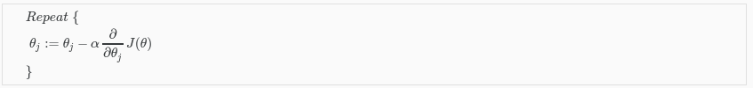
We can work out the derivative part using calculus to get:
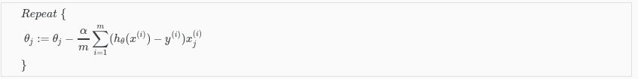
Notice that this algorithm is identical to the one we used in linear regression. We still have to simultaneously update all values in theta.
A vectorized implementation is:

