Cost Function
We can measure the accuracy of our hypothesis function by using a cost function. This takes an average difference (actually a fancier version of an average) of all the results of the hypothesis with inputs from x's and the actual output y's.
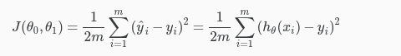
To break it apart, it is 21​ x¯ where x¯ is the mean of the squares of hθ​(xi​)−yi​ , or the difference between the predicted value and the actual value.
This function is otherwise called the "Squared error function", or "Mean squared error". The mean is halved (21​) as a convenience for the computation of the gradient descent, as the derivative term of the square function will cancel out the 21​ term. The following image summarizes what the cost function does:
