Matrices and Vectors
Matrices are 2-dimensional arrays:
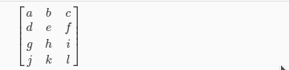
The above matrix has four rows and three columns, so it is a 4 x 3 matrix.
A vector is a matrix with one column and many rows:
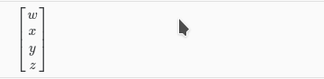
So vectors are a subset of matrices. The above vector is a 4 x 1 matrix.
Notation and terms:
- Aij​ refers to the element in the ith row and jth column of matrix A.
- A vector with 'n' rows is referred to as an 'n'-dimensional vector.
- vi​ refers to the element in the ith row of the vector.
- In general, all our vectors and matrices will be 1-indexed. Note that for some programming languages, the arrays are 0-indexed.
- Matrices are usually denoted by uppercase names while vectors are lowercase.
- "Scalar" means that an object is a single value, not a vector or matrix.
- R refers to the set of scalar real numbers.
- Rn refers to the set of n-dimensional vectors of real numbers.
Run the cell below to get familiar with the commands in Octave/Matlab. Feel free to create matrices and vectors and try out different things.
