Addition and Scalar Multiplication
Addition and subtraction are element-wise, so you simply add or subtract each corresponding element:
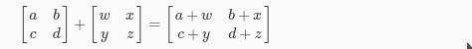
Subtracting Matrices:
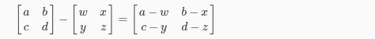
To add or subtract two matrices, their dimensions must be the same.
In scalar multiplication, we simply multiply every element by the scalar value:
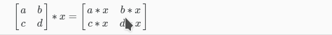
In scalar division, we simply divide every element by the scalar value:
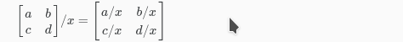
Experiment below with the Octave/Matlab commands for matrix addition and scalar multiplication. Feel free to try out different commands. Try to write out your answers for each command before running the cell below.
