Matrix-Matrix Multiplication
We multiply two matrices by breaking it into several vector multiplications and concatenating the result.
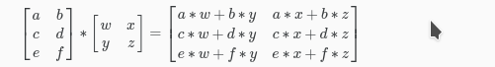
An m x n matrix multiplied by an n x o matrix results in an m x o matrix. In the above example, a 3 x 2 matrix times a 2 x 2 matrix resulted in a 3 x 2 matrix.
To multiply two matrices, the number of columns of the first matrix must equal the number of rows of the second matrix.
For example:
