Machine Learning
- Definitions
m number of training examples
α learning rate
Θ parameter vector (2 parameters: Θ₀, Θ₁)
y value vector (m values)
X training input vector (m values)
i^{th} training example
2 featured-hypothesis of y (linear function)
2 featured Squared error Cost function - should be minimized
Gradient descent algorithm to minimize

n number of features (Θ)
value of j^{th} feature in the i^{th} training example

 |  |  | ... |  | y
1 |  |  | ...
1 |  |  | ...
... | ... | ... | ... | ... | ...
1 |  |  | ...

n featured m training data. The first X is always “1” for simplify the vectorization

multiple featured-hypothesis of y (jD)
vectorized multiple featured hypothesis
vectorized Cost function
Gradient descent algorithm

- Linear Regression
  - Hypothesis – estimate y values
We suppose the training data follows linear line. That is the hypothesis. The equation is:

The equation has two parameters: Θ₀, Θ₁. The task is to calculate them so that the function fits better to the training data.
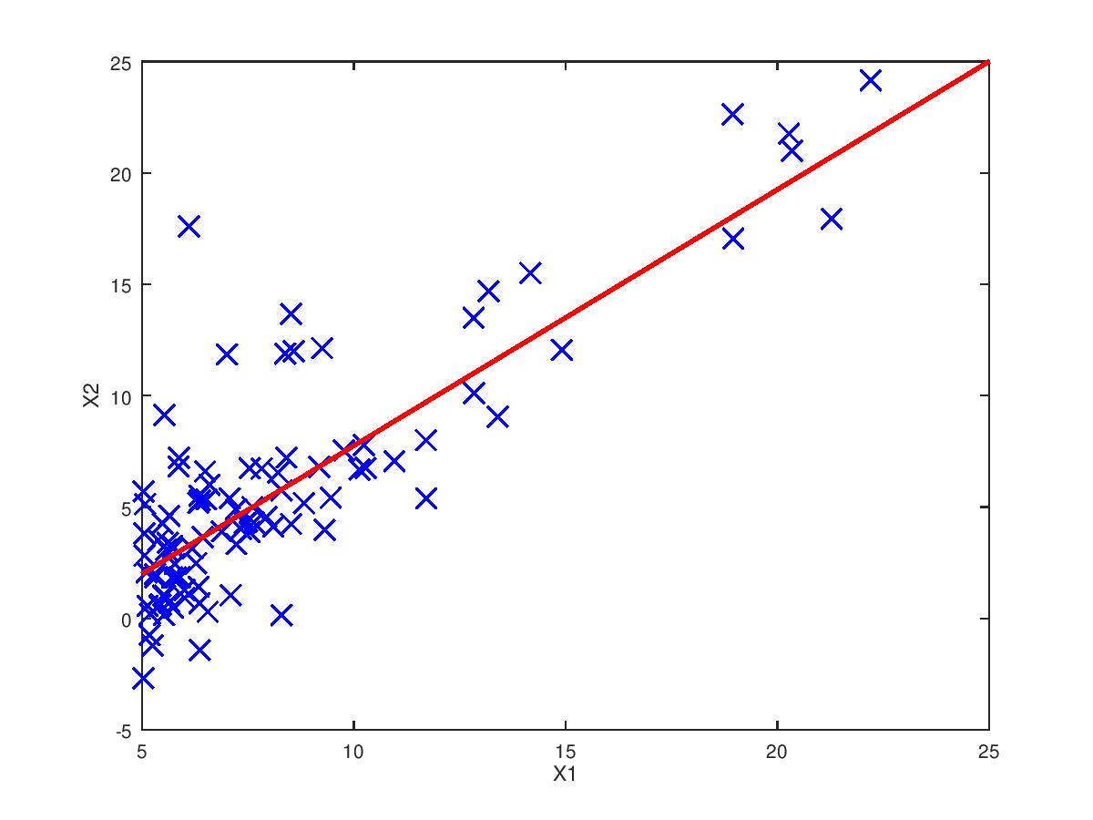
  - Cost function
The cost function is a definition so it does not need to be proven. It defines a value which shows how our graph is far from the ideal graph. The task is to find the minimum of this value.

We chose a squared function, which means that it is guaranteed that the function has minimum value.
    - Uni-featured
In this case we modify only the Θ₁ parameter and we keep Θ₀=0
Let’s say that the training data fallows the y=1*X formula so some points are: (0,0), (1,1), (2,2), (3,2)

- First we chose the Θ₁=2 which means that our function is y=2*X (red).
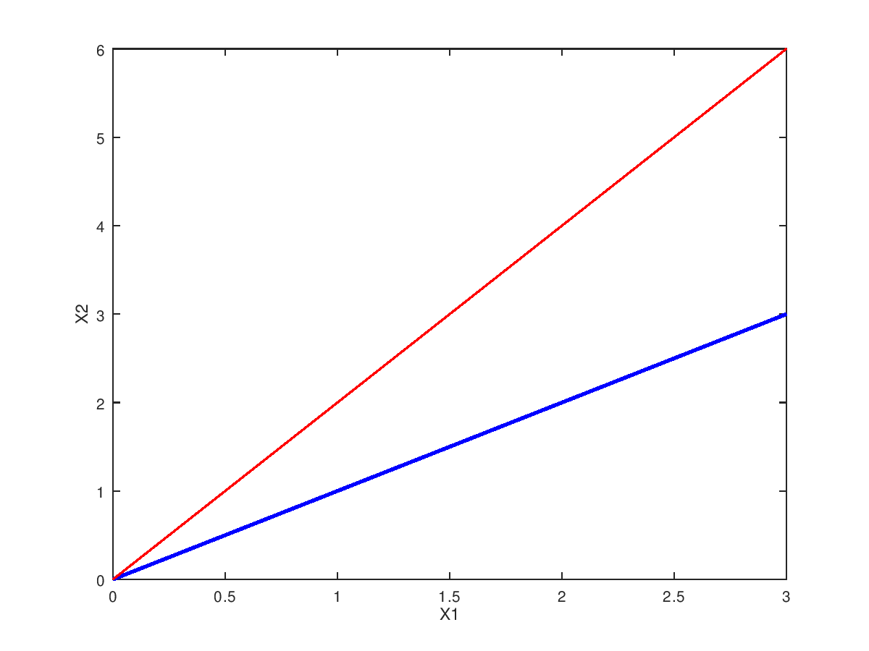
You can see that our graph differs from the training data (blue). The different is

- Let’s choose Θ₁=3 which means that our function is y=3*X (red).
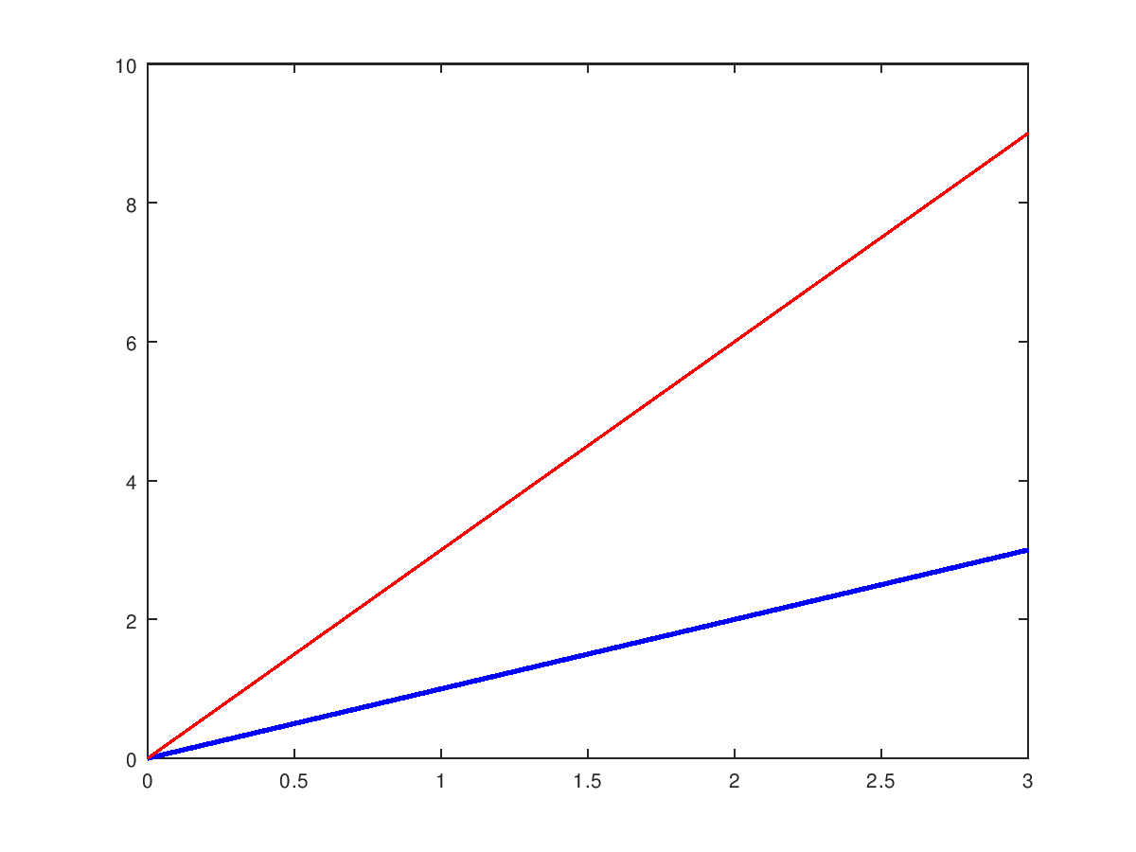
You can see that the differences are bigger than before:

- If we choose Θ₁=1, which means that our function is y=1*X, then the two graphs covers each other so the J=0

- Now let’s investigate how J function looks like:

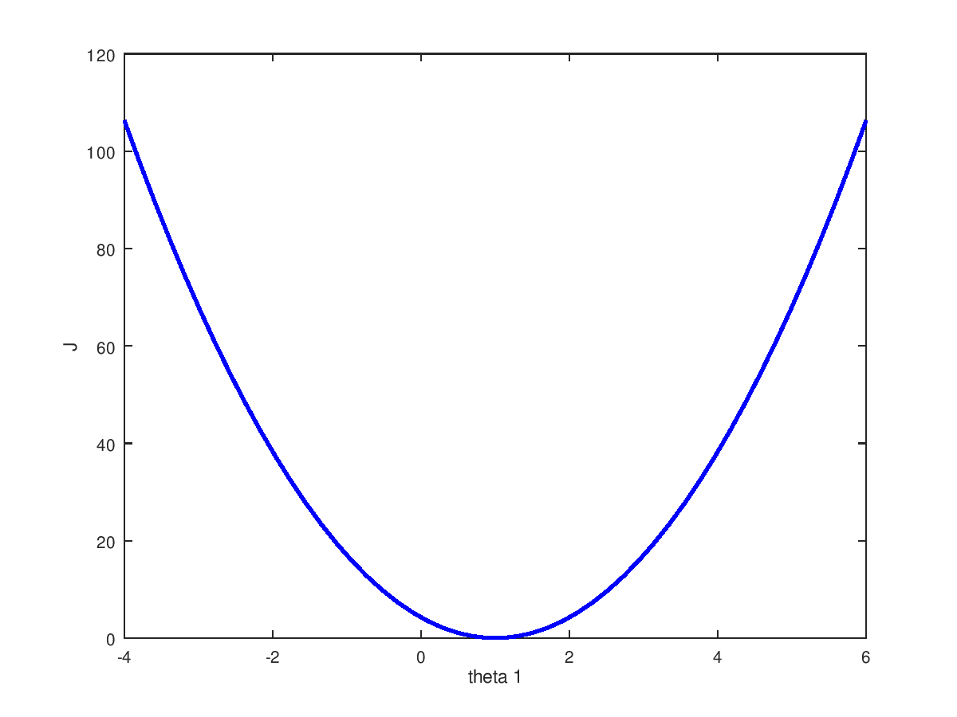 | Octave  >> m = 100;  >> n = 100;  >> theta = linspace(-4,6,n);  >> X=linspace(-5,5,m);  >> y=1*X;  >> h=theta'*X;  >> h2=h-y;  >> h3=h2 .^ 2;  >> t=ones(m,1);  >> r=(h3*t)/(2*m);  >> figure(1); plot(theta, r, 'b', 'linewidth', 2)

This figure shows that the function has minimum value at Θ₁=1 point and it’s value is 0. The 0 value means that the two functions fit together without error-perfect match.

    - Multi-featured
In this case we modify both Θ₀ and Θ₁ parameters. Those two parameters are the features.
Now let’s choose training data that follows the y=3+2*X formula so some points are: (0,3), (1,5), (2,7), (3,9)
It is a little bit harder to find the minimum J as we have two parameters instead of one. It means that now not a line but a surface will represent the Cost function.
Let’s calculate and show the J function:

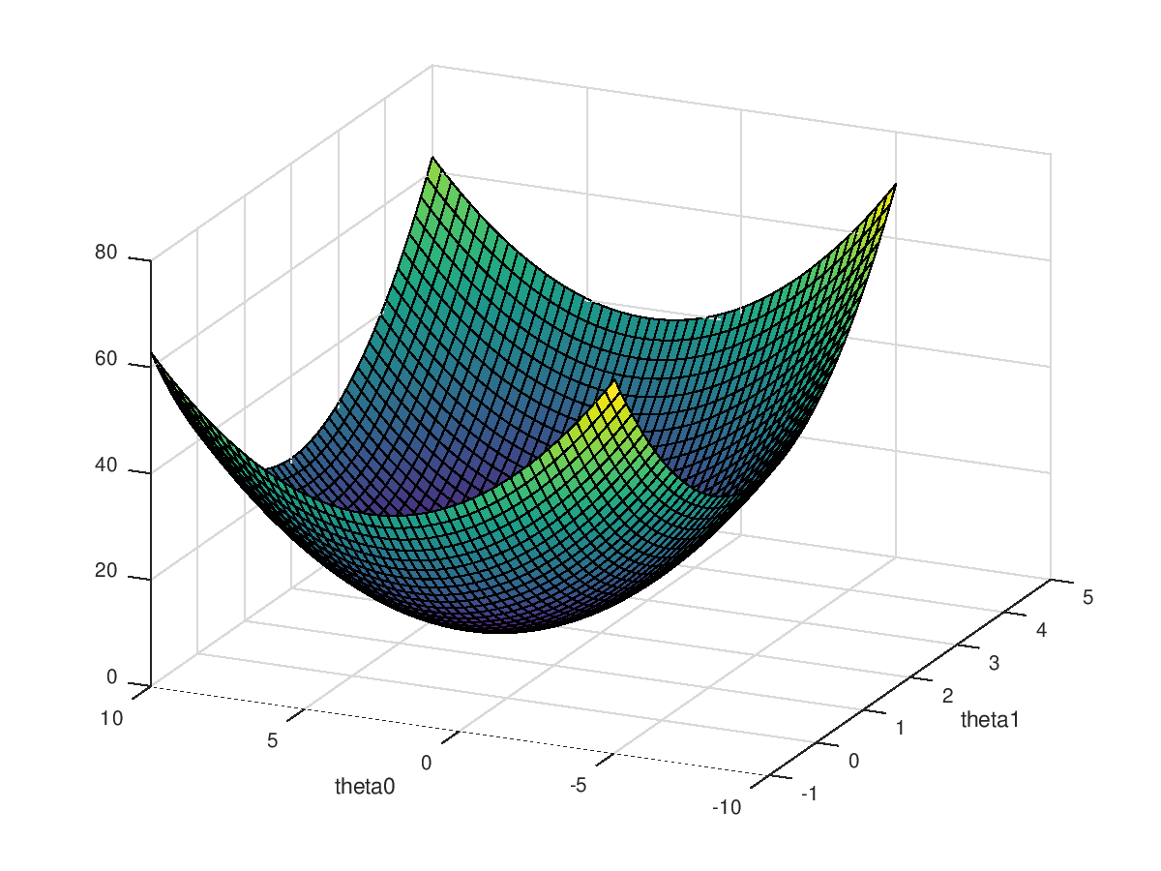  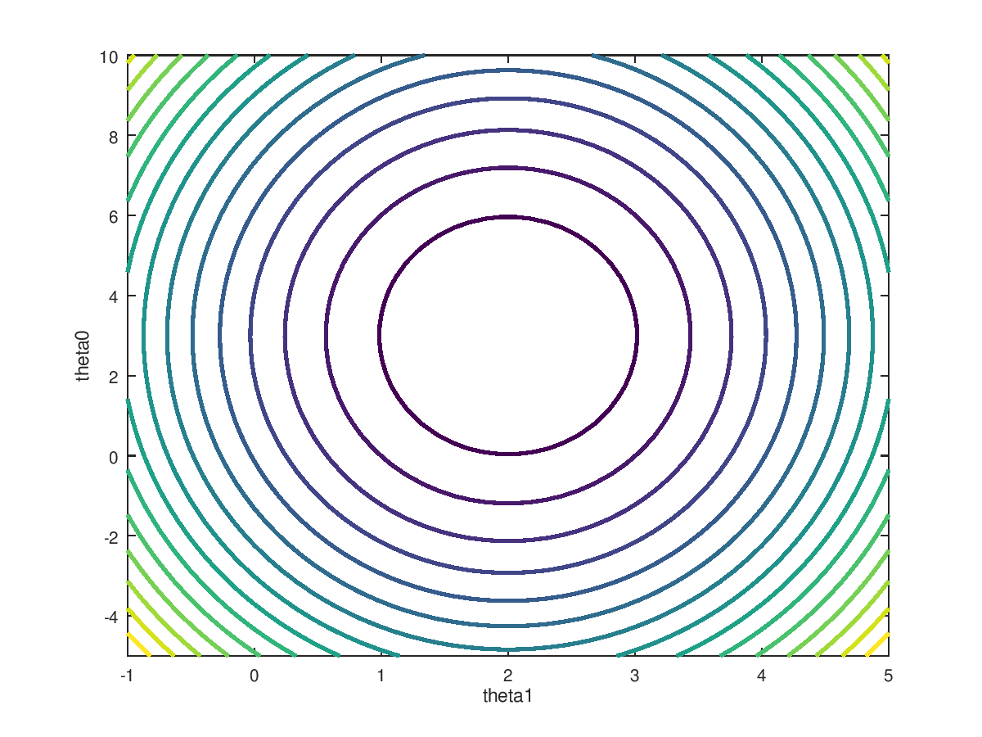 | Octave  >> m = 100;  >> n = 50;  >> t=ones(m,1);  >> theta0 = linspace(-5,10,n);  >> theta1 = linspace(-1,5,n);  >> theta = cartprod(theta0,theta1);  >> X=[ones(1,m);linspace(-5,5,m)];  >> y=X'*[3;2];  >> h=(theta*X-y').^ 2;  >> r=(h*ones(m,1))/(2*m);  >> figure(1); surf(theta1', theta0',reshape(r,n,n))  >> xlabel("theta1");  >> ylabel("theta0");  >>  >> contour(theta1', theta0',reshape(r,n,n), 15, 'linewidth',2);  >> ylabel("theta0");  >> xlabel("theta1");

You can see that “bowl” shaped surface represents the Cost function. We saw that in case of one feature, the Cost function is one-dimensional, in case of two features, the Cost function is two-dimensional. And so on. It means that unfortunately, the higher-dimensional Cost functions can’t be represented on graph – but, of course, still can be calculated.
This Cost function always has a global minimum. If we find the global minimum (Θ₀, Θ₁), we can construct the function (hypothesis) which is closest to the training data.
Now the question is, how to reach the minimum.

  - Gradient descent algorithm
One way to reach the global minimum of the Cost function is the Gradient descent algorithm.

Here is how it works.
- Select a random position on the Cost function (Θ_{j}).
- Derive the function on that point. The absolute value of the derivation show how far you are from the ideal point. The bigger the number (bigger slope) the further you are. The sign of the value of the derivation shows that you are on the right or left side of the ideal point. Negative value means you are on the left side, positive value means, you are on the right side.
- An alpha variable is introduced which you should multiply the derivation with
- Deduct this value from the actual position (Θ_{j}) and you get your new position (which should be closer to the minimum point).
- Continue this process until you get as close to the minimum point as you wanted.

With one-featured Cost-function it is easy to understand and demonstrate this as the function has only one parameter.
With two-featured Cost-function it is more difficult to understand and demonstrate the process as the Cost function has two parameters. It represents a surface where we have to find the minimum. To do that we have to partial derive the function once on one axis and once on the perpendicular axis.
With multi-featured Cost-function we are not able to represent graphically what we are doing. We have to believe in math and do what we done so far. Partial derive the function on every perpendicular axis which are the features.

Now let’s vectorize the Gradient descent algorithm.
1.
2.
3.
4.
5.
6.

Vectorization solution:
There is an analytic solution as well:
And here is the vectorization Cost-function:

  - Feature Scaling-Normalize
Generally the features are in different scale. For example one feature is the price ($100-10000/m2) and the other is the number of bedrooms (1-4).
In this case the Contour of Cost function is pretty elongated ellipse, which is hard and slow to find the global minimum.

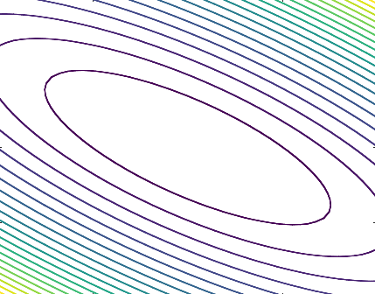
To make it easier and faster, you should Normalize the X before you use it:
Octave
>> mu = mean(X);
>> sigma = std(X);
>> X_norm = (X-mu)./sigma

  - Gradient Descent example
We have 4 points: (0,0), (0,2), (2,0), (3.3). We are looking for the plan surface which fit to them best. Our hypothesis is y=Θ₀ + Θ₁ X₁ + Θ₂X₂

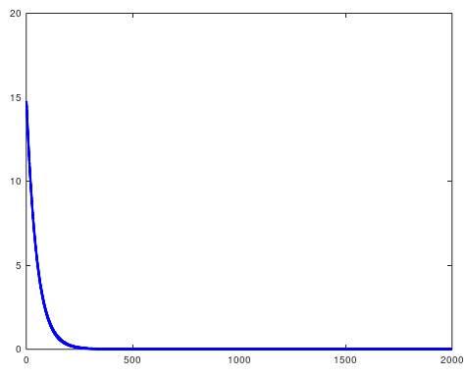  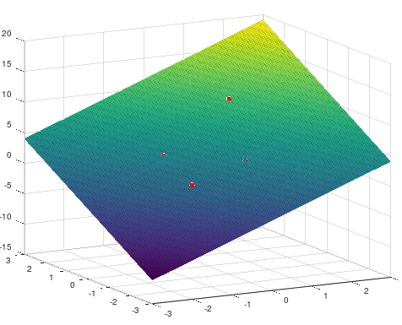 | Octave  clear;  % --- Function: normalizeFeature ---  function [X_norm, mu, sigma] = normalizeFeature(X)  mu=mean(X);  sigma=std(X);  X_norm=(X-mu)./sigma;  endfunction  %--- Function: Gradient Descent ---  function [theta, J_history] = gradientDescent(X,y,theta,alpha,num_iters)  m=length(y);  J_history=zeros(num_iters,1);  for iter=1:num_iters  A=X*theta-y;  b=A'*A;  theta=theta-(alpha/m)*X'*A;  J_history(iter) = b/(2*m);  end  endfunction  %--- Input data ---  X=[0,0;0,2;2,0;3,3];  y=[0;3;3;10];  %--- Preparation for theta calculation ---  m=length(y);  [X mu sigma] = normalizeFeature(X);  X=[ones(m,1) X];  alpha=0.01;  num_iters=2000;  theta=zeros(3,1);  %--- theta calculation ---  [theta, J_history]=gradientDescent(X,y,theta,alpha, num_iters);  %--- visualization ---  theta  figure(1);plot(1:numel(J_history),J_history,'linewidth',3,'b')  figure(2);scatter3(X(:, 2), X(:,3), y, 30, 'r', 'filled')  hold on;  t=100;  Xt1=linspace(-3,3,t);  Xt2=linspace(-3,3,t);  XtList=[ones(t*t,1), cartprod(Xt1,Xt2)];  yt=reshape(XtList*theta,t,t);  surf(Xt1,Xt2,yt);  theta =  4.0000  2.5263  2.5263

  - Advanced optimization
There are many other optimization algorithm besides the Gradient Descent:
- Gradient Descent
- Conjugate Gradient
- BFGS
- L-BFGS
Here is an example how we can make simpler our code. We have to define a function where the Cost and the Gradient are calculated for a Θ and then we call the “fminunc” function:
Let’s say our Cost function is:
Let’s say gradient is:
As you can see, the lowest Θ is [3; 7]. That what we expecting to be calculated.
We put these information into the “costFunction” function:
Octave: costFunction.m
function [jVal, gradient] = costFunction(theta)
jVal = (theta(1)-3)^2 + (theta(2)-7)^2;
gradient = zeros(2,1);
gradient(1) = 2 * (theta(1)-3);
gradient(2) = 2 * (theta(2)-7);

And now we have to make some preparation and then call the “fminunc” function:
Octave
>> options = optimset('GradObj', 'on', 'MaxIter', '100');
>> initialTheta = zeros(2,1);
>> [optTheta, functionalVal, exitFlag] = fminunc(@costFunction, initialTheta, options)

optTheta =

3
7

functionalVal = 0
exitFlag = 1
The “optTheta” shows the result of Θ. It is [3;7] and that what we expected.
The “functionalVal” shows the Cost. It is 0, and this is what we expected.

  - Advanced example
We have the same 4 points as we had in the “Gradient Descent Example”: (0,0), (0,2), (2,0), (3.3). We are looking for the plan surface which fit to them best, but now we use the “fminunc” built-in function instead of the “Gradient Descent” algorithm. Our hypothesis is y=Θ₀ + Θ₁ X₁ + Θ₂X₂

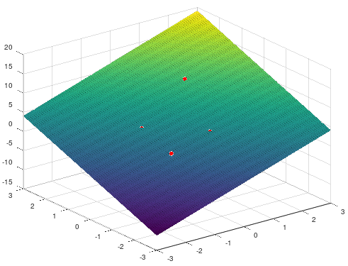 | Octave  clear;  % --- normalizeFeature ---  function [X_norm, mu, sigma] = normalizeFeature(X)  mu=mean(X);  sigma=std(X);  X_norm=(X-mu)./sigma;  endfunction  %--- CostFunction ---  function [jVal, gradient] = myCostFunction(theta)  global m;  global y;  global X;  A=X*theta-y;  b=A'*A;  jVal = b/(2*m);  gradient = 2*(X'*A);  endfunction  %--- Preparation for theta calculation ---  global X=[0,0;0,2;2,0;3,3];  global y=[0;3;3;10];  global m=length(y);  [X mu sigma] = normalizeFeature(X);  X=[ones(m,1) X];  theta=zeros(3,1);  options = optimset('GradObj', 'on', 'MaxIter', 1000);  [theta, functionalVal, exitFlag] = fminunc(@myCostFunction, theta, options);  %--- visualization ---  theta  figure(2);scatter3(X(:, 2), X(:,3), y, 30, 'r', 'filled')  hold on;  t=100;  Xt1=linspace(-3,3,t);  Xt2=linspace(-3,3,t);  XtList=[ones(t*t,1), cartprod(Xt1,Xt2)];  yt=reshape(XtList*theta,t,t);  surf(Xt1,Xt2,yt);  theta =  4.0000  2.5263  2.5263

  - Regularized linear regression

λ - regularization parameter
But we do not want to regularize (penalize) Θ₀, so here is the modified process when we minimize Θ:

- Classification-Logistic regression
The classification is an other machine learning problem.

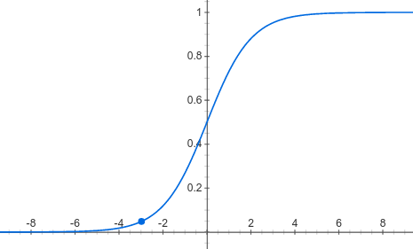
We distinguish two clusters: 0 and 1.
h_{Θ}(X)=0 if g<0.5 => z<0
h_{Θ}(X)=1 if g>=0.5 => z>=0

- Example 1 – linear solution
z=Θ₀ + Θ₁*X₁ + Θ₂*X₂ >= 0
let’s say: Θ=[-3, 1, 1]
X=[ X₀, X₁, X₂] = [1, X₁, X₂]
z=X*Θ^{T} = -3 + 1*X₁ + 1*X₂ >= 0
There is solution for this equation in 2D and 3D. In 3D it is a mathematical inclined-plane which intersects the base-plane in a line.
We consider the points to be belonging to the cluster 1. which are on the half-plane where the inclined-plane is above the base-plane.

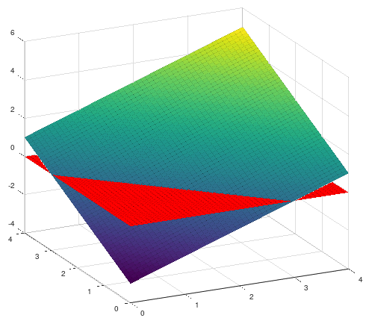 | Octave  m=50;  X1=linspace(0,4,m);  X2=linspace(0,4,m);  X=cartprod(X1,X2);  y=X*[1;1]-3;  figure(1); surf(X1', X2',reshape(y,50,50))  hold on;  con=linspace(0,0,m^2);  figure(1); surf(X1', X2',reshape(con,m,m), 'facecolor', [1,0,0]);

- Example 2 – higher order polynomial
z=(X₁ - a)² + (X₂ - b)² - R² = Θ₀ + Θ₁*X₁² + Θ₂*X₁ + Θ₃*X₂² + Θ₄*X₂ >= 0
let’s say: a=5, b=5, R=3 => Θ=[47, 1, 10, 1, 10]
X=[ X₀, X₁² , X₁ + X₂² , X₂ ] = [1, X₁² , X₁ + X₂² , X₂]
z=X*Θ^{T} = 47 + X₁² + 10*X₁ + X₂² + 10*X₂ >= 0
There is solution for this equation in 2D and 3D. In 3D it is a bowl shape surface which intersects the base-plane in a circle.
We consider the points to be belonging to the cluster 1. which are on the base-plane where the inclined-plane is above the base-plane.

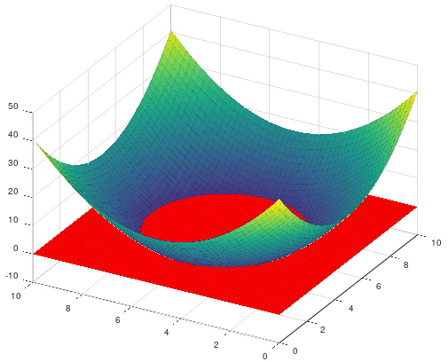 | Octave  m=50;  X1=linspace(0,10,m);  X2=linspace(0,10,m);  X=cartprod(X1,X2);  X=[ones(m^2,1),X(:,1).^2,X(:,1),X(:,2).^2,X(:,2)];  theta = [41;1;-10;1;-10];  y=X*theta;  figure(1);surf(X1',X2',reshape(y,m,m));  hold on;  con=linspace(0, 0, m^2);  figure(1);surf(X1',X2',reshape(con,m,m), 'facecolor', [1,0,0]);

We can not use the same Cost function as we used in the linear regression. Our Cost function would be a “Convex” function with many local minimums.
So we choose a different Cost function:

In short:

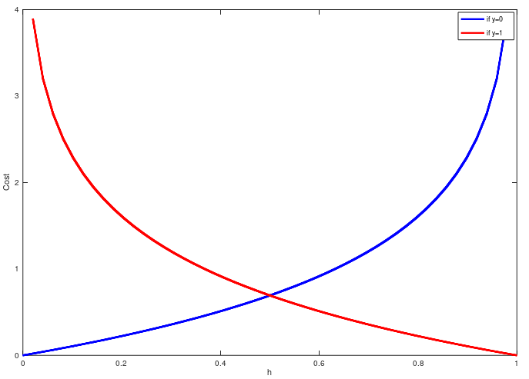 | Octave  h=linspace(0,1,50);  plot(h,cost0,'b', 'linewidth', 3)  hold on;  plot(h,cost1,'r', 'linewidth', 3)  ylabel('Cost')  xlabel('h')  legend('if y=0', 'if y=1');

You can read from the graph that the Cost is 0 if the training value is 0 (not in the cluster) and the hypothesis is 0 or if the training value is 1 (is in the cluster) and the hypothesis is 1.

Here is the Cost function J(Θ) which we have to minimaze.

Finally here is how to calculate the Θ by deriving the Cost function:

Here are the form from the Assignment:

- PlotDecisionBoundary  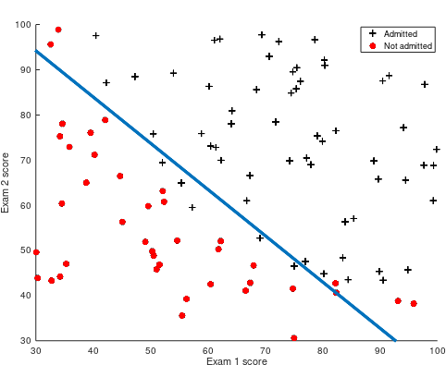 | plotDecisionBoundary.m - Octave  function plotDecisionBoundary(theta, X, y)  plotData(X(:,2:3), y);  hold on  % Only need 2 points to define a line, so choose two endpoints  plot_x = [min(X(:,2))-2, max(X(:,2))+2];  % Calculate the decision boundary line  plot_y = (-1./theta(3)).*(theta(2).*plot_x + theta(1));  % Plot, and adjust axes for better viewing  plot(plot_x, plot_y,'linewidth', 3)  % Legend, specific for the exercise  legend('Admitted', 'Not admitted', 'Decision Boundary')  axis([30, 100, 30, 100])

- sigmoid function | ex2.m - Octave  function g = sigmoid(z)  %SIGMOID Compute sigmoid function  % z = theta'*X  % g = SIGMOID(z) computes the sigmoid of z.  % You need to return the following variables correctly  g = zeros(size(z));  % ====================== YOUR CODE HERE ======================  % Compute the sigmoid of each value of z (z can be a matrix, vector or scalar).  g = 1 ./ (1 + e .^ (-z));

- CostFunction | costFunction.m - Octave  function [J, grad] = costFunction(theta, X, y)  %COSTFUNCTION Compute cost and gradient for logistic regression  % J = COSTFUNCTION(theta, X, y) computes the cost of using theta as the  % parameter for logistic regression and the gradient of the cost  % w.r.t. to the parameters.  % Initialize some useful values  m = length(y); % number of training examples  % You need to return the following variables correctly  J = 0;  grad = zeros(size(theta));  % ====================== YOUR CODE HERE ======================  % Instructions: Compute the cost of a particular choice of theta.  % You should set J to the cost.  % Compute the partial derivatives and set grad to the partial  % derivatives of the cost w.r.t. each parameter in theta  %  % Note: grad should have the same dimensions as theta  %  z = X * theta;  h = sigmoid(z);  tmp = y .* log(h) + (1-y) .* log(1-h);  J = ( ones(1,m) * tmp ) ./ -m;  grad = X'*(h-y) ./ m;

- prediction | prediction.m - Octave  function p = predict(theta, X)  %PREDICT Predict whether the label is 0 or 1 using learned logistic  %regression parameters theta  % p = PREDICT(theta, X) computes the predictions for X using a  % threshold at 0.5 (i.e., if sigmoid(theta'*x) >= 0.5, predict 1)  m = size(X, 1); % Number of training examples  % You need to return the following variables correctly  p = zeros(m, 1);  % ====================== YOUR CODE HERE ======================  % Instructions: Complete the following code to make predictions using  % your learned logistic regression parameters.  % You should set p to a vector of 0's and 1's  %  g=sigmoid(X*theta);  one=find(g>=0.5);  p(one,1)=1;  =============================================================  end

  - Regularized logistic regression

gradient:

- costFunctionReg  (regularized costFunction) | costFunctionReg.m - Octave  function [J, grad] = costFunctionReg(theta, X, y, lambda)  m = length(y); % number of training examples  % You need to return the following variables correctly  J = 0;  grad = zeros(size(theta));  n=length(theta);  z=X*theta;  h=sigmoid(z);  tmp=y.*log(h)+(1-y).*log(1-h);  sumtheta2=(lambda/(2*m)) * [0, ones(1, n-1)] * (theta .^2);  J = ( (ones(1,m) * tmp) ./ -m ) + sumtheta2;  sumtheta=(lambda/m) * ( [0, ones(1, n-1)]' .* theta );  grad = (X' * (h-y) ./m ) + sumtheta;  end

- MapFeature  generates polynomial X | mapFeature.m - Octave  function out = mapFeature(X1, X2)  % MAPFEATURE Feature mapping function to polynomial features  %  % MAPFEATURE(X1, X2) maps the two input features  % to quadratic features used in the regularization exercise.  %  % Returns a new feature array with more features, comprising of  % X1, X2, X1.^2, X2.^2, X1*X2, X1*X2.^2, etc..  %  % Inputs X1, X2 must be the same size  degree = 6;  out = ones(size(X1(:,1)));  for i = 1:degree  for j = 0:i  out(:, end+1) = (X1.^(i-j)).*(X2.^j);  end  end

- plotDecisionBoundary  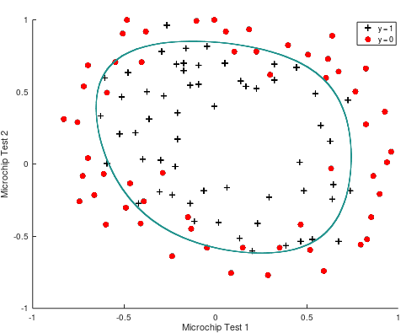  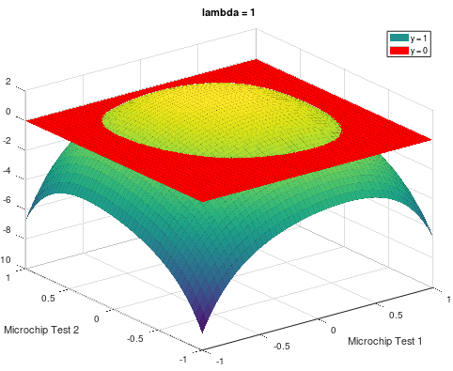 | plotDecisionBoundary.m - Octave  function plotDecisionBoundary(theta, X, y)  plotData(X(:,2:3), y);  hold on  % Here is the grid range  u = linspace(-1, 1, 50);  v = linspace(-1, 1, 50);  z = zeros(length(u), length(v));  % Evaluate z = theta*x over the grid  for i = 1:length(u)  for j = 1:length(v)  z(i,j) = mapFeature(u(i), v(j))*theta;  end  end  z = z'; % important to transpose z before calling contour  % Plot z = 0  % Notice you need to specify the range [0, 0]  contour(u, v, z, [0,0], 'LineWidth', 2)  hold off;  figure(2); surf(u, v, z);  hold on;  con=linspace(0, 0, 50^2);  figure(2);surf(u,v,reshape(con,50,50), 'facecolor', [1,0,0]);

- Overfitting
Underfit - “High bias” - very strong prediction – fail to fit even the training set
Overfit - “High variance” - create a good job fitting the training set but it is a wiggly curve.

Options:
- Reduce number of features
- Manually select which features to keep
- Model selection algorithms
- Regularization
- Keep all the features, but reduce magnitude/values of parameters Θ_{j}

- Neural Networks
a_{i}^{(j)} activation unit i in layer j
s_{j} number of units in the j^{th} layer (not counting bias)
K number of units in the output layer
L total number of layers
Θ^{(j)} matrix of weights controlling function mapping from layer j to layer j+1
size of the matrix: s_{j+1} x (s_{j} + 1)
Θ_{mn}^{(j)} wight from the n^{th} unit in the j layer to the m^{th} unit in the j+1 layer
x_{k} k^{th} input
g logistic function
a₀⁽²⁾ =1
x₀ =1

a₁⁽²⁾
x₁

a₂⁽²⁾
a₁⁽³⁾
x₂
h_{Θ}(x)
a₃⁽²⁾
x₃

Binary Classification: one output unit K=1 → y = 0 or 1
Multi-class classification: K output units >= 3

  - Cost function

  - Backpropagation
δ_{j}^{(l)} error of node j in layer l – shows how much that node was responsible for any arrors in output.
For an output node, we can directly measure the difference between the network’s activation and the true target value, and use that to to define δ_{j}^{(L)}.
For hidden units, you will compute δ_{j}^{(l)} based on a weighted average of the error terms of the nodes in layer (l+1)
a₀⁽²⁾ =1
x₀ =1
a₀⁽³⁾ =1

a₁⁽²⁾
x₁
a₁⁽³⁾
a₁⁽⁴⁾
Y₁⁽⁴⁾
a₂⁽²⁾
x₂
a₂⁽³⁾
a₂⁽⁴⁾
Y₂⁽⁴⁾
a₃⁽²⁾
x₃
a₃⁽³⁾
a₃⁽⁴⁾
Y₃⁽⁴⁾

δ⁽²⁾ δ⁽³⁾ δ⁽⁴⁾ (remove δ₀^{(l)})

δ⁽⁴⁾ = a⁽⁴⁾ - y
δ⁽³⁾ = (Θ⁽³⁾)^{T} * δ_{j}⁽⁴⁾ .* g’ (z⁽³⁾) = (Θ⁽³⁾)^{T} * δ_{j}⁽⁴⁾ .* sigmoid(z⁽³⁾) .* (1-sigmoid(z⁽³⁾)) = (Θ⁽³⁾)^{T} * δ_{j}⁽⁴⁾ .* a⁽³⁾ .* (1-a⁽³⁾)
δ⁽²⁾ = (Θ⁽²⁾)^{T} * δ_{j}⁽³⁾ .* g’ (z⁽²⁾) = (Θ⁽²⁾)^{T} * δ_{j}⁽³⁾ .* sigmoid(z⁽²⁾) .* (1-sigmoid(z⁽²⁾)) = (Θ⁽²⁾)^{T} * δ_{j}⁽³⁾ .* a⁽²⁾ .* (1-a⁽²⁾)

Prerequisites:
Θ^{(l)} [s_{l+1} * s_{l}+1] Rows represent the number of outputs (number of units in the next layer). Columns represent the number of inputs + 1 bias (number of units in the actual layer, including the bias)
X [m * s₀] Every row represents one training input set. The number of columns equal to the number of inputs.
y [m * 1] Every row represents one training output set. In case of multi-class output, you have to convert this output to have as many columns as the number of multi-classes. For example in case of 1 numeric output from 0-10, you need [m * 10] matrix where the lines are like this [0,0,0,0,0,0,0,0,0,1], [1,0,0,0,0,0,0,0,0,0], [0,1,0,0,0,0,0,0,0,0] and so on.
y_dig [m * s_{L}] The converted y. The number of columns equal to the number of outputs

Steps:
a⁽¹⁾ [m * (s₀+1)] a⁽¹⁾ = X^{(i)}. You have to add 1 extra column to the beginning, with value=1, which represents the bias
z^{(l)} [m * s_{l}] for l=2,3 … L with forward propagation. z^{(l)} = a^{(l-1)} * (Θ^{(l-1)})^{T}. The number of columns equal to the number of units in the actual layer.
a^{(l)} [m * (s_{l}+1)] for l=2,3 … L-1 with forward propagation. a^{(l)} = sigmoid(z^{(l)}) + add one bias column with value=1
a^{(L)}=h [m * s_{L}] activation for the output layer with forward propagation. a^{(L)} = sigmoid(z^{(L)}) (do not add bias column)
reg Cost regularization. Do not regularize the bias! reg=λ/2m * ΣΣΣΘ² (Θ without the first (bias) column)
J_m Cost by training data, without regularization. J_m=y_dig.log(h)+(1-y_dig) .*log(1-h)
J Regularized Cost. J=(ΣΣJ_m)/m + reg

for i = 1 to m:
δ^{(L)} [s_{L}* 1] δ^{(L)} = a^{(L) –} y^{(i)} The error of the output layer. The column represent the error of the units
δ^{(L-1)} ,δ^{(L-2)} … δ⁽²⁾ [s_{l}* 1] Do not calculate δ for the bias!
δ^{(l)}=(Θ^{(l)})^{T} * δ_{j}^{(l+1)} .* g’ (z^{(l)})
Two ways to calculate:
- (Θ^{(l)})^{T} * δ_{j}^{(l+1)} .* sigmoid(z^{(l)}) .* (1-sigmoid(z^{(l)})) – before you do the operation, remove the bias column from the Θ.
- (Θ^{(l)})^{T} * δ_{j}^{(l+1)} .* a^{(l)} .* (1-a^{(l)}) - you have to remove the first row from the result, as it represents the bias. (It became row because of the transpose). You need it before the operation because the a^{(l)} contains the bias.
Δ^{(l)}_{i,j} [s_{l+1} * s_{l}+1] The delta, what we have to correct the Θs with. Δ^{(l)}_{i,j} = δ_{i}^{(l+1)} * a^{(l)}_{j}. The dimensions of the Δ^{(l)} must be the same as the Θ^{(l)}
a₀^{(l)} =1

δ₁^{(l+1)}
a₁^{(l)}
δ₂^{(l+1)}
a₂^{(l)}
δ₃^{(l+1)}

end
compute D^{(l)}_{i,j} := 1/m * ( Δ^{(l)}_{i,j} + λ * Θ^{(l)}_{i,j} ) if j ≠ 0
compute D^{(l)}_{i,j} := 1/m * Δ^{(l)}_{i,j} if j = 0 (bias)

use gradient descent or advanced optimization method with back-propagation to try to minimize J( Θ) as a function of parameters Θ.

