Android Basics
- Simple View without any function
AndroidManifest.xml
<?xml version="1.0" encoding="utf-8"?>
<manifest xmlns:android="http://schemas.android.com/apk/res/android"
package="com.example.akoel.myapplication" >
<application
android:allowBackup="true"
android:icon="@mipmap/ic_launcher"
android:label="@string/app_name"
android:supportsRtl="true"
android:theme="@style/AppTheme" >
<activity
android:name=".MainActivity"
android:label="@string/app_name"
android:theme="@style/AppTheme.NoActionBar" >
<intent-filter>
<action android:name="android.intent.action.MAIN" />
<category android:name="android.intent.category.LAUNCHER" />
</intent-filter>
</activity>
</application>
</manifest>
Whatever component you develop as a part of your application, you must declare all its components in a manifest.xml which resides at the root of the application project directory. This file works as an interface between Android OS and your application, so if you do not declare your component in this file, then it will not be considered by the OS.

<application>...</application> tags enclosed the components related to the application.
android:icon will point to the application icon available under res/drawable-hdpi. The application uses the image named ic_launcher.png located in the drawable folders
<activity> tag is used to specify an activity. You can specify multiple activities using <activity> tags.
android:name specifies the fully qualified class name of the Activity subclass
android:label specifies a string to use as the label for the activity.
<intent-filter>
<action android:name> android.intent.action.MAIN indicates that this activity serves as the entry point for the application.
<category android:name> android.intent.category.LAUNCHER indicates that the application can be launched from the device's launcher icon.

MainActivity.java
package com.example.akoel.myapplication;
import android.os.Bundle;
import android.support.v7.app.AppCompatActivity;
public class MainActivity extends AppCompatActivity {
@Override
public void onCreate(Bundle savedInstanceState) {
super.onCreate(savedInstanceState);
setContentView(R.layout.activity_main);
}
}
res/layout/activity_main.xml
<?xml version="1.0" encoding="utf-8"?>
<LinearLayout xmlns:android="http://schemas.android.com/apk/res/android"
xmlns:app="http://schemas.android.com/apk/res-auto"
android:layout_width="match_parent"
android:layout_height="match_parent"
android:orientation="vertical"
app:layout_collapseParallaxMultiplier="1.0">
<TextView xmlns:android="http://schemas.android.com/apk/res/android"
android:id="@+id/maintitle_id"
android:layout_width="fill_parent"
android:layout_height="wrap_content"
android:gravity="center_horizontal"
android:text="@string/maintitle_text"
android:textStyle="bold"
android:textColor="@color/maintitle_color"
android:textSize="100px" />
<TextView xmlns:android="http://schemas.android.com/apk/res/android"
android:id="@+id/subtitle_id"
android:layout_width="fill_parent"
android:layout_height="wrap_content"
android:gravity="center_horizontal"
android:text="@string/subtitle_text"
android:textStyle="italic"
android:textColor="@color/subtitle_color"
android:textSize="70px" />
<TextView xmlns:android="http://schemas.android.com/apk/res/android"
android:id="@+id/namelabel_id"
android:layout_width="wrap_content"
android:layout_height="wrap_content"
android:gravity="left"
android:text="@string/namelabel_text"
android:textStyle="italic"
android:textColor="@color/namelabel_color" />
<EditText xmlns:android="http://schemas.android.com/apk/res/android"
android:id="@+id/name_id"
android:layout_width="wrap_content"
android:layout_height="wrap_content"
android:hint="@string/name_hint"
android:textColor="@color/name_color" />
<Button
android:id="@+id/submitbutton_id"
android:layout_width="wrap_content"
android:layout_height="wrap_content"
android:text="@string/submitbutton_text"
android:background="@color/submitbutton_color"/>
</LinearLayout>

Layout of activity_main.xml
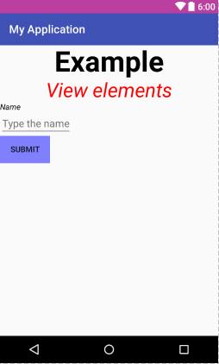
res/values/colors.xml
<?xml version="1.0" encoding="utf-8"?>
<resources>
<color name="colorPrimary">#3F51B5</color>
<color name="colorPrimaryDark">#BA3F9F</color>
<color name="colorAccent">#B59031</color>
<color name="subtitle_color">#ff0000</color>
<color name="maintitle_color">#000000</color>
<color name="namelabel_color">#000000</color>
<color name="name_color">#000000</color>
<color name="submitbutton_color">#8080ff</color>
</resources>
res/values/strings.xml
<resources>
<string name="action_settings">Action Setting</string>
<string name="app_name">My Application</string>
<string name="maintitle_text">Example</string>
<string name="subtitle_text">View elements</string>
<string name="namelabel_text">Name</string>
<string name="name_hint">Type the name</string>
<string name="submitbutton_text">Submit</string>
</resources>
/res/values/styles.xml
<resources>
<!-- Base application theme. -->
<style name="AppTheme" parent="Theme.AppCompat.Light.DarkActionBar">
<!-- Customize your theme here. -->
<item name="colorPrimary">@color/colorPrimary</item>
<item name="colorPrimaryDark">@color/colorPrimaryDark</item>
<item name="colorAccent">@color/colorAccent</item>
</style>
<style name="AppTheme.NoActionBar">
<item name="windowActionBar">true</item>
<item name="windowNoTitle">false</item>
</style>
<style name="AppTheme.AppBarOverlay" parent="ThemeOverlay.AppCompat.Dark.ActionBar" />
<style name="AppTheme.PopupOverlay" parent="ThemeOverlay.AppCompat.Light" />
</resources>

build.gradle
// Top-level build file where you can add configuration options common to all sub-projects/modules.
buildscript {
repositories {
jcenter()
}
dependencies {
classpath 'com.android.tools.build:gradle:2.2.3'
// NOTE: Do not place your application dependencies here; they belong
// in the individual module build.gradle files
}
}
allprojects {
repositories {
jcenter()
}
}
task clean(type: Delete) {
delete rootProject.buildDir
}
app/build.gradle
apply plugin: 'com.android.application'
android {
compileSdkVersion 23
buildToolsVersion "23.0.3"
defaultConfig {
applicationId "com.example.akoel.myapplication"
minSdkVersion 15
targetSdkVersion 23
versionCode 1
versionName "1.0"
testInstrumentationRunner "android.support.test.runner.AndroidJUnitRunner"
}
buildTypes {
release {
minifyEnabled false
proguardFiles getDefaultProguardFile('proguard-android.txt'), 'proguard-rules.pro'
}
}
}
dependencies {
compile fileTree(dir: 'libs', include: ['*.jar'])
androidTestCompile('com.android.support.test.espresso:espresso-core:2.2.2', {
exclude group: 'com.android.support', module: 'support-annotations'
})
compile 'com.android.support:appcompat-v7:23.4.0'
compile 'com.android.support.constraint:constraint-layout:1.0.2'
compile 'com.android.support:design:23.4.0'
testCompile 'junit:junit:4.12'
}

- Lifecycle
Activity lifecycle diagram
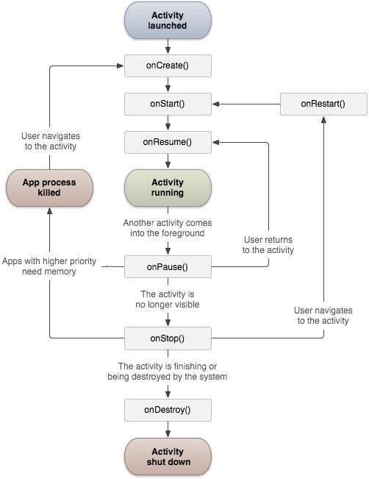
onCreate() This is the first callback and called when the activity is first created.
onStart() This callback is called when the activity becomes visible to the user.
onResume() This is called when the user starts interacting with the application.
onPause() The paused activity does not receive user input and cannot execute any code and called when the current activity is being paused and the previous activity is being resumed.
onStop() This callback is called when the activity is no longer visible.
onDestroy() This callback is called before the activity is destroyed by the system.
onRestart() This callback is called when the activity restarts after stopping it.

MainActivity.java
package com.example.akoel.myapplication;

import android.os.Bundle;
import android.support.v7.app.AppCompatActivity;
import android.util.Log;

public class MainActivity extends AppCompatActivity {
String msg = "Android : ";
/** Called when the activity is first created. */
@Override
public void onCreate(Bundle savedInstanceState) {
super.onCreate(savedInstanceState);
setContentView(R.layout.activity_main);
Log.d(msg, "The onCreate() event");
}
/** Called when the activity is about to become visible. */
@Override
protected void onStart() {
super.onStart();
Log.d(msg, "The onStart() event");
}
/** Called when the activity has become visible. */
@Override
protected void onResume() {
super.onResume();
Log.d(msg, "The onResume() event");
}
/** Called when another activity is taking focus. */
@Override
protected void onPause() {
super.onPause();
Log.d(msg, "The onPause() event");
}
/** Called when the activity is no longer visible. */
@Override
protected void onStop() {
super.onStop();
Log.d(msg, "The onStop() event");
}
/** Called just before the activity is destroyed. */
@Override
public void onDestroy() {
super.onDestroy();
Log.d(msg, "The onDestroy() event");
}
@Override
public void onRestart() {
super.onRestart();
Log.d(msg, "The onRestart() event");
}
}

logcat – in case of start application
05-05 16:45:31.484 5466-5466/com.example.akoel.myapplication D/Android :: The onCreate() event
05-05 16:45:31.484 5466-5466/com.example.akoel.myapplication D/Android :: The onStart() event
05-05 16:45:31.484 5466-5466/com.example.akoel.myapplication D/Android :: The onResume() event
logcat – in case of stop application - clicking on the back button
05-05 16:50:01.354 5466-5466/com.example.akoel.myapplication D/Android :: The onPause() event
05-05 16:50:01.354 5466-5466/com.example.akoel.myapplication D/Android :: The onStop() event
logcat – in case of sending background – Long click on middle button/Turn off the device
05-05 16:59:38.534 17370-17370/com.example.akoel.myapplication D/Android :: The onPause() event
05-05 16:59:39.034 17370-17370/com.example.akoel.myapplication D/Android :: The onStop() event
logcat – in case of bringing to front end from … task
05-05 17:02:56.484 17370-17370/com.example.akoel.myapplication D/Android :: The onStart() event
05-05 17:02:56.484 17370-17370/com.example.akoel.myapplication D/Android :: The onResume() event
logcat – in case of activating again – Turn on the device (the app was running before)
05-05 17:09:43.024 26599-26599/com.example.akoel.myapplication D/Android :: The onRestart() event
05-05 17:09:43.024 26599-26599/com.example.akoel.myapplication D/Android :: The onStart() event
05-05 17:09:43.024 26599-26599/com.example.akoel.myapplication D/Android :: The onResume() event

- Services
A service is a component that runs in the background to perform long-running operations without needing to interact with the user and it works even if application is destroyed. A service can essentially take three states:
Scheduled A service is scheduled when an API such as the JobScheduler, introduced in Android 5.0 (API level 21), launches the service. You can use the JobScheduler by registering jobs and specifying their requirements for network and timing. The system then gracefully schedules the jobs for execution at the appropriate times. The JobScheduler provides many methods to define service-execution conditions.
Started A service is started when an application component, such as an activity, starts it by calling startService(). Once started, a service can run in the background indefinitely, even if the component that started it is destroyed.
Bound A service is bound when an application component binds to it by calling bindService(). A bound service offers a client-server interface that allows components to interact with the service, send requests, get results, and even do so across processes with interprocess communication (IPC).
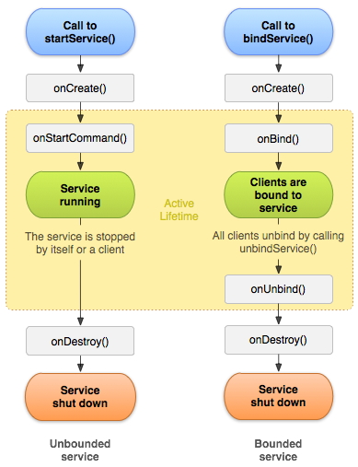

onStartCommand() The system calls this method when another component, such as an activity, requests that the service be started, by calling startService(). If you implement this method, it is your responsibility to stop the service when its work is done, by calling stopSelf() or stopService() methods.
onBind() The system calls this method when another component wants to bind with the service by calling bindService(). If you implement this method, you must provide an interface that clients use to communicate with the service, by returning an IBinder object. You must always implement this method, but if you don't want to allow binding, then you should return null.
onUnbind() The system calls this method when all clients have disconnected from a particular interface published by the service.
onRebind() The system calls this method when new clients have connected to the service, after it had previously been notified that all had disconnected in its onUnbind(Intent).
onCreate() The system calls this method when the service is first created using onStartCommand() or onBind(). This call is required to perform one-time set-up.
onDestroy() The system calls this method when the service is no longer used and is being destroyed. Your service should implement this to clean up any resources such as threads, registered listeners, receivers, etc.
Notice that the onStartCommand() method must return an integer. The integer is a value that describes how the system should continue the service in the event that the system kills it. The default implementation for IntentService handles this for you, but you are able to modify it. The return value from onStartCommand() must be one of the following constants:
START_NOT_STICKY If the system kills the service after onStartCommand() returns, do not recreate the service unless there are pending intents to deliver. This is the safest option to avoid running your service when not necessary and when your application can simply restart any unfinished jobs.
START_STICKY If the system kills the service after onStartCommand() returns, recreate the service and call onStartCommand(), but do not redeliver the last intent. Instead, the system calls onStartCommand() with a null intent unless there are pending intents to start the service. In that case, those intents are delivered. This is suitable for media players (or similar services) that are not executing commands but are running indefinitely and waiting for a job.
START_REDELIVER_INTENT If the system kills the service after onStartCommand() returns, recreate the service and call onStartCommand() with the last intent that was delivered to the service. Any pending intents are delivered in turn. This is suitable for services that are actively performing a job that should be immediately resumed, such as downloading a file.

You can start a service from an activity or other application component by passing an Intent (specifying the service to start) to startService(). The Android system calls the service's onStartCommand() method and passes it the Intent.
Note: Never call onStartCommand() directly.
For example, an activity can start the example service in the previous section (HelloService) using an explicit intent with startService(), as shown here:
Intent intent = new Intent(this, HelloService.class);
startService(intent);
The startService() method returns immediately, and the Android system calls the service's onStartCommand() method.
If the service is not already running, the system first calls onCreate(), and then it calls onStartCommand(). If the service does not also provide binding, the intent that is delivered with startService() is the only mode of communication between the application component and the service. However, if you want the service to send a result back, the client that starts the service can create a PendingIntent for a broadcast (with getBroadcast()) and deliver it to the service in the Intent that starts the service. The service can then use the broadcast to deliver a result.
Multiple requests to start the service result in multiple corresponding calls to the service's onStartCommand(). However, only one request to stop the service (with stopSelf() or stopService()) is required to stop it.

A started service must manage its own lifecycle. That is, the system does not stop or destroy the service unless it must recover system memory and the service continues to run after onStartCommand() returns. The service must stop itself by calling stopSelf(), or another component can stop it by calling stopService(). Once requested to stop with stopSelf() or stopService(), the system destroys the service as soon as possible.
If your service handles multiple requests to onStartCommand() concurrently, you shouldn't stop the service when you're done processing a start request, as you might have received a new start request (stopping at the end of the first request would terminate the second one). To avoid this problem, you can use stopSelf(int) to ensure that your request to stop the service is always based on the most recent start request. That is, when you call stopSelf(int), you pass the ID of the start request (the startId delivered to onStartCommand()) to which your stop request corresponds. Then, if the service receives a new start request before you are able to call stopSelf(int), the ID does not match and the service does not stop.
Caution: To avoid wasting system resources and consuming battery power, ensure that your application stops its services when it's done working. If necessary, other components can stop the service by calling stopService(). Even if you enable binding for the service, you must always stop the service yourself if it ever receives a call to onStartCommand().
AndroidManifest.xml
<?xml version="1.0" encoding="utf-8"?>
<manifest xmlns:android="http://schemas.android.com/apk/res/android"
package="com.example.akoel.myapplication" >
<application
android:allowBackup="true"
android:icon="@mipmap/ic_launcher"
android:label="@string/app_name"
android:supportsRtl="true"
android:theme="@style/AppTheme" >
<activity
android:name=".MainActivity"
android:label="@string/app_name"
android:theme="@style/AppTheme.NoActionBar" >
<intent-filter>
<action android:name="android.intent.action.MAIN" />
<category android:name="android.intent.category.LAUNCHER" />
</intent-filter>
</activity>
<service android:enabled="true" android:name=".MyService" />
</application>
</manifest>
res/values/strings.xml
<resources>
<string name="action_settings">Action Setting</string>
<string name="app_name">My Application</string>
<string name="maintitle_text">Example</string>
<string name="subtitle_text">\"Started\" service</string>
<string name="startbutton_text">Start Service</string>
<string name="stopbutton_text">Stop Service</string>
</resources>

MainActivity.java
package com.example.akoel.myapplication;
import android.content.Intent;
import android.os.Bundle;
import android.app.Activity;
import android.util.Log;
import android.view.View;
public class MainActivity extends Activity {
String msg = "Android : ";
@Override
public void onCreate(Bundle savedInstanceState) {
super.onCreate(savedInstanceState);
setContentView(R.layout.activity_main);
Log.d(msg, "The onCreate() event");
}
public void startService(View view) {
startService(new Intent(getBaseContext(), MyService.class));
}
public void stopService(View view) {
stopService(new Intent(getBaseContext(), MyService.class));
}
}
MyService.java
package com.example.akoel.myapplication;
import android.app.Service;
import android.content.Intent;
import android.os.IBinder;
import android.widget.Toast;
import android.util.Log;
import java.util.Timer;
import java.util.TimerTask;
public class MyService extends Service {
Timer timer = null;
@Override
public IBinder onBind(Intent intent) {
return null;
}
@Override
public int onStartCommand(Intent intent, int flags, int startId) {
Toast.makeText(this, "Service Started", Toast.LENGTH_LONG).show();
initTimer();
return START_STICKY;
}
@Override
public void onDestroy() {
super.onDestroy();
Toast.makeText(this, "Service Destroyed", Toast.LENGTH_LONG).show();
timer.cancel();
}
private void initTimer(){
timer = new Timer();
timer.schedule(new TimerTask(){
@Override
public void run(){
long millis = System.currentTimeMillis();
int seconds = (int) (millis / 1000);
Log.d("MyService", String.valueOf(seconds));
}
}, 0, 1000);
}
}
res/layout/activity_main.xml
<?xml version="1.0" encoding="utf-8"?>
<LinearLayout xmlns:android="http://schemas.android.com/apk/res/android"
xmlns:app="http://schemas.android.com/apk/res-auto"
android:layout_width="match_parent"
android:layout_height="match_parent"
app:layout_collapseParallaxMultiplier="1.0"
android:orientation="vertical">
<TextView xmlns:android="http://schemas.android.com/apk/res/android"
android:id="@+id/maintitle_id"
android:layout_width="fill_parent"
android:layout_height="wrap_content"
android:gravity="center_horizontal"
android:text="@string/maintitle_text"
android:textStyle="bold"
android:textColor="@color/maintitle_color"
android:textSize="100px" />
<TextView xmlns:android="http://schemas.android.com/apk/res/android"
android:id="@+id/subtitle_id"
android:layout_width="fill_parent"
android:layout_height="wrap_content"
android:gravity="center_horizontal"
android:text="@string/subtitle_text"
android:textStyle="italic"
android:textColor="@color/subtitle_color"
android:textSize="70px" />
<Button
android:id="@+id/startbutton_id"
android:layout_width="wrap_content"
android:layout_height="wrap_content"
android:text="@string/startbutton_text"
android:background="@color/startbutton_color"
find/>
<Button
android:id="@+id/stopbutton_id"
android:layout_width="wrap_content"
android:layout_height="wrap_content"
android:text="@string/stopbutton_text"
android:background="@color/stopbutton_color"
android:onClick="stopService"/>
</LinearLayout>
Layout of activity_main.xml
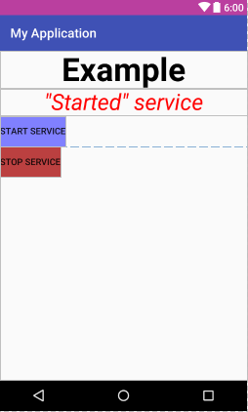
- Broadcast Receivers
Broadcast Receivers simply respond to broadcast messages from other applications or from the system itself. These messages are sometime called events or intents. For example, applications can also initiate broadcasts to let other applications know that some data has been downloaded to the device and is available for them to use, so this is broadcast receiver who will intercept this communication and will initiate appropriate action.
AndroidManifest.xml
<?xml version="1.0" encoding="utf-8"?>
<manifest xmlns:android="http://schemas.android.com/apk/res/android"
package="com.example.akoel.myapplication" >
<application
android:allowBackup="true"
android:icon="@mipmap/ic_launcher"
android:label="@string/app_name"
android:supportsRtl="true"
android:theme="@style/AppTheme" >
<activity
android:name=".MainActivity"
android:label="@string/app_name"
android:theme="@style/AppTheme.NoActionBar" >
<intent-filter>
<action android:name="android.intent.action.MAIN" />
<category android:name="android.intent.category.LAUNCHER" />
</intent-filter>
</activity>
<receiver android:name="MyReceiver">
<intent-filter>
<action android:name="com.example.akoel.CUSTOM_INTENT">
</action>
</intent-filter>
</receiver>
</application>
</manifest>
res/values/strings.xml
<resources>
<string name="action_settings">Action Setting</string>
<string name="app_name">My Application</string>
<string name="maintitle_text">Example</string>
<string name="subtitle_text">Broadcast Receiver</string>
<string name="broadcast_text">Send broadcast</string>
</resources>

MainActivity.java
package com.example.akoel.myapplication;
import android.app.Activity;
import android.content.Intent;
import android.os.Bundle;
import android.view.View;
public class MainActivity extends Activity {
@Override
public void onCreate(Bundle savedInstanceState) {
super.onCreate(savedInstanceState);
setContentView(R.layout.activity_main);
}
public void sendBroadcast(View view){
Intent intent = new Intent();
intent.putExtra("extra_data", "This is a message to the receiver");
intent.setAction("com.example.akoel.CUSTOM_INTENT");
sendBroadcast(intent);
}
}
MyReceiver.java
package com.example.akoel.myapplication;
import android.content.BroadcastReceiver;
import android.content.Context;
import android.content.Intent;
import android.widget.Toast;
import android.util.Log;
public class MyReceiver extends BroadcastReceiver{
@Override
public void onReceive(Context context, Intent intent) {
String msg = "" + intent.getStringExtra("extra_data") + "\"";
Toast.makeText(context, "Intent Detected: " + msg, Toast.LENGTH_LONG).show();
Log.d("Intent Detected", msg);
}
}

res/layout/activity_main.xml
<?xml version="1.0" encoding="utf-8"?>
<LinearLayout xmlns:android="http://schemas.android.com/apk/res/android"
xmlns:app="http://schemas.android.com/apk/res-auto"
android:layout_width="match_parent"
android:layout_height="match_parent"
app:layout_collapseParallaxMultiplier="1.0"
android:orientation="vertical">
<TextView xmlns:android="http://schemas.android.com/apk/res/android"
android:id="@+id/maintitle_id"
android:layout_width="fill_parent"
android:layout_height="wrap_content"
android:gravity="center_horizontal"
android:text="@string/maintitle_text"
android:textStyle="bold"
android:textColor="@color/maintitle_color"
android:textSize="100px" />
<TextView xmlns:android="http://schemas.android.com/apk/res/android"
android:id="@+id/subtitle_id"
android:layout_width="fill_parent"
android:layout_height="wrap_content"
android:gravity="center_horizontal"
android:text="@string/subtitle_text"
android:textStyle="italic"
android:textColor="@color/subtitle_color"
android:textSize="70px" />
<Button
android:id="@+id/broadcastbutton_id"
android:layout_width="wrap_content"
android:layout_height="wrap_content"
android:text="@string/broadcast_text"
android:background="@color/stopbutton_color"
android:onClick="sendBroadcast"
/>
</LinearLayout>
Layout of activity_main.xml
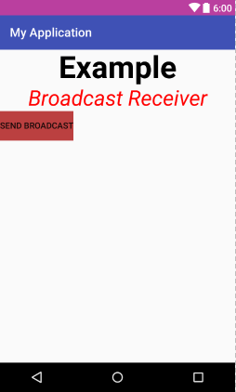

- Content Provider
A content provider component supplies data from one application to others on request. Such requests are handled by the methods of the ContentResolver class. A content provider can use different ways to store its data and the data can be stored in a database, in files, or even over a network.
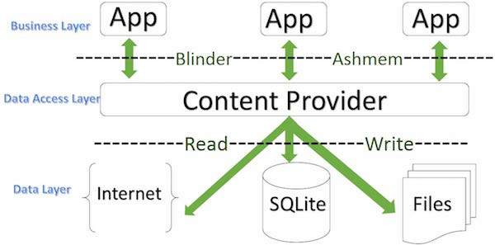
Content providers let you centralize content in one place and have many different applications access it as needed. A content provider behaves very much like a database where you can query it, edit its content, as well as add or delete content using insert(), update(), delete(), and query() methods. In most cases this data is stored in an SQlite database.
Here is the list of methods which you need to override in Content Provider class to have your Content Provider working:
onCreate() This method is called when the provider is started
query() This method receives a request from a client. The result is returned as a Cursor object
insert() This method inserts a new record into the content provider
delete() This method deletes an existing record from the content provider
update() This method updates an existing record from the content provider
getType() This method returns the MIME type of the data at the given URI
To query a content provider, you specify the query string in the form of a URI which has following format: <prefix>://<authority>/<data_type>/<id>
prefix This is always set to content://
authority This specifies the name of the content provider, for example contacts, browser etc. For third-party content providers, this could be the fully qualified name, such as com.tutorialspoint.statusprovider
data_type This indicates the type of data that this particular provider provides. For example, if you are getting all the contacts from the Contacts content provider, then the data path would be people and URI would look like this content://contacts/people
id This specifies the specific record requested. For example, if you are looking for contact number 5 in the Contacts content provider then URI would look like this content://contacts/people/5

AndroidManifest.xml
<?xml version="1.0" encoding="utf-8"?>
<manifest xmlns:android="http://schemas.android.com/apk/res/android"
package="com.example.akoel.myapplication" >
<application
android:allowBackup="true"
android:icon="@mipmap/ic_launcher"
android:label="@string/app_name"
android:supportsRtl="true"
android:theme="@style/AppTheme" >
<activity
android:name=".MainActivity"
android:label="@string/app_name"
android:theme="@style/AppTheme.NoActionBar" >
<intent-filter>
<action android:name="android.intent.action.MAIN" />
<category android:name="android.intent.category.LAUNCHER" />
</intent-filter>
</activity>
<provider android:name="StudentsProvider"
android:authorities="com.example.akoel.myapplication.StudentsProvider"/>
</application>
</manifest>
res/values/strings.xml
<resources>
<string name="action_settings">Action Setting</string>
<string name="app_name">My Application</string>
<string name="maintitle_text">Example</string>
<string name="subtitle_text">Content Provider</string>
<string name="button_addstudent">Add Student</string>
<string name="button_retreivestudents">Retreive Students</string>
</resources>

MainActivity.java
package com.example.akoel.myapplication;

import android.net.Uri;
import android.os.Bundle;
import android.app.Activity;
import android.content.ContentValues;
import android.database.Cursor;
import android.view.View;
import android.widget.EditText;
import android.widget.Toast;
import android.util.Log;
public class MainActivity extends Activity {
String logId = "Provider Main";

@Override
protected void onCreate(Bundle savedInstanceState) {
super.onCreate(savedInstanceState);
setContentView(R.layout.activity_main);
}

public void onClickAddStudent(View view) {
String name = ((EditText)findViewById(R.id.edit_name)).getText().toString();
String grade = ((EditText)findViewById(R.id.edit_grade)).getText().toString();
ContentValues values = new ContentValues();
values.put( StudentsProvider.NAME, name );
values.put( StudentsProvider.GRADE,grade );
Uri uri = getContentResolver().insert(StudentsProvider.CONTENT_URI, values );
Toast.makeText(getBaseContext(), uri.toString(), Toast.LENGTH_LONG).show();
Log.d( logId, "'" + name + " - " + grade + "' added" );
}

public void onClickRetrieveStudents(View view) {
String name;
String grade;
String id;
Uri students = StudentsProvider.CONTENT_URI;
Cursor cursor = getContentResolver().query(students, null, null, null, "name");
if(cursor.moveToFirst() ) {
Log.d(logId, "List of Students:");
do {
name = cursor.getString(cursor.getColumnIndex(StudentsProvider.NAME));
grade = cursor.getString(cursor.getColumnIndex(StudentsProvider.GRADE));
Toast.makeText(this, name + " - " + grade, Toast.LENGTH_LONG).show();
Log.d(logId, " " + name + " - " + grade);
} while (cursor.moveToNext());
}
}
}

StudentsProvider.java
package com.example.akoel.myapplication;
import java.util.TreeMap;
import java.util.Map;
import android.content.ContentProvider;
import android.content.ContentValues;
import android.database.Cursor;
import android.database.MatrixCursor;
import android.net.Uri;
import android.util.Log;
public class StudentsProvider extends ContentProvider {
String logId = "Provider Student";
static final String PROVIDER_NAME = "com.example.akoel.myapplication.StudentsProvider";
static final String URL = "content://" + PROVIDER_NAME + "/students";
static final Uri CONTENT_URI = Uri.parse(URL);
static final String NAME = "name";
static final String GRADE = "grade";
private TreeMap<String, String> students;
@Override
public boolean onCreate() {
students = new TreeMap<>();
Log.d(logId, "DB created");
return true;
}
@Override
public Uri insert(Uri uri, ContentValues values) {
students.put( values.getAsString("name"), values.getAsString("grade"));
getContext().getContentResolver().notifyChange(uri, null);
return uri;
}
@Override
public Cursor query(Uri uri, String[] projection, String selection,String[] selectionArgs, String sortOrder) {
String[] columns = new String[] { "name", "grade" };
MatrixCursor matrixCursor= new MatrixCursor(columns);
for(Map.Entry<String,String> student : students.entrySet()) {
String name = student.getKey();
String grade = student.getValue();
matrixCursor.addRow(new Object[]{name, grade});
}
getContext().getContentResolver().notifyChange(uri, null);
return matrixCursor;
}
@Override
public int delete(Uri uri, String selection, String[] selectionArgs) {
int count = 0;
getContext().getContentResolver().notifyChange(uri, null);
return count;
}
@Override
public int update(Uri uri, ContentValues values, String selection, String[] selectionArgs) {
int count = 0;
getContext().getContentResolver().notifyChange(uri, null);
return count;
}
@Override
public String getType(Uri uri) {
Log.d(logId, "getType");
return "MIME type";
}
}
res/layout/activity_main.xml
<?xml version="1.0" encoding="utf-8"?>
<LinearLayout xmlns:android="http://schemas.android.com/apk/res/android"
xmlns:app="http://schemas.android.com/apk/res-auto"
android:layout_width="match_parent"
android:layout_height="match_parent"
app:layout_collapseParallaxMultiplier="1.0"
android:orientation="vertical">
<TextView xmlns:android="http://schemas.android.com/apk/res/android"
android:id="@+id/maintitle_id"
android:layout_width="fill_parent"
android:layout_height="wrap_content"
android:gravity="center_horizontal"
android:text="@string/maintitle_text"
android:textStyle="bold"
android:textColor="@color/maintitle_color"
android:textSize="100px" />
<TextView xmlns:android="http://schemas.android.com/apk/res/android"
android:id="@+id/subtitle_id"
android:layout_width="fill_parent"
android:layout_height="wrap_content"
android:gravity="center_horizontal"
android:text="@string/subtitle_text"
android:textStyle="italic"
android:textColor="@color/subtitle_color"
android:textSize="70px" />
<EditText
android:layout_width="wrap_content"
android:layout_height="wrap_content"
android:id="@+id/edit_name"
android:layout_below="@+id/subtitle_id"
android:hint="Student's Name"/>
<EditText
android:layout_width="wrap_content"
android:layout_height="wrap_content"
android:id="@+id/edit_grade"
android:layout_below="@+id/edit_name"
android:hint="Grade"/>
<Button
android:layout_width="wrap_content"
android:layout_height="wrap_content"
android:id="@+id/button_addstudent"
android:text="@string/button_addstudent"
android:layout_below="@+id/edit_grade"
android:onClick="onClickAddStudent"/>
<Button
android:layout_width="wrap_content"
android:layout_height="wrap_content"
android:text="@string/button_retreivestudents"
android:id="@+id/button_retreivestudents"
android:layout_below="@+id/button_addstudent"
android:onClick="onClickRetrieveStudents"/>
</LinearLayout>
- Fragments
A Fragment is a piece of an activity which enable more modular activity design. It will not be wrong if we say, a fragment is a kind of sub-activity.
Prior to fragment introduction, we had a limitation because we can show only a single activity on the screen at one given point in time. So we were not able to divide device screen and control different parts separately. But with the introduction of fragment we got more flexibility and removed the limitation of having a single activity on the screen at a time. Now we can have a single activity but each activity can comprise of multiple fragments which will have their own layout, events and complete life cycle.
Following is a typical example of how two UI modules defined by fragments can be combined into one activity for a tablet design, but separated for a handset design.
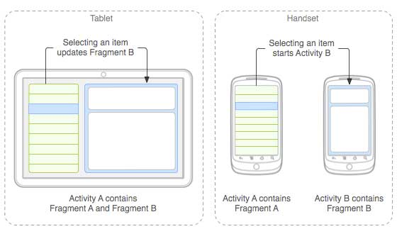
The application can embed two fragments in Activity A, when running on a tablet-sized device. However, on a handset-sized screen, there's not enough room for both fragments, so Activity A includes only the fragment for the list of articles, and when the user selects an article, it starts Activity B, which includes the second fragment to read the article.
Android fragments have their own life cycle very similar to an android activity. This section briefs different stages of its life cycle.
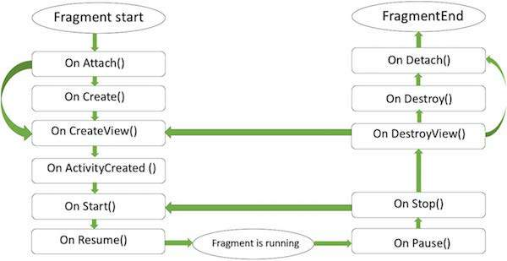
Here is the list of methods which you can to override in your fragment class:
onAttach() The fragment instance is associated with an activity instance.The fragment and the activity is not fully initialized. Typically you get in this method a reference to the activity which uses the fragment for further initialization work.
onCreate() The system calls this method when creating the fragment. You should initialize essential components of the fragment that you want to retain when the fragment is paused or stopped, then resumed
onCreateView() The system calls this callback when it's time for the fragment to draw its user interface for the first time. To draw a UI for your fragment, you must return a View component from this method that is the root of your fragment's layout. You can return null if the fragment does not provide a UI
onActivityCreated() The onActivityCreated() is called after the onCreateView() method when the host activity is created. Activity and fragment instance have been created as well as the view hierarchy of the activity. At this point, view can be accessed with the findViewById() method. example. In this method you can instantiate objects which require a Context object
onStart() The onStart() method is called once the fragment gets visible
onResume() Fragment becomes active
onPause() The system calls this method as the first indication that the user is leaving the fragment. This is usually where you should commit any changes that should be persisted beyond the current user session
onStop() Fragment going to be stopped by calling onStop()
onDestroyView() Fragment view will destroy after call this method
onDestroy() onDestroy() called to do final clean up of the fragment's state but Not guaranteed to be called by the Android platform.

AndroidManifest.xml
<?xml version="1.0" encoding="utf-8"?>
<manifest xmlns:android="http://schemas.android.com/apk/res/android"
package="com.example.akoel.myapplication" >
<application
android:allowBackup="true"
android:icon="@mipmap/ic_launcher"
android:label="@string/app_name"
android:supportsRtl="true"
android:theme="@style/AppTheme" >
<activity
android:name=".MainActivity"
android:label="@string/app_name"
android:theme="@style/AppTheme.NoActionBar" >
<intent-filter>
<action android:name="android.intent.action.MAIN" />
<category android:name="android.intent.category.LAUNCHER" />
</intent-filter>
</activity>
</application>
</manifest>
res/values/strings.xml
<resources>
<string name="app_name">MyFragments</string>
<string name="action_settings">Settings</string>
<string name="hello_world">Hello world!</string>
<string name="landscape_message">This is Landscape mode fragment</string>
<string name="portrait_message">This is Portrait mode fragment</string>
</resources>
MainActivity.java
package com.example.akoel.myapplication;
import android.os.Bundle;
import android.app.Activity;
import android.app.FragmentManager;
import android.app.FragmentTransaction;
import android.content.res.Configuration;
public class MainActivity extends Activity {
@Override
protected void onCreate(Bundle savedInstanceState) {
super.onCreate(savedInstanceState);
Configuration config = getResources().getConfiguration();
FragmentManager fragmentManager = getFragmentManager();
FragmentTransaction fragmentTransaction = fragmentManager.beginTransaction();
if (config.orientation == Configuration.ORIENTATION_LANDSCAPE) {
// Landscape mode of the device
LM_Fragment ls_fragment = new LM_Fragment();
fragmentTransaction.replace(android.R.id.content, ls_fragment);
} else {
// Portrait mode of the device
PM_Fragment pm_fragment = new PM_Fragment();
fragmentTransaction.replace(android.R.id.content, pm_fragment);
}
fragmentTransaction.commit();
}
}
LM_Fragment.java
package com.example.akoel.myapplication;
import android.app.Fragment;
import android.os.Bundle;
import android.view.LayoutInflater;
import android.view.View;
import android.view.ViewGroup;
public class LM_Fragment extends Fragment{
@Override
public View onCreateView(LayoutInflater inflater, ViewGroup container, Bundle savedInstanceState) {
/**
* Inflate the layout for this fragment
*/
return inflater.inflate(
R.layout.lm_fragment, container, false);
}
}
PM_Fragment.java
package com.example.akoel.myapplication;
import android.app.Fragment;
import android.os.Bundle;
import android.view.LayoutInflater;
import android.view.View;
import android.view.ViewGroup;
public class PM_Fragment extends Fragment{
@Override
public View onCreateView(LayoutInflater inflater, ViewGroup container, Bundle savedInstanceState) {
/**
* Inflate the layout for this fragment
*/
return inflater.inflate(
R.layout.pm_fragment, container, false);
}
}
res/layout/activity_main.xml
<?xml version="1.0" encoding="utf-8"?>
<LinearLayout xmlns:android="http://schemas.android.com/apk/res/android"
xmlns:app="http://schemas.android.com/apk/res-auto"
android:layout_width="match_parent"
android:layout_height="match_parent"
app:layout_collapseParallaxMultiplier="1.0"
android:orientation="vertical">
<fragment
android:name="com.example.akoel.myapplication.LM_Fragment"
android:id="@+id/lm_fragment"
android:layout_weight="1"
android:layout_width="0dp"
android:layout_height="wrap_content"/>
<fragment
android:name="com.example.akoel.myapplication.PM_Fragment"
android:id="@+id/pm_fragment"
android:layout_weight="2"
android:layout_width="0dp"
android:layout_height="wrap_content"/>
</LinearLayout>
Layout of activity_main.xml
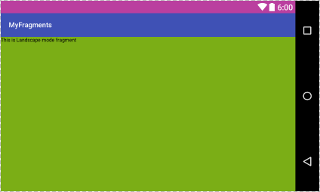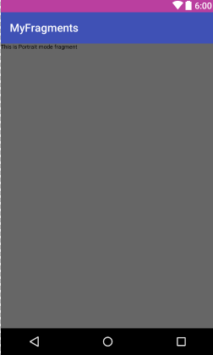

- Intents/Filters/Click Listener/Open new Activity
An Android Intent is an abstract description of an operation to be performed. It can be used with startActivity to launch an Activity, broadcastIntent to send it to any interested BroadcastReceiver components, and startService(Intent) or bindService(Intent, ServiceConnection, int) to communicate with a background Service.
The intent itself, an Intent object, is a passive data structure holding an abstract description of an operation to be performed.
There are separate mechanisms for delivering intents to each type of component − activities, services, and broadcast receivers.
Context.startActivity() The Intent object is passed to this method to launch a new activity or get an existing activity to do something new.
Context.startService() The Intent object is passed to this method to initiate a service or deliver new instructions to an ongoing service.
Context.sendBroadcast() The Intent object is passed to this method to deliver the message to all interested broadcast receivers.
An Intent object is a bundle of information which is used by the component that receives the intent as well as information used by the Android system.
An Intent object can contain the following components based on what it is communicating or going to perform
Action This is mandatory part of the Intent object and is a string naming the action to be performed — or, in the case of broadcast intents, the action that took place and is being reported. The action largely determines how the rest of the intent object is structured .
Data Adds a data specification to an intent filter. The specification can be just a data type (the mimeType attribute), just a URI, or both a data type and a URI.
Category The category is an optional part of Intent object and it's a string containing additional information about the kind of component that should handle the intent.
Extras This will be in key-value pairs for additional information that should be delivered to the component handling the intent.
Flags These flags are optional part of Intent object and instruct the Android system how to launch an activity, and how to treat it after it's launched etc.
Component Name This optional field is an android ComponentName object representing either Activity, Service or BroadcastReceiver class. If it is set, the Intent object is delivered to an instance of the designated class otherwise Android uses other information in the Intent object to locate a suitable target. The component name is set by setComponent(), setClass(), or setClassName() and read by getComponent().

Action/Data pairs
ACTION_VIEW content://contacts/people/1 Display information about the person whose identifier is "1".
ACTION_DIAL content://contacts/people/1 Display the phone dialer with the person filled in.
ACTION_VIEW tel:123 Display the phone dialer with the given number filled in.
ACTION_DIAL tel:123 Display the phone dialer with the given number filled in.
ACTION_EDIT content://contacts/people/1 Edit information about the person whose identifier is "1".
ACTION_VIEW content://contacts/people/ Display a list of people, which the user can browse through.
ACTION_SET_WALLPAPER Show settings for choosing wallpaper
ACTION_SYNC It going to be synchronous the data,Constant Value is android.intent.action.SYNC
ACTION_SYSTEM_TUTORIAL It will start the platform-defined tutorial(Default tutorial or start up tutorial)
ACTION_TIMEZONE_CHANGED It intimates when time zone has changed
ACTION_UNINSTALL_PACKAGE It is used to run default uninstaller

AndroidManifest.xml
<?xml version="1.0" encoding="utf-8"?>
<manifest xmlns:android="http://schemas.android.com/apk/res/android"
package="com.example.akoel.myapplication" >
<application
android:allowBackup="true"
android:icon="@mipmap/ic_launcher"
android:label="@string/app_name"
android:supportsRtl="true"
android:theme="@style/AppTheme" >
<activity
android:name=".MainActivity"
android:label="@string/app_name"
android:theme="@style/AppTheme.NoActionBar" >
<intent-filter>
<action android:name="android.intent.action.MAIN" />
<category android:name="android.intent.category.LAUNCHER" />
</intent-filter>
</activity>
<activity android:name="com.example.akoel.myapplication.CustomActivity">
<intent-filter>
<action android:name = "my.activity.identifier.SEND" />
<data android:scheme = "ownprotocol" />
</intent-filter>
</activity>
</application>
</manifest>
res/values/strings.xml
<resources>
<string name="app_name">MyFragments</string>
<string name="action_settings">Settings</string>
<string name="maintitle_text">Example</string>
<string name="subtitle_text">Intent Example</string>
<string name="startbrowser_text">Start Browser</string>
<string name="startphone_text">Start Phone</string>
<string name="sendemail_text">Send e-mail</string>
<string name="sendparamtocustom_text">Send Param To Custom Activity</string>
<string name="noactivityfound_text">No Activity found to handle Intent EXCEPTION</string>
</resources>
res/values/colors.xml
<?xml version="1.0" encoding="utf-8"?>
<resources>
<color name="colorPrimary">#3F51B5</color>
<color name="colorPrimaryDark">#BA3F9F</color>
<color name="colorAccent">#B59031</color>
<color name="subtitle_color">#ff0000</color>
<color name="maintitle_color">#000000</color>
<color name="noactivityfound_color">#ff0000</color>
</resources>

MainActivity.java
package com.example.akoel.myapplication;
import android.content.Intent;
import android.net.Uri;
import android.support.v7.app.AppCompatActivity;
import android.os.Bundle;
import android.view.View;
import android.widget.Button;
public class MainActivity extends AppCompatActivity {
Button b_startBrowser, b_startPhone, b_sendemail, b_sendParamToCustomActivity, b_noActivityFound;
@Override
protected void onCreate(Bundle savedInstanceState) {
super.onCreate(savedInstanceState);
setContentView(R.layout.activity_main);

b_startBrowser =(Button)findViewById(R.id.startbrowser);
b_startBrowser.setOnClickListener(new View.OnClickListener() {
@Override
public void onClick(View v) {
Intent i = new Intent(android.content.Intent.ACTION_VIEW, Uri.parse("http://www.example.com"));
startActivity(i);
}
});
b_startPhone =(Button)findViewById(R.id.startphone);
b_startPhone.setOnClickListener(new View.OnClickListener() {
@Override
public void onClick(View v) {
Intent i = new Intent(Intent.ACTION_VIEW, Uri.parse("tel:123"));
startActivity(i);
}
});
b_sendemail =(Button)findViewById(R.id.sendemail);
b_sendemail.setOnClickListener(new View.OnClickListener() {
@Override
public void onClick(View v) {
Intent i = new Intent(Intent.ACTION_VIEW, Uri.parse("mailto:"));
i.putExtra(Intent.EXTRA_EMAIL, new String[] {"dallaszkorben@gmail.com"});
i.putExtra(Intent.EXTRA_SUBJECT, "test android");
i.putExtra(Intent.EXTRA_TEXT, "Delete this email. It is only for test");
startActivity(Intent.createChooser(i, "Choose an email client from..."));
//startActivity(i);
}
});
b_sendParamToCustomActivity = (Button)findViewById(R.id.sendparamtocustom);
b_sendParamToCustomActivity.setOnClickListener(new View.OnClickListener() {
@Override
public void onClick(View v) {
Intent i = new Intent("my.activity.identifier.SEND",Uri.parse("ownprotocol://www.example.com"));
startActivity(i);
}
});
b_noActivityFound = (Button)findViewById(R.id.noactivityfound);
b_noActivityFound.setOnClickListener(new View.OnClickListener() {
@Override
public void onClick(View v) {
Intent i = new Intent("none.existing.activity.identifier", Uri.parse("https://www.example.com"));
startActivity(i);
}
});
}
}
CustomActivity.java
package com.example.akoel.myapplication;
import android.app.Activity;
import android.net.Uri;
import android.os.Bundle;
import android.widget.TextView;
public class CustomActivity extends Activity {
@Override
public void onCreate(Bundle savedInstanceState) {
super.onCreate(savedInstanceState);
setContentView(R.layout.custom_view);
TextView label = (TextView) findViewById(R.id.show_data);
Uri url = getIntent().getData();
label.setText(url.toString());
}
}
res/layout/activity_main.xml
<?xml version="1.0" encoding="utf-8"?>
<LinearLayout xmlns:android="http://schemas.android.com/apk/res/android"
xmlns:app="http://schemas.android.com/apk/res-auto"
android:layout_width="match_parent"
android:layout_height="match_parent"
app:layout_collapseParallaxMultiplier="1.0"
android:orientation="vertical">
<TextView xmlns:android="http://schemas.android.com/apk/res/android"
android:id="@+id/maintitle_id"
android:layout_width="fill_parent"
android:layout_height="wrap_content"
android:gravity="center_horizontal"
android:text="@string/maintitle_text"
android:textStyle="bold"
android:textColor="@color/maintitle_color"
android:textSize="100px" />
<TextView xmlns:android="http://schemas.android.com/apk/res/android"
android:id="@+id/subtitle_id"
android:layout_width="fill_parent"
android:layout_height="wrap_content"
android:gravity="center_horizontal"
android:text="@string/subtitle_text"
android:textStyle="italic"
android:textColor="@color/subtitle_color"
android:textSize="70px" />
<Button
android:layout_width="wrap_content"
android:layout_height="wrap_content"
android:text="@string/startbrowser_text"
android:id="@+id/startbrowser"/>
<Button
android:layout_width="wrap_content"
android:layout_height="wrap_content"
android:text="@string/startphone_text"
android:id="@+id/startphone"/>
<Button
android:layout_width="wrap_content"
android:layout_height="wrap_content"
android:text="@string/sendemail_text"
android:id="@+id/sendemail"/>
<Button
android:layout_width="wrap_content"
android:layout_height="wrap_content"
android:text="@string/sendparamtocustom_text"
android:id="@+id/sendparamtocustom"/>
<Button
android:layout_width="wrap_content"
android:layout_height="wrap_content"
android:text="@string/noactivityfound_text"
android:textColor="@color/noactivityfound_color"
android:id="@+id/noactivityfound"
/>
</LinearLayout>
res/layout/custom_view.xml
<?xml version="1.0" encoding="utf-8"?>
<LinearLayout xmlns:android="http://schemas.android.com/apk/res/android"
android:orientation="vertical" android:layout_width="match_parent"
android:layout_height="match_parent">
<TextView android:id="@+id/show_data"
android:layout_width="fill_parent"
android:layout_height="400dp"/>
</LinearLayout>

- UI Layouts
The basic building block for user interface is a View object which is created from the View class and occupies a rectangular area on the screen and is responsible for drawing and event handling. View is the base class for widgets, which are used to create interactive UI components like buttons, text fields, etc
The ViewGroup is a subclass of View and provides invisible container that hold other Views or other ViewGroups and define their layout properties.
At third level we have different layouts which are subclasses of ViewGroup class and a typical layout defines the visual structure for an Android user interface and can be created either at run time using View/ViewGroup objects or you can declare your layout using simple XML file main_layout.xml which is located in the res/layout folder of your project.
There are number of Layouts provided by Android which you will use in almost all the Android applications to provide different view, look and feel.
Layouts:
Linear Layout LinearLayout is a view group that aligns all children in a single direction, vertically or horizontally.
Relative Layout RelativeLayout is a view group that displays child views in relative positions.
Table Layout TableLayout is a view that groups views into rows and columns.
Absolute Layout AbsoluteLayout enables you to specify the exact location of its children.
Frame Layout The FrameLayout is a placeholder on screen that you can use to display a single view.
List View ListView is a view group that displays a list of scrollable items.
Grid View GridView is a ViewGroup that displays items in a two-dimensional, scrollable grid.

  - Linear Layout
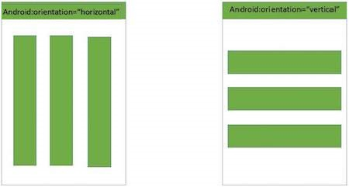
Linear Layout Attributes
android:id This is the ID which uniquely identifies the layout
android:baselineAligned This must be a boolean value, either "true" or "false" and prevents the layout from aligning its children's baselines.
android:baselineAlignedChildIndex When a linear layout is part of another layout that is baseline aligned, it can specify which of its children to baseline align.
android:divider This is drawable to use as a vertical divider between buttons. You use a color value, in the form of "#rgb", "#argb", "#rrggbb", or "#aarrggbb".
android:gravity This specifies how an object should position its content, on both the X and Y axes. Possible values are top, bottom, left, right, center, center_vertical, center_horizontal etc.
android:orientation This specifies the direction of arrangement and you will use "horizontal" for a row, "vertical" for a column. The default is horizontal.
android:weightSum Sum up of child weight
MainActivity.java
package com.example.akoel.myapplication;
import android.os.Bundle;
import android.app.Activity;
public class MainActivity extends Activity {
@Override
protected void onCreate(Bundle savedInstanceState) {
super.onCreate(savedInstanceState);
setContentView(R.layout.activity_main);
}
}
res/layout/activity_main.xml
<?xml version="1.0" encoding="utf-8"?>
<LinearLayout xmlns:android="http://schemas.android.com/apk/res/android"
android:layout_width="fill_parent"
android:layout_height="fill_parent"
android:orientation="vertical" >
<Button android:id="@+id/btnStartService"
android:layout_weight="1"
android:layout_width="wrap_content"
android:layout_height="wrap_content"
android:text="start_service"/>
<Button android:id="@+id/btnPauseService"
android:layout_weight="1"
android:layout_width="wrap_content"
android:layout_height="wrap_content"
android:text="pause_service"/>
<Button android:id="@+id/btnStopService"
android:layout_weight="1"
android:layout_width="wrap_content"
android:layout_height="wrap_content"
android:text="stop_service"/>
</LinearLayout>
Layout of activity_main.xml
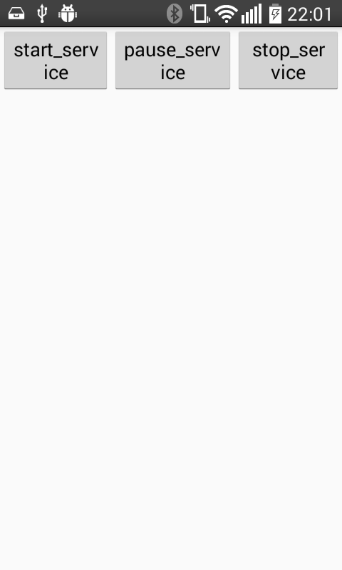
Make some changes in the activity_main.xml file:
res/layout/activity_main.xml
<?xml version="1.0" encoding="utf-8"?>
<LinearLayout xmlns:android="http://schemas.android.com/apk/res/android"
android:layout_width="fill_parent"
android:layout_height="fill_parent"
android:orientation="vertical" >
<Button android:id="@+id/btnStartService"
android:layout_width="270dp"
android:layout_height="wrap_content"
android:text="start_service"/>
<Button android:id="@+id/btnPauseService"
android:layout_width="270dp"
android:layout_height="wrap_content"
android:text="pause_service"/>
<Button android:id="@+id/btnStopService"
android:layout_width="270dp"
android:layout_height="wrap_content"
android:text="stop_service"/>
</LinearLayout>
Layout of activity_main.xml
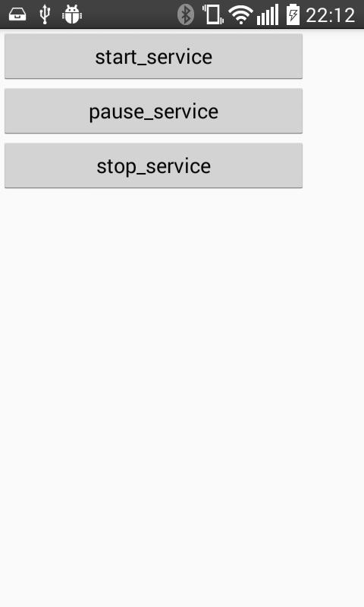

  - Relative Layout
Android RelativeLayout enables you to specify how child views are positioned relative to each other. The position of each view can be specified as relative to sibling elements or relative to the parent.
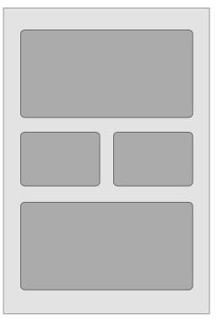
RelativeLayout Attributes
android:id This is the ID which uniquely identifies the layout.
android:gravity This specifies how an object should position its content, on both the X and Y axes. Possible values are top, bottom, left, right, center, center_vertical, center_horizontal etc.
android:ignoreGravity This indicates what view should not be affected by gravity.
Element’s Attributes
android:layout_above Positions the bottom edge of this view above the given anchor view ID and must be a reference to another resource, in the form "@[+][package:]type:name"
android:layout_alignBottom Makes the bottom edge of this view match the bottom edge of the given anchor view ID and must be a reference to another resource, in the form "@[+][package:]type:name".
android:layout_alignLeft Makes the left edge of this view match the left edge of the given anchor view ID and must be a reference to another resource, in the form "@[+][package:]type:name".
android:layout_alignParentBottom If true, makes the bottom edge of this view match the bottom edge of the parent. Must be a boolean value, either "true" or "false".
android:layout_alignParentEnd If true, makes the end edge of this view match the end edge of the parent. Must be a boolean value, either "true" or "false".
android:layout_alignParentLeft If true, makes the left edge of this view match the left edge of the parent. Must be a boolean value, either "true" or "false".
android:layout_alignParentRight If true, makes the right edge of this view match the right edge of the parent. Must be a boolean value, either "true" or "false".
android:layout_alignParentStart If true, makes the start edge of this view match the start edge of the parent. Must be a boolean value, either "true" or "false".
android:layout_alignParentTop If true, makes the top edge of this view match the top edge of the parent. Must be a boolean value, either "true" or "false".
android:layout_alignRight Makes the right edge of this view match the right edge of the given anchor view ID and must be a reference to another resource, in the form "@[+][package:]type:name".
android:layout_alignStart Makes the start edge of this view match the start edge of the given anchor view ID and must be a reference to another resource, in the form "@[+][package:]type:name".
android:layout_alignTop Makes the top edge of this view match the top edge of the given anchor view ID and must be a reference to another resource, in the form "@[+][package:]type:name".
android:layout_below Positions the top edge of this view below the given anchor view ID and must be a reference to another resource, in the form "@[+][package:]type:name".
android:layout_centerHorizontal If true, centers this child horizontally within its parent. Must be a boolean value, either "true" or "false".
android:layout_centerInParent If true, centers this child horizontally and vertically within its parent. Must be a boolean value, either "true" or "false".
android:layout_centerVertical If true, centers this child vertically within its parent. Must be a boolean value, either "true" or "false".
android:layout_toEndOf Positions the start edge of this view to the end of the given anchor view ID and must be a reference to another resource, in the form "@[+][package:]type:name".
android:layout_toLeftOf Positions the right edge of this view to the left of the given anchor view ID and must be a reference to another resource, in the form "@[+][package:]type:name".
android:layout_toRightOf Positions the left edge of this view to the right of the given anchor view ID and must be a reference to another resource, in the form "@[+][package:]type:name".
android:layout_toStartOf Positions the end edge of this view to the start of the given anchor view ID and must be a reference to another resource, in the form "@[+][package:]type:name".
MainActivity.java
package com.example.akoel.myapplication;
import android.os.Bundle;
import android.app.Activity;
public class MainActivity extends Activity {
@Override
protected void onCreate(Bundle savedInstanceState) {
super.onCreate(savedInstanceState);
setContentView(R.layout.activity_main);
}
}
res/layout/activity_main.xml
<?xml version="1.0" encoding="utf-8"?>
<RelativeLayout xmlns:android="http://schemas.android.com/apk/res/android"
android:layout_width="fill_parent"
android:layout_height="fill_parent" >
<Button
android:id="@+id/btnButton1"
android:layout_width="wrap_content"
android:layout_height="wrap_content"
android:text="Button 1"/>
<Button
android:id="@+id/btnButton2"
android:layout_width="wrap_content"
android:layout_height="wrap_content"
android:text="Button 2"
android:layout_toRightOf="@+id/btnButton1"/>
<Button
android:id="@+id/btnButton3"
android:layout_width="wrap_content"
android:layout_height="wrap_content"
android:text="Button 3"
android:layout_alignParentRight="true"
android:layout_alignLeft="@+id/btnButton2"
android:layout_below="@+id/btnButton1"/>
<TextView
android:id="@+id/textView1"
android:layout_width="wrap_content"
android:layout_height="wrap_content"
android:layout_below="@+id/btnButton3"
android:layout_marginTop="94dp"
android:text="User :"
android:textAppearance="?android:attr/textAppearanceLarge" />
<EditText
android:id="@+id/editText1"
android:layout_width="wrap_content"
android:layout_height="wrap_content"
android:layout_alignParentRight="true"
android:layout_alignTop="@+id/textView1"
android:layout_toRightOf="@+id/textView1" />
<Button
android:id="@+id/btnSubmit"
android:layout_width="wrap_content"
android:layout_height="wrap_content"
android:layout_alignParentRight="true"
android:layout_below="@+id/editText1"
android:text="Submit" />
</RelativeLayout>
Layout of activity_main.xml
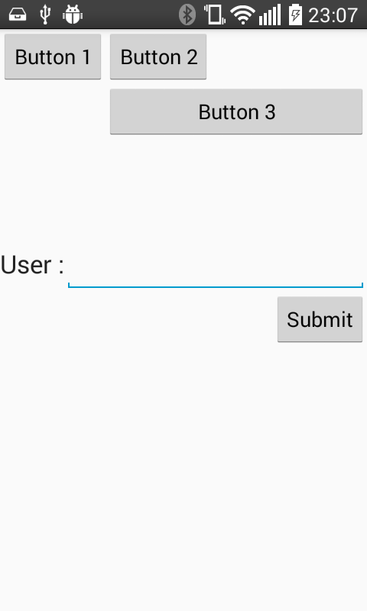

  - Table Layout
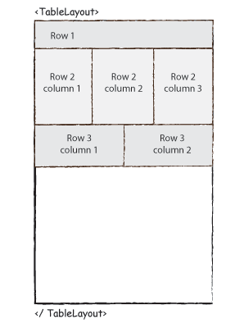
TableLayout Attributes
android:id This is the ID which uniquely identifies the layout.
android:collapseColumns This specifies the zero-based index of the columns to collapse. The column indices must be separated by a comma: 1, 2, 5.
android:shrinkColumns The zero-based index of the columns to shrink. The column indices must be separated by a comma: 1, 2, 5.
android:stretchColumns The zero-based index of the columns to stretch. The column indices must be separated by a comma: 1, 2, 5.
MainActivity.java
package com.example.akoel.myapplication;
import android.os.Bundle;
import android.app.Activity;
public class MainActivity extends Activity {
@Override
protected void onCreate(Bundle savedInstanceState) {
super.onCreate(savedInstanceState);
setContentView(R.layout.activity_main);
}
}
res/layout/activity_main.xml
<TableLayout xmlns:android="http://schemas.android.com/apk/res/android"
android:layout_width="fill_parent"
android:layout_height="fill_parent">
<TableRow
android:layout_width="fill_parent"
android:layout_height="fill_parent">
<TextView
android:text="Time"
android:layout_width="wrap_content"
android:layout_height="wrap_content"
android:layout_column="1" />
<TextClock
android:layout_width="wrap_content"
android:layout_height="wrap_content"
android:id="@+id/textClock"
android:layout_column="2" />
</TableRow>
<TableRow>
<TextView
android:text="First Name"
android:layout_width="wrap_content"
android:layout_height="wrap_content"
android:layout_column="1" />
<EditText
android:width="200px"
android:layout_width="wrap_content"
android:layout_height="wrap_content" />
</TableRow>
<TableRow>
<TextView
android:text="Last Name"
android:layout_width="wrap_content"
android:layout_height="wrap_content"
android:layout_column="1" />
<EditText
android:width="100px"
android:layout_width="wrap_content"
android:layout_height="wrap_content" />
</TableRow>
<TableRow
android:layout_width="fill_parent"
android:layout_height="fill_parent">
<RatingBar
android:layout_width="wrap_content"
android:layout_height="wrap_content"
android:id="@+id/ratingBar"
android:layout_column="2" />
</TableRow>
<TableRow
android:layout_width="fill_parent"
android:layout_height="fill_parent">
<TextView
android:layout_width="wrap_content"
android:layout_height="wrap_content"
android:text="H"
android:id="@+id/text"
android:layout_column="3" />
</TableRow>
<TableRow
android:layout_width="fill_parent"
android:layout_height="fill_parent">
<Button
android:layout_width="wrap_content"
android:layout_height="wrap_content"
android:text="Submit"
android:id="@+id/button"
android:layout_column="2" />
</TableRow>
</TableLayout>
Layout of activity_main.xml
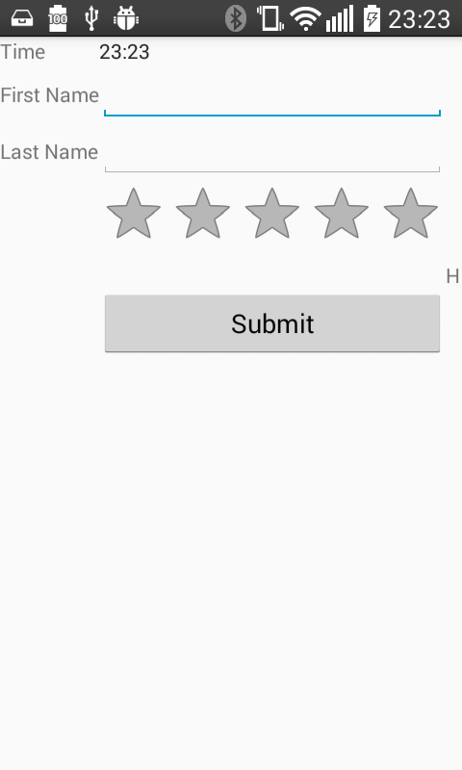

  - Absolute LayoutInflater
An Absolute Layout lets you specify exact locations (x/y coordinates) of its children. Absolute layouts are less flexible and harder to maintain than other types of layouts without absolute positioning.
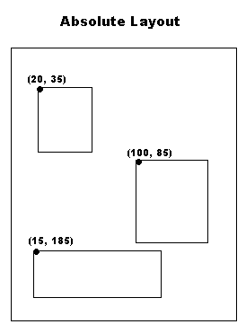
AbsoluteLayout Attributes
android:id This is the ID which uniquely identifies the layout.
android:layout_x This specifies the x-coordinate of the view.
android:layout_y This specifies the y-coordinate of the view.
MainActivity.java
package com.example.akoel.myapplication;
import android.os.Bundle;
import android.app.Activity;
public class MainActivity extends Activity {
@Override
protected void onCreate(Bundle savedInstanceState) {
super.onCreate(savedInstanceState);
setContentView(R.layout.activity_main);
}
}
res/layout/activity_main.xml
<AbsoluteLayout xmlns:android="http://schemas.android.com/apk/res/android"
android:layout_width="fill_parent"
android:layout_height="fill_parent">
<Button
android:layout_width="100dp"
android:layout_height="wrap_content"
android:text="OK"
android:layout_x="50px"
android:layout_y="361px" />
<Button
android:layout_width="100dp"
android:layout_height="wrap_content"
android:text="Cancel"
android:layout_x="225px"
android:layout_y="361px" />
</AbsoluteLayout>
Layout of activity_main.xml
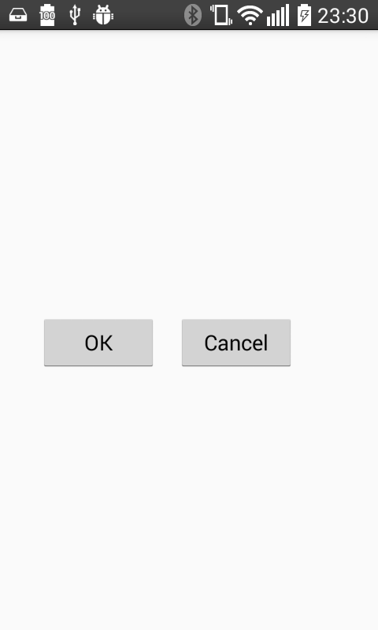

  - Frame Layout
Frame Layout is designed to block out an area on the screen to display a single item. Generally, FrameLayout should be used to hold a single child view, because it can be difficult to organize child views in a way that's scalable to different screen sizes without the children overlapping each other.
You can, however, add multiple children to a FrameLayout and control their position within the FrameLayout by assigning gravity to each child, using the android:layout_gravity attribute.
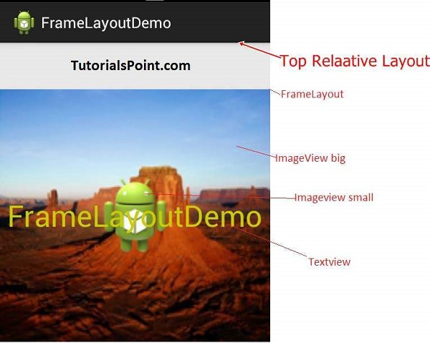
FrameLayout Attributes
android:id This is the ID which uniquely identifies the layout.
android:foreground This defines the drawable to draw over the content and possible values may be a color value, in the form of "#rgb", "#argb", "#rrggbb", or "#aarrggbb".
android:foregroundGravity Defines the gravity to apply to the foreground drawable. The gravity defaults to fill. Possible values are top, bottom, left, right, center, center_vertical, center_horizontal etc.
android:measureAllChildren Determines whether to measure all children or just those in the VISIBLE or INVISIBLE state when measuring. Defaults to false.
MainActivity.java
package com.example.akoel.myapplication;
import android.os.Bundle;
import android.app.Activity;
public class MainActivity extends Activity {
@Override
protected void onCreate(Bundle savedInstanceState) {
super.onCreate(savedInstanceState);
setContentView(R.layout.activity_main);
}
}
res/layout/activity_main.xml
<FrameLayout xmlns:android="http://schemas.android.com/apk/res/android"
android:layout_width="fill_parent"
android:layout_height="fill_parent">
<ImageView
android:src="@drawable/ic_launcher"
android:scaleType="fitCenter"
android:layout_height="450px"
android:layout_width="450px"/>
<TextView
android:text="Frame Demo"
android:textSize="30px"
android:textStyle="bold"
android:layout_height="fill_parent"
android:layout_width="fill_parent"
android:gravity="center"/>
</FrameLayout>
Layout of activity_main.xml
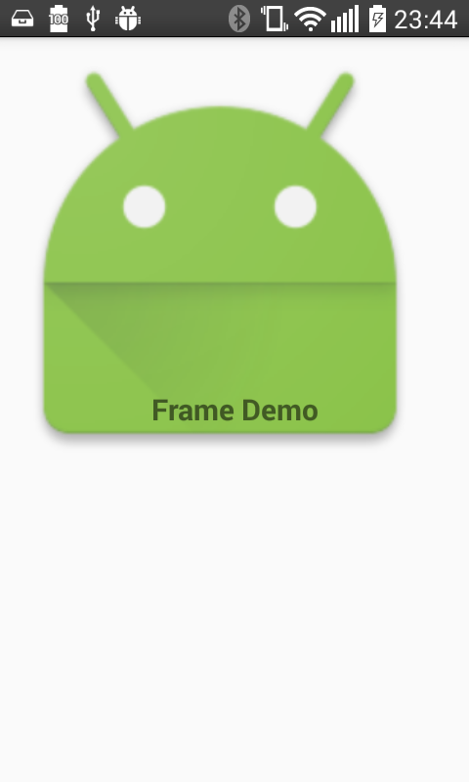

  - List View
Android ListView is a view which groups several items and display them in vertical scrollable list. The list items are automatically inserted to the list using an Adapter that pulls content from a source such as an array or database.
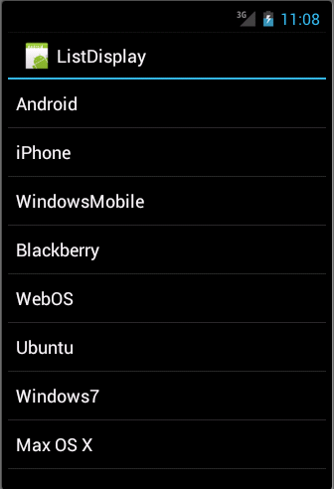
The ListView and GridView are subclasses of AdapterView and they can be populated by binding them to an Adapter, which retrieves data from an external source and creates a View that represents each data entry.
Android provides several subclasses of Adapter that are useful for retrieving different kinds of data and building views for an AdapterView ( i.e. ListView or GridView). The common adapters are ArrayAdapter, BaseAdapter, CursorAdapter, SimpleCursorAdapter, SpinnerAdapter and WrapperListAdapter.
ListView attributes
android:id This is the ID which uniquely identifies the layout.
android:divider This is drawable or color to draw between list items.
android:dividerHeight This specifies height of the divider. This could be in px, dp, sp, in, or mm.
android:entries Specifies the reference to an array resource that will populate the ListView.
android:footerDividersEnabled When set to false, the ListView will not draw the divider before each footer view. The default value is true.
android:headerDividersEnabled When set to false, the ListView will not draw the divider after each header view. The default value is true.
    - ArrayAdapter
You can use this adapter when your data source is an array. By default, ArrayAdapter creates a view for each array item by calling toString() on each item and placing the contents in a TextView. Consider you have an array of strings you want to display in a ListView, initialize a new ArrayAdapter using a constructor to specify the layout for each string and the string array
ArrayAdapter adapter = new ArrayAdapter<String>(this,R.layout.ListView,StringArray);
Arguments for constructor
First argument this is the application context. Most of the case, keep it this
Second argument will be layout defined in XML file and having TextView for each string in the array.
Final argument is an array of strings which will be populated in the text view.
Once you have array adapter created, then simply call setAdapter() on your ListView object as follows
ListView listView = (ListView) findViewById(R.id.listview);
listView.setAdapter(adapter);
MainActivity.java
package com.example.akoel.myapplication;
import android.app.Activity;
import android.os.Bundle;
import android.widget.ArrayAdapter;
import android.widget.ListView;
public class MainActivity extends Activity {
// Array of strings...
String[] mobileArray = {"Android","IPhone","WindowsMobile","Blackberry",
"WebOS","Ubuntu","Windows7","Max OS X"};
@Override
protected void onCreate(Bundle savedInstanceState) {
super.onCreate(savedInstanceState);
setContentView(R.layout.activity_main);
ArrayAdapter adapter = new ArrayAdapter<String>(this,
R.layout.activity_listview, mobileArray);
cursor
listView.setAdapter(adapter);
}
}
res/layout/activity_main.xml
<LinearLayout xmlns:android="http://schemas.android.com/apk/res/android"
xmlns:tools="http://schemas.android.com/tools"
android:layout_width="match_parent"
android:layout_height="match_parent"
android:orientation="vertical"
tools:context=".MainActivity" >
<ListView
android:id="@+id/mobile_list"
android:layout_width="match_parent"
android:layout_height="wrap_content" >
</ListView>
</LinearLayout>
res/layout/activity_listview.xml
<?xml version="1.0" encoding="utf-8"?>
<!-- Single List Item Design -->
<TextView xmlns:android="http://schemas.android.com/apk/res/android"
android:id="@+id/label"
android:layout_width="fill_parent"
android:layout_height="fill_parent"
android:padding="10dip"
android:textSize="16dip"
android:textStyle="bold" >
</TextView>
Layout of activity_main.xml
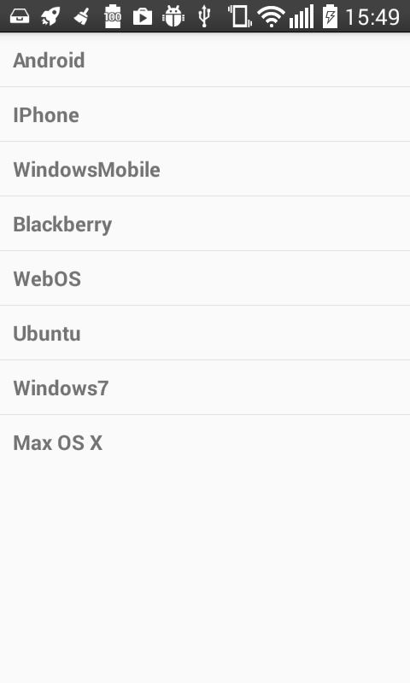

    - SimpleCursorAdapter
You can use this adapter when your data source is a database Cursor. When using SimpleCursorAdapter, you must specify a layout to use for each row in the Cursor and which columns in the Cursor should be inserted into which views of the layout.
For example, if you want to create a list of people's names and phone numbers, you can perform a query that returns a Cursor containing a row for each person and columns for the names and numbers. You then create a string array specifying which columns from the Cursor you want in the layout for each result and an integer array specifying the corresponding views that each column should be placed
String[] fromColumns = {ContactsContract.Data.DISPLAY_NAME,
ContactsContract.CommonDataKinds.Phone.NUMBER};
int[] toViews = {R.id.display_name, R.id.phone_number};
When you instantiate the SimpleCursorAdapter, pass the layout to use for each result, the Cursor containing the results, and these two arrays
SimpleCursorAdapter adapter = new SimpleCursorAdapter(this,
R.layout.person_name_and_number, cursor, fromColumns, toViews, 0);
ListView listView = getListView();
listView.setAdapter(adapter);
The SimpleCursorAdapter then creates a view for each row in the Cursor using the provided layout by inserting each from Columns item into the corresponding toViews view.
In the below example we list the Contact list. In a record will be the name in the first row and the phone number in the second row. At the end of every name we put an asterisk
AndroidManifest.xml
<?xml version="1.0" encoding="utf-8"?>
<manifest xmlns:android="http://schemas.android.com/apk/res/android"
package="com.example.akoel.myapplication" android:installLocation="auto">
<uses-permission android:name="android.permission.READ_CONTACTS" />
<application
android:icon="@mipmap/ic_launcher"
android:label="@string/app_name"
android:supportsRtl="true"
android:theme="@style/AppTheme" >
<activity
android:name=".MainActivity"
android:label="@string/app_name"
android:theme="@style/AppTheme.NoActionBar" >
<intent-filter>
<action android:name="android.intent.action.MAIN" />
<category android:name="android.intent.category.LAUNCHER" />
</intent-filter>
</activity>
</application>
</manifest>
MainActivity.java
package com.example.akoel.myapplication;
import android.app.ListActivity;
import android.provider.ContactsContract.CommonDataKinds.Phone;
import android.provider.ContactsContract.Data;
import android.database.Cursor;
import android.os.Bundle;
import android.util.Log;
import android.view.View;
import android.widget.SimpleCursorAdapter;
import android.widget.TextView;
public class MainActivity extends ListActivity {
@Override
protected void onCreate(Bundle savedInstanceState) {
super.onCreate(savedInstanceState);
Cursor c = getContentResolver().query(Phone.CONTENT_URI, PHONE_PROJECTION, null, null, null);
startManagingCursor(c);
String[] fromColumns = {Data.DISPLAY_NAME, Phone.NUMBER};
int[] toViews = {R.id.name, R.id.phone};
SimpleCursorAdapter adapter = new SimpleCursorAdapter(this,
R.layout.activity_main, c, fromColumns, toViews);
//Used to add asterisk * to the name
adapter.setViewBinder(new SimpleCursorAdapter.ViewBinder() {
public boolean setViewValue(View view, Cursor cursor, int columnIndex) {
if (columnIndex == COLUMN_NAME) {
((TextView) view).setText( cursor.getString( columnIndex ) + "*");
return true;
}
return false;
}
});
setListAdapter(adapter);
}
private static final String[] PHONE_PROJECTION = new String[] {
Phone._ID,
Phone.TYPE,
Data.DISPLAY_NAME,
Phone.LABEL,
Phone.NUMBER
};
private static final int COLUMN_NAME = 2;
private static final int COLUMN_NUMBER = 4;
}
res/layout/activity_main.xml
<TwoLineListItem xmlns:android="http://schemas.android.com/apk/res/android"
android:layout_width="match_parent"
android:layout_height="wrap_content"
android:minHeight="?android:attr/listPreferredItemHeight"
android:mode="twoLine"
android:paddingStart="?android:attr/listPreferredItemPaddingStart"
android:paddingEnd="?android:attr/listPreferredItemPaddingEnd" >
<TextView android:id="@+id/name"
android:layout_width="match_parent"
android:layout_height="wrap_content"
android:layout_marginTop="8dip"
android:textAppearance="?android:attr/textAppearanceListItem"
/>
<TextView android:id="@+id/phone"
android:layout_width="match_parent"
android:layout_height="wrap_content"
android:layout_below="@+id/name"
android:layout_alignStart="@+id/name"
android:textAppearance="?android:attr/textAppearanceSmall" />
</TwoLineListItem>

  - Grid View
Android GridView shows items in two-dimensional scrolling grid (rows & columns) and the grid items are not necessarily predetermined but they automatically inserted to the layout using a ListAdapter.
An adapter actually bridges between UI components and the data source that fill data into UI Component. Adapter can be used to supply the data to like spinner, list view, grid view etc.
The ListView and GridView are subclasses of AdapterView and they can be populated by binding them to an Adapter, which retrieves data from an external source and creates a View that represents each data entry.
GridView attributes
android:id This is the ID which uniquely identifies the layout.
android:columnWidth This specifies the fixed width for each column. This could be in px, dp, sp, in, or mm.
android:gravity Specifies the gravity within each cell. Possible values are top, bottom, left, right, center, center_vertical, center_horizontal etc.
android:horizontalSpacing Defines the default horizontal spacing between columns. This could be in px, dp, sp, in, or mm.
android:numColumns Defines how many columns to show. May be an integer value, such as "100" or auto_fit which means display as many columns as possible to fill the available space.
android:stretchMode Defines how columns should stretch to fill the available empty space, if any. This must be either of the values
none Stretching is disabled
spacingWidth The spacing between each column is stretched
columnWidth Each column is stretched equally
spacingWidthUniform The spacing between each column is uniformly stretched..
android:verticalSpacing Defines the default vertical spacing between rows. This could be in px, dp, sp, in, or mm.

AndroidManifest.xml
<?xml version="1.0" encoding="utf-8"?>
<manifest xmlns:android="http://schemas.android.com/apk/res/android"
package="com.example.akoel.myapplication" android:installLocation="auto">
<uses-permission android:name="android.permission.READ_CONTACTS" />
<application
android:icon="@mipmap/ic_launcher"
android:label="@string/app_name"
android:supportsRtl="true"
android:theme="@style/AppTheme" >
<activity
android:name=".MainActivity"
android:label="@string/app_name"
android:theme="@style/AppTheme.NoActionBar" >
<intent-filter>
<action android:name="android.intent.action.MAIN" />
<category android:name="android.intent.category.LAUNCHER" />
</intent-filter>
</activity>
<activity android:name=".SingleViewActivity"></activity>
</application>
</manifest>
MainActivity.java
package com.example.akoel.myapplication;
import android.app.Activity;
import android.content.Intent;
import android.os.Bundle;
import android.view.Menu;
import android.view.View;
import android.widget.AdapterView;
import android.widget.AdapterView.OnItemClickListener;
import android.widget.GridView;
public class MainActivity extends Activity {
@Override
protected void onCreate(Bundle savedInstanceState) {
super.onCreate(savedInstanceState);
setContentView(R.layout.activity_main);

GridView gridview = (GridView) findViewById(R.id.gridview);
gridview.setAdapter(new ImageAdapter(this));
gridview.setOnItemClickListener(new OnItemClickListener() {
public void onItemClick(AdapterView<?> parent, View v, int position, long id){
// Send intent to SingleViewActivity
Intent i = new Intent(getApplicationContext(), SingleViewActivity.class);
// Pass image index
i.putExtra("id", position);
startActivity(i);
}
});
}
}
SingleViewActivity.java
package com.example.akoel.myapplication;
import android.app.Activity;
import android.content.Intent;
import android.os.Bundle;
import android.widget.ImageView;
public class SingleViewActivity extends Activity {
@Override
public void onCreate(Bundle savedInstanceState) {
super.onCreate(savedInstanceState);
setContentView(R.layout.single_view);

// Get intent data
Intent i = getIntent();
// Selected image id
int position = i.getExtras().getInt("id");
ImageAdapter imageAdapter = new ImageAdapter(this);
ImageView imageView = (ImageView) findViewById(R.id.SingleView);
imageView.setImageResource(imageAdapter.mThumbIds[position]);
}
}
res/layout/activity_main.xml
<?xml version="1.0" encoding="utf-8"?>
<GridView xmlns:android="http://schemas.android.com/apk/res/android"
android:id="@+id/gridview"
android:layout_width="fill_parent"
android:layout_height="fill_parent"
android:columnWidth="90dp"
android:numColumns="auto_fit"
android:verticalSpacing="10dp"
android:horizontalSpacing="10dp"
android:stretchMode="columnWidth"
android:gravity="center"
/>
res/layout/single_view.xml
<?xml version="1.0" encoding="utf-8"?>
<LinearLayout
xmlns:android="http://schemas.android.com/apk/res/android"
android:layout_width="match_parent"
android:layout_height="match_parent"
android:orientation="vertical" >
<ImageView android:id="@+id/SingleView"
android:layout_width="fill_parent"
android:layout_height="fill_parent"/>
</LinearLayout>
Layout of activity_main.xml
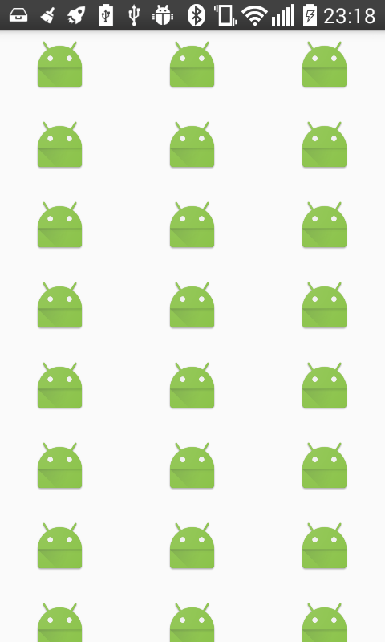
Layout of single_view.xml

- UI Controls
Input controls are the interactive components in your app's user interface. Android provides a wide variety of controls you can use in your UI, such as buttons, text fields, seek bars, check box, zoom buttons, toggle buttons, and many more.
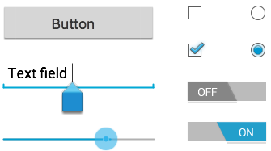
A View is an object that draws something on the screen that the user can interact with and a ViewGroup is an object that holds other View (and ViewGroup) objects in order to define the layout of the user interface.
You define your layout in an XML file which offers a human-readable structure for the layout, similar to HTML.
UI Controls
TextView This control is used to display text to the user.

TextView attributes:
android:id This is the ID which uniquely identifies the control.
android:capitalize If set, specifies that this TextView has a textual input method and should automatically capitalize what the user types.
0 Don't automatically capitalize anything
1 Capitalize the first word of each sentence
2 Capitalize the first letter of every word
3 Capitalize every character
android:cursorVisible Makes the cursor visible (the default) or invisible. Default is false
android:editable If set to true, specifies that this TextView has an input method.
android:fontFamily Font family (named by string) for the text.
android:gravity Specifies how to align the text by the view's x- and/or y-axis when the text is smaller than the view
android:hint Hint text to display when the text is empty
android:inputType The type of data being placed in a text field. Phone, Date, Time, Number, Password etc
android:maxHeight Makes the TextView be at most this many pixels tall
android:maxWidth Makes the TextView be at most this many pixels wide.
android:minHeight Makes the TextView be at least this many pixels tall.
android:minWidth Makes the TextView be at least this many pixels wide.
android:password Whether the characters of the field are displayed as password dots instead of themselves. Possible value either "true" or "false"
android:phoneNumber If set, specifies that this TextView has a phone number input method. Possible value either "true" or "false".
android:text Text to display.
android:textAllCaps Present the text in ALL CAPS. Possible value either "true" or "false".
android:textColor Text color. May be a color value, in the form of "#rgb", "#argb", "#rrggbb", or "#aarrggbb".
android:textColorHighlight Color of the text selection highlight.
android:textColorHint Color of the hint text. May be a color value, in the form of "#rgb", "#argb", "#rrggbb", or "#aarrggbb".
android:textIsSelectable Indicates that the content of a non-editable text can be selected. Possible value either "true" or "false".
android:textSize Size of the text. Recommended dimension type for text is "sp" for scaled-pixels (example: 15sp).
android:textStyle Style (bold, italic, bolditalic) for the text. You can use or more of the following values separated by '|'.
0 normal
1 bold
2 italic
android:typeface Typeface (normal, sans, serif, monospace) for the text. You can use or more of the following values separated by '|'.
0 normal
1 sans
2 serif
3 monospace
EditText EditText is a predefined subclass of TextView that includes rich editing capabilities.
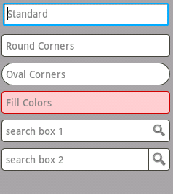

EditText attributes:
Inherited from android.widget.TextView
android:autoText If set, specifies that this TextView has a textual input method and automatically corrects some common spelling errors.
android:drawableBottom This is the drawable to be drawn below the text
android:drawableRight This is the drawable to be drawn to the right of the text.
android:editable If set, specifies that this TextView has an input method.
android:text This is the Text to display.

Inherited from android.view.View
android:background This is a drawable to use as the background.
android:contentDescription This defines text that briefly describes content of the view.
android:id This supplies an identifier name for this view.
android:onClick This is the name of the method in this View's context to invoke when the view is clicked.
android:visibility This controls the initial visibility of the view.
AutoCompleteTextView The AutoCompleteTextView is a view that is similar to EditText, except that it shows a list of completion suggestions automatically while the user is typing.
AutoCompleteTextView attributes:
android:completionHint This defines the hint displayed in the drop down menu.
android:completionHintView This defines the hint view displayed in the drop down menu.
android:completionThreshold This defines the number of characters that the user must type before completion suggestions are displayed in a drop down menu.
android:dropDownAnchor This is the View to anchor the auto-complete dropdown to.
android:dropDownHeight This specifies the basic height of the dropdown.
android:dropDownHorizontalOffset The amount of pixels by which the drop down should be offset horizontally.
android:dropDownSelector This is the selector in a drop down list.
android:dropDownVerticalOffset The amount of pixels by which the drop down should be offset vertically.
android:dropDownWidth This specifies the basic width of the dropdown.
android:popupBackground This sets the background.
Button A push-button that can be pressed, or clicked, by the user to perform an action.
EditText attributes:
Inherited from android.widget.TextView
Inherited from android.view.View
ImageButton An ImageButton is an AbsoluteLayout which enables you to specify the exact location of its children. This shows a button with an image (instead of text) that can be pressed or clicked by the user.
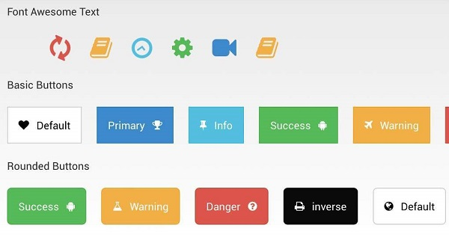
ImageButton attributes:
Inherited from android.view.View
Inherited from android.widget.ImageView
android:adjustViewBounds Set this to true if you want the ImageView to adjust its bounds to preserve the aspect ratio of its drawable.
android:baseline This is the offset of the baseline within this view.
android:baselineAlignBottom If true, the image view will be baseline aligned with based on its bottom edge.
android:cropToPadding If true, the image will be cropped to fit within its padding.
android:src This sets a drawable as the content of this ImageView.
CheckBox An on/off switch that can be toggled by the user. You should use check box when presenting users with a group of selectable options that are not mutually exclusive.
EditText attributes:
Inherited from android.widget.TextView
Inherited from android.view.View
ToggleButton An on/off button with a light indicator.
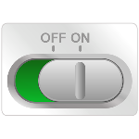
ToggleButton attributes:
Inherited from android.widget.TextView
Inherited from android.view.View

android:disabledAlpha This is the alpha to apply to the indicator when disabled.
android:textOff This is the text for the button when it is not checked.
android:textOn This is the text for the button when it is checked.
RadioButton The RadioButton has two states: either checked or unchecked.
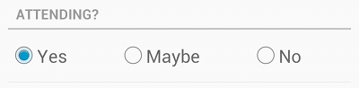
RadioGroup A RadioGroup is used to group together one or more RadioButtons.
ToggleButton attributes:
Inherited from android.view.View

android:checkedButton This is the id of child radio button that should be checked by default within this radio group.
ProgressBar The ProgressBar view provides visual feedback about some ongoing tasks, such as when you are performing a task in the background.
In android there is a class called ProgressDialog that allows you to create progress bar. In order to do this, you need to instantiate an object of this class. Its syntax is.
ProgressDialog progress = new ProgressDialog(this);
Now you can set some properties of this dialog. Such as, its style, its text etc.
progress.setMessage("Downloading Music :) "); progress.setProgressStyle(ProgressDialog.STYLE_HORIZONTAL); progress.setIndeterminate(true);
ProgressBar methods:
getMax() This method returns the maximum value of the progress.
incrementProgressBy(int diff) This method increments the progress bar by the difference of value passed as a parameter.
setIndeterminate(boolean indeterminate) This method sets the progress indicator as determinate or indeterminate.
setMax(int max) This method sets the maximum value of the progress dialog.
setProgress(int value) This method is used to update the progress dialog with some specific value.
show(Context context, CharSequence title, CharSequence message) This is a static method, used to display progress dialog
Spinner A drop-down list that allows users to select one value from a set.
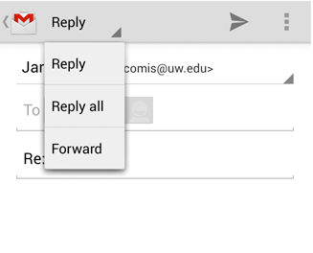
TimePicker The TimePicker view enables users to select a time of the day, in either 24-hour mode or AM/PM mode.
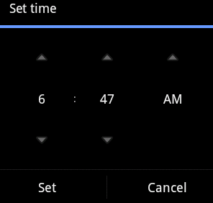
TimePicker methods:
is24HourView() This method returns true if this is in 24 hour view else false
isEnabled() This method returns the enabled status for this view
setCurrentHour(Integer currentHour) This method sets the current hour
setCurrentMinute(Integer currentMinute) This method sets the current minute
setEnabled(boolean enabled) This method set the enabled state of this view
setIs24HourView(Boolean is24HourView) This method set whether in 24 hour or AM/PM mode
setOnTimeChangedListener(TimePicker.OnTimeChangedListener onTimeChangedListener) This method Set the callback that indicates the time has been adjusted by the user
DatePicker The DatePicker view enables users to select a date of the day.
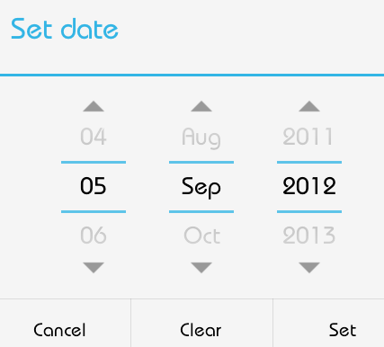
DatePicker methods:
getDayOfMonth() This method gets the selected day of month
getMonth() This method gets the selected month
getYear() This method gets the selected year
setMaxDate(long maxDate) This method sets the maximal date supported by this DatePicker in milliseconds since January 1, 1970 00:00:00 in getDefault() time zone
setMinDate(long minDate) This method sets the minimal date supported by this NumberPicker in milliseconds since January 1, 1970 00:00:00 in getDefault() time zone
setSpinnersShown(boolean shown) This method sets whether the spinners are shown
updateDate(int year, int month, int dayOfMonth) This method updates the current date
getCalendarView() This method returns calendar view
getFirstDayOfWeek() This Method returns first day of the week
- Event Handling
Events are a useful way to collect data about a user's interaction with interactive components of Applications. Like button presses or screen touch etc. The Android framework maintains an event queue as first-in, first-out (FIFO) basis. You can capture these events in your program and take appropriate action as per requirements.
There are following three concepts related to Android Event Management
Event Listeners An event listener is an interface in the View class that contains a single callback method. These methods will be called by the Android framework when the View to which the listener has been registered is triggered by user interaction with the item in the UI.
Event Listeners Registration Event Registration is the process by which an Event Handler gets registered with an Event Listener so that the handler is called when the Event Listener fires the event.
Event Handlers When an event happens and we have registered an event listener for the event, the event listener calls the Event Handlers, which is the method that actually handles the event.
Event Handler | Event Listener | Description
onClick() | OnClickListener() | This is called when the user either clicks or touches or focuses upon any widget like button, text, image etc. You will use onClick() event handler to handle such event
onLongClick() | OnLongClickListener() | This is called when the user either clicks or touches or focuses upon any widget like button, text, image etc. for one or more seconds. You will use onLongClick() event handler to handle such event
onFocusChange() | OnFocusChangeListener() | This is called when the widget looses its focus ie. user goes away from the view item. You will use onFocusChange() event handler to handle such event
onKey() | OnFocusChangeListener() | This is called when the user is focused on the item and presses or releases a hardware key on the device. You will use onKey() event handler to handle such event.
onTouch() | OnTouchListener() | This is called when the user presses the key, releases the key, or any movement gesture on the screen. You will use onTouch() event handler to handle such event.
onMenuItemClick() | OnMenuItemClickListener() | This is called when the user selects a menu item. You will use onMenuItemClick() event handler to handle such event.
onCreateContextMenu() | onCreateContextMenuItemListener() | This is called when the context menu is being built(as the result of a sustained "long click)
Event Registration is the process by which an Event Handler gets registered with an Event Listener so that the handler is called when the Event Listener fires the event. Though there are several tricky ways to register your event listener for any event, but I'm going to list down only top 3 ways, out of which you can use any of them based on the situation.
-Using an Anonymous Inner Class
-Activity class implements the Listener interface.
-Using Layout file activity_main.xml to specify event handler directly.

