Android Solutions
- Get the connected devices
Connect the Android device to the Linux box and there get the console:
~$ adb devices
List of devices attached
LGD320b45fd065 device
- Get to the Android shell
Connect the Android device to the Linux box and there get the console:
~$ adb shell
shell@w5n:/ $
And now you can give any command to the shell. For example get the list of the actual folder or change the folder
shell@w5n:/ $ ls
acct
cache
charger
config
cust
d
...
- Search for the database/table for a specific app
Let’s say that there is an application: com.example.akoel.myapplication which has a Database: College and this database has a table: students.
First you should get to the Android shell and then use the run-as command to get to the application workspace where you can list the content.
shell@w5n:/ $ run-as com.example.akoel.myapplication
130|shell@w5n:/data/data/com.example.akoel.myapplication $ ls
cache
databases
lib
You can see that the application has 3 subfolders. Get into the database and check its content
shell@w5n:/data/data/com.example.akoel.myapplication $ cd databases
shell@w5n:/data/data/com.example.akoel.myapplication/databases $ ls
College
College-journal
- debug/AndroidManifest.xml gives “connot resolve symbol error
In the AndroidStudio File > Invalidate Caches / Restart menu.
- Problems with the build because of the versions
Build.grandle (Project:...)
buildscript {
repositories {
jcenter()
}
dependencies {
classpath 'com.android.tools.build:gradle:2.2.3'
}
}

Build.grandle (Module:app)
android {
compileSdkVersion 25
buildToolsVersion "23.0.3"
defaultConfig {
applicationId "..."
minSdkVersion 19
targetSdkVersion 25
versionCode 1
versionName "1.0"
testInstrumentationRunner "android.support.test.runner.AndroidJUnitRunner"
}
buildTypes {
release {
minifyEnabled false
proguardFiles getDefaultProguardFile('proguard-android.txt'), 'proguard-rules.pro'
}
}
}
- Where are the android.R.layout-s?
<Local SDK path>/platforms/android-…/data/res/layout
- Localization
Customizing the resources (as texts, colors, styles …) you should create a new values folder indicating the language at the end separated by a hyphen. For example for hungarian language you should create the values-hu folder.
And then inside this values-xx folder you copy the resource file, for example the strings.xml, and now you can modify the strings according to that specific language in the strings.xml.
If you change the language on the device to the same as you created for the values folder, then the string will be used from that folder. In case of other languege, which has no localized values folder, the string will be used from the default values folder.
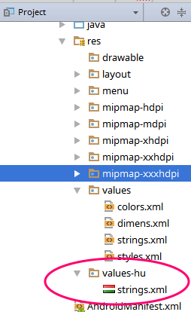

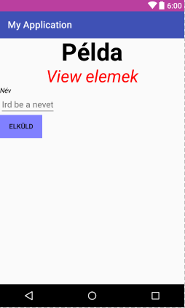
- Decision where to install the app
https://code.tutsplus.com/tutorials/quick-tip-enabling-the-android-move-to-sd-card-feature--mobile-862
Modifying the attributes in the <manifest> tag in the AndroidManifest.xml file you are able to control where to install the app:
AndroidManifest.xml
<manifest xmlns:android="http://schemas.android.com/apk/res/android"
package="com.example.akoel.myapplication" android:installLocation="auto">
Possible values for the android:installLocation
internalOnly It allows installation only to internal storage and does give the user a choice
preferExternal It will install the app on the SD card first if it is available and there is enough room
auto The user can decide where to install the application
<default> if the value is not set then the default value is internalOnly
- Make black an element in the Layout
//Make the surfaceView element black
surfaceView.setZOrderOnTop(true);
surfaceView.getHolder().setFormat(PixelFormat.TRANSLUCENT);

//Make the surfaceView element transparent
surfaceView.setZOrderOnTop(true);
surfaceView.getHolder().setFormat(PixelFormat.TRANSPARENT);
- “Only the original thread that created a view hierarchy can touch its views”
runOnUiThread(new Runnable() {
@Override
public void run() {
//stuff that updates ui
}
});
- Take picture without showing it on SurfaceView
SurfaceTexture surfaceTexture = new SurfaceTexture(10);
<camera object>.setPreviewTexture(surfaceTexture);
- Run the code after the Layout had been rendered
surfaceView = (SurfaceView) findViewById(R.id.surfaceview);
surfaceView.post(new Runnable() {
public void run() {
...
- Make the Back button not to Destroy Activity
public boolean onKeyDown(int keycode, KeyEvent event) {
if (keycode == KeyEvent.KEYCODE_BACK) {
moveTaskToBack(true);
}
return super.onKeyDown(keycode, event);
}

- Get Running Activities
private void printRunningActivities() {
ActivityManager manager = (ActivityManager) getSystemService(ACTIVITY_SERVICE);
for (ActivityManager.RunningAppProcessInfo app : manager.getRunningAppProcesses()) {
Log.d( tagMsg, app.processName);
}
}
- Get Running Services
private void runningServices() {
ActivityManager manager = (ActivityManager) getSystemService(ACTIVITY_SERVICE);
for (ActivityManager.RunningServiceInfo service : manager.getRunningServices(Integer.MAX_VALUE)) {
Log.d( tagMsg, service.service.getClassName());
}
}
- Linear progressbar
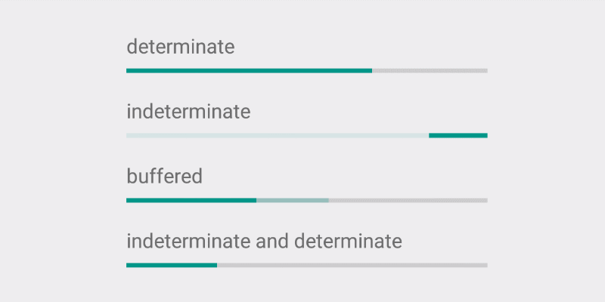
res/layout/activity_main.xml
<LinearLayout xmlns:android="http://schemas.android.com/apk/res/android"
xmlns:tools="http://schemas.android.com/tools" ... >
...
<ProgressBar
android:id="@+id/progressbar"
style="@style/Widget.AppCompat.ProgressBar.Horizontal"
android:layout_width="match_parent"
android:layout_height="wrap_content"/>
</LinearLayout>
java code snipet
ProgressBar progressBar = (ProgressBar) findViewById(R.id.progressbar);
...
progressBar.setMax(10);
progressBar.setProgress(0);
...
- Linear progressbar dinamically created
progressBar = new ProgressBar(MainActivity.this, null, android.R.attr.progressBarStyleHorizontal);
LinearLayout ll = (LinearLayout) findViewById(R.id.ll);
LinearLayout.LayoutParams lp = new LinearLayout.LayoutParams(
LinearLayout.LayoutParams.MATCH_PARENT,
LinearLayout.LayoutParams.WRAP_CONTENT);
progressBar.setLayoutParams(lp);
ll.addView(progressBar);
progressBar.setMax(steps);
progressBar.setProgress(0);
- Wait some seconds before run
Handler handler = new Handler();
handler.postDelayed(new Runnable() {
public void run() {
// Actions to do after 10 seconds
}
}, 10000);
- Tasks in queues – HandlerThread
public class MainActivity extends Activity {
...
private Looper myLooper;
private MyHandler myHandler;
@Override
protected void onCreate(Bundle savedInstanceState) {
super.onCreate(savedInstanceState);

HandlerThread thread = new HandlerThread( "Parameter_to_Thread" );
thread.start();
myLooper = thread.getLooper();
myHandler = new MyHandler(myLooper);
}

public void startTask(View view) {
Message msg = myHandler.obtainMessage();
msg.arg1 = 111;
myHandler.sendMessage(msg);
...
}

private final class MyHandler extends Handler {
public MyHandler(Looper looper) {
super(looper);
}
@Override
public void handleMessage(Message msg) {
...
try {
Thread.sleep(5000);
} catch (InterruptedException e) {
// Restore interrupt status.
Thread.currentThread().interrupt();
}
}
}
}
- Tasks run Serial/Parallel – AsyncTask
If you want run the tasks serial or parallel you have to define it when you call the execute method. The default value is the serial. That is what you see in the example:
myTask.execute("params");
Invoking the executeOnExecutor method you can set the running mode explicitly:
myTask.executeOnExecutor(AsyncTask.THREAD_POOL_EXECUTOR, "params" );
myTask.executeOnExecutor(AsyncTask.SERIAL_EXECUTOR, "params" );
In the AsyncTask class it is not possible to manipulate the UI directly ! To do that you have to delegate the operation to the Activity.

package com.example.akoel.asynctask;
import android.graphics.Color;
import android.graphics.PorterDuff;
import android.os.AsyncTask;
import android.os.Bundle;
import android.support.v7.app.AppCompatActivity;
import android.util.Log;
import android.view.KeyEvent;
import android.view.View;
import android.widget.LinearLayout;
import android.widget.ProgressBar;
public class MainActivity extends AppCompatActivity {
private String tagMsg = "MyApp";
private int orderNumber = 0;
@Override
protected void onCreate(Bundle savedInstanceState) {
super.onCreate(savedInstanceState);
setContentView(R.layout.activity_main);
}
public void startTask(View view) {
Log.d(tagMsg, " " + this.hashCode() + ". task has triggered.");
MyAsyncTask myTask = new MyAsyncTask(this.hashCode());
myTask.execute("" + orderNumber++ );
}
public class MyAsyncTask extends AsyncTask<String, Void, Integer> {
private static final int steps = 10;
private ProgressBar progressBar;
private Integer activityId;
public MyAsyncTask(Integer ActivityId) {
this.activityId = ActivityId;
}
@Override
protected void onPreExecute() {
Log.d( tagMsg, " " + activityId + " activity/" + this.hashCode() + " AsyncTask Started");
}
@Override
protected Integer doInBackground(String... strings) {
for( int i = 1; i <= steps; i++ ) {
try {
Thread.sleep(1000);
} catch (InterruptedException e) {
Thread.currentThread().interrupt();
}
Log.d( tagMsg, " " + activityId + " activity/" + this.hashCode() + "/" + strings[0] + ": " + i + ". counted");
}
return 315;
}
@Override
protected void onPostExecute(Integer integer) {
Log.d( tagMsg, " " + activityId + " activity/" + this.hashCode() + " AsyncTask Ended: " + integer);
}
}
}

- StartService sends message to the ActivityId
AndroidManifest.xml
<?xml version="1.0" encoding="utf-8"?>
<manifest xmlns:android="http://schemas.android.com/apk/res/android" ...>
<application
...
<activity android:name=".MainActivity">
<intent-filter>
<action android:name="android.intent.action.MAIN" />
<category android:name="android.intent.category.LAUNCHER" />
</intent-filter>
</activity>
<service android:name=".MyService" />
</application>
</manifest>

MainActivity.java
public class MainActivity extends AppCompatActivity {
private BroadcastReceiver receiver;
/** Called when the activity is first created. */
@Override
public void onCreate(Bundle savedInstanceState) {
super.onCreate(savedInstanceState);
setContentView(R.layout.activity_main);

receiver = new BroadcastReceiver() {
@Override
public void onReceive(Context context, Intent intent) {
//Get the parameters from the service
Integer bar_id = intent.getIntExtra("bar_id", 1);
Integer bar_value = intent.getIntExtra("bar_value", 0);
...
}
}
};
//You have to Register the receiver
IntentFilter filter = new IntentFilter();
filter.addAction( MyService.ACTION );
registerReceiver(receiver, filter);
}
//It is important to unregister the receiver on Destroy
public void onDestroy(){
super.onDestroy();
unregisterReceiver(receiver);
}
public void startService(View view) {
startService(new Intent(getBaseContext(), MyService.class));
}
public void stopService(View view) {
stopService(new Intent(getBaseContext(), MyService.class));
}
}
MyService.java
public class MyService extends Service {
public static String ACTION = "com.example.akoel.USE_SERVICE";
private Looper mServiceLooper;
private MyServiceHandler mServiceHandler;
@Nullable
@Override
public IBinder onBind(Intent intent) {
return null;
}
@Override
public void onCreate() {
HandlerThread thread = new HandlerThread("Parameters to Service");
thread.start();
mServiceLooper = thread.getLooper();
mServiceHandler = new MyServiceHandler(mServiceLooper);
}
@Override
public int onStartCommand(Intent intent, int flags, int startId) {
Message msg = mServiceHandler.obtainMessage();
msg.arg1 = hashCode();
mServiceHandler.sendMessage(msg);
return START_STICKY;
}
@Override
public void onDestroy() {
super.onDestroy();
}
private final class MyServiceHandler extends Handler {
public MyServiceHandler(Looper looper) {
super(looper);
}
@Override
public void handleMessage(Message msg) {
...
sendBroadcast(msg.arg1, 0);
...
}
}
public void sendBroadcast( int taskId, int value ){
Intent intent = new Intent();
intent.putExtra("bar_id", taskId );
intent.putExtra("bar_value", value );
intent.setAction( ACTION );
sendBroadcast(intent);
}
}
- Get the Contact list
AndroidManifest.xml
<?xml version="1.0" encoding="utf-8"?>
<manifest xmlns:android="http://schemas.android.com/apk/res/android">
...
<uses-permission android:name="android.permission.ACCESS_FINE_LOCATION"/>
...
</manifest>
MainActivity.java
package com.example.akoel.myapplication;
import android.app.Activity;
import android.content.ContentResolver;
import android.database.Cursor;
import android.os.Bundle;
import android.provider.ContactsContract;
import android.util.Log;
import android.widget.ArrayAdapter;
import android.widget.ListView;
public class MainActivity extends Activity {
@Override
protected void onCreate(Bundle savedInstanceState) {
super.onCreate(savedInstanceState);
setContentView(R.layout.activity_main);
collectAllContacts( getContentResolver() );
}
public void collectAllContacts(ContentResolver cr) {
Cursor phones = cr.query(ContactsContract.CommonDataKinds.Phone.CONTENT_URI, null,null,null, null);
Log.d("Phonelist - cursor:", phones.toString() );
while (phones.moveToNext()) {
String name =
phones.getString(phones.getColumnIndex( ContactsContract.CommonDataKinds.Phone.DISPLAY_NAME) );
String phoneNumber =
phones.getString(phones.getColumnIndex(ContactsContract.CommonDataKinds.Phone.NUMBER));
Log.d("Phonelist", name + " - " + phoneNumber);
}
phones.close();
}
}

- Handle Database
AndroidManifest.xml
<?xml version="1.0" encoding="utf-8"?>
<manifest xmlns:android="http://schemas.android.com/apk/res/android"
package="com.example.akoel.myapplication" >
<application
android:allowBackup="true"
android:icon="@mipmap/ic_launcher"
android:label="@string/app_name"
android:supportsRtl="true"
android:theme="@style/AppTheme" >
<activity
android:name=".MainActivity"
android:label="@string/app_name"
android:theme="@style/AppTheme.NoActionBar" >
<intent-filter>
<action android:name="android.intent.action.MAIN" />
<category android:name="android.intent.category.LAUNCHER" />
</intent-filter>
</activity>
</application>
</manifest>
res/values/strings.xml
<resources>
<string name="action_settings">Action Setting</string>
<string name="app_name">My Application</string>
<string name="maintitle_text">Example</string>
<string name="subtitle_text">Database</string>
<string name="hint_name">Name</string>
<string name="hint_age">Age</string>
<string name="button_insertupdate">Insert/Update</string>
<string name="button_delete">Delete</string>
<string name="button_listall">List All</string>
</resources>

MainActivity.java
package com.example.akoel.myapplication;
import android.os.Bundle;
import android.app.Activity;
import android.content.ContentValues;
import android.database.Cursor;
import android.view.View;
import android.widget.EditText;
import android.widget.Toast;
import android.util.Log;
public class MainActivity extends Activity {
public static String logId = "MyDatabase";
private MyDatabase myDatabase;
private static MainActivity context;
@Override
protected void onCreate(Bundle savedInstanceState) {
super.onCreate(savedInstanceState);
setContentView(R.layout.activity_main);
this.context = this;
myDatabase = new MyDatabase(context );
}
public void onClickInsertUpdate(View view) {
String name = ((EditText)findViewById(R.id.edit_name)).getText().toString();
String age = ((EditText)findViewById(R.id.edit_age)).getText().toString();
ContentValues values = new ContentValues();
values.put(MyDatabase.NAME, name);
values.put(MyDatabase.AGE, age);
int res = myDatabase.insertUpdate( values );
if( res == 0 ){
Toast.makeText(context, name + " was INSERTED", Toast.LENGTH_LONG).show();
}else if( res == 1 ){
Toast.makeText(context, name + " was UPDATED", Toast.LENGTH_LONG).show();
}else{
Toast.makeText(context, "There was NO ACTION", Toast.LENGTH_LONG).show();
}
}
public void onClickDelete(View view) {
String name = ((EditText)findViewById(R.id.edit_name)).getText().toString();
String age = ((EditText)findViewById(R.id.edit_age)).getText().toString();
ContentValues values = new ContentValues();
values.put(MyDatabase.NAME, name);
values.put(MyDatabase.AGE, age);
int res = myDatabase.delete( values );
if( res == 0 ){
Toast.makeText(context, name + " was DELETED", Toast.LENGTH_LONG).show();
}else{
Toast.makeText(context, "There was NO ACTION", Toast.LENGTH_LONG).show();
}
}
public void onClickListAll( View view ){
String projection[] = { MyDatabase._ID, MyDatabase.NAME, MyDatabase.AGE};
String selection = "age > 0";
String sortOrder = "Name";
Cursor cursor = myDatabase.query( projection, selection, null, sortOrder );
if (cursor.moveToFirst()) {
do{
Log.d(MainActivity.logId, " " +
cursor.getString( cursor.getColumnIndex( MyDatabase._ID ))+ ": " +
cursor.getString( cursor.getColumnIndex( MyDatabase.NAME ))+ ", " +
cursor.getString( cursor.getColumnIndex( MyDatabase.AGE )));
} while (cursor.moveToNext());
}
}
}

MyDatabase.java
package com.example.akoel.myapplication;
import android.database.Cursor;
import android.database.SQLException;
import android.content.ContentValues;
import android.content.Context;
import android.database.sqlite.SQLiteDatabase;
import android.database.sqlite.SQLiteOpenHelper;
import android.database.sqlite.SQLiteQueryBuilder;
import android.util.Log;
public class MyDatabase {
private Context context;
public static final String _ID = "_id";
public static final String NAME = "name";
public static final String AGE = "age";
private SQLiteDatabase db;
static final String DATABASE_NAME = "College";
static final String STUDENTS_TABLE_NAME = "students";
static final int DATABASE_VERSION = 1;
static final String CREATE_DB_TABLE =
"CREATE TABLE " + STUDENTS_TABLE_NAME +
" (" + _ID + " INTEGER PRIMARY KEY AUTOINCREMENT, " +
" " + NAME + " TEXT NOT NULL UNIQUE, " +
" " + AGE + " TEXT NOT NULL);";
static final String DROP_TABLE =
"DROP TABLE IF EXISTS " + STUDENTS_TABLE_NAME + ";";
public MyDatabase( Context context ){
this.context = context;
DatabaseHelper dbHelper = new DatabaseHelper(context);
db = dbHelper.getWritableDatabase();
dbHelper.onCreate(db);
if( null == db ) {
throw new RuntimeException("!!! Problem opening db !!!");
}
}
public int insertUpdate( ContentValues values ){
if( values.getAsString(NAME).trim().length() == 0 ){
return -1;
}
//Try to insert
long rowID = 0;
try {
rowID = db.insertOrThrow(STUDENTS_TABLE_NAME, "", values);
}catch( SQLException e ){
Log.d(MainActivity.logId, e.toString() + " Exception occured");
rowID = -1;
}
if( rowID != -1 ){
return 0;
}
//Try to update
long affectedRows=db.update (STUDENTS_TABLE_NAME, values, NAME + "='" + values.getAsString(NAME) + "'", null );
if( affectedRows == 1 ){
return 1;
}
return -1;
}
public int delete( ContentValues values ){
if( values.getAsString(NAME).trim().length() == 0 ){
return -1;
}
long affectedRows = db.delete(STUDENTS_TABLE_NAME, NAME + "='" + values.getAsString(NAME) + "'", null);
if( affectedRows > 0 ){
return 0;
}
return -1;
}
public Cursor query(String[] projection, String selection,String[] selectionArgs, String sortOrder) {
SQLiteQueryBuilder qb = new SQLiteQueryBuilder();
qb.setTables(STUDENTS_TABLE_NAME);
Cursor c = qb.query(db, projection, selection, null, null, null, sortOrder);
return c;
}
private static class DatabaseHelper extends SQLiteOpenHelper {
DatabaseHelper(Context context){
super(context, DATABASE_NAME, null, DATABASE_VERSION);
}
@Override
public void onCreate(SQLiteDatabase db) {
Log.d(MainActivity.logId, "onCreate() started");
db.execSQL(DROP_TABLE);
db.execSQL(CREATE_DB_TABLE);
}
@Override
public void onUpgrade(SQLiteDatabase db, int oldVersion, int newVersion) {
Log.d(MainActivity.logId, "onUpgrade() started");
//db.execSQL("DROP TABLE IF EXISTS " + STUDENTS_TABLE_NAME);
//onCreate(db);
}
}
}

res/layout/activity_main.xml
<?xml version="1.0" encoding="utf-8"?>
<LinearLayout xmlns:android="http://schemas.android.com/apk/res/android"
xmlns:app="http://schemas.android.com/apk/res-auto"
android:layout_width="match_parent"
android:layout_height="match_parent"
app:layout_collapseParallaxMultiplier="1.0"
android:orientation="vertical">
<TextView xmlns:android="http://schemas.android.com/apk/res/android"
android:id="@+id/maintitle_id"
android:layout_width="fill_parent"
android:layout_height="wrap_content"
android:gravity="center_horizontal"
android:text="@string/maintitle_text"
android:textStyle="bold"
android:textColor="@color/maintitle_color"
android:textSize="100px" />
<TextView xmlns:android="http://schemas.android.com/apk/res/android"
android:id="@+id/subtitle_id"
android:layout_width="fill_parent"
android:layout_height="wrap_content"
android:gravity="center_horizontal"
android:text="@string/subtitle_text"
android:textStyle="italic"
android:textColor="@color/subtitle_color"
android:textSize="70px" />
<EditText
android:layout_width="wrap_content"
android:layout_height="wrap_content"
android:id="@+id/edit_name"
android:layout_below="@+id/subtitle_id"
android:hint="Student's Name"/>
<EditText
android:layout_width="wrap_content"
android:layout_height="wrap_content"
android:id="@+id/edit_age"
android:layout_below="@+id/hint_name"
android:inputType="number"
android:hint="@string/hint_age"/>
<Button
android:layout_width="wrap_content"
android:layout_height="wrap_content"
android:id="@+id/button_insertupdate"
android:text="@string/button_insertupdate"
android:layout_below="@+id/edit_age"
android:onClick="onClickInsertUpdate"/>
<Button
android:layout_width="wrap_content"
android:layout_height="wrap_content"
android:id="@+id/button_delete"
android:text="@string/button_delete"
android:layout_below="@+id/button_insertupdate"
android:onClick="onClickDelete"/>
<Button
android:layout_width="wrap_content"
android:layout_height="wrap_content"
android:id="@+id/button_listall"
android:text="@string/button_listall"
android:layout_below="@+id/button_delete"
android:onClick="onClickListAll"/>
</LinearLayout>

Layout of activity_main.xml
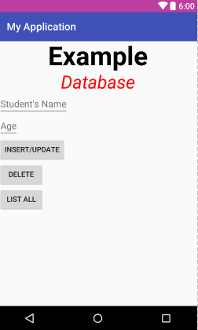

- Automatically pick a specific email app (instead of user selects if from a list)
AndroidManifest.xml
<?xml version="1.0" encoding="utf-8"?>
<manifest xmlns:android="http://schemas.android.com/apk/res/android"
package="com.example.akoel.myapplication" >
<application
android:allowBackup="true"
android:icon="@mipmap/ic_launcher"
android:label="@string/app_name"
android:supportsRtl="true"
android:theme="@style/AppTheme" >
<activity
android:name=".MainActivity"
android:label="@string/app_name"
android:theme="@style/AppTheme.NoActionBar" >
<intent-filter>
<action android:name="android.intent.action.MAIN" />
<category android:name="android.intent.category.LAUNCHER" />
</intent-filter>
</activity>
</application>
</manifest>
MainActivity.java
package com.example.akoel.myapplication;
import android.content.Intent;
import android.content.pm.PackageManager;
import android.content.pm.ResolveInfo;
import android.support.v7.app.AppCompatActivity;
import android.os.Bundle;
import android.widget.Button;
import java.util.List;
public class MainActivity extends AppCompatActivity {
@Override
protected void onCreate(Bundle savedInstanceState) {
super.onCreate(savedInstanceState);
setContentView(R.layout.activity_main);
Intent intent = new Intent(Intent.ACTION_SEND, null);
intent.setType("plain/text");
intent.setPackage("com.google.android.gm");
List<ResolveInfo> pkgAppsList = this.getPackageManager().queryIntentActivities( intent, PackageManager.MATCH_DEFAULT_ONLY | PackageManager.GET_RESOLVED_FILTER);
for (ResolveInfo resolveInfo : pkgAppsList) {
String packageName = resolveInfo.activityInfo.packageName;
String className = "";
if(packageName.equals("com.google.android.gm")) {
className = resolveInfo.activityInfo.name;
intent.setClassName(packageName, className);
break;
}
}
intent.putExtra(Intent.EXTRA_EMAIL, new String[] {"dallaszkorben@gmail.com"});
intent.putExtra(Intent.EXTRA_SUBJECT, "test android");
intent.putExtra(Intent.EXTRA_TEXT, "Delete this email. It is only for test");
startActivity(intent);
}
}

- Too much methods
There is a limit to the methods that your app can reference, and that limit amounts to 65536. More specifically, this limit is found inside the header of the DEX file, which contains all the compiled Java classes required by our app. It may seem like a lot of room for one app, but if you start considering that the most popular libraries contain thousands of methods each, that limit will look tremendously nearer to you.
This issue has grown bigger and bigger, and big companies were usually the first to trip into this obstacle, having to resort to hacky workarounds (e.g. loading a secondary DEX at runtime, or using ProGuard/DexGuard to strip the libraries from unused methods). But there was no official way of addressing the problem, especially from Google. Until Lollipop, of course. Enter MultiDex.
[Starting from Lollipop, we have a new runtime called ART (Android RunTime). Among the greatest advantages that it brought, we find the ability of loading multiple DEX files for a single app. By explicitely declaring the use of MultiDex programmatically, the build system takes care of creating multiple DEXs and bundling them into the final APK. Thanks to ART, the DEXs are then assembled back and converted to another file (an OAT file), which will then be loaded when the user opens the app.]
If you exceed the limit you get the error message: The number of method references in a .dex file cannot exceed 64k
It means that you have too many methods. In this case you have two solutions

  - multidex support
For this you should add two more lines into the build.grande (Module: app) file:
build.grande (Module: app) file
android {
...
defaultConfig {
...
multiDexEnabled true
}
...
}

dependencies {
...
compile 'com.android.support:multidex:1.0.1'
...
}

In the Manifest file you add an extra android:name to the application
AndroidManifest.xml
<application
android:name="android.support.multidex.MultiDexApplication"
…

And override the attachBaseContext method in the MainActivity file
MainActivity.java
public class MainActivity extends Activity implements LocationListener {
...
@Override
protected void attachBaseContext(Context newBase) {
super.attachBaseContext(newBase);
MultiDex.install(this);
}

  - ProGuard
Another solution is to try to remove unused code with ProGuard - Configure the ProGuard settings for your app to run ProGuard and ensure you have shrinking enabled for release builds.
Build.grade (Module: app)
android {
...
}
buildTypes {
release {
minifyEnabled true
shrinkResources true
proguardFiles getDefaultProguardFile('proguard-android.txt'), 'proguard-rules.pro'
}
debug {
minifyEnabled true
shrinkResources true
}
}
}
dependencies {
...
}

- GPS using fuse location provider
Most Android devices allow to determine the current geo location. This can be done via a GPS (Global Positioning System) module, via cell tower triangulation and via wifi networks.

To use the GPS you need some preparations before.
  - Install Google Play services
To access the fused location provider, your app's development project must include Google Play services.
Tools > Android > SDK Manager > SDK Tools
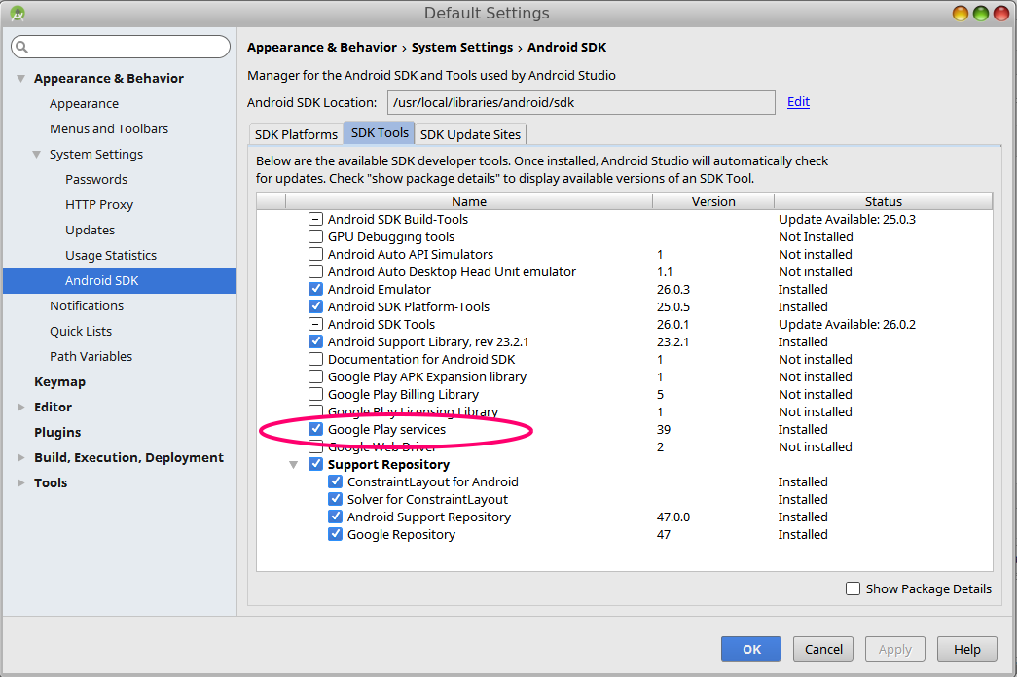
  - Make the Google Play Services available
Add extra dependencies to the build.grande (Module: app) file:
build.grande (Module: app) file
dependencies {
...
compile 'com.google.android.gms:play-services:9.4.0'
compile 'com.google.android.gms:play-services-location:9.2.0'
...
}
  - Specify app permitions
Apps that use location services must request location permissions. Android offers two location permissions: ACCESS_COARSE_LOCATION and ACCESS_FINE_LOCATION. The permission you choose determines the accuracy of the location returned by the API. If you specify ACCESS_COARSE_LOCATION, the API returns a location with an accuracy approximately equivalent to a city block.
<manifest xmlns:android="http://schemas.android.com/apk/res/android"
package="com.example.akoel.myapplication">
<uses-permission android:name="android.permission.ACCESS_FINE_LOCATION"/>
...
</manifest>
  - Application class
If you are using your own Application class, change the parent class from Application to MultiDexApplication
  - Code
AndroidManifest.xml
<?xml version="1.0" encoding="utf-8"?>
<manifest xmlns:android="http://schemas.android.com/apk/res/android"
package="com.example.akoel.myapplication" android:installLocation="auto">
<uses-permission android:name="android.permission.ACCESS_FINE_LOCATION"/>
<application
android:name="android.support.multidex.MultiDexApplication"
android:allowBackup="true"
android:icon="@mipmap/ic_launcher"
android:label="@string/app_name"
android:supportsRtl="true"
android:theme="@style/AppTheme" >
<activity
android:name=".MainActivity"
android:label="@string/app_name"
android:theme="@style/AppTheme.NoActionBar" >
<intent-filter>
<action android:name="android.intent.action.MAIN" />
<category android:name="android.intent.category.LAUNCHER" />
</intent-filter>
</activity>
</application>
</manifest>
build.grandle (Module: app)
apply plugin: 'com.android.application'
android {
compileSdkVersion 23
buildToolsVersion '23.0.3'
defaultConfig {
applicationId "com.example.akoel.myapplication"
minSdkVersion 15
targetSdkVersion 23
versionCode 1
versionName "1.0"
testInstrumentationRunner "android.support.test.runner.AndroidJUnitRunner"
multiDexEnabled true
}
buildTypes {
release {
minifyEnabled false
proguardFiles getDefaultProguardFile('proguard-android.txt'), 'proguard-rules.pro'
}
}
}
dependencies {
compile fileTree(dir: 'libs', include: ['*.jar'])
androidTestCompile('com.android.support.test.espresso:espresso-core:2.2.2', {
exclude group: 'com.android.support', module: 'support-annotations'
})
compile 'com.android.support:appcompat-v7:23.4.0'
compile 'com.android.support.constraint:constraint-layout:1.0.2'
compile 'com.android.support:design:23.4.0'
compile 'com.google.android.gms:play-services:9.4.0'
compile 'com.google.android.gms:play-services-location:9.2.0'
compile 'com.android.support:multidex:1.0.1'
testCompile 'junit:junit:4.12'
}
MainActivity.java
package com.example.akoel.myapplication;
import android.app.Activity;
import android.content.Context;
import android.location.Criteria;
import android.location.Location;
import android.location.LocationListener;
import android.location.LocationManager;
import android.os.Bundle;
import android.support.multidex.MultiDex;
import android.widget.TextView;
import android.widget.Toast;
public class MainActivity extends Activity implements LocationListener {
private TextView latitudeField;
private TextView longitudeField;
private TextView altitudeField;
private LocationManager locationManager;
private String provider;
@Override
protected void attachBaseContext(Context newBase) {
super.attachBaseContext(newBase);
MultiDex.install(this);
}
/** Called when the activity is first created. */
@Override
public void onCreate(Bundle savedInstanceState) {
super.onCreate(savedInstanceState);
setContentView(R.layout.activity_main);
latitudeField = (TextView) findViewById(R.id.TextView02);
longitudeField = (TextView) findViewById(R.id.TextView04);
altitudeField = (TextView) findViewById(R.id.TextView06);
// Get the location manager
locationManager = (LocationManager) getSystemService(Context.LOCATION_SERVICE);
// Define the criteria how to select the locatioin provider -> use
// default
Criteria criteria = new Criteria();
provider = locationManager.getBestProvider(criteria, false);
Location location = locationManager.getLastKnownLocation(provider);
// Initialize the location fields
if (location != null) {
System.out.println("Provider " + provider + " has been selected.");
onLocationChanged(location);
} else {
latitudeField.setText("Location not available");
longitudeField.setText("Location not available");
altitudeField.setText("Location not available");
}
}
/* Request updates at startup */
@Override
protected void onResume() {
super.onResume();
locationManager.requestLocationUpdates(provider, 400, 1, this);
}
/* Remove the locationlistener updates when Activity is paused */
@Override
protected void onPause() {
super.onPause();
locationManager.removeUpdates(this);
}
@Override
public void onLocationChanged(Location location) {
double alt = location.getAltitude();
double lat = location.getLatitude();
double lng = location.getLongitude();
latitudeField.setText(String.valueOf(lat));
longitudeField.setText(String.valueOf(lng));
altitudeField.setText(String.valueOf(alt));
}
@Override
public void onStatusChanged(String provider, int status, Bundle extras) {
// TODO Auto-generated method stub
}
@Override
public void onProviderEnabled(String provider) {
Toast.makeText(this, "Enabled new provider " + provider, Toast.LENGTH_SHORT).show();
}
@Override
public void onProviderDisabled(String provider) {
Toast.makeText(this, "Disabled provider " + provider, Toast.LENGTH_SHORT).show();
}
}
res/layout/activity_main.xml
<?xml version="1.0" encoding="utf-8"?>
<LinearLayout xmlns:android="http://schemas.android.com/apk/res/android"
android:layout_width="match_parent"
android:layout_height="match_parent"
android:orientation="vertical" >
<LinearLayout
android:id="@+id/linearLayout1"
android:layout_width="match_parent"
android:layout_height="wrap_content"
android:layout_marginTop="40dip"
android:orientation="horizontal" >
<TextView
android:id="@+id/TextView01"
android:layout_width="wrap_content"
android:layout_height="wrap_content"
android:layout_marginLeft="10dip"
android:layout_marginRight="5dip"
android:text="Latitude: "
android:textSize="20dip" >
</TextView>
<TextView
android:id="@+id/TextView02"
android:layout_width="wrap_content"
android:layout_height="wrap_content"
android:text="unknown"
android:textSize="20dip" >
</TextView>
</LinearLayout>
<LinearLayout
android:id="@+id/linearLayout2"
android:layout_width="match_parent"
android:layout_height="wrap_content" >
<TextView
android:id="@+id/TextView03"
android:layout_width="wrap_content"
android:layout_height="wrap_content"
android:layout_marginLeft="10dip"
android:layout_marginRight="5dip"
android:text="Longitute: "
android:textSize="20dip" >
</TextView>
<TextView
android:id="@+id/TextView04"
android:layout_width="wrap_content"
android:layout_height="wrap_content"
android:text="unknown"
android:textSize="20dip" >
</TextView>
</LinearLayout>
<LinearLayout
android:id="@+id/linearLayout3"
android:layout_width="match_parent"
android:layout_height="wrap_content" >
<TextView
android:id="@+id/TextView05"
android:layout_width="wrap_content"
android:layout_height="wrap_content"
android:layout_marginLeft="10dip"
android:layout_marginRight="5dip"
android:text="Altitude: "
android:textSize="20dip" >
</TextView>
<TextView
android:id="@+id/TextView06"
android:layout_width="wrap_content"
android:layout_height="wrap_content"
android:text="unknown"
android:textSize="20dip" >
</TextView>
</LinearLayout>
</LinearLayout>

Layout of activity_main.xml
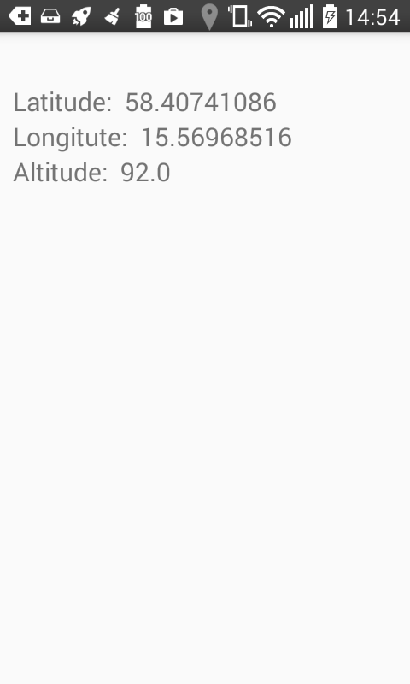

- Element in one row fills up the available space
Let’s say that you want to put 4 buttons to the bottom of the screen and you want all buttons to have the same width. Plus you want the buttons to occupy the all available horizontal spaces. And let’s say that your main layout is RelativeLayout.
To achive your goal you have to insert a LinearLayout into the RelativeLayout. The LinearLayout will hold the Button-s. This layout has two important settings: layout_width=”fill_parents” wich will extends the width of the layout to the maximum width and layout_alignParentBottom=”true” which will place the all layout to the bottom.
In the Button views you have to define the layout_weight=”1”. If you use the same number “1” to all Buttons then all buttons will have the same width.
The weight is used to distribute the remaining empty space for the specific element. If you want different width for some Buttons then you should use the right portions for them.
For example if you want the first button to occupy all available free spaces and you want the others to have only the default width the the fist Buttons will have layout_weight=”1” and the others will have layout_weight=”0”.
Layout of activity_main.xml
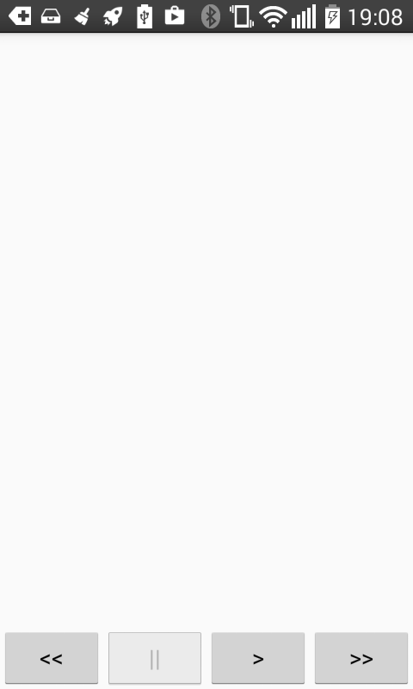
activity_main.xml
<?xml version="1.0" encoding="utf-8"?>
<RelativeLayout xmlns:android="http://schemas.android.com/apk/res/android"
xmlns:tools="http://schemas.android.com/tools"
android:layout_width = "fill_parent"
android:layout_height = "fill_parent">
<ImageView
android:id = "@+id/my_image"
android:layout_width = "wrap_content"
android:layout_height = "wrap_content"
android:layout_alignParentTop ="true" />

<LinearLayout
android:id="@+id/buttons"
android:layout_width="fill_parent"
android:layout_height="wrap_content"
android:orientation="horizontal"
android:layout_alignParentBottom="true">
<Button
android:layout_width="wrap_content"
android:layout_height="wrap_content"
android:text="@string/backward"
android:id="@+id/button_backward"
android:layout_weight="1"/>
<Button
android:layout_width = "wrap_content"
android:layout_height = "wrap_content"
android:text="@string/pause"
android:id="@+id/button_pause"
android:layout_weight="1"/>
<Button
android:layout_width="wrap_content"
android:layout_height="wrap_content"
android:text= "@string/play"
android:id="@+id/button_play"
android:layout_weight="1"/>
<Button
android:layout_width="wrap_content"
android:layout_height="wrap_content"
android:text= "@string/forward"
android:id="@+id/button_forward"
android:layout_weight="1"/>
</LinearLayout>
</RelativeLayout>

- Changing orientation will run the onCreate() method every time
When you change the orientation of the mobile the onCreate() method will be triggered. It means that if you create an object in the onCreate() method then it will be created again and again every time when you change the orientation.
It means that if the initialized object, for example, starts a process then newer and newer object going to be created and the process can be started multiple times pararelly after you changed the orientation.
One solution for that is to define the objects as static and check if the object is already created. If it was created then skip the createion and initialization part.
The other solution is to use the Status Save-Restore mechanizm. When you change the orientation then onSaveInstanceState(Budle saveInstanceState) – onCreate(Budle saveInstanceState) – onRestoreInstanceState(Budle saveInstanceState) method sequence will be called. What you have to do is that
in the onSaveInstanceState() method save the actual status of your object, stop every activity. In the onCreate() method you should not care about the object duplication. Leave it as it was. In the onRestoreInstanceState() method you get back the saved status and you modify the newly created object by these saved status.
In the following example you can see the second type of solution on the MediaPlayer. In this case we save the position as the status.
public class MainActivity extends Activity {
...
private MediaPlayer mediaPlayer;
...
@Override
protected void onCreate(Bundle savedInstanceState) {
super.onCreate(savedInstanceState);
setContentView(R.layout.activity_main);
...
mediaPlayer = MediaPlayer.create(this, R.raw.song);
...
}
....
@Override
public void onSaveInstanceState(Bundle savedInstanceState) {
super.onSaveInstanceState(savedInstanceState);
savedInstanceState.putInt("Position", mediaPlayer.getCurrentPosition());
savedInstanceState.putBoolean("isplaying", mediaPlayer.isPlaying());
if (mediaPlayer.isPlaying())
pausePlaying( mediaPlayer );
}
@Override
public void onRestoreInstanceState(Bundle savedInstanceState) {
super.onRestoreInstanceState(savedInstanceState);
int position = savedInstanceState.getInt("Position");
mediaPlayer.seekTo(position);
if (savedInstanceState.getBoolean("isplaying"))
continuePlaying( mediaPlayer);
}
}

W

