Creating your own Haar Cascade OpenCV

In this tutorial we want to train the Haar Cascade to detect a mobile phone in a picture. Of course you can teach it to detect any other object.
- Places to start
https://docs.opencv.org/2.4/doc/user_guide/ug_traincascade.html

http://note.sonots.com/SciSoftware/haartraining.html

https://memememememememe.me/post/training-haar-cascades/

- Install OpenCV
Follow the instruction for Install OpenCV. At the end you get
/usr/local/lib/python3.6/site-packages/cv2.so
- Create your python virtual env
Projects/
$ mkdir TrainingHaarCascade

$ cd TrainingHaarCascade

$ virtualenv --python=python3.6 --system-site-packages env
$ source env/bin/activate
(env) $ ln -s cv2.so ./env/lib/python3.6/site-packages
- Negative images
Now we need the negative images, the ones that don’t show a banana. In the best case, if we were to train a highly accurate classifier, we would have a lot of negative images that look exactly like the positive ones, except that they don’t contain the object we want to recognize. If you want to detect stop signs on walls, the negative images would ideally be a lot of pictures of walls. Maybe even with other signs.
We need at least 600 of them. And yes, getting them manually by hand takes a long time. I know, I’ve been there. But again: you could take a video file and extract the frames as images. That way you’d get 600 pictures pretty fast.
You can take negative images from:
http://haar.thiagohersan.com/haartraining/negatives/
Projects/TrainingHaarCascade/
(env) $ mkdir negative-images
(env) $ cd negative-images
(env) $ wget -nd -r -A "neg-0*.jpg" http://haar.thiagohersan.com/haartraining/negatives/

Once we have the images, we put all of them in the negative-images folder of the repository and use find to save the list of relative paths to a file:

Projects/TrainingHaarCascade/
$ find ./negative-images -iname "*.jpg" > negatives.txt

- Positive images
This is where we gather about 1000 images of our phone. Some people use video, some people use scripts… we used scripts.
  - Pictures
This is where we take pictures of our phone. We don’t need 1000 of them. Somewhere between 15 and 20 should be enough.
Since our object is pretty black, we used a white background, and took high-contrast pictures in order to make the next step easier. Also, the pictures don’t have to be large because OpenCV will shrink them anyway: ours were 1024x773.
  - Crop the pictures
Once we have the pictures, we need to crop them so that only our desired object is visible. Keep an eye on the ratios of the cropped images, they shouldn’t differ that much. The best results come from positive images that look exactly like the ones you’d want to detect the object in, except that they are cropped so only the object is visible.
For example pictures of mobile phones:

Take the positive, cropped images and put them in the ./positive-images directory of the cloned repository.

  - Generate sample images
Under the "sample-images" folder, create folders holding the sample images for every posivite, cropped images
Projects/TrainingHaarCascade/
(env) $ mkdir sample-images/001

We have to separate the sample-images because the next command will override the previous sample-images if they are stored in the same directory.
Run the following command for each of our cropped images:

Projects/TrainingHaarCascade/
(env) $ opencv_createsamples -img positive-images/cropped-001.jpg -bg negatives.txt -info sample-images/001/cropped-001.txt -num 200 -maxxangle 0.5 -maxyangle 0.5 -maxzangle 0.5 -bgcolor 255 -bgthresh 8 -w 48 -h 48

Where cropped001.jpg is one of the cropped images from the Processing script, negatives.txt is the collection file for the negative images, cropped001.txt is where the opencv_createsamples utility will write its output description file.

This will generate 128 images by placing a slightly rotated and slightly brighter/darker version of cropped001.jpg on top of a randomly selected negative image. And because we used a white background when we took our pictures, specifying 255 as the -bgcolor makes the white on the cropped image transparent, giving us 128 images like these:
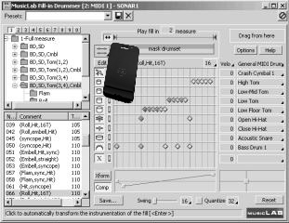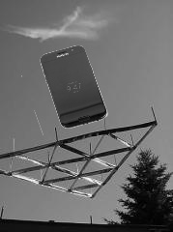
Running this command also generates a description file with information about where the cell phone is in each of the 128 images.

Modify the description file adding the folder name to the beginning of all lines:
Projects/TrainingHaarCascade/
(env) $ sed -i -e 's/^/sample-images\/001\//' sample-images/001/cropped-001.txt

If we had 15 pictures, running the previous steps on each of them would have produced 1920 pictures of cell phones floating in random places. What we have to do now is collect all of them into a single .vec file before we can run the training utility.

  - Creating vec file
Collect all 15 description files into one, by running this command:.

Projects/TrainingHaarCascade/
(env) $ cat sample-images/*/cropped-*.txt > positives.txt

Create the vec file:

Projects/TrainingHaarCascade/
(env) $ opencv_createsamples -info positives.txt -bg negatives.txt -vec cropped.vec -num 1920 -w 48 -h 48

This will create 1920 cropped images of the cell phone, where each is rotated slightly different, and with a different background. Like this, but thousands:
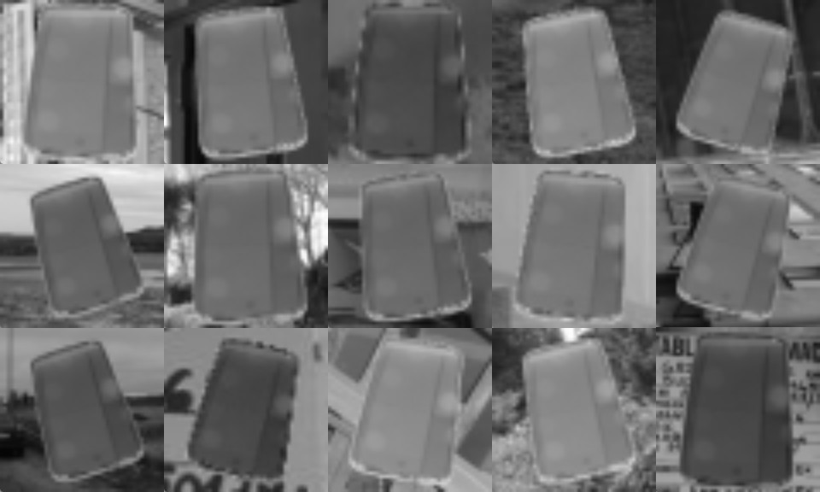

Actually the this files will not be created, instead the vec file is generated. You can see these pictures using the "-show" option.
- Train the cascade
Projects/TrainingHaarCascade/
(env) $ opencv_traincascade -data output-dir -vec cropped.vec -bg negatives.txt -numPos 1200 -numNeg 600 -numStages 20 -precalcValBufSize 1024 -precalcIdxBufSize 1024 -featureType HAAR -minHitRate 0.995 -maxFalseAlarmRate 0.5 -w 48 -h 48

PARAMETERS:
cascadeDirName: output-dir
vecFileName: cropped.vec
bgFileName: negatives.txt
numPos: 1500
numNeg: 600
numStages: 10
precalcValBufSize[Mb] : 1024
precalcIdxBufSize[Mb] : 1024
acceptanceRatioBreakValue : -1
stageType: BOOST
featureType: HAAR
sampleWidth: 48
sampleHeight: 48
boostType: GAB
minHitRate: 0.93
maxFalseAlarmRate: 0.7
weightTrimRate: 0.95
maxDepth: 1
maxWeakCount: 100
mode: BASIC
Number of unique features given windowSize [48,48] : 2570880
===== TRAINING 0-stage =====
<BEGIN
POS count : consumed 1500 : 1500
NEG count : acceptanceRatio 600 : 1
Precalculation time: 311
+----+---------+---------+
| N | HR | FA |
+----+---------+---------+
| 1| 0.996| 0.56|
+----+---------+---------+
END>
Training until now has taken 0 days 0 hours 30 minutes 36 seconds.
===== TRAINING 1-stage =====

