Test Automation Environment
- Preconditions
Before you start to setup your Jenkins you need a project which you want to build. In our case it is a Maven based Java project. The source code is committed to a Git server.
Besides the Java program we have automated “Junit” and “Functional” tests written in Java and automated front-end tests written in Robotframework. The automated cases are described in TestLink.
  - Generate a Maven based Java project
You can generate a new Maven project using the Maven’s archetype plugin
mvn archetype:generate
-DgroupId=projectId
-DartifactId=artifactId
-Dversion=version
-Dpackage=packageName
-DarchetypeArtifactId=maven-archetype-quickstart
-Dinteractivemode=false
  - File Hierarcy
.
├── pom.xml
├── src
│ ├── main
│ │ └── java
│ │ └── hu
│ │ └── akoel
│ │ └── app
│ │ └── App.java
│ └── test
│ └── java
│ └── hu
│ └── akoel
│ ├── junit
│ │ └── JUTest.java
│ └── functional
│ └── FUTest.java
└── target

  - Files
package hu.akoel.app
public class App{
public static void main( String[] args ){
System.out.println( "Hello Jenkins World!" );
}
}Java Test Codes
FUTest.java
package hu.akoel.functional;

import org.testng.Assert;
import org.testng.annotations.Test;

public class FUTest{

@Test
public void testFUTFalse() {
Assert.assertTrue(false);
}

@Test
public void testFUTTrue() {
Assert.assertTrue( true );
}
}
JUTest.java
package hu.akoel.junit;

import org.testng.Assert;
import org.testng.annotations.Test;

public class JUTest{

@Test
public void testJUTFalse() {
Assert.assertTrue(true);
}

@Test
public void testJUTTrue() {
Assert.assertTrue( true );
}
}

pom.xml
<project xmlns="http://maven.apache.org/POM/4.0.0" xmlns:xsi="http://www.w3.org/2001/XMLSchema-instance" xsi:schemaLocation="http://maven.apache.org/POM/4.0.0 http://maven.apache.org/maven-v4_0_0.xsd">
<properties>
<testfolder.under.test-java>junit</testfolder.under.test-java>
</properties>
<modelVersion>4.0.0</modelVersion>
<groupId>hu.akoel.test</groupId>
<artifactId>hu.akoel.test</artifactId>
<packaging>jar</packaging>
<version>1.0-SNAPSHOT</version>
<name>hu-akoel-test</name>
<url>http://maven.apache.org</url>
<build>
<plugins>
<plugin>
<groupId>org.apache.maven.plugins</groupId>
<artifactId>maven-surefire-plugin</artifactId>
<version>2.19.1</version>
<configuration>
<includes>
<include>**/${testfolder.under.test-java}/*.java</include>
</includes>
</configuration>
</plugin>
</plugins>
</build>
<dependencies>
<dependency>
<groupId>org.testng</groupId>
<artifactId>testng</artifactId>
<version>6.9.8</version>
<scope>test</scope>
</dependency>
</dependencies>
</project>
In this pom file we define a Maven plugin for running junit tests: maven-surefire-plugin. This plugin:goal will be invoked in the test phase as test:test.
We located our java tests into different folder make different between the test types (/junit for JUnit tests, /functional for Functional tests...) For running the test cases only under a specific folder we intorudece a parameter called testfolder.under.test-java. By default its value is junit. In the <configuration> section we define the path, where we want the tests run, using this parameter.
By default, when the testfolder.under.test-java parameter is not added to the mvn, the **/junit/*.java test files will be run. You can call the Maven with parameter like this:
mvn clean test -Dtestfolder.under.test-java=functional
In this case the **/functional/*.java files will be run.
If you want to run Integration tests in the integration-test phase the you should use the maven-failsafe-plugin.
Adding the testng plugin to the pom we are able to use testng annotations and codes in java and in the test phase the testng-result.xml file will be generated under the target/surefire-reports folder. The Testlink-plugin will use this in the Jenkins.
- Jenkins setup
  - Install/Upgrade Jenkins
    - Install
wget -q -O - https://pkg.jenkins.io/debian/jenkins-ci.org.key | sudo apt-key add -
sudo sh -c 'echo deb http://pkg.jenkins.io/debian-stable binary/ > /etc/apt/sources.list.d/jenkins.list'
sudo apt-get update
sudo apt-get install jenkins
    - Upgrade
sudo apt-get update
sudo apt-get install jenkins
  - Jenkins related values and paths
Default Port: 8282
Restart server: sudo /etc/init.d/jenkins restart
war file: /usr/share/jenkins/jenkins.war
Startup script: /etc/init.d/jenkins
Run with parameters: java -Xmx2500 -jar jenkins.war --httpPort=8282 --prefix=/jenkins
Config file: /etc/default/jenkins
/var/lib/jenkins/config.xml
Home dir: /var/lib/jenkins
Workspace: /var/lib/jenkins/workspace

  - Run Jenkins under different users
After the installation you have to define which user want you to run Jenkins. To do that you should modify the /etc/default/jenkins Configuration file setting the following variables:
JENKINS_USER= {desired_linux_user}
JENKINS_GROUP= {desired_linux_usergroup}
After this you should make the files accessable to this user so you should modify theirs owner.
chown -R {user}:{usergroup} /var/lib/jenkins
chown -R {user}:{usergroup} /var/cache/jenkins
chown -R {user}:{usergroup} /var/log/jenkins
sudo /etc/init.d/jenkins restart
  - Manage users
The standard Jenkins installation is not secured. Anybody can do anything. You should configure the securuty if you need it.
This example shows how to do this configuration not from the basic setup but from a general case when everything has been set but the administrator forgot his password.
    - Turn of the security
Go to the /var/lib/jenkins/config.xm configuration file and change the <useSecurity>true</useSecurity> to false and restart the Jenkins:
sudo service jenkins restart
    - Manage users
Get to the Jenkins’ Dashboard page. This time you do not have to (you cant) login.
Select Manage Jenkins > Manage Users menu. Here you can do anything with any users (delete/Change password/Create a new user...).
    - Set Security back
Get back to the Jenkins’ Dashboard page. On Dashboard select Manage Jenkins > Configure Global Security menu
Enable security Mark it
Access Control
Security Realm:
Jenkins own user database 
Allow user to sign up / Mark it on unmark it. It depends on you
Authorization:
Matrix-based security :
And now you should set the matrix.

- Create Basic Project
First of all we need a basic project in our Jenkins order to start our job. So login into the Jenkins and on the Main page select the “New Item” menu. Add the desired name to your project filling up the “Enter an Item Name” field and select the “Maven project” icon. Click on the “Ok” button on the bottom to create the new project and start to configure it.
  - General
Maven project name: Modify the name of your Maven project
Description: You can add any description to your project
Discard old builds: Mark this checkbox to delete old builds
Strategy: Select the “Log Rotation” strategy
Max # of builds to keep: Set it to 5 to keep the last 5 builds
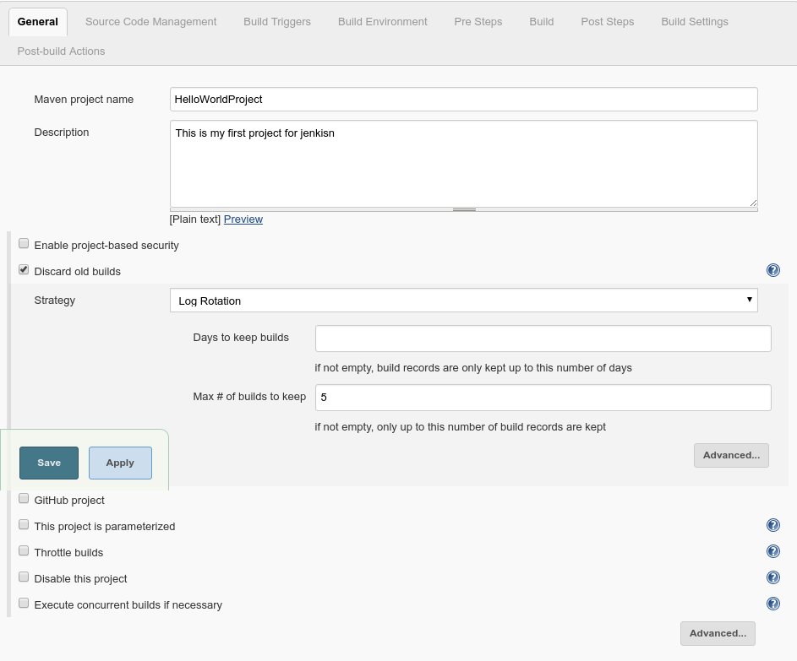
  - Source Code Management
Git: Mark this Radiobutton as we use Git VC
Repository URL: Give the URL of our project on the GitHub

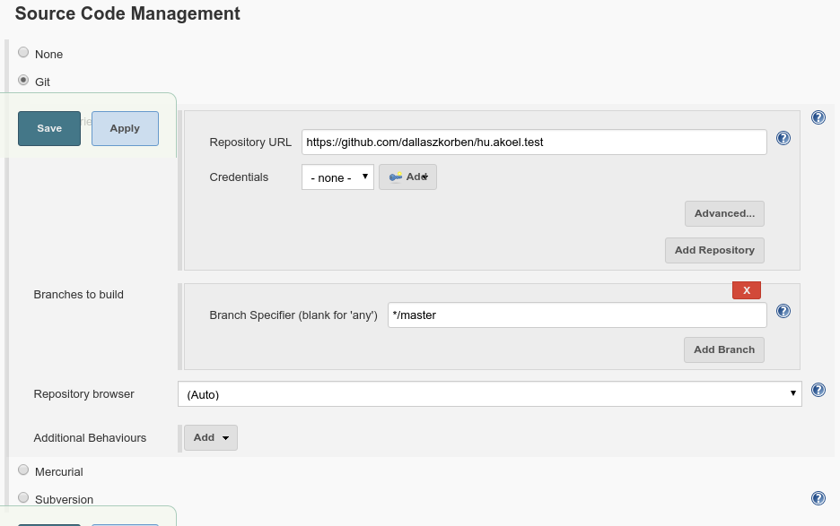
  - Build Triggers
Pol SCM: Mark this Checkbox to be able to set a Scheduler polling (checks if there was changes in the SCM)
Schedule: * * * * *
This means every minute
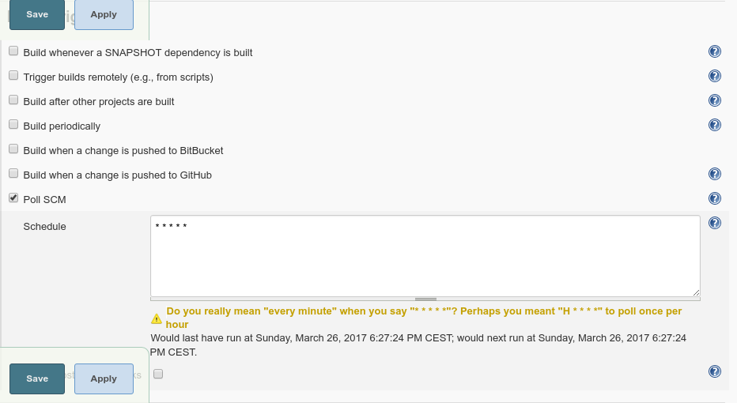

  - Build Environment
  - Pre Steps
  - Build
Root POM: pom.xml
Goals and options: verify
Advanced...MAVEN_OPTS -Dmaven.test.failure.ignore=false
If you want your build to be Failed when the Unit Tests (under the test folder) fail. Otherwise the build will Pass if the Test Fails (and every thing was OK)
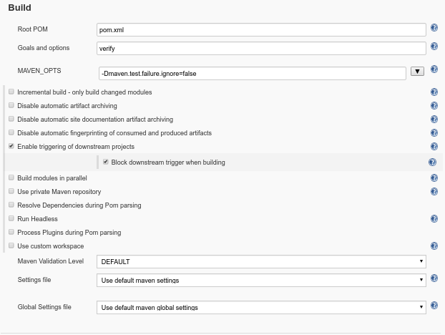
  - Post Steps
  - Build Settings
  - Post Build Actions
  - Make Build
Now you can run the project manually, clicking on the icon or you can trigger it by changing the code and pushing the changes into the remote repository in Git.
On the Jenkins’s Project page you can see the graph of the Junit test’s result:
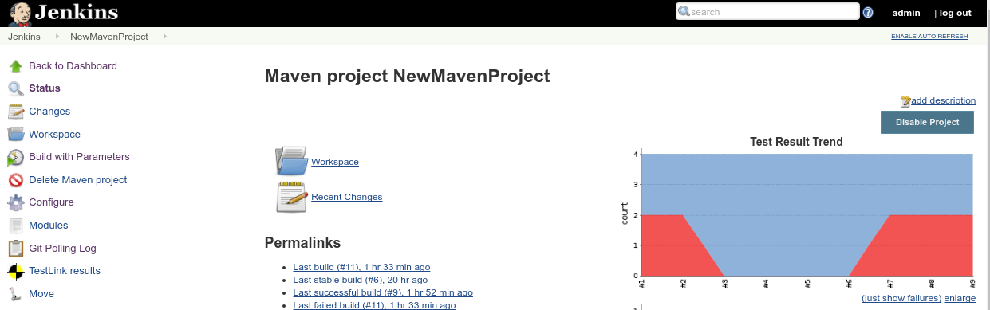

- Add parameter to the project on the GUI to control the running of junit tests
The parameters are available as environment variables. For example shell ($FOO) or Ant (${env.FOO}) can access these values.
In this example configure the Jenkins to ask for a drop-down parameter before we run the job. The possible choices are:
junit This value will be shown in the log in the Pre Step phase
And this value will be a parameter of Maven showing that only the test files in the /functional folder should be run.
functional This value will be shown in the log in the Pre Step phase
And this value will be a parameter of Maven showing that only the test files in the /functional folder shuld be run.
regression This choices will FAIL the build in the Pre Step regardless of any other conditions.
You can configure it modifying the project’s Configuration:
  - General Section
This project parameterized
Mark this Checkbox
Add Parameter: Choice Paramter
You can choose a type of parameter from this list:
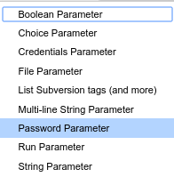
Name: TEST_TO_RUN
Set the name of the parameter
Choices: junit
functional
regression
The mentioned lines will be the elements of the drop-down. The first element will be the Default value
Description The Description will appear under the parameter (drop-down) on the Build with Parameter page just above the Build button

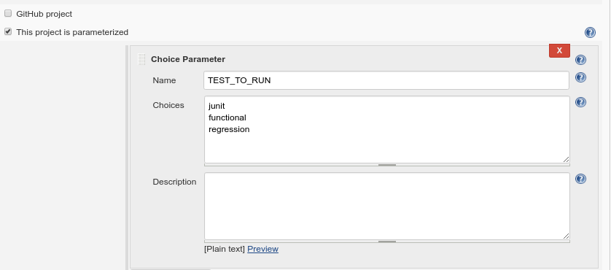

  - Pre Steps / Post Steps
Add pre-build step Click on this button and select the “Execute shell” element in the appearing menu.
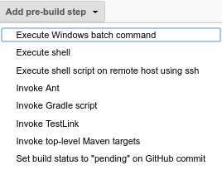
Command: Here you can add any Shell command using the Parameters as Environment Variables
Besides the Parameters there are lot of predefined Environment Variables. You can have the list of them clicking on the “See the list of available environment variable” link under the “Command” field
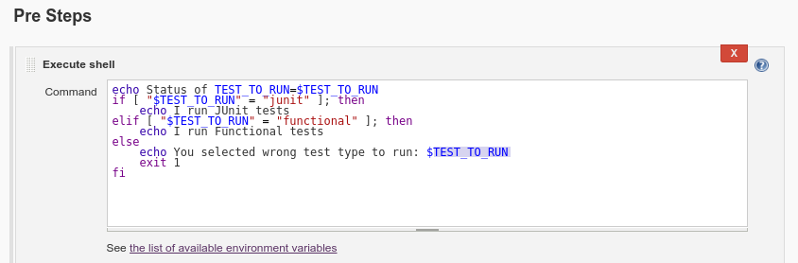
  - Build
Change the “Goal and options” adding the chosen parameter to Maven to be able to control which folder we want to run, containing java test files.
Goals and options: clean test -Dtestfolder.under.test-java=$TEST_TO_RUN

  - Trigger a Build
No you can trigger the build by changing the code and pushing the changes into the remote repository in Git. In this case the Parameter will have the default value
Or you can run the project manually, clicking on the icon. In this case you can select the desired parameter from the drop-down.
In our example we select “functional”.
Build with Paramters
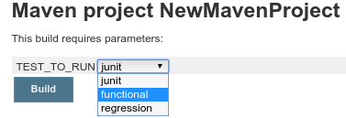
Log
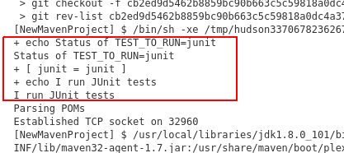
Test Result Trend
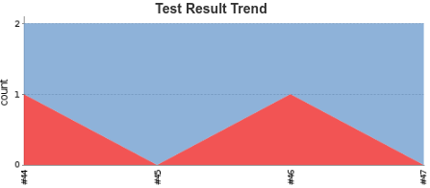

- Handle TestLink test cases
Lets say that you want to keep track of your Junit tests. So you want to see the result of the Junit test executions on the TestLink and you want to see a graphical presentation of the failed/passed/blocked/skiped test cases in timeline.
  - TestLink Configuration
    - Generate the API key in TestLink
In the TestLink Click on the MySettings icon on the top and in the API interface section click on the Generate a new key button to generat the key.
Later you will use this key in the Jenkins.
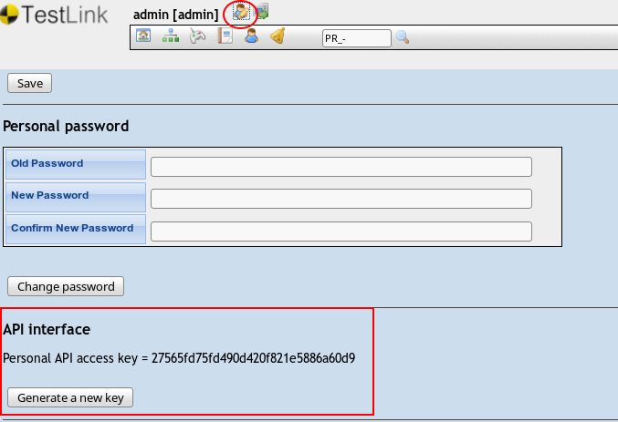
    - Create Custom field
For executing Junit tests automatically it is necessary to create a Custom Field for the Test Cases where you can place the fully qualified name of the Test Java methods. The TestLink plugin in the Jenkins will identify the test cases by this field.
You can reach the link to the Define Custom Field function from the Desktop in the System block.
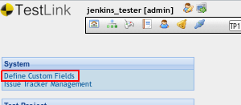
Name script
Choose any name for the Custom Field. You can refer to the Custom Field by this name
Label script
This string will appear on the Test Cases in the TestLink
Available for Test Case
Type String
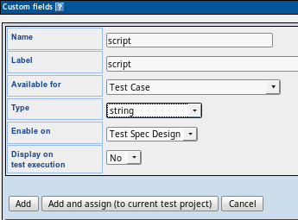
    - Define Test Project
To create Test Cases you need to have at least one Test Project. You will put your test cases into a specific Test Project
You can reach the link to the Test Project Management function from the Desktop in the Test Project block.
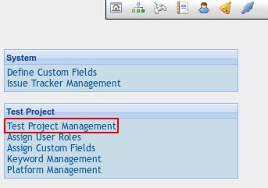
On the Test Project Management page Click on the Create button to get to the page where you can Define the Test Project:
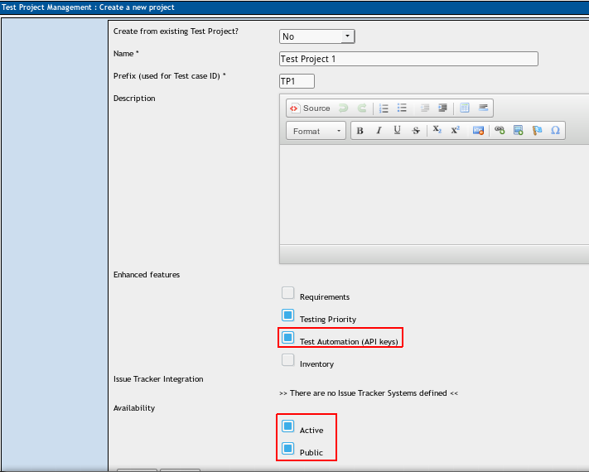
Name: Test Project 1
Choose any name for your Test Project. Later you can refer to this Project by the Name
Prefix: TP1
You can Choose any string for the Prefix
Test Automation (API keys):
Active
Public

    - Define Test Plan
To be able to execute Test Cases in the TestLink you need to have at least one Test Plan. You can assigne your Test Cases to one ore more Test Plan (In a specific Test Project).
Practically you fill up Test Result pages assigned to a Build in a Test Plan wen you execute Test Cases.
In case of automation we do not create the Build, because Jenkins will generate it in every run, but we have to create the Test Plan at least, were we going to assigne the Test Cases to, which we want to be run in the Jenkins build (they will run anyway but without the right assignments the result will not be registered in the TestLink).
You can reach the link to the Test Plan Management function from the Desktop in the Test Plan block. Before that you should select the desired Test Project from the drop-down on the top 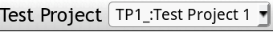.
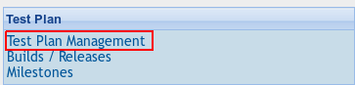
On the Test Plan Management page Click on the Create button to get to the page where you can Define the Test Plan:
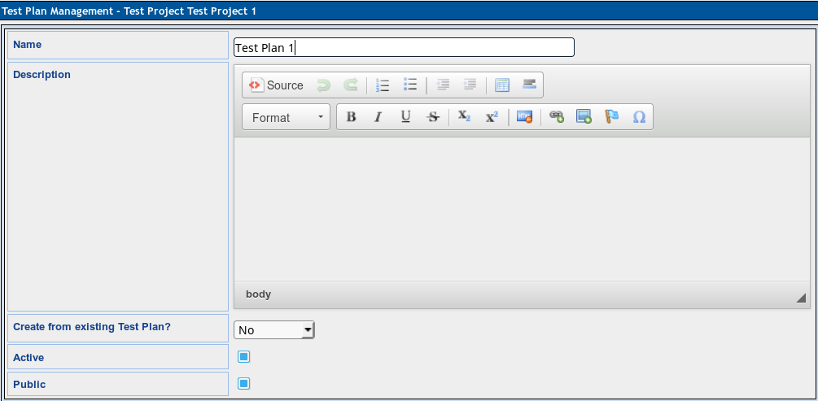
Name: Test Plan 1
Choose any name for your Test Plan. Later you can refer to this Plan by the Name
Active:
Public:
    - Create Test Cases
select the desired project from the Test Project dropdown
click on the Test Specification icon in the Toolbar on the top.
In the appearing Test Specification Navigator you can add your test suits and test cases inserting them in the the Test Project hierarchy.
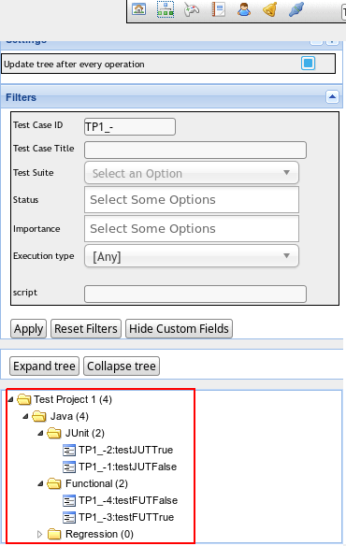
Name: testJUTTrue
You can choose any name for the Test Case
Summary: You can add any additional information
Precondition: You can add any additional information
Execution type: Automated
script: hu.akoel.junit.JUTest#testJUTTrue
It must be a fully qualified method name. The Method name should be separated from the Class name by # (NOT .)
Test Plan: Test Plan 1
You have to add the Test Case to a Test Plan
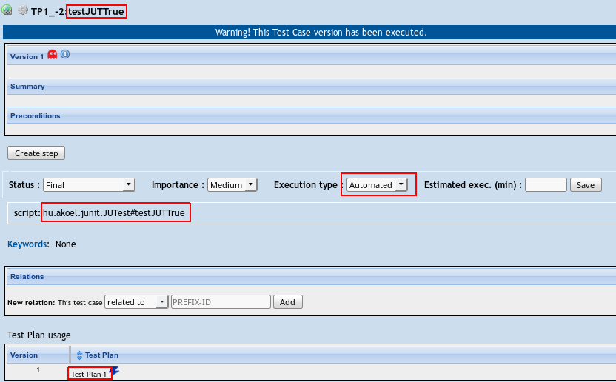

  - Jenkins General Configuration
    - Install TestLink Plug-In
The plug-ins in Jenkins are distributed from a central update site. Select the option Manage Jenkins in the leftmenu and look for the Manage Plugins option.
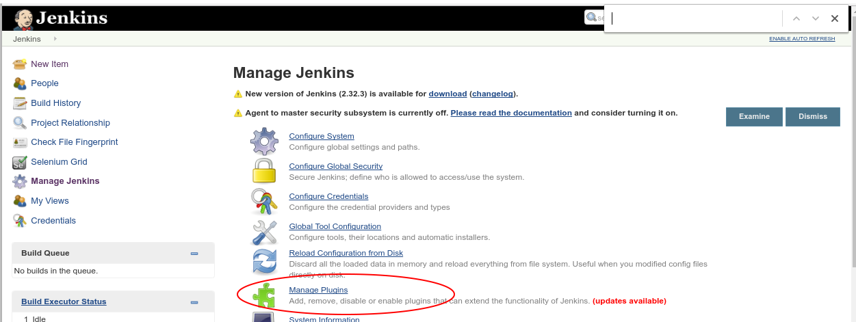
Clicking on Available will bring you the list of plug-ins readyto be installed in your Jenkins installation. Just check the check box besides the plug-in name on the list and click on Install to install the plug-in. Jenkins will download and install the plug-in automatically for you. Restart Jenkins to enable your plug-in.
Restart Jenkins: <jenkins_URL>/restart or <jenkins_URL>/safeRestart
    - Configure TestLink Plug-In
After restarting Jenkins, go to Manage Jenkins again, this time click on Configure System option and look for the TestLink section. Fill the TestLink configuration form.
Name: Run Automated Test Link
Name your TestLink installation
URL: http://localhost/testlink/lib/api/xmlrpc/v1/xmlrpc.php
URLof the XML-RPC API
Developer Key: Copy the Generated API Key from TestLink here
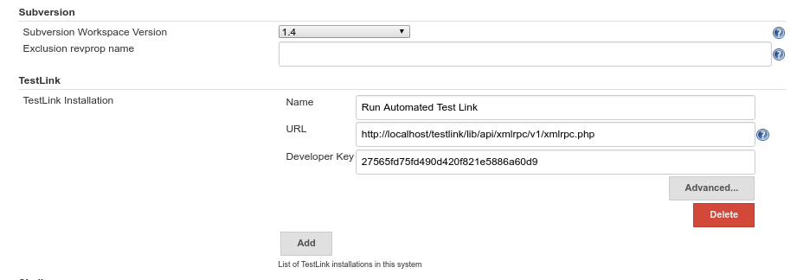
The plug-ins in Jenkins are distributed from a central update site. Select the option Manage

  - Jenkins Project Configuration I-JunitTest.
On the Post Step section Select Run only if build succeeds radio button
Click on the Add post-build step drop-down and select the Invoke TestLink elment. This is one solution. There is an another which will be presented soon.
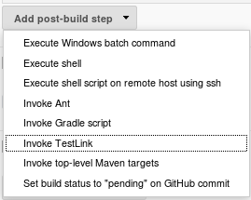
3 sub-section will appear in the Invoke TestLink block: TestLink Configuration, Test Execution, Result Seeking Strategy.
    - TestLink Configuration
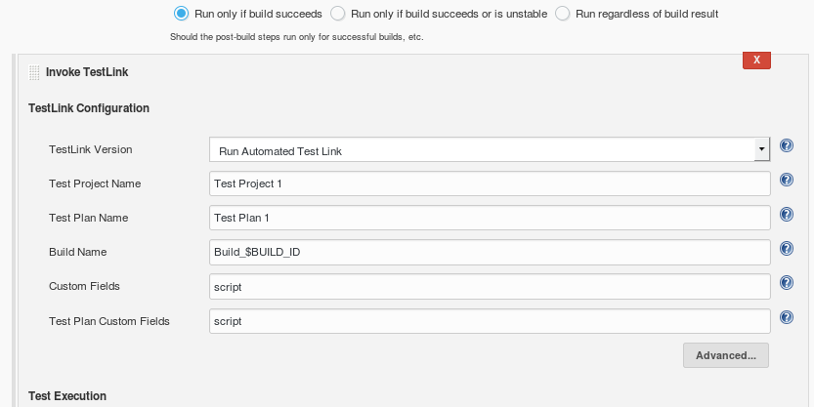
TestLink version: Run Automated Test Link
Select the TestLink installation name from the drop-down (defined in the Configure System)
Test Project name: Test Project 1
Add the name of the Test Project keeping your Test Cases in the TestLink
Test Plan name: Test Plan 1
Add the name of the Test Plan keeping your Test Cases in the TestLink
Build name: Build_$BUILD_ID
Define the name of the automatically generated Build in TestLink. You can use Jenkins variables as $BUILD_ID
Custom field: script
?
Test Plan Custom Field: script
?
    - Test Execution
Clicking on Add action drop-down under the TestExecution sub-section and select the Publish JUnit test result report element
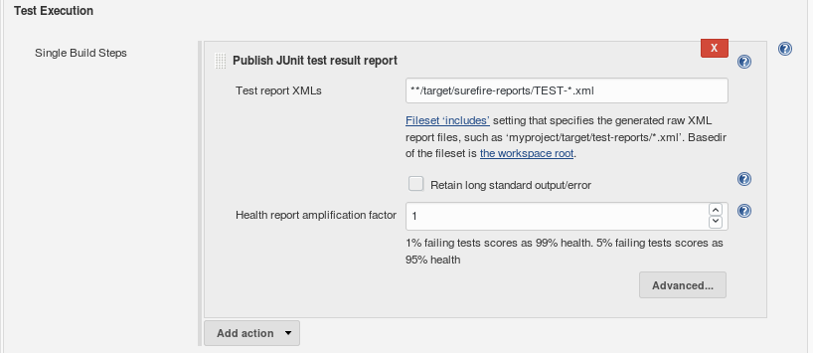
Test report XMLs: target/surefire-reports/TEST-*.xml
The Jenkins project’s work directory is /var/lib/jenkins/workspace/{Jenkins_Project_Name}
In this folder you can find the target/surefire-reports folder.
The Maven will generate junit xml file, containing the result of the Junit tests, using the surefire plugin. You have to provide this xml file name in this field.
Healt report amlificator factor: 1
    - Result Seeking Strategy
Clicking on Add strategy drop-down under the Result Seeking Strategy sub-section and select the JUnit method name element
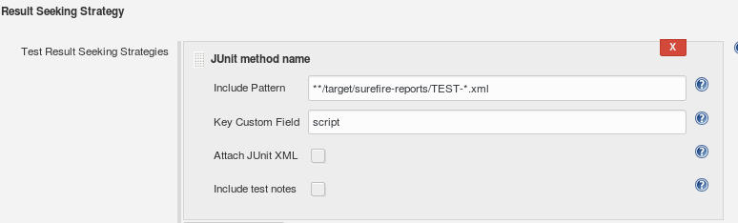
Include Pattern: target/surefire-reports/TEST-*.xml
The name and the path of the generated junit xml file.
Key Custom Field: script
This Custom Field contains the Fully qualified Java Junit Test method names, in TestLink, which you want to run.

  - Jenkins Project Configuration II-TestNG.
Now we create a Freestyle project instead of Maven project. Fill up the General, Source Code Management, Build Triggers sections.
On the Build section Click on the Add build step drop-down and select the Invoke TestLink elment.
    - TestLink Configuration
TestLink version: Run Automated Test Link
Select the TestLink installation name from the drop-down (defined in the Configure System)
Test Project name: Test Project 1
Add the name of the Test Project keeping your Test Cases in the TestLink
Test Plan name: Test Plan 1
Add the name of the Test Plan keeping your Test Cases in the TestLink
Build name: BuildNew_$BUILD_ID
Define the name of the automatically generated Build in TestLink. You can use Jenkins variables as $BUILD_ID
Custom field: script?
Test Plan Custom Field: script?
    - Test Execution
Clicking on Add action drop-down under the TestExecution sub-section and select the Invoke top-level Maven targets element
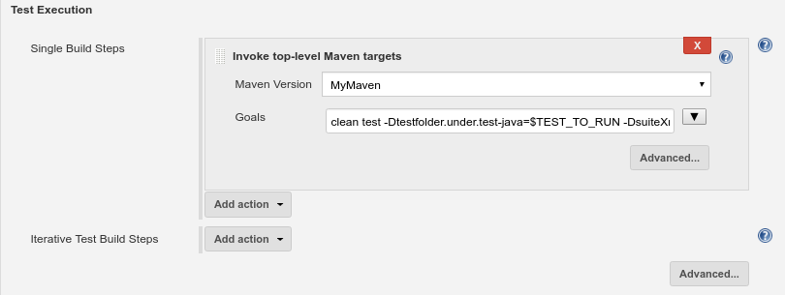
Maven verson: MyMaven
Goals: clean test -Dtestfolder.under.test-java=$TEST_TO_RUN
    - Result Seeking Strategy
Clicking on Add strategy drop-down under the Result Seeking Strategy sub-section and select the TestNG method name element
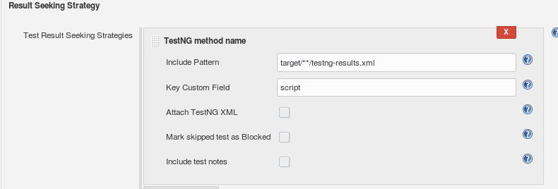
Include Pattern: target/**/testng-result.xml
Key Custom Field: script
This Custom Field contains the Fully qualified Java Junit Test method names, in TestLink, which you want to run.

  - Trigger a Build
After you build the Jenkins Project you get this graph on the Jenkins page. It is similar to the builtin “Test Result Trend” graph.

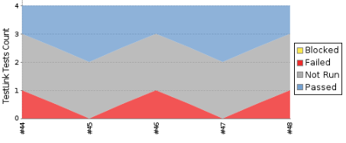

But the point is that the result is pushed into the TestLink
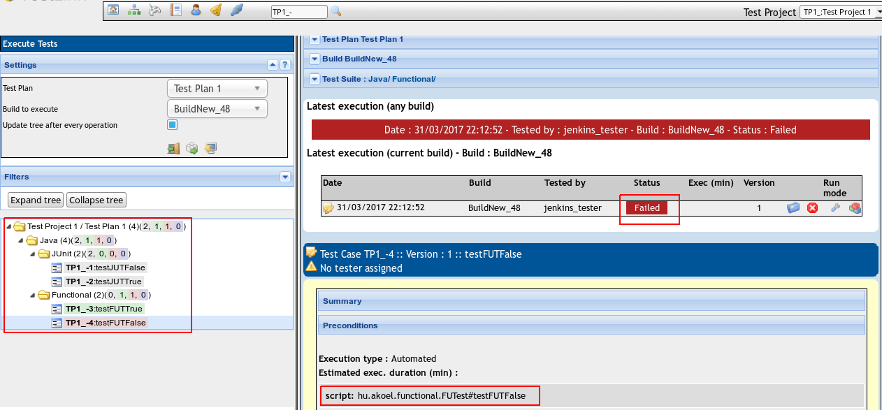
- Pipeline
You can build up your own build sequence piece by piece using groovy script. The following example is not a real-life case but it can show the basics of the pipelineing.
First of all select the “New Item” menu on the Dashboard. Add the desired name to your project filling up the “Enter an Item Name” field and select the “Pipeline” icon. Click on the “Ok” button on the bottom to create the new project and start to configure it.
  - General
Maven project name: Modify the name of your Maven project
Description: You can add any description to your project
Discard old builds: Mark this checkbox to delete old builds
Strategy: Select the “Log Rotation” strategy
Max # of builds to keep: Set it to 5 to keep the last 5 builds
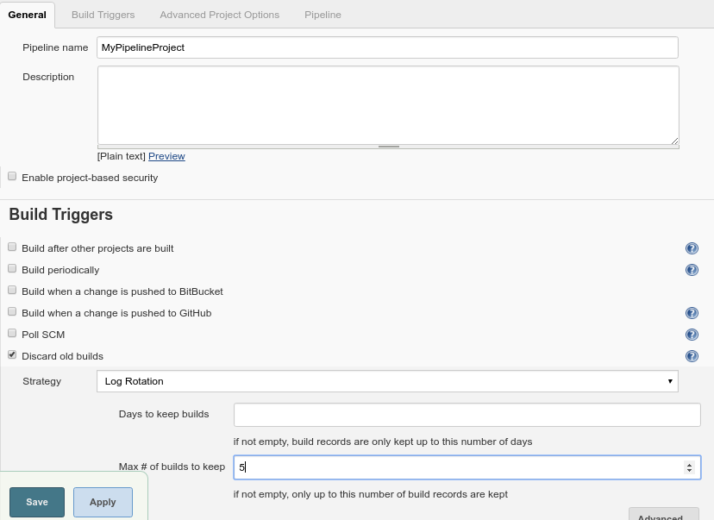
  - Pipeline
Definition Pipeline script
Script You can write your script here defining the pipeline.
The pipeline is built up by “stages”. You can create separated stages using the stage keyword followed by the name of the stage. The stages will appear as a boxes next to each other in one line on the project’s page.
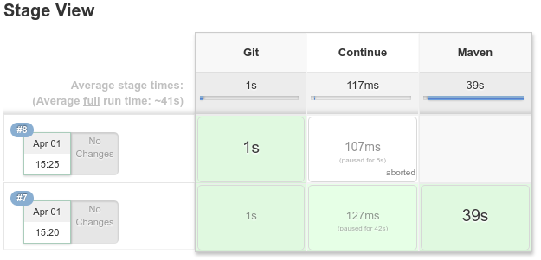
Under the “stage <name>” line you can write your code doing what ever you want the stage to do. For example you can echo any message to the log, pull git, check if a file exists or not, wait interactively, run Shell script, sleep, run an existing project...) 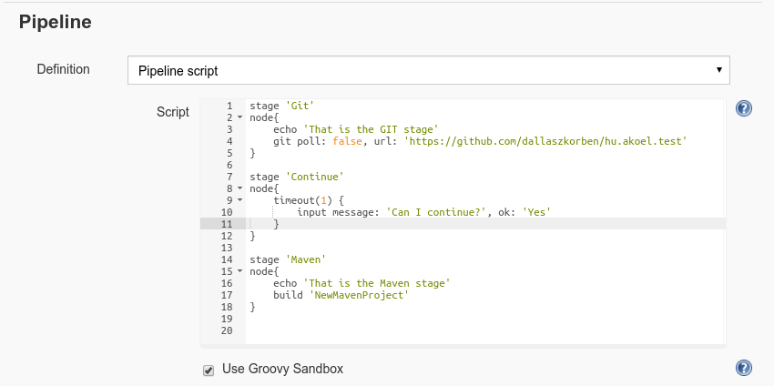
We use the following process. In the first stage we pull git.
In the second stage we are waiting for a user’s respond. When the user hover the mouse over the stage box, a window appears asking if you want to continue or abort. If there is no response for a minute then it abort the build anyway.
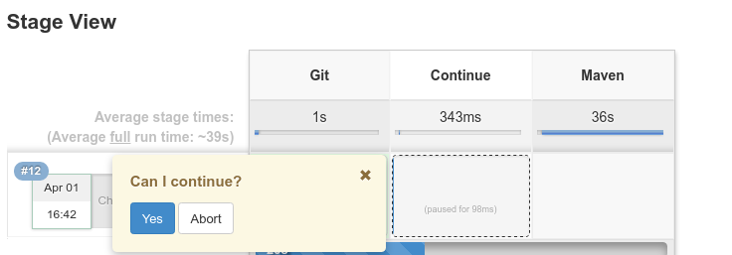
If the user clicks on the “Ok” button then next stage comes, which is invoking the “NewMavenProject” project. Here is the log about this part:
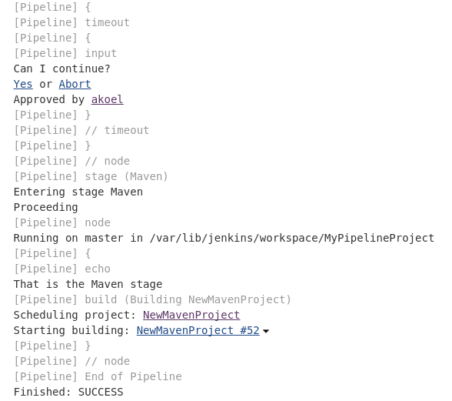
You can see that after the Approval the “MyMavenProject” starts. This log does not contains the MyMavenProject’s log. To check it you have to click on the link to it.

- Distributed build
You can run the build on an othet machine than the machine where the Jenkins runs. That machine is called “slave” node. To do that you need access to the “slave” machine, for example through ssh.
  - Define the new node
First of all login then select the “Manage Jenkins” > “Manage Nodes” > “New Node” menu from the Dashboard.
Node name: Chose any name for your node
Permanent Agent: 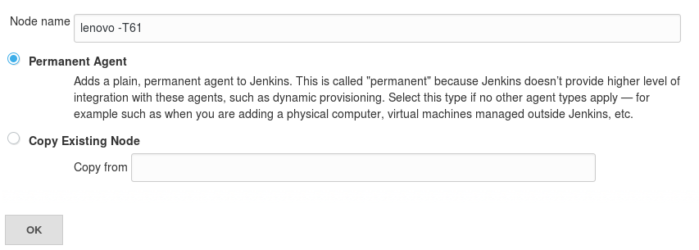
The next page appears:
Name: You can keep the Node name what you chose before
Description:: You can add a description to the node
# of executors: 1
The maximum number of concurent builds
Remote root directory: /home/akoel/jenkins-slave
the path (use absolute path instead of relative) on the slave machine to the workspace.
Labels: linux-group
Labels (or tags) are used to group multiple agents into one logical group.
Usage: Use this node as much as possible
Launch methode: Launch save agents on Unix machines via SSH
Host: 192.168.0.12
The IP of the Slave
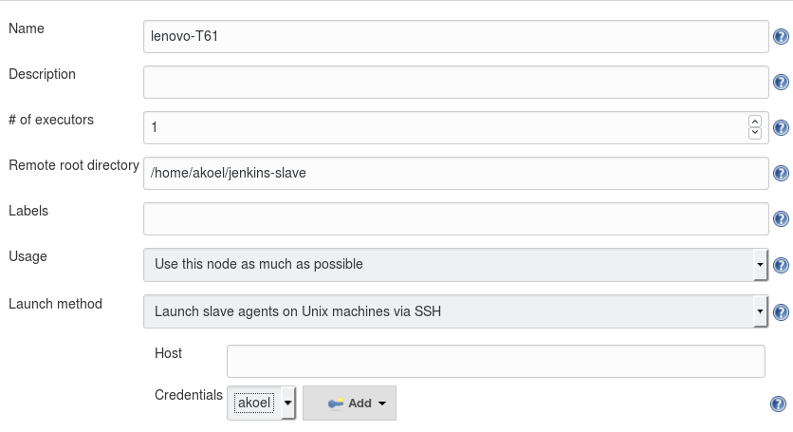
Click on the Add > Jenkins button. The Credentials Provider modal window appears:
Domain: Global credentials
Kind: SSH Username with private key
Username: akoel
the user name on the Slave side where the Jenkins can connect to
Private Key: Enter directly
Key: The private key of the user (akoel) who whant to login with to the Slave
Passphrase: The user’s passphrase to the Slave machine
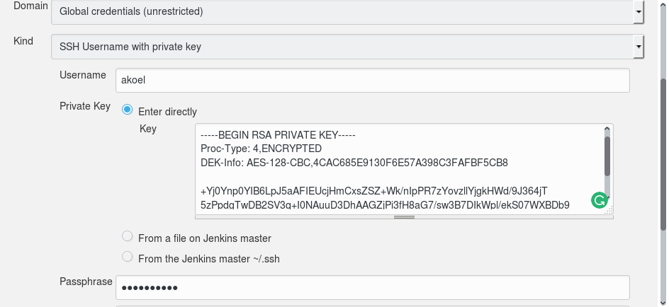
  - Assigne the node to a Jenkins project
Now you go to any project which you want to build on the “Slave” machine (instead of the “Master”) and click on the Configure button to modify it.
In the General tab search for the Restrict where this project can be run entry.
Restrict where this project can be run:
Label Expression: linux-group
You can name the node you wish or the group of the nodes (label)
  - Trigger a Build
Now if trigger the build on the project with the distributed build, it will run on the Slave machine. You can check the content of the “Remote root directory”. It will change.
Even you can check the Jenkins log:
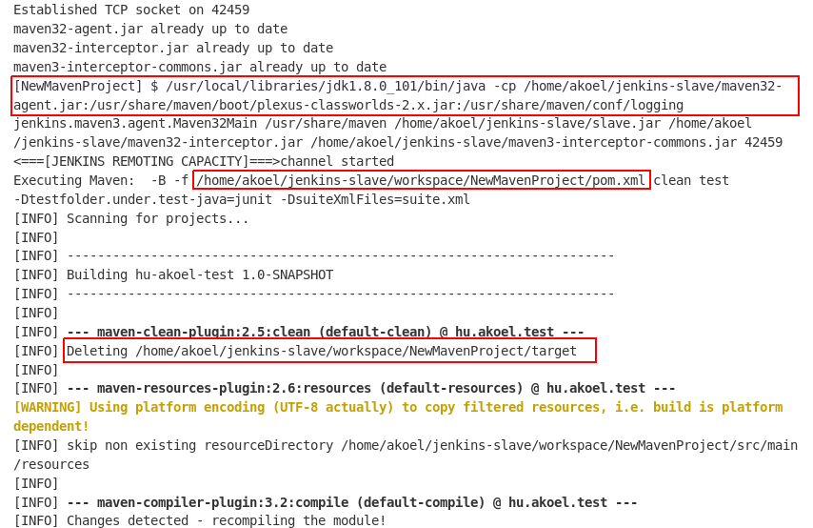
It shows that the build and test runs on the Slave machine.

- Robotframework
Let’s say that your project has some front-end related development so you need some front-end test as well. You chose Robotframework for testing so you had to install it first.
  - Robotframework source
front-end.robot’s path
.
├── pom.xml
├── src
│ ├── main
│ └── test
│ ├── java
│ └── robotframework
│ └── functional
│ └── front-end.robot
front-end.robot’s path
*** settings ***
Library Selenium2Library
*** Test Cases ***
testFE-01-Fail
[Tags] nobrowser fail integration
Log Log: testIT-01-Fail
fail Message: testIT-01-Faile
testFE-02-Pass
[Tags] browser pass integration
Log Message: testIT-02-Pass
Open Browser https://www.cs.tut.fi/~jkorpela/www/testel.html chrome
sleep 10s
Close Browser
  - TestLink
Add extra test cases to the TestLink, map them to the corresponding Robot test cases and add them to the Test plan.
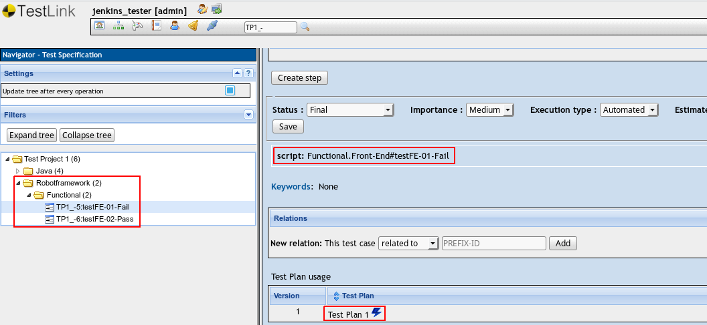
script: Functional.Front-End#testFE-01-Fail
The first part is the robotframework file with the path, the second part is the Keyword, separated by #.
You can get these data from the console after you run the Robotframework:

akoel@akoel-lenovo:~/Projects/java/test/hu.akoel.test/hu.akoel.test$ /usr/local/bin/pybot -
x rfjunit.xml src/test/robotframework/functional
==============================================================================
Functional
==============================================================================
Functional.Front-End
==============================================================================
testFE-01-Fail | FAIL |
Message: testIT-01-Faile
------------------------------------------------------------------------------
testFE-02-Pass | PASS |
  - Jenkins
    - Execute shell
In the Post Step section add a new “Execute shell” step clicking on the “Add post-build step”
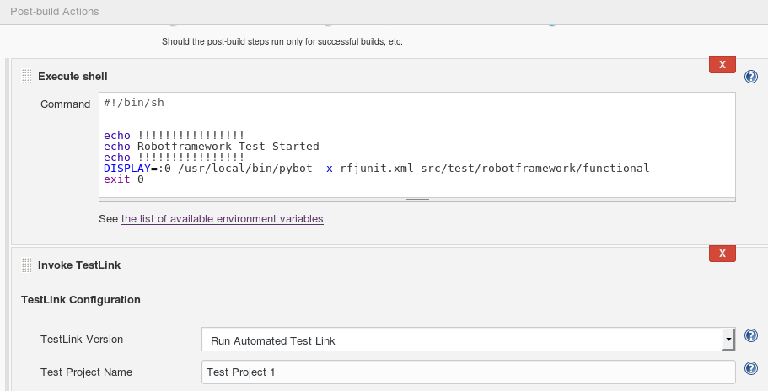
In the command field you can write your shell script where you can run the appropriate test case.
There are four important things:
-The script must start with #!/bin/sh
-The script must return 0 (exit 0)
-The DISPLAY should be added to the pybot
-The -x swich should be used when the pybot is called so that the xUnit compatible result file could be generated (rfjunit.xml)
#!/bin/sh
echo !!!!!!!!!!!!!!!!
echo Robotframework Test Started
echo !!!!!!!!!!!!!!!!
DISPLAY=:0 /usr/local/bin/pybot -x rfjunit.xml src/test/robotframework/functional
exit 0
    - Test Result Seeking Strategy
You should add a new “JUnit method name” Result Seeking Strategy clicking on the “Add strategy” button
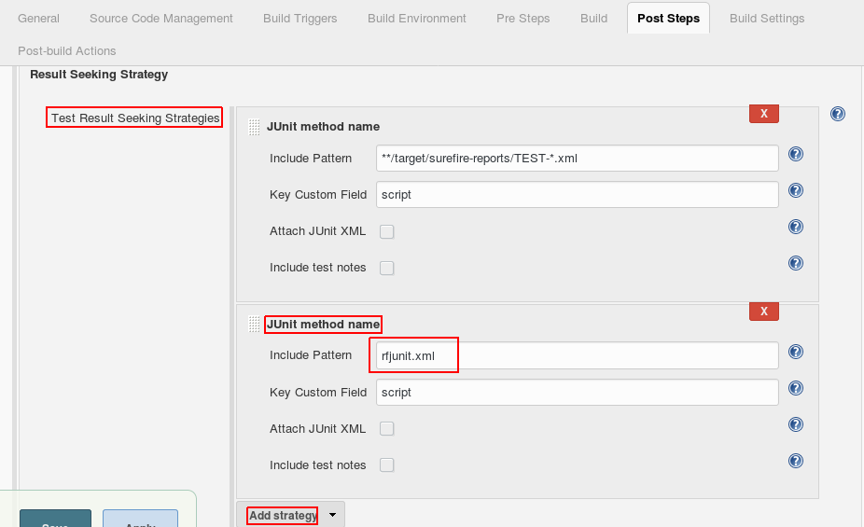
Include Pattern rfjunit.xml
The generated (by pybot) xUnit compatible result file
Key Custom Field script
This field contains the custom field in TestLink, in which the Robotframework Keyword is mapped.
  - Trigger a Build
Now after you trigger the build on the project, after the build, the Robotframework test starts. The browsers open on the same display where the Jenkins run.
After the Robotframework run finished the result will be registered in the TestLink.
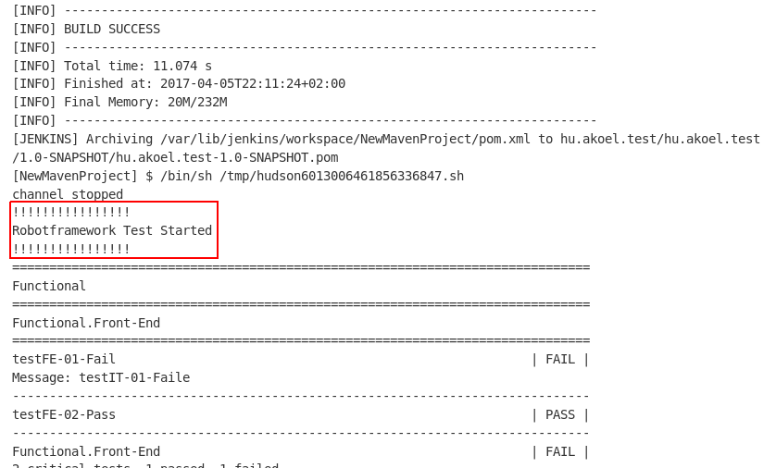
- Robotframework on virtual display
Let’s say that you want to run the Robotframework test cases in the same machine where the Jenkins run but you do not want to be disturbed the active display so you want it to run in a virtual display. For that you should modify the Shell script:
#!/bin/sh

echo !!!!!!!!!!!!!!!!
echo Robotframework Test Started
echo !!!!!!!!!!!!!!!!

Xvfb :99 &
fluxbox -display :99 &

DISPLAY=:99 /usr/local/bin/pybot -x rfjunit.xml src/test/robotframework/functional 2>/dev/null

killall fluxbox
killall Xvfb

exit 0
Xvfb X11 display server, performs all graphical operations in virtual memory without showing any screen output. This virtual server does not require the computer it is running on to have any kind of graphics adapter. Only network layer is necessary.
Fluxbox Lightweight window manager for the X Window System.
- Robotframework on the Server machine
Let’s say that you want to run the Robotframework test cases in the Slave machine. To do that you should
-follow the description on “7. Distributed build”
-Install the Robotframework on the Slave machine
-Place the chrome driver on the Slave machine and its path shold be in the PATH environment variable

- Robotframework on mobile device
Appium is a client/server architecture.
Client is used to run the test cases.
Server is used to run the Appium Server.
The mobile devices or the emulators are required to run the tests against the app which we are testing.
Client & Server mentioned above could be 2 different hosts or can be a same host.
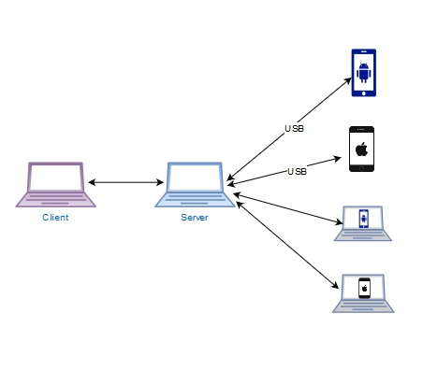
  - Client Setup
Client is basically used to run the test cases. Tests can be written using any WebDriver-compatible language such as Java, Objective-C, JavaScript, Ruby, Python, PHP & RobotFramework.
    - Install Robotframework
sudo apt-get update
sudo apt-get install python
sudo apt-get install wxgtk2.8
sudo apt-get install python-pip
sudo -H pip install --upgrade pip #upgrade it – it is necessary
sudo -H pip install robotframework-selenium2library
sudo -H pip install robotframework
sudo -H pip install robotframework-ride

#uninstall a library
#sudo -H pip uninstall robotframework-selenium2library

    - Install Appium Client library
sudo pip install robotframework-appiumlibrary
  - Server Setup
With the server setup, the main step is the installation of Appium. For testing the app, the server needs to be directly connected to the mobile devices as shown in the diagram or simulators need to be run. We need vendor specific SDKs to run simulators.
Please note IOS SDK can be run only on OSX, whereas Android SDK can be installed OSX / Windows / Linux.
    - Install Java JDK
After the installation set the PATH
echo 'export JAVA_HOME=/path_to_jdk_folder' >> ~/.bashrc
    - Instal node with npm without having sudo
As I understand the sudo apt-get install node.js is not good for that, so if you have already had it then uninstall it.
The other important thing is that some softwares are not implemented to 32 bit OS. In that case you should follow the below method instead of the official solution which uses the brew.
echo 'export PATH=$HOME/local/bin:$PATH' >> ~/.bashrc
. ~/.bashrc
mkdir ~/local
mkdir ~/node-latest-install
cd ~/node-latest-install
curl http://nodejs.org/dist/node-latest.tar.gz | tar xz --strip-components=1
./configure --prefix=~/local
make install # It takes about 1 hour
curl https://www.npmjs.org/install.sh | sh
    - Install Appium Server
Appium is an open source test automation framework for use with native, hybrid and mobile web. People familiar with Selenium, appium is the selenium for mobile apps.
npm install -g appium
At the end you get a message: “Not installing WinAppDriver since did not detect a Windows system” but do not worry about it.
npm install wd
    - Run appium
appium
    - Check if appium server is up & running
~$ netstat -an |grep 4723
    - Install Android SDK
-Install Android Studio
-Run Android Studio
-Start SDK manager
-In SDK manager select Appearance&Behaiviour > System Setting > Android SDK
-In the Android SDK Location you can install Android SDK
The problem is that automatically a 64 bit version will be installed. In a 32 bit environment when you run adb devices you get an error message: cannot execute binary file: Exec format error. To fix it you have to install the 32 bit version:
sudo add-apt-repository ppa:nilarimogard/webupd8
sudo apt-get update
sudo apt-get install android-tools-adb android-tools-fastboot
after this, Replace the copy of 'adb' and 'fastboot' provided by the official Android SDK with those installed from the above step:
cp /usr/bin/adb <path-to-your-adt-sdk-package>/sdk/platform-tools/adb
cp /usr/bin/fastboot <path-to-your-adt-sdk-package>/sdk/platform-tools/fastboot
( <path-to-your-adt-sdk-package> = /usr/local/libraries/android )
    - Set $PATH to Android SDK
Add the correct path of Android SDK.
~/.bashrc
ANDROID_HOME=/usr/local/libraries/android/sdk
export PATH=”$PATH:$ANDROID_HOME/tools:$ANDROID_HOME/platform-tools”
export ANDROID_HOME
    - Test if the mobile device is connected
Enable the USB debuging in the Android phon:. Settings > Developer options > USB debugging.
Connect the mobile to the machine. On the phone Authorize the connection clicking on the OK button.
~$ adb devices
List of devices attached
LGD320b45fd065 device
    - Check the app packages installed on the mobile device
~$ adb shell pm list packages -f
package:/system/app/com.lge.shutdownmonitor.apk=com.lge.shutdownmonitor
package:/system/app/TimeService.apk=com.qualcomm.timeservice
package:/system/app/atfwd.apk=com.qualcomm.atfwd
...

    - Run the simple test on Android
Now as the appium is running the Android mobile is connected to the server, the Robotframework and AppiumLibrary is installed you can run your simple test on your mobile.
The test case Opens the Chrome browser, Goes to the google.com page, searches for the “appium” word and clicks on the first hit, then waits 10 seconds and Closes the browser. Here s the Robotframework test case which you can run with pybot command.
*** Settings ***
Documentation demo for appium library
Force Tags demo
Library AppiumLibrary

*** Variables ***

*** Test Cases ***
Open-Close App
Open Application http://localhost:4723/wd/hub platformName=Android platformVersion=4.4.2 deviceName=LGD320b45fd065 browserName=Chrome
Go To Url http://www.google.com
sleep 10s
Wait Until Page Contains Element //input[@id='lst-ib']
Input Text //input[@id='lst-ib'] appium
#Search button
Click Element //button[@class='lsbb']
#Select the first element
Click Element //div[@id='rso']/div[1]//h3/a[contains(@class,'wSg')]
sleep 10s
[Teardown] Close Application
Open Application - Opening a browser:
platformName: Android
platformVersion: 4.4.2
you can get this value by running the following command:
adb shell getprop | grep build.version.release
deviceName: LGD320b45fd065
you can get this value by running the following command:
adb devices
browserName: Chrome

Open Application - Opening an application:
platformName: Android
platformVersion: 4.4.2
deviceName: LGD320b45fd065
you can get this value by running the following command:
adb devices
app: app=com.android.chrome
you can get this value by running the following command (after the = sign):
adb shell pm list packages -f
appPackage: com.android.chrome
You can get the installed packages by running the following command:
adb shell pm list packages -f
appActivity: com.google.android.apps.chrome.Main
To get the list of the activities install the “APK info” app from the play store and run it.

