Selenium architecture
- How the Selenium works
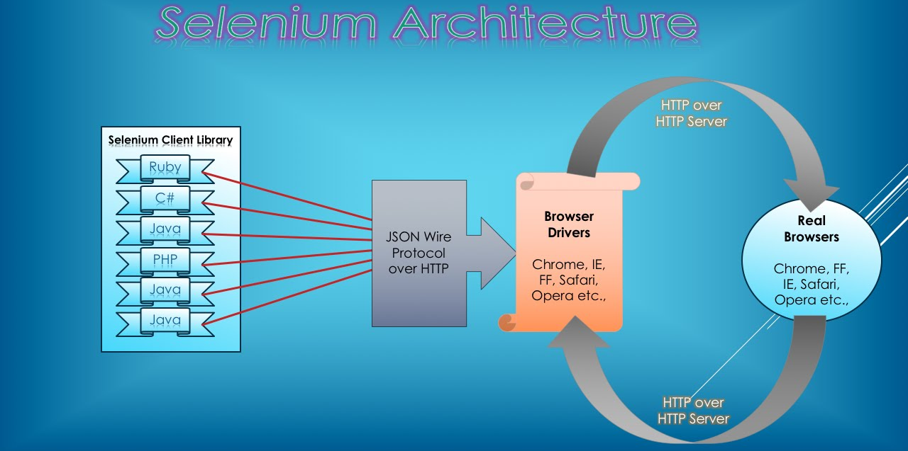$

The Selenium architecture consists of 4 parts:
- Selenium Client Library. This part is depends on the programming language what you want to use for the automation. Selenium supports multiple libraries such as Java, Ruby, Python, etc. It translate the code to a JSON request.
- JSON Wire Protocol is a rest-based web service. By default it listens on the 4444 port. When you download the Selenium Server Standalone from the Selenium page you get the Client and the Server in one package. For example in the selenium-server-standalone.jar
- Browser Driver. Each browser contains separate browser driver. Browser drivers communicate with respective browser without revealing the internal logic of browser’s functionality. When a browser driver is received any command then that command will be executed on the respective browser and the response will go back in the form of HTTP response.
- Real Browser. Finally you need the real browser installed on your environment regarding on the Driver. For example if you want to test Chrome then you need the Chrome Driver and you need to have the Chrome installed on your environment.

  - When your program runs, the Client takes the next command. Let’s say the Java code is the following which means that it sends the browser to a home page:
driver.get( “http://google.com” )
  - The Client translate the command to a REST message
POST
Body { "url": "http://google.com" }
  - This message will be send to the JSON Wire Protocol.
  - The server will understand this message and forwards it to the Web Driver.
  - The Web Driver finds the real Browser and send the message to it.
  - The Browser reacts (try to find the home page) and according to the success, it gets back a result page with the result code, which can be a 200 OK message or any other error message.
  - This message goes back to the Web Driver
  - The JSON Wire Protocol gets this message back
{
"sessionId": "ea3302002b0fc8002d274331b3aa7a4a",
"status": 0,
"value": null
}
  - JSON Wire Protocol sends the status back to Client.

- REST API
Let’s play with the REST API. We will send messages to the Server, directly to the JSON Wire Protocol, to control the Browser as if we sent it from the program code.
Let’s say that we have Chrome browser in our system and we want to use it to demonstrate the REST API.

  - Start the Server
  - Download the Chrome Webdriver: chromedriver_linux64.zip from: https://sites.google.com/a/chromium.org/chromedriver/ and save it in a specific folder, for example ~/tmp
  - Download the Selenium Standalone Server: selenium-server-statndalone.x.x.xjar from the Selenum page: http://www.seleniumhq.org/download/ and save it to the same folder.
  - To start the Server get into the ~/tmp folder and run the following command
java -jar ./selenium-server-standalone.x.x.x.jar

The server starts to run. You get some messages on the terminal. The last line is:
22:11:28.584 INFO - Selenium Server is up and running on port 4444
The most important information is the port number which is 4444.
  - Make a new session
  - Open a browser
  - Type http://localhost:4444 into the address field. Use the port number what the Selenium Server shows on the console.
  - On the appearing page click on the “Standalone console“ link.
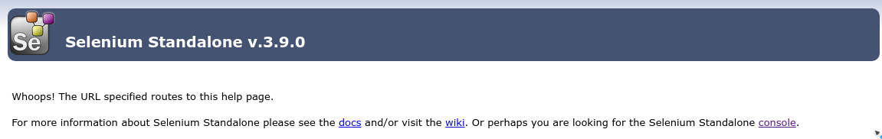
  - On the appearing console check the address. Find the REST address which is the first part, before the “static/resource/hub.html”. In this case it is http://localhost:4444/wd/hub.
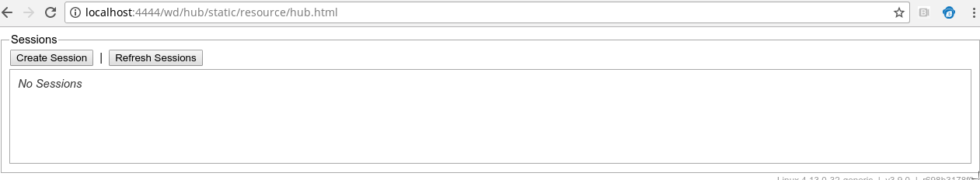
  - Click on the “Create Session” button
  - In the appearing window select the “chrome” element and click on the OK button.
  - The Chrome Browser opens
  - Check the session number which appears on the console
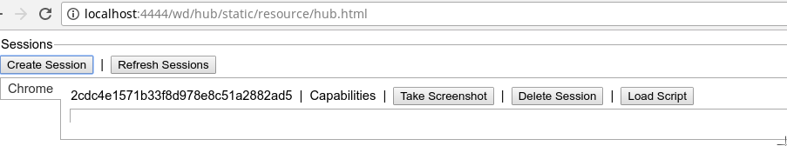

  - Start a REST API (Postman)
  - Download a REST API software. For example Postman.
  - Run Postman.

  - Send messages to the Server
In this section we will send some messages to the Selenium Server and check what happens. You can find the list of the REST commands on the https://github.com/SeleniumHQ/selenium/wiki/JsonWireProtocol page.
    - Get the session number
  - Command: GET.
  - Address http://localhost:4444/wd/hub/session
  - Click on the Send button
  - Check the result on the console:
INFO - Found handler: org.openqa.selenium.remote.server.commandhandler.GetAllSessions@5018d390
INFO - /sessions: Executing GET on /sessions (handler: GetAllSessions)
  - Check the result in the Postman
  - Status: 200
  - Result body:
{
"status": 0,
"value": [
{
"id": "2cdc4e1571b33f8d978e8c51a2882ad5",
"capabilities": {
"applicationCacheEnabled": false,
"rotatable": false,
"mobileEmulationEnabled": false,
"networkConnectionEnabled": false,
"chrome": {
"chromedriverVersion": "2.35.528139 (47ead77cb35ad2a9a83248b292151462a66cd881)",
"userDataDir": "/tmp/.org.chromium.Chromium.PTVQ6w"
},
"takesHeapSnapshot": true,
"pageLoadStrategy": "normal",
"databaseEnabled": false,
"handlesAlerts": true,
"hasTouchScreen": false,
"version": "64.0.3282.140",
"platform": "Linux",
"browserConnectionEnabled": false,
"nativeEvents": true,
"acceptSslCerts": false,
"acceptInsecureCerts": false,
"locationContextEnabled": true,
"webStorageEnabled": true,
"browserName": "chrome",
"takesScreenshot": true,
"javascriptEnabled": true,
"cssSelectorsEnabled": true,
"setWindowRect": true,
"unexpectedAlertBehaviour": ""
}
}
]
}
You can see the session number after the id attribute is the same number as in the console.
    - Navigate to a specific page
Let’s navigate to the google.com page.
  - Command: POST.
  - Address: http://localhost:4444/wd/hub/session/2cdc4e1571b33f8d978e8c51a2882ad5/url
  - Message body:
{
"url": "http://google.com"
}
  - Click on the Send button
  - Check the result on the console:
INFO - Found handler: org.openqa.selenium.remote.server.ServicedSession@761a355f
INFO - Handler thread for session 2cdc4e1571b33f8d978e8c51a2882ad5 (chrome): Executing POST on /session/2cdc4e1571b33f8d978e8c51a2882ad5/url (handler: ServicedSession)
00:08:02.738 INFO - To upstream: {
"url": "http://google.com"
}
INFO - To downstream: {"sessionId":"2cdc4e1571b33f8d978e8c51a2882ad5","status":0,"value":null}
  - Check the result in the Postman:
  - Status: 200
  - Result body:
{
"sessionId": "2cdc4e1571b33f8d978e8c51a2882ad5",
"status": 0,
"value": null
}

