Django
- Build up the env
  - Create a folder for your project
~$ mkdir djangogirls
~/djangogirls$ cd djangogirl
  - Create en python environment
~/djangogirls$ virtualenv env
  - Activate the environment
~/djangogirls$ source ./env/bin/activte
(env) ~/djangogirls$
  - Git
(env) $ git init
(env) $ echo /env > .gitignore
you can ignore the following files as well: *~,__pycache__, db.sqlite3, /static,.DS_Store
  - Upgrade pip in the environment
(env) ~/djangogirls$ pip install –upgrade pip
  - Install Django
(env) ~/djangogirls$ pip install django~=1.11.0
~= means that it tries to install the latest version of django under the 1.11 version (1.11.*), but it will not try to install for example the 1.12.0 version.
  - Create Django project
(env) ~/djangogirls$ django-admin startproject mysite .
Do not forget about the dot at the end!
Under the djangogirls folder a new folder appears with mysite name and a python file with the manage.py name.
Do not rename, delete or relocate them.
  - Settings
Change some settings in the mysite/settings.py file if they are different.
TIME_ZONE = 'Europe/Budapest'
STATIC_URL = '/static/'
STATIC_ROOT = os.path.join(BASE_DIR, 'static')
ALLOWED_HOSTS = ['127.0.0.1', '.pythonanywhere.com', ‘localhost’, ‘192.168.0.200’]
DATABASES = {
'default': {
'ENGINE': 'django.db.backends.sqlite3',
'NAME': os.path.join(BASE_DIR, 'db.sqlite3'),
}
}

  - Create sqlite database
(env) ~/djangogirls$ python manage.py migrate
  - Check webserver
Run the webserver. It will listen on the 8000 port:
(env) ~/djangogirls$ python manage.py runserver
If the 8000 port is reserved then change it for example to 9000:
(env) ~/djangogir$ python manage.py runserver 0:9000

Open an web browser and use the localhost and the webserver’s port in the address field: localhost:8000
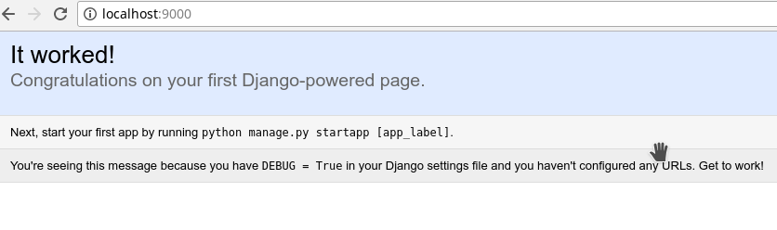

- Create an Application
  - Generate the App
(env) ~/djangogirls$ python manage.py startapp blog
Now a new folder is created named blog.
.
├── blog
│ ├── admin.py
│ ├── apps.py
│ ├── __init__.py
│ ├── migrations
│ ├── models.py
│ ├── tests.py
│ └── views.py
├── db.sqlite3
├── env
│ ├── bin
│ ├── include
│ ├── lib
│ └── pip-selfcheck.json
├── manage.py
└── mysite
├── __init__.py
├── __pycache__
├── settings.py
├── urls.py
└── wsgi.py
  - Tell to Django to use this appe
In the mysite/settings.py change the INSTALLED_APPS section. Add the “blog” to the list:
INSTALLED_APPS = [
'django.contrib.admin',
'django.contrib.auth',
'django.contrib.contenttypes',
'django.contrib.sessions',
'django.contrib.messages',
'django.contrib.staticfiles',
‘blog’
]

  - Create the model of the blogpost
Change the blog/models.py by deleting everything and adding the following code:

from django.db import models
from django.utils import timezone
class Post(models.Model):
author = models.ForeignKey('auth.User')
title = models.CharField(max_length=200)
text = models.TextField()
created_date = models.DateTimeField(default=timezone.now)
published_date = models.DateTimeField( blank=True, null=True)
def publish(self):
self.published_date = timezone.now()
self.save()
def __str__(self):
return self.title

  - Create tables for the model in the db
(env) ~/djangogirls$ python manage.py makemigrations blog

Migrations for 'blog':
blog/migrations/0001_initial.py
- Create model Post
Vi inform the Django that the model was changed.
Django creates an migration file which we will run on the database.
(env) ~/djangogirls$ python manage.py migrate blog

Operations to perform:
Apply all migrations: blog
Running migrations:
Applying blog.0001_initial... OK
The database has changed.

- Admin the model
  - Register the model on the admin page
To create modify or delete the model we are using the Django’s admin.
First modify the blog/admin.py file by deleting everything in it and inserting the following code:
from django.contrib import admin
from .models import Post
admin.site.register(Post)
  - Create admin user
(env) ~/djangogirls$ python manage.py createsuperuser

  - Check the Post model
First run the server as usual
(env) ~/djangogirls$ python manage.py runserver
Then in the browser address field type the admin page address:
localhost:8000/admin
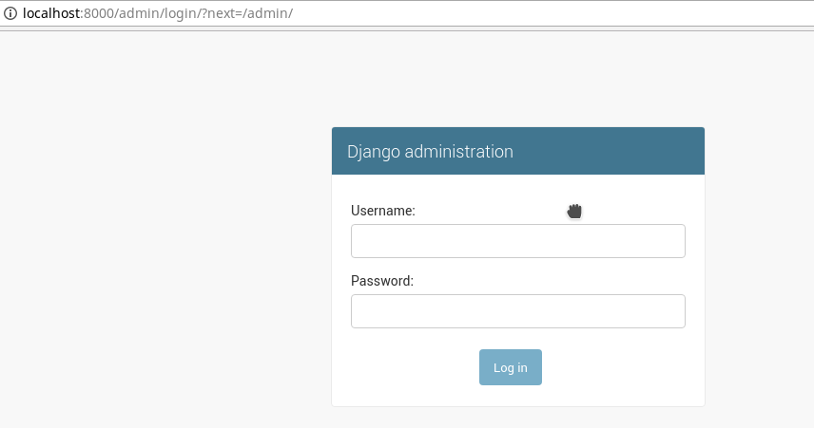

Login with your admin user
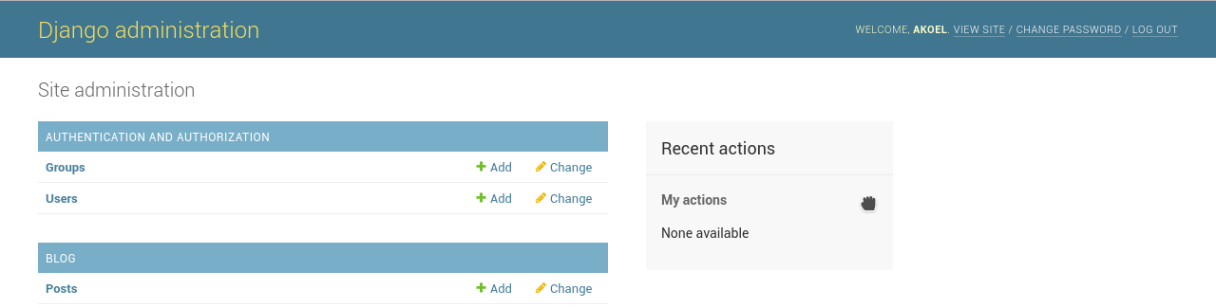

- Deploy
  - Register on the PythonAnywhere page
  - Upload source code to PythonAnywhere
Lets say that your code is already on the Github. So on the PythonAnywhere Dashboard click on the Bash button to get to a console. On the console clone your source code from the Github. For example:
$ git clone https://github.com/dallaszkorben/test-01.git
The test-01 folder is created.
  - Create virtual environment on the PythonAnywhere as well
~$ cd test-01

~/test-01 (master)$ virtualenv --python=python3.6 env

~/test-01 (master)$ source env/bin/activate

(env) ~/test-01 (master)$ pip install django~=1.11.0

  - Publish the blog on web
    - Create databse
Django creates an migration file which we will run on the database.
(env) ~/djangogirls$ python manage.py migrate blog

(env) ~/djangogirls$ python manage.py createsuperuser
    - Settings
Go back to the PythonAnywhere Dashboard by clicking on the logo.
Click on the Web tab.
Click on the Add new web app button. You get your own webapp domain. In our case for example: dallaszkorben.pythonantwhere.com.
Click on the Next button. In the appearing list select the Manual configuration element.
In the appearing list select the Python 3.6 element. Click on the Next button.
Under the Virtualenv section set your virtualenv path. For example /home/dallaszkorben/test-01/env
Under the Code section set your source code path. For example /home/dallaszkorben/test-01

    - Configure WSGI file
Modify the WSGI file by deleting everything in it and inserting the following code:

import os
import sys

path = '/home/<your-username>/<project-name>' # use your username and app name!
if path not in sys.path:
sys.path.append(path)

os.environ['DJANGO_SETTINGS_MODULE'] = 'mysite.settings'

from django.core.wsgi import get_wsgi_application
from django.contrib.staticfiles.handlers import StaticFilesHandler
application = StaticFilesHandler(get_wsgi_application())

To

