Docker
- Install Docker
  - Add PPG key
Add the GPG key for the official Docker repository to the system:
~$ curl -fsSL https://download.docker.com/linux/ubuntu/gpg | sudo apt-key add -
  - Docker repo to APT
Add the Docker repository to APT sources
~$ sudo add-apt-repository "deb [arch=amd64] https://download.docker.com/linux/ubuntu $(lsb_release -cs) stable"
  - Update
Next, update the package database with the Docker packages from the newly added repo
~$ sudo apt-get update
  - Check
Make sure you are about to install from the Docker repo instead of the default Ubuntu 16.04 repo
~$ apt-cache policy docker-ce

docker-ce:
Installed: (none)
Candidate: 17.12.0~ce-0~ubuntu
Version table:
17.12.0~ce-0~ubuntu 500
500 https://download.docker.com/linux/ubuntu xenial/stable amd64 Packages
17.09.1~ce-0~ubuntu 500
Notice that docker-ce is not installed, but the candidate for installation is from the Docker repository for Ubuntu 16.04. The docker-ce version number might be different.
  - Install
~$ sudo apt-get install -y docker-ce
Docker should now be installed, the daemon started, and the process enabled to start on boot.
  - Check Docker daemon
~$ sudo systemctl status docker
● docker.service - Docker Application Container Engine
Loaded: loaded (/lib/systemd/system/docker.service; enabled; vendor preset: enabled)
Active: active (running) since fre 2018-02-02 17:23:41 CET; 50s ago
Docs: https://docs.docker.com
Main PID: 7289 (dockerd)
Tasks: 18
Memory: 25.2M
CPU: 466ms
CGroup: /system.slice/docker.service
├─7289 /usr/bin/dockerd -H fd://
└─7294 docker-containerd --config /var/run/docker/containerd/containerd.toml
  - Set user group
By default, running the docker command requires root privileges — that is, you have to prefix the command with sudo. It can also be run by a user in the docker group, which is automatically created during the installation of Docker. If you attempt to run the docker command without prefixing it with sudo or without being in the docker group, you'll get an error message.
If you want to avoid typing sudo whenever you run the docker command, add your username to the docker group
~$ sudo usermod -aG docker ${USER}

To apply the new group membership, you can log out of the server and back in, or you can type the following:
~$ su - ${USER}

You will be prompted to enter your user's password to continue. Afterwards, you can confirm that your user is now added to the docker group by typing:
~$ id -nG

- General
Docker containers are run from Docker images. A running instance of an image is called container.
By default, it pulls these images from Docker Hub, a Docker registry managed by Docker, the company behind the Docker project. Anybody can build and host their Docker images on Docker Hub, so most applications and Linux distributions you'll need to run Docker containers have images that are hosted on Docker Hub.

A container runs natively on Linux and shares the kernel of the host machine with other containers. It runs a discrete process, taking no more memory than any other executable, making it lightweight.
By contrast, a virtual machine (VM) runs a full-blown “guest” operating system with virtual access to host resources through a hypervisor. In general, VMs provide an environment with more resources than most applications need.

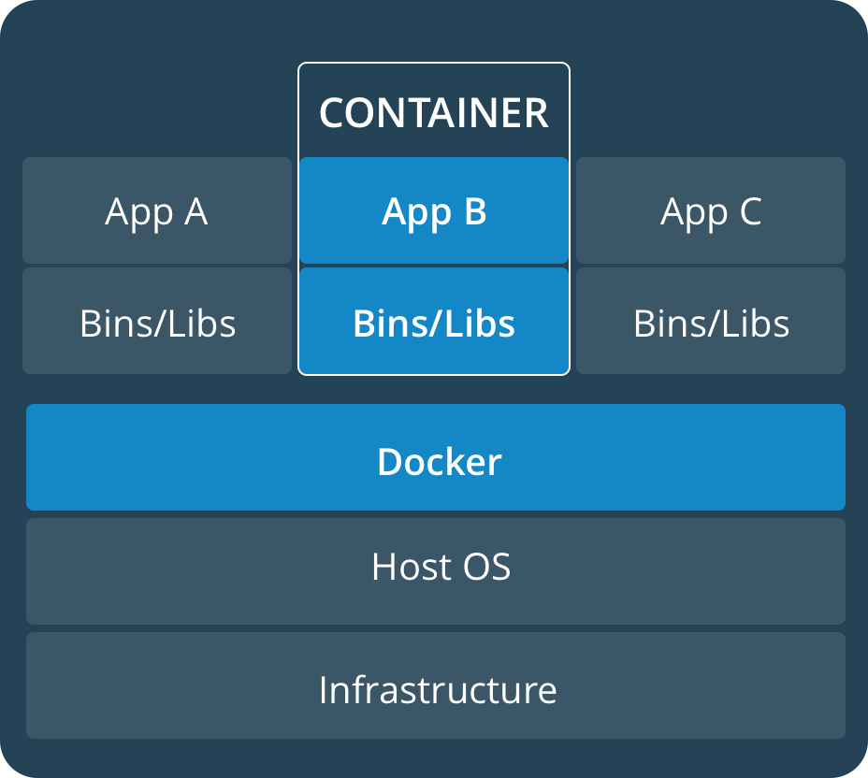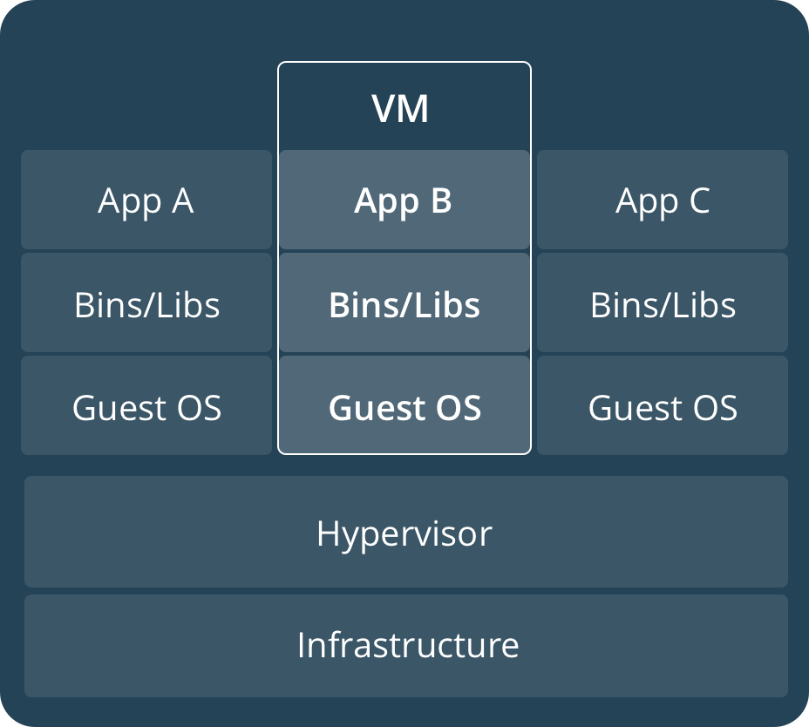

- Working with the Dockerfile
One choice to store the Images is to generate it locally from the Dockerfile.

  - Create Dockerfile
You have to create a file which must have a conventionalized name Dockerfile.
In this file the lines start with a command keyword fallowed by parameters:

Dockerfile
#----------------------
# Base image
#----------------------
FROM ubuntu:latest

#----------------------
# Install apps
#----------------------
RUN apt-get update && apt-get install -y mc

#----------------------
# User definition
#----------------------
# Replace 1000 with your user / group id
RUN export uid=1000 gid=1000 && \
mkdir -p /home/developer && \
echo "developer:x:${uid}:${gid}:Developer,,,:/home/developer:/bin/bash" >> /etc/passwd && \
echo "developer:x:${uid}:" >> /etc/group && \
chown ${uid}:${gid} -R /home/developer

USER developer
ENV HOME /home/developer

#----------------------
# Start app (if you want)
#----------------------
  - Build the Image
In the same folder where the Dockerfile is you can generate the Image
~$ docker build -t <image-name> .

Now the image with the given image-name is in the Docker, so you can run it or do whatever you want with it.
- Working with the Docker Hub
One choice to store the Images is the Docker Hub
  - Search for images on Docker Hub
~$ docker search ubuntu

NAME DESCRIPTION STARS OFFICIAL AUTOMATED
ubuntu Ubuntu is a Debian-based Linux operating sys… 7183 [OK]
dorowu/ubuntu-desktop-lxde-vnc Ubuntu with openssh-server and NoVNC 159 [OK]
rastasheep/ubuntu-sshd Dockerized SSH service, built on top of offi… 130 [OK]
ansible/ubuntu14.04-ansible Ubuntu 14.04 LTS with ansible 90
  - Download the image
~$ docker pull ubuntu
After an image has been downloaded, you may then run a container using the downloaded image with the run subcommand. If an image has not been downloaded when docker is executed with the run subcommand, the Docker client will first download the image, then run a container using it.

- Working with the Images
Once the Image is in your docker (pulled from Docker Hub or generated it from Dockerfile) you can manipulate it as you wish. The Image which runs called Container (like an instance). The Container has a unique id. When you run the same Image more than once on the same host, the Containers have different ids.
  - List images
~$ docker images

REPOSITORY TAG IMAGE ID CREATED SIZE
ubuntu latest 0458a4468cbc 8 days ago 112MB
hello-world latest f2a91732366c 2 months ago 1.85kB
  - Remove an Image
~$ docker images #get the list of the images

~$ docker rmi hello-world
  - Remove All Images
~$ docker rmi $(docker images -q)

  - Run a Docker Container
If the Image has not been in your Container yet, it tries to pull it first from the Docker Hub.
~$ docker run hello-world
Hello from Docker!
This message shows that your installation appears to be working correctly.

  - Interactive Run of Docker Container
The hello-world container you ran in the previous is an example of a container that runs and exits, after emitting a test message. Containers, however, can be much more useful than that, and they can be interactive. After all, they are similar to virtual machines, only more resource-friendly.
As an example, let's run a container using the latest image of Ubuntu. The combination of the -i and -t switches gives you interactive shell access into the container:

~$ docker run -it ubuntu

root@0cb61e57e2f7:/#
Your command prompt should change to reflect the fact that you're now working inside the container and should take this form.
Note the container id in the command prompt. In the above example, it is 0cb61e57e2f7
  - List Containers
~$ docker ds -aq
  - Stop Container
You can Stop a container and its status will be exited from the container clicking on the <Ctrl-C> button or using the exit command in the container, or from an other terminal on the host using the docker stop command. You can check its status with the docker ps -a command. After you stopped it you can remove or restart it.
~$ docker stop <container-id>
  - Remove a Container
You can remove a stopped (exited) container. In this case all data will be lost you changed in it.
~$ docker rm <container-id>
  - Remove All Containers
~$ docker rm $(docker ps -aq)
  - Continue working a Stopped Container
You are able to restart an existing but stopped (exited) container and all your changes will be still there
~$ docker start <container-id> #restart it in the background
~$ docker attach <container-id> #reattach the terminal & stdin

- Commiting Changes in a container
When you start up a Docker image, you can create, modify, and delete files just like you can with a virtual machine. The changes that you make will only apply to that container. You can make changes to a container, but these changes will not affect the image
You can start and stop it, but once you destroy it with the docker rm command, the changes will be lost for good. However, you can create a new image from a running container (and all it changes) using docker commit command.
This section shows you how to save the state of a container as a new Docker image.
  - Change the container
Now you may run any command inside the container. For example, let's update the package database inside the container. No need to prefix any command with sudo, because you're operating inside the container with root privileges:
root@0cb61e57e2f7:/# apt-get update
Then install any application in it. Let's install NodeJS, for example.
root@0cb61e57e2f7:/# apt-get install -y nodejs

After installing nodejs inside the Ubuntu container, you now have a container running off an image, but the container is different from the image you used to create it.
  - Exit from the container
root@0cb61e57e2f7:/# exit
  - Commit the changes
Then commit the changes to a new Docker image instance using the following command.
The -m switch is for the commit message that helps you and others know what changes you made, while -a is used to specify the author. The container ID is the one you noted earlier in the tutorial when you started the interactive docker session. Unless you created additional repositories on Docker Hub, the repository is usually your Docker Hub username.
~$ docker commit -m "updated and added node.js" -a "Dallas Korben" 0cb61e57e2f7 <docker-registry-username>/<new-imagename>

~$ docker commit -m "updated and added node.js" -a "Dallas Korben" 0cb61e57e2f7 dallaszkorben/ubuntu-nodejs

When you commit an image, the new image is saved locally, that is, on your computer. Later in this tutorial, you'll learn how to push an image to a Docker registry like Docker Hub so that it may be assessed and used by you and others.
  - Check the new image
~$ docker images

REPOSITORY TAG IMAGE ID CREATED SIZE
dallaszkorben/testrepo latest c41206e4e94e 15 seconds ago 200MB
ubuntu latest 0458a4468cbc 8 days ago 112MB
hello-world latest f2a91732366c 2 months ago 1.85kB

In the above example, ubuntu-nodejs is the new image, which was derived from the existing ubuntu image from Docker Hub. The size difference reflects the changes that were made. And in this example, the change was that NodeJS was installed. So next time you need to run a container using Ubuntu with NodeJS pre-installed, you can just use the new image. Images may also be built from what's called a Dockerfile. But that's a very involved process that's well outside the scope of this article.
  - List the active Docker Containers
~$ docker ps

CONTAINER ID IMAGE COMMAND CREATED STATUS PORTS NAMES
6852a07d5535 ubuntu "/bin/bash" 19 seconds ago Up 17 seconds practical_gates
  - List the active and inactive (all) Docker Containers
~$ docker ps -a

CONTAINER ID IMAGE COMMAND CREATED STATUS PORTS NAMES
6852a07d5535 ubuntu "/bin/bash" 5 minutes ago Up 5 minutes practical_gates
087bf26ff66d ubuntu "/bin/bash" 17 minutes ago Exited (0) 15 minutes ago zealous_darwin
8be8d2b9431e ubuntu "/bin/bash" 19 minutes ago Exited (0) 17 minutes ago affectionate_mahavira
712d0cab3863 ubuntu "/bin/bash" 22 minutes ago Exited (127) 19 minutes ago xenodochial_franklin
319f8185d88b ubuntu "/bin/bash" 42 minutes ago Exited (0) 31 minutes ago keen_ritchie
0cb61e57e2f7 ubuntu "/bin/bash" 44 minutes ago Exited (0) 42 minutes ago angry_borg
c073a7664a3f hello-world "/hello" 3 hours ago Exited (0) 3 hours ago nifty_liskov
  - List the latest Docker Containers
~$ docker ps -l
  - Stopping a running Docker Containers
~$ docker stop container-id
  - Pushing Docker Image to Docker Repository
The next logical step after creating a new image from an existing image is to share it with a select few of your friends, the whole world on Docker Hub, or other Docker registry that you have access to. To push an image to Docker Hub or any other Docker registry, you must have an account there.
~$ docker login -u <docker-registry-username>

If you specified the correct password, authentication should succeed. Then you may push your own image using:
~$ docker push <docker-registry-username>/<new-imagename>

~$ docker push dallaszkorben/ubuntu-nodejs

- Run GUI app
  - Create Dockerfile
Dockerfile
#----------------------
# Base image
#----------------------
FROM ubuntu:14.04

#----------------------
# Install apps
#----------------------
RUN apt-get update && apt-get install -y firefox

#----------------------
# User definition
#----------------------
# Replace 1000 with your user / group id
RUN export uid=1000 gid=1000 && \
mkdir -p /home/developer && \
echo "developer:x:${uid}:${gid}:Developer,,,:/home/developer:/bin/bash" >> /etc/passwd && \
echo "developer:x:${uid}:" >> /etc/group && \
echo "developer ALL=(ALL) NOPASSWD: ALL" > /etc/sudoers.d/developer && \
chmod 0440 /etc/sudoers.d/developer && \
chown ${uid}:${gid} -R /home/developer

USER developer
ENV HOME /home/developer

#----------------------
# Start app
#----------------------
CMD /usr/bin/firefox

  - Build the Image
~$ docker build -t <image-name> .

  - Run
~$ docker run -it --rm \
-e DISPLAY=$DISPLAY \
-v /tmp/.X11-unix:/tmp/.X11-unix \
<image-name>

- Volumes
Volumes are the preferred mechanism for persisting data generated by and used by Docker containers. While bind mounts are dependent on the directory structure of the host machine, volumes are completely managed by Docker.
The idea is that your volumes can be shared between your docker containers and they will stay around as long as there's a container (running or stopped) that references them.
  - Create a VOLUME
There are two ways to create Volume.
    - Create VOLUME on the console with name
~$ docker volume create <volume-name>

~$ docker volume create myvolume
myvolume
~$ docker volume ls
DRIVER VOLUME NAME
local myvolume
    - Create VOLUME by Dockerfile with generated name
You can create a Volume using the VOLUME keyword in the Dockerfile. In this case the name of the Volume is a long generated string. Every time when you run your Image, which was created by the Dockerfile, a new Volume will be created with a unique name and the default content.
If you stop the Container or even if you remove it the Volume will be intact. It will be not deleted, the content will stay the same as it was after the last change.
Dockerfile
#----------------------
# Base image
#----------------------
FROM ubuntu:latest

#----------------------
# Install apps
#----------------------
RUN apt-get update && apt-get install -y mc

#----------------------
# User definition
#----------------------
# Replace 1000 with your user / group id
RUN export uid=1000 gid=1000 && \
mkdir -p /home/developer && \
echo "developer:x:${uid}:${gid}:Developer,,,:/home/developer:/bin/bash" >> /etc/passwd && \
echo "developer:x:${uid}:" >> /etc/group && \
chown ${uid}:${gid} -R /home/developer

#----------------------
# Volume
#----------------------
RUN mkdir /shared
RUN echo “This is the default file and its default content” > /shared/default.txt
RUN chmod ugo+rwx -R /shared
VOLUME /shared

USER developer
ENV HOME /home/developer

After this you can generate a new Image using the docker build command and then you can ran the Image.
Under the run the new Volume will be generated and appear in the Docker. It’s name is a long generated string.
~$ docker build -t <image-name> .
…
~$ docker run <image-name>
…
~$ docker volume ls
DRIVER VOLUME NAME
local 4391529f71c7e03d8d40dae811d32c8a0dc7957308b1eee075f5168b39f83658

  - Mount Volume
There are two ways to Mount a Volume.
    - Mount the Volume from the Volume list
Let’s say that you already have a Volume. It could be done by run an Image which was created from a Dockerfile which had the VOLUME definition or it was created by hand from the console using the docker volume create command. You can see the existing Volume-s using the docker volume ls command.
~$ docker volume ls
DRIVER VOLUME NAME
local 4391529f71c7e03d8d40dae811d32c8a0dc7957308b1eee075f5168b39f83658
local myvolume
You can see in this example that the first Volume was generated under an Image run and the second one was created on the console.
So let’s say that you want to mount for example the myvolume Volume to the /vol folder in the file system in an for example ubuntu Container.
~$ docker run -ti -v myvolume:/vol ubuntu
In this case you get a console on an ubuntu Container. You can check that a /vol folder appears in the root file system. You can modify its content. It will be persistent.
    - Mount the Volume from a running Container
Let’s say that you run a Container which was generated from a Dockerfile which had a definition of VOLUME like this: VOLUME /shared. That means that you are ready to share /shared folder to anybody who needs it. You generated the Image and you ran this Image. Let’s say that this running image Container’s container-id is fe21e7ab586e.
Now you want this /shared folder appear in the file system in an ubuntu Container.
~$ docker run -it --volumes-from fe21e7ab586e ubuntu
After the --volumes-from keyword you put the container-id of the Container which shares its folders.

  - Manage Volume
    - List of Volumes
~$ docker volume ls
DRIVER VOLUME NAME
local 4391529f71c7e03d8d40dae811d32c8a0dc7957308b1eee075f5168b39f83658
local myvolume
    - Remove a Volume
~$ docker volume rm <volume-name>
    - Remove all Volumes
~$ docker volume rm $(docker volume ls -q)

- Save-Export container
  - Save-Load Image
Save is used to persist an image (not a container).
~$ docker images #get the image name

~$ docker save <image-name> > /home/save.tar
Load
~$ docker load < /home/export.tar
As we saved the Image, the loaded image name will be the same. We could not change it.
  - Export-Import Container
Export is used to persist a container (not an image).
~$ docker ps -a #get the container ID

~$ docker export <containder-id> > /home/export.tar
Import

~$ cat /home/export.tar | docker import - <new-image-name>:latest
As we exported the Container, in the import process we have to give a name of the new image.

- Images
hello-world
busybox The Swiss Army Knife of Embedded Linux
BusyBox combines tiny versions of many common UNIX utilities into a single small executable
ubuntu Ubuntu is a Debian-based Linux operating system, with Unity as its default desktop environment

