Snap
- General
Docker containers are run from Docker images. A running instance of an image is called container.
By default, it pulls these images from Docker Hub, a Docker registry managed by Docker, the company behind the Docker project. Anybody can build and host their Docker images on Docker Hub, so most applications and Linux distributions you'll need to run Docker containers have images that are hosted on Docker Hub.

A container runs natively on Linux and shares the kernel of the host machine with other containers. It runs a discrete process, taking no more memory than any other executable, making it lightweight.
By contrast, a virtual machine (VM) runs a full-blown “guest” operating system with virtual access to host resources through a hypervisor. In general, VMs provide an environment with more resources than most applications need.

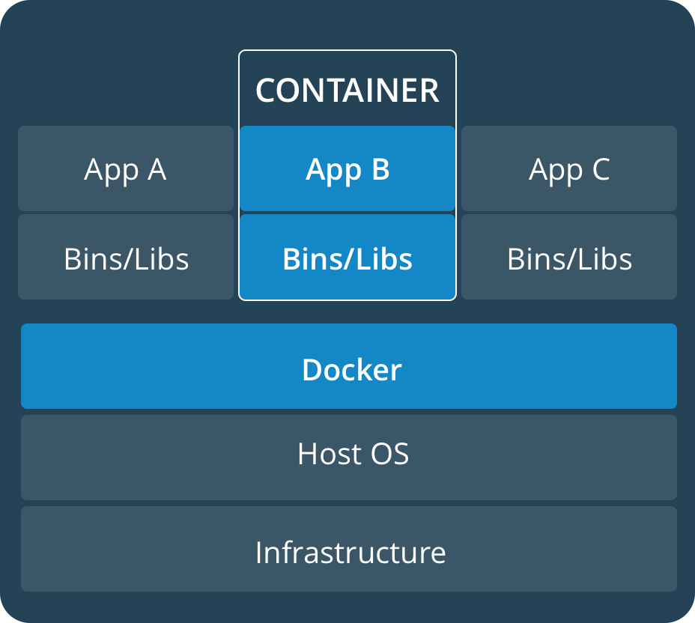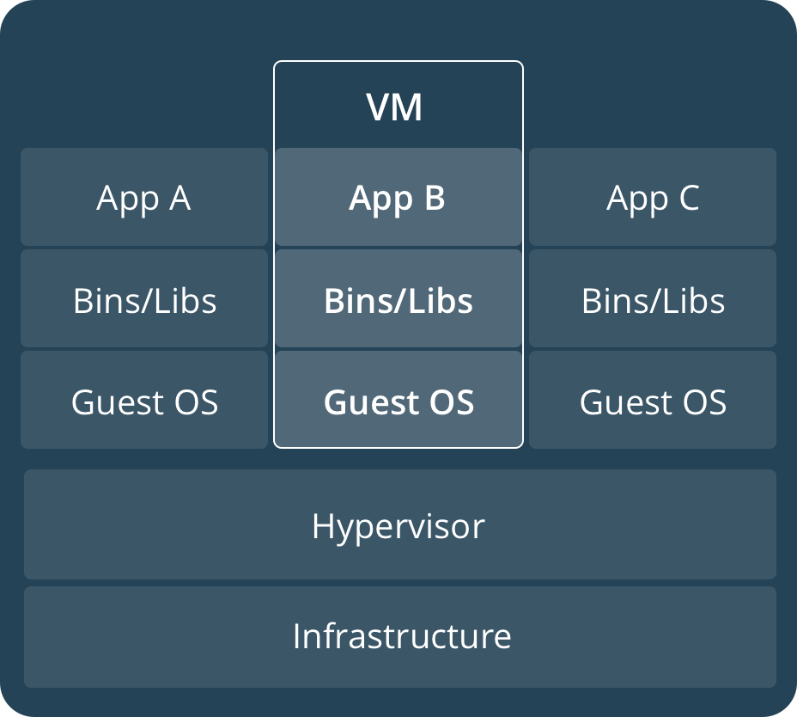

- Working with the Dockerfile
One choice to store the Images is to generate it locally from the Dockerfile.

  - Create Dockerfile
You have to create a file which must have a conventionalized name Dockerfile.
In this file the lines start with a command keyword fallowed by parameters:

Dockerfile
#----------------------
# Base image
#----------------------
FROM ubuntu:latest

#----------------------
# Install apps
#----------------------
RUN apt-get update && apt-get install -y mc

#----------------------
# User definition
#----------------------
# Replace 1000 with your user / group id
RUN export uid=1000 gid=1000 && \
mkdir -p /home/developer && \
echo "developer:x:${uid}:${gid}:Developer,,,:/home/developer:/bin/bash" >> /etc/passwd && \
echo "developer:x:${uid}:" >> /etc/group && \
chown ${uid}:${gid} -R /home/developer

USER developer
ENV HOME /home/developer

#----------------------
# Start app (if you want)
#----------------------
  - Build the Image
In the same folder where the Dockerfile is you can generate the Image
~$ docker build -t <image-name> .

Now the image with the given image-name is in the Docker, so you can run it or

