Karaf
- About Karaf
Apache Karaf is not another OSGi implementation, but acts like a wrapper on top of an already existing OSGi runtimes like Apache Felix or Eclipse Equinox.
You can configure it to use one of these OSGi implementations as a basis. The Karaf offers some value added services on top these runtimes.
Most of these services have been designed as OSGi bundles which are getting deployed on container when Apache Karaf starts. Features like central logging, manipulating configuration through commands, accessing OSGi runtime remotely using SSH, integration with OS and Apache Karaf’s extensible command shell are some of the most important capabilities that an OSGi application can benefit from.
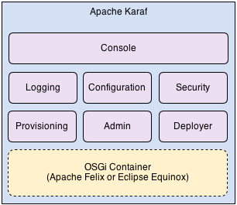
  - Deployer
The Deployer is one of the most important modules in Apache Karaf. It provides an extensible mechanism to retrieve bundles through different protocols and repositories to install them on underlying OSGi container. If you have ever tried to install bundles in an OSGi container directly, you know that in order to install your bundle, the main option would be through the file system (file:// protocol). When using Apache Karaf, thanks to different protocol handlers included by default, you can access bundles from different repositories like your Maven local repository. There is also a hot deployment option which enables you to just drop your bundle in deploy folder and let the Apache Karaf do the rest for you. Any changes to bundles deployed in this way will be detected and automatically applied. So it boosts your productivity in development phase.
The provisioning in OSGi world is the process of locating and downloading bundles required to run an application. In Apache Karaf, there is a concept named Feature that could be used to define an application. It’s simply a descriptor (in XML) that specifies a collection of bundles that have to be installed together. When you install a Feature in Apache Karaf, it tries to provision all bundles specified in it and installs them on the OSGi container. This way, an application could be defined as a Feature referring all its bundles and also bundles they depend on. The provisioning mechanism provided by Apache Karaf doesn’t detect bundle’s dependencies. So you have to specify all the dependencies of your application when preparing its Feature XML file.
Features can also be nested. This way, you can for example define dependencies of your application as a separate Feature and include it in the main one. Some third party frameworks like Eclipse RAP, Apache Camel or Apache ActiveMQ have already defined their required bundles as a Feature XML file that could be used to include their services in any application at runtime. Usually installing a Feature is a two step process. At first the Feature XML (which could be a collection of Feature definitions) has to be introduced to Apache Karaf and then each item defined in it could be installed separately. In Apache Karaf vocabulary, when you add a new feature XML file, you’re actually defining a new repository which could be used to search for when you’re trying to install a new feature. The provisioning process heavily depends on the deployer services mentioned above. The sample XML below, defines a feature named my_feature consisting three bundles.

features.xml
<?xml version="1.0" encoding="UTF-8"?>
<features>
<feature name='my_feature' version='1.0'>
<bundle>mvn:project_group_id/bundle1/1.0.0/bundle1-1.0.0</bundle>
<bundle>mvn:project_group_id/bundle2/1.1.0/bundle2-1.1.0</bundle>
<bundle>mvn:project_group_id/bundle3/1.0.0/bundle3-1.0.0</bundle>
</feature>
</features>

  - Admin
Apache Karaf administration features enables a user to instantiate multiple instances of Karaf that work beside each other smoothly. Having multiple instances enables you to achieve high availability, fail over and similar non functional requirements. The administration services enable you to start, stop, create new instance or even delete it. It also let you access instances remotely using SSH protocol, so you can connect to an instance from anywhere using a SSH client. There is also a special client utility provided as an administration tool by Apache Karaf to connect to an already running instance (local or remote). When you have access to Apache Karaf console, using client utility or through SSH, you can issue any command just like when you’re using its console locally.
  - Logging
The OSGi compendium specification defines a basic logging service to be implemented by OSGi containers. The Pax Logging project is an implementation of OSGi log service (as a bundle) with some added features and supports most of well known logging APIs like Log4J, Apache Commons Logging API, JDK Logging API, SLF4J, etc. The Apache Karaf uses Pax Logging as basis to provide higher level logging facilities required by most enterprise applications. It redirects all logging output to a single file and provides some basic console commands to access last logged messages and exceptions or change the log level at runtime.
  - Configuration
As specified in compendium specification of OSGi, a Configuration Admin service is responsible to store bundle configurations and give them back to services who need them. Apache Karaf provides some console commands which let you access these configuration at runtime and manipulate them. Configurations are stored as simple property files in {karaf_home}/etc folder with .cfg extension and its contents could be altered directly.
  - Console
Apache Karaf console acts as the main interaction mechanism between user and the system. Almost all services mentioned above could be controlled by commands provided through the console. Thanks to extendability mechanism provided by Apache Karaf, every bundle can add its own commands to the console. This way, you can interact with your bundle through console and manipulate its behaviour in runtime. For example, the logging service provides commands like log:display to display the latest logs or log:set to set the logging level of Apache Karaf.
  - Remote
Apache Karaf supports a complete remote mechanism allowing you to remotely connect to a running Apache Karaf instance. More over, you can also browse, download, and upload files remotely to a running Apache Karaf instance.

Apache Karaf embeds a complete SSHd server. When you start Apache Karaf, it enables a remote console that can be accessed over SSH. This remote console provides all the features of the "local" console, and gives a remote user complete control over the container and services running inside of it. As the "local" console, the remote console is secured by a RBAC mechanism.

The users are currently used in three different places in Karaf:
- access to the SSH console
- access to the JMX management layer
- access to the Web console
Those three ways all delegate to the same JAAS based security authentication.

    - Password
Authentication with User and Password (plan text)
The default security configuration uses a property file located at {karaf_home}/etc/users.properties to store authorized users and their passwords.
The default user name is karaf and the associated password is karaf too. We strongly encourage you to change the default password by editing the file before moving Karaf into production.
The users.properties file contains one or more lines, each line defining a user, its password and the associated roles.
user=password[,role][,role]...

etc/usr.properties
karaf = karaf,_g_:admingroup

Authentication by key

The SSH client uses a public/private keys pair that will identify himself on Karaf SSHD (server side).
The keys allowed to connect are stored in {karaf_home}etc/keys.properties file, following the format:
user=key,role

Steps to create the key using OpenSSH:
- generate karaf.id_dsa and karaf.id_dsa.pub files
Ubuntu shell
~$ ssh-keygen -d dsa -f karaf.id_dsa -N karaf

- copy the content of the karaf.id_dsa.pub into etc/keys.properties in the following format:
{user_name}={generated_public_key}, admin

- tell to the karaf client to use the karaf.id_dsa private key
bin/client -k ~/karaf.id_dsa

- tell to the ssh client to use the karaf.id_dsa private key
ssh -p 8101 -i ~/karaf.id_dsa karaf@localhost

    - Connect to Karaf with ssh client
The Apache Karaf SSHd server is a pure SSHd server, similar to OpenSSH daemon. It means that you can use directly a SSH client from your system.
Ubuntu shell
$ ssh -p 8101 karaf@localhosst

The authenticity of host '[localhost]:8101 ([127.0.0.1]:8101)' can't be established.
RSA key fingerprint is SHA256:OWBB42TbZW8V0iqLf4Alj5Y6LCLyFWPsw1oP6HueyTg.
Are you sure you want to continue connecting (yes/no)? yes
Warning: Permanently added '[localhost]:8101' (RSA) to the list of known hosts.
Password authentication
Password:
__ __ ____
/ //_/____ __________ _/ __/
/ ,< / __ `/ ___/ __ `/ /_
/ /| |/ /_/ / / / /_/ / __/
/_/ |_|\__,_/_/ \__,_/_/
Apache Karaf (4.2.0)
Hit '<tab>' for a list of available commands
and '[cmd] --help' for help on a specific command.
Hit 'system:shutdown' to shutdown Karaf.
Hit '<ctrl-d>' or type 'logout' to disconnect shell from current session.
karaf@root()>

    - Connect to Karaf with Karaf client
If you don’t have SSH client installed on your machine, you can use Apache Karaf client.
Karaf shell
karaf@root()> ssh:ssh -p 8101 karaf@localhost
    - Connect to ssh server with Karaf client
As the ssh:ssh command is a pure SSH client, so it means that you can connect to a Unix OpenSSH daemon:
Karaf shell
karaf@root()> ssh:ssh pi@192.168.1.111

    - Configuration
The configuration of the SSHd server is stored in the {karaf_home}/etc/org.apache.karaf.shell.cfg file
sshPort is the port number where the SSHd server is bound (by default, it’s 8101)
sshHost is the address of the network interface where the SSHd server is bound. The default value is 0.0.0.0, meaning that the SSHd server is bound on all network interfaces. You can bind on a target interface providing the IP address of the network interface.
hostKey is the location of the host.key file. By defaut, it uses etc/host.key. This file stores the public and private key pair of the SSHd server.
sshRole is the default role used for SSH access. The default value is the value of karaf.admin.role property defined in etc/system.properties
keySize is the key size used by the SSHd server. The possible values are 1024, 2048, 3072, or 4096. The default value is 1024.
algorithm is the host key algorithm used by the SSHd server. The possible values are DSA or RSA. The default value is DSA.

The SSHd server configuration can be changed at runtime:
- by editing the etc/org.apache.karaf.shell.cfg configuration file
- by using the config:* commands

At runtime, when you change the SSHd server configuration, you have to restart the SSHd server to load the changes. You can do it with:
Karaf shell
karaf@root()> bundle:restart -f org.apache.karaf.shell.ssh

- Install Karaf

- Download the latest stable version
- Extract the zip to location of your choice {karaf_home}

- Create a simple Java Bundle
  - Create a new Maven project using Eclipse
- File > New > Project
- Select Maven Project
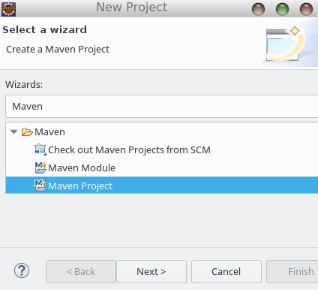
- Click on Next button
- Click on Next button
- Click on "Add Archetype..." button
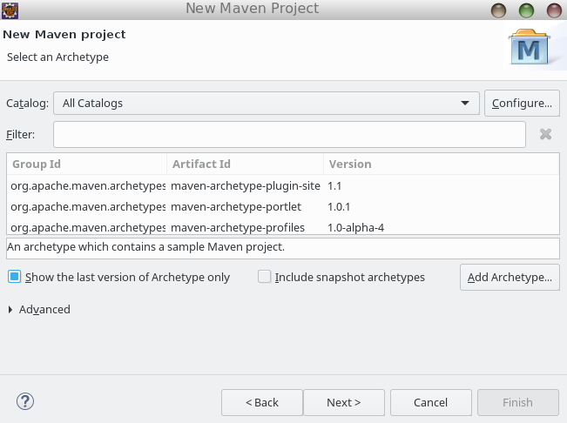
- Fill out Archetype fields
Archetype Group Id: org.apache.karaf.archetypes
Archetype Artifact Id: karaf-bundle-archetype
Archetype Version: 4.0.0
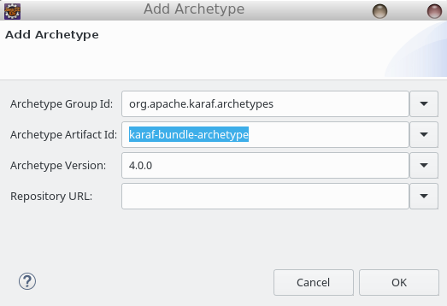
- Click on OK button
- And now we can select the "karaf-bundle-archetype"
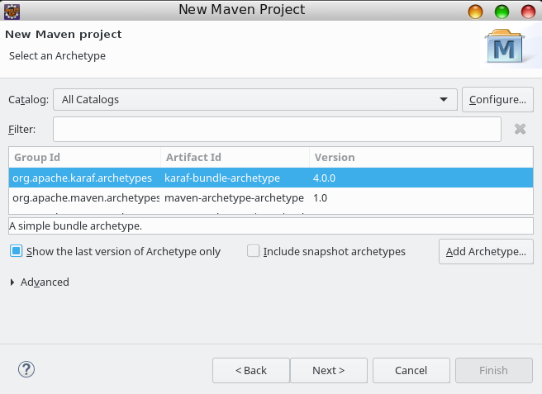
- Click on Next button
- On the next window set the you new maven project
Group Id: {hu.akoel.karafTest}
Artifact Id: {myKarafTest}
Version: 0.0.1-SNAPSHOT
Package: {hu.akoel.karaf.myKarafTest}
package: {hu.akoel.karaf.myKarafTest}
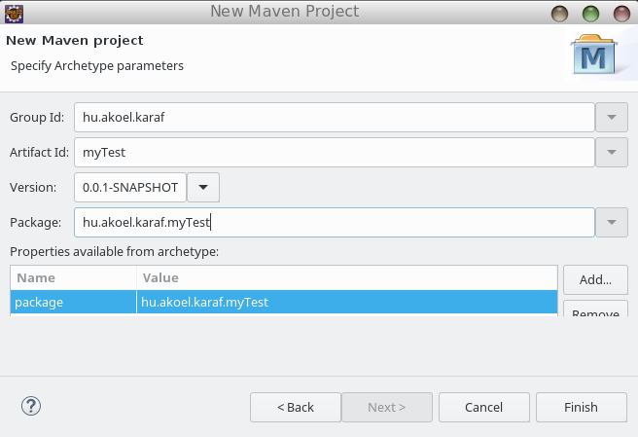
- Click on "Finish" button
  - Implement the code
    - POM
Now the pom file was generated automatically, but it needs to be fixed. Here is what we need int the pom.xml
pom.xml
<?xml version="1.0" encoding="UTF-8"?>
<project xmlns="http://maven.apache.org/POM/4.0.0" xmlns:xsi="http://www.w3.org/2001/XMLSchema-instance" xsi:schemaLocation="http://maven.apache.org/POM/4.0.0 http://maven.apache.org/xsd/maven-4.0.0.xsd">

<modelVersion>4.0.0</modelVersion>
<groupId>hu.akoel.karaf</groupId>
<artifactId>myKarafTest</artifactId>
<version>0.0.1-SNAPSHOT</version>

<name>myKarafTest Bundle</name>
<description>myKarafTest OSGi bundle project.</description>

<properties>
<maven.compiler.source>1.6</maven.compiler.source>
<maven.compiler.target>1.6</maven.compiler.target>

<maven-bundle-plugin.version>2.5.4</maven-bundle-plugin.version>
<osgi.version>6.0.0</osgi.version>
</properties>

<dependencies>
<dependency>
<groupId>org.osgi</groupId>
<artifactId>org.osgi.core</artifactId>
<version>${osgi.version}</version>
<scope>provided</scope>
</dependency>
<dependency>
<groupId>org.osgi</groupId>
<artifactId>org.osgi.compendium</artifactId>
<version>4.2.0</version>
</dependency>
</dependencies>

<build>
<plugins>
<plugin>
<groupId>org.apache.felix</groupId>
<artifactId>maven-bundle-plugin</artifactId>
<version>3.0.0</version>
<extensions>true</extensions>
<configuration>
<instructions>
<Bundle-SymbolicName>${project.artifactId}</Bundle-SymbolicName>
<Bundle-Version>${project.version}</Bundle-Version>
<Bundle-Activator>hu.akoel.karaf.myKarafTest.Activator</Bundle-Activator>
<Export-Package>hu.akoel.karaf.myKarafTest*;version=${project.version}</Export-Package>
<Import-Package>*</Import-Package>
</instructions>
</configuration>
</plugin>

<plugin>
<artifactId>maven-compiler-plugin</artifactId>
<configuration>
<executable>javac9</executable>
</configuration>
</plugin>
</plugins>
</build>
<packaging>bundle</packaging>
</project>
    - Java
Activator.java
package hu.akoel.karaf.myKarafTest;

import java.util.Dictionary;
import java.util.Hashtable;
import java.util.logging.Logger;
import org.osgi.framework.BundleActivator;
import org.osgi.framework.BundleContext;
import org.osgi.framework.Constants;
import org.osgi.framework.ServiceRegistration;
import org.osgi.service.cm.ConfigurationException;
import org.osgi.service.cm.ManagedService;

public class Activator implements BundleActivator, ManagedService {

private static final String BUNDLE_ID = "SimpleBundleTest";
private ServiceRegistration serviceReg;
private Logger log = Logger.getLogger(this.getClass().getName());

public void start(BundleContext context) {
Hashtable<String, Object> properties = new Hashtable<String, Object>();
properties.put(Constants.SERVICE_PID, BUNDLE_ID);
serviceReg = context.registerService(ManagedService.class.getName(), this, properties);
log.info("Starting Bundle " + BUNDLE_ID);
}

public void stop(BundleContext context) {
log.info("Stopping Bundle " + BUNDLE_ID);
}

public void updated(Dictionary properties) throws ConfigurationException {
if (properties == null) {
log.info(BUNDLE_ID + " ... config not found - Please give me a config File in Folder config");
return;
}
log.info("mqttGpioActor Config was set.");
log.info("Found " + properties.size() + " config Items.");
}
}
  - Install the Bundle to local Maven repository
    - Create a new Maven Run Configuration
- Run > Run Configurations...
Name: Install Simple Bundle Test
Base directory: ${workspace_loc:/myKarafTest}
Goals: clean install
User settings: {/home/akoel/.m2/settings.xml}

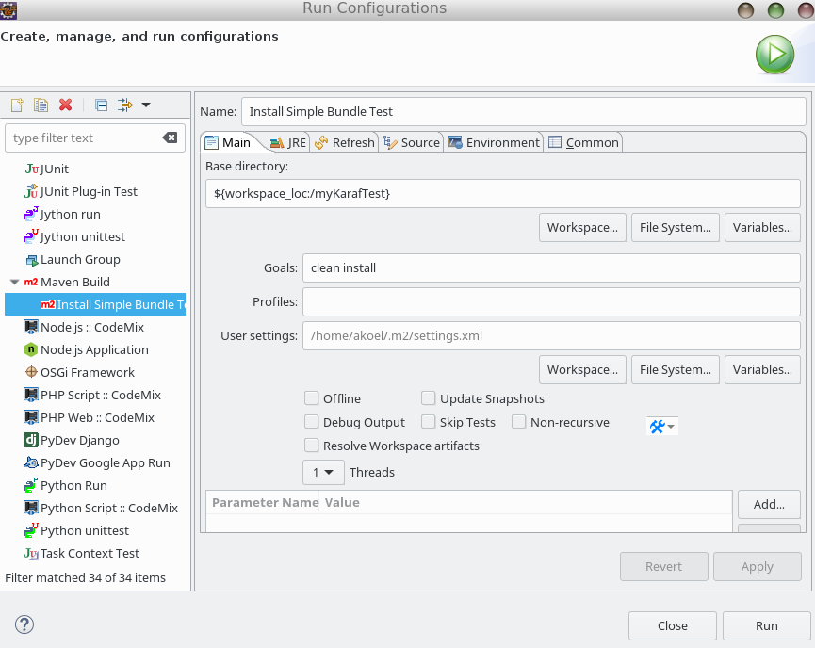
- Click on "Apply" button
    - Create Maven Install
- Green Play button > Install Simple Bundle Test
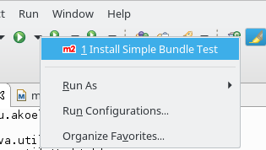
- The result of of the Maven Instal is "BUILD SUCCESS"

[INFO] Scanning for projects...
[WARNING]
[WARNING] Some problems were encountered while building the effective model for hu.akoel.karaf:myKarafTest:bundle:0.0.1-SNAPSHOT
[WARNING] 'build.plugins.plugin.version' for org.apache.maven.plugins:maven-compiler-plugin is missing. @ line 53, column 21
[WARNING]
[WARNING] It is highly recommended to fix these problems because they threaten the stability of your build.
[WARNING]
[WARNING] For this reason, future Maven versions might no longer support building such malformed projects.
[WARNING]
[INFO]
[INFO] ------------------------------------------------------------------------
[INFO] Building myKarafTest Bundle 0.0.1-SNAPSHOT
[INFO] ------------------------------------------------------------------------
[INFO]
[INFO] --- maven-clean-plugin:2.5:clean (default-clean) @ myKarafTest ---
[INFO] Deleting /home/akoel/Projects/karaf/helloworld/myKarafTest/target
[INFO]
[INFO] --- maven-resources-plugin:3.1.0:resources (default-resources) @ myKarafTest ---
[WARNING] Using platform encoding (UTF-8 actually) to copy filtered resources, i.e. build is platform dependent!
[INFO] skip non existing resourceDirectory /home/akoel/Projects/karaf/helloworld/myKarafTest/src/main/resources
[INFO]
[INFO] --- maven-compiler-plugin:3.7.0:compile (default-compile) @ myKarafTest ---
[INFO] Changes detected - recompiling the module!
[WARNING] File encoding has not been set, using platform encoding UTF-8, i.e. build is platform dependent!
[INFO] Compiling 1 source file to /home/akoel/Projects/karaf/helloworld/myKarafTest/target/classes
[INFO]
[INFO] --- maven-resources-plugin:3.1.0:testResources (default-testResources) @ myKarafTest ---
[WARNING] Using platform encoding (UTF-8 actually) to copy filtered resources, i.e. build is platform dependent!
[INFO] skip non existing resourceDirectory /home/akoel/Projects/karaf/helloworld/myKarafTest/src/test/resources
[INFO]
[INFO] --- maven-compiler-plugin:3.7.0:testCompile (default-testCompile) @ myKarafTest ---
[INFO] Nothing to compile - all classes are up to date
[INFO]
[INFO] --- maven-surefire-plugin:2.22.0:test (default-test) @ myKarafTest ---
[INFO]
[INFO] --- maven-bundle-plugin:3.0.0:bundle (default-bundle) @ myKarafTest ---
[INFO]
[INFO] --- maven-install-plugin:2.5.2:install (default-install) @ myKarafTest ---
[INFO] Installing /home/akoel/Projects/karaf/helloworld/myKarafTest/target/myKarafTest-0.0.1-SNAPSHOT.jar to /home/akoel/.m2/repository/hu/akoel/karaf/myKarafTest/0.0.1-SNAPSHOT/myKarafTest-0.0.1-SNAPSHOT.jar
[INFO] Installing /home/akoel/Projects/karaf/helloworld/myKarafTest/pom.xml to /home/akoel/.m2/repository/hu/akoel/karaf/myKarafTest/0.0.1-SNAPSHOT/myKarafTest-0.0.1-SNAPSHOT.pom
[INFO]
[INFO] --- maven-bundle-plugin:3.0.0:install (default-install) @ myKarafTest ---
[INFO] Installing hu/akoel/karaf/myKarafTest/0.0.1-SNAPSHOT/myKarafTest-0.0.1-SNAPSHOT.jar
[INFO] Writing OBR metadata
[INFO] ------------------------------------------------------------------------
[INFO] BUILD SUCCESS
[INFO] ------------------------------------------------------------------------
[INFO] Total time: 31.984 s
[INFO] Finished at: 2018-07-21T22:47:37+02:00
[INFO] Final Memory: 19M/64M
[INFO] ------------------------------------------------------------------------

- Karaf Administration
- Start Karaf
Ubuntu shell
$ {karaf_home}/bin/karaf debug

Listening for transport dt_socket at address: 5005
__ __ ____
/ //_/____ __________ _/ __/
/ ,< / __ `/ ___/ __ `/ /_
/ /| |/ /_/ / / / /_/ / __/
/_/ |_|\__,_/_/ \__,_/_/
Apache Karaf (4.2.0)
Hit '<tab>' for a list of available commands
and '[cmd] --help' for help on a specific command.
Hit '<ctrl-d>' or type 'system:shutdown' or 'logout' to shutdown Karaf.
karaf@root()>
- Stop Karaf
Ubuntu shell
karaf@root()> ^D

alternatively
Ubuntu shell
karaf@root()> halt
- List of installed Bundles
Karaf shell
karaf@root()> bundle:list

START LEVEL 100 , List Threshold: 50
ID │ State │ Lvl │ Version │ Name
───┼────────┼─────┼─────────┼────────────────────────────────────────────────────────────
21 │ Active │ 80 │ 4.2.0 │ Apache Karaf :: OSGi Services :: Event
49 │ Active │ 50 │ 2.20.0 │ camel-blueprint
50 │ Active │ 80 │ 2.20.0 │ camel-commands-core
51 │ Active │ 50 │ 2.20.0 │ camel-core
52 │ Active │ 80 │ 2.20.0 │ camel-karaf-commands
- Install the Bundle to Karaf from local Maven repository
Karaf shell
karaf@root()> bundle:install mvn:hu.akoel.karaf/myKarafTest/0.0.1-SNAPSHOT

Bundle ID: 87

karaf@root()> bundle:list

START LEVEL 100 , List Threshold: 50
ID │ State │ Lvl │ Version │ Name
───┼───────────┼─────┼────────────────┼─────────────────────────────────────────────────
21 │ Active │ 80 │ 4.2.0 │ Apache Karaf :: OSGi Services :: Event
49 │ Active │ 50 │ 2.20.0 │ camel-blueprint
50 │ Active │ 80 │ 2.20.0 │ camel-commands-core
51 │ Active │ 50 │ 2.20.0 │ camel-core
52 │ Active │ 80 │ 2.20.0 │ camel-karaf-commands
87 │ Installed │ 80 │ 0.0.1.SNAPSHOT │ myKarafTest Bundle
- Install the Bundle to Karaf from local file system
Karaf shell
karaf@root()> bundle:install file:///home/akoel/.m2/repository/hu/akoel/karaf/myKarafTest/0.0.1-SNAPSHOT/myKarafTest-0.0.1-SNAPSHOT.jar
Bundle ID: 88
- Uninstall the Bundle to Karaf from local Maven repository
Karaf shell
karaf@root()> bundle:uninstall 87
- Start/Stop the Bundle
Karaf shell
karaf@root()> bundle:start 87

... Starting the bundle - on console
... Updating the bundle - on console
- Check the log
Karaf shell
karaf@root()> log:display

16:49:58.710 INFO [CM Configuration Updater (ManagedService Update: pid=[SimpleBundleTest])] SimpleBundleTest ... config not found - Pleas
e give me a config File in Folder config
16:49:58.712 INFO [pipe-bundle:start 97] Starting Bundle SimpleBundleTest

