Maven

http://maven.apache.org/plugins/maven-war-plugin/
http://books.sonatype.com/mvnref-book/reference/index.html

- Preparation
  - Search Maven package
In a terminal, run apt-cache search maven, to get all the available Maven package.
$ apt-cache search maven
....
libxmlbeans-maven-plugin-java-doc - Documentation for Maven XMLBeans Plugin
maven - Java software project management and comprehension tool
maven-debian-helper - Helper tools for building Debian packages with Maven
maven2 - Java software project management and comprehension tool
The maven package always comes with latest Apache Maven.
  - Install it
Run command sudo apt-get install maven, to install the latest Apache Maven.
$ sudo apt-get install maven
It takes few minutes to download, patient.

  - Verification
Run command mvn -version to verify your installation.
$ mvn -version
Apache Maven 3.0.4
Maven home: /usr/share/maven
Java version: 1.7.0_09, vendor: Oracle Corporation
Java home: /usr/lib/jvm/java-7-openjdk-amd64/jre
Default locale: en_US, platform encoding: UTF-8
OS name: "linux", version: "3.5.0-17-generic", arch: "amd64", family: "unix"
The Apache Maven is installed successfully.
Where is Maven installed?
The command apt-get install the Maven in /usr/share/maven.
$ls -ls /usr/share/maven
total 16
4 drwxr-xr-x 2 root root 4096 Dec 7 01:28 bin
4 drwxr-xr-x 2 root root 4096 Dec 7 01:28 boot
0 lrwxrwxrwx 1 root root 10 May 28 2012 conf -> /etc/maven
4 drwxr-xr-x 2 root root 4096 Dec 7 01:28 lib
4 drwxr-xr-x 2 root root 4096 Dec 7 01:28 man
The Maven configuration files are stored in /etc/maven
$ls -ls /etc/maven
total 16
4 -rw-r--r-- 1 root root 184 Jan 21 2012 m2.conf
12 -rw-r--r-- 1 root root 10224 Jan 21 2012 settings.xml

  - Convert a project to Maven project
Select your project, right-click on it and select Configure → Convert to Maven project....
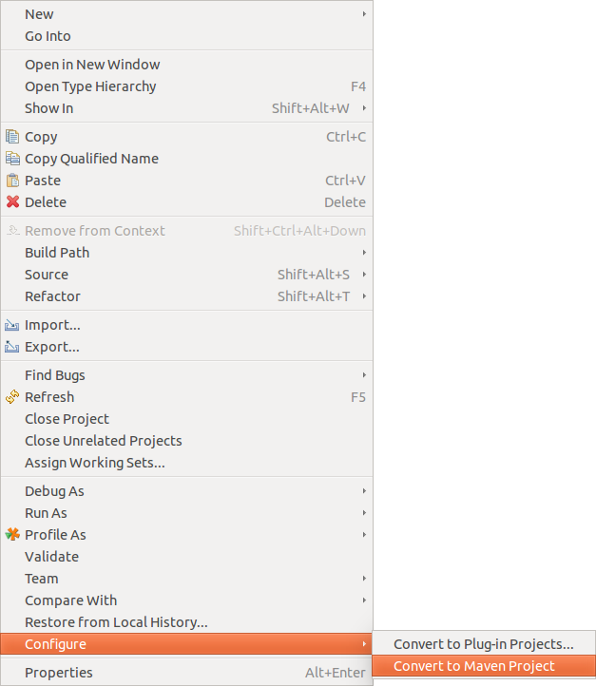
This creates a pom.xml file similar to the following.
<project xmlns="http://maven.apache.org/POM/4.0.0" xmlns:xsi="http://www.w3.org/2001/XMLSchema-instance" xsi:schemaLocation="http://maven.apache.org/POM/4.0.0 http://maven.apache.org/xsd/maven-4.0.0.xsd">
<modelVersion>4.0.0</modelVersion>
<groupId>hu.akoel.maventest</groupId>
<artifactId>hu.akoel.maventest</artifactId>
<version>0.0.1-SNAPSHOT</version>
<build>
<sourceDirectory>src</sourceDirectory>
<testSourceDirectory>src/hu/akoel/maventest/test</testSourceDirectory>
<plugins>
<plugin>
<artifactId>maven-compiler-plugin</artifactId>
<version>3.3</version>
<configuration>
<source>1.8</source>
<target>1.8</target>
</configuration>
</plugin>
</plugins>
</build>
<dependencies>
<dependency>
<groupId>junit</groupId>
<artifactId>junit</artifactId>
<version>4.12</version>
</dependency>
<dependency>
<groupId>com.google.code.gson</groupId>
<artifactId>gson</artifactId>
<version>2.3.1</version>
</dependency>
</dependencies>
</project>

  - Enable Maven index
When you search for a dependency the Maven index helps to find the exact GroupId, ArtifactId, Version. It is a good idea to turn it on. But in a normal usage you should turn it off to avoid network traffic at every start of Eclipse
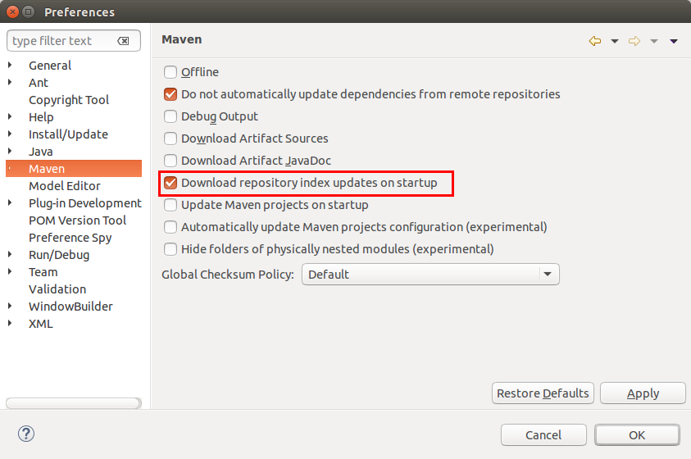

  - Add dependencies to the project
In the pom.xml editor select the Dependencies tab. Click on the Add button. If the Maven Index is on, you can search for the dependency or if you know exactly the GroupId, ArticactId, Version then you fill out the fields by hand. In the example we add the Liquibase.
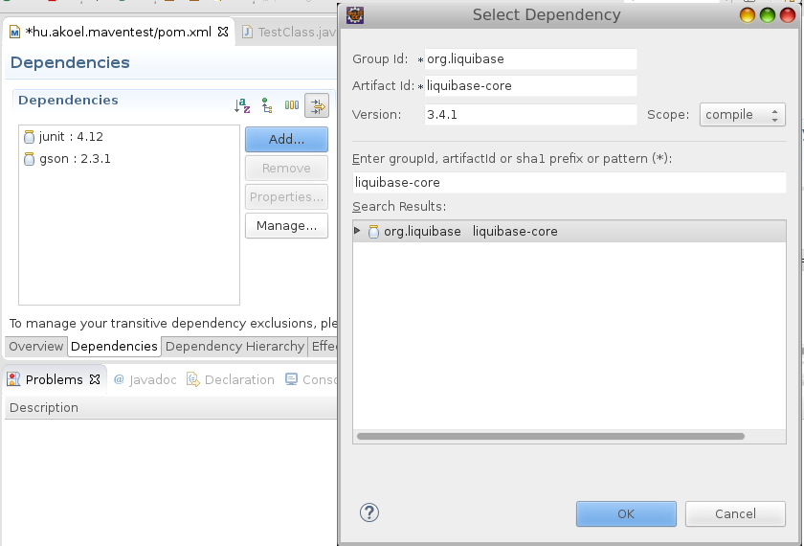

  - Maven build
In this phase the dependencies are not in the Build Path yet. First you should run a Maven build.
right-click the pom.xml file and select Run As → Maven build.
This opens a dialog which allows to define the parameters for the start. Enter clean verify in the Goals: field and press the Run button.

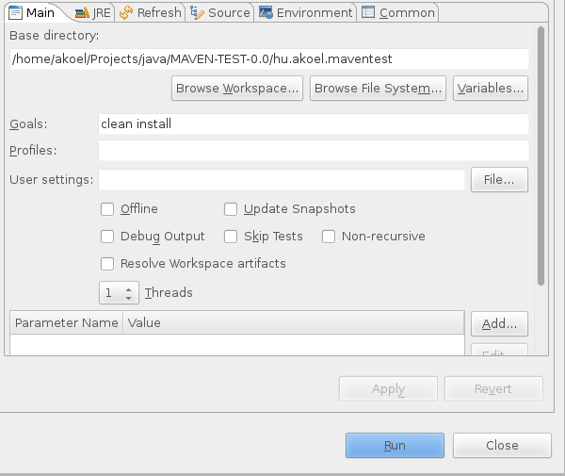

Press Finish. This starts the build, which you can follow in the Console view. The first time you run this build, it takes longer than the second time; Maven downloads all required artifacts into the local repository.
Once the build finishes, press F5 on the project to refresh it. You see a target folder, which contains the build artifacts, e.g., a JAR file.

  - Check the Build path
After the Maven build you can check the Build path which contains all your dependencies
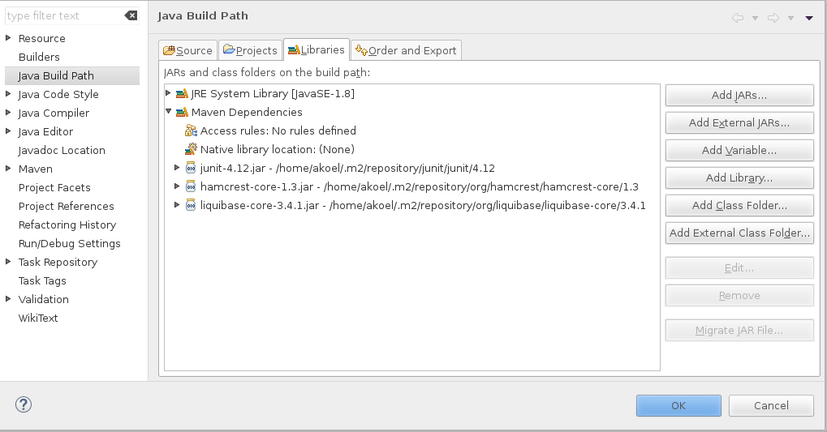

- Introduction
  - Life cycle
Maven is based around the central concept of a build lifecycle. What this means is that the process for building and distributing a particular artifact (project) is clearly defined.
For the person building a project, this means that it is only necessary to learn a small set of commands to build any Maven project, and the POM will ensure they get the results they desired.
There are three built-in build lifecycles: default, clean and site. The default lifecycle handles your project deployment, the clean lifecycle handles project cleaning, while the site lifecycle handles the creation of your project's site documentation.
Clean Lifecycle
pre-clean executes processes needed prior to the actual project cleaning
clean remove all files generated by the previous build
post-clean executes processes needed to finalize the project cleaning

Default Lifecycle
validate validate the project is correct and all necessary information is available.
initialize initialize build state, e.g. set properties or create directories.
generate-sources generate any source code for inclusion in compilation.
process-sources process the source code, for example to filter any values.
generate-resources generate resources for inclusion in the package.
process-resources copy and process the resources into the destination directory, ready for packaging.
compile compile the source code of the project.
Process-classes post-process the generated files from compilation, for example to do bytecode enhancement on Java classes.
generate-test-sources generate any test source code for inclusion in compilation.
process-test-sources process the test source code, for example to filter any values.
generate-test-resources create resources for testing.
process-test-resources copy and process the resources into the test destination directory.
test-compile compile the test source code into the test destination directory
process-test-classes post-process the generated files from test compilation, for example to do bytecode enhancement on Java classes. For Maven 2.0.5 and above.
test run tests using a suitable unit testing framework. These tests should not require the code be packaged or deployed.
prepare-package perform any operations necessary to prepare a package before the actual packaging. This often results in an unpacked, processed version of the package. (Maven 2.1 and above)
package take the compiled code and package it in its distributable format, such as a JAR.
pre-integration-test perform actions required before integration tests are executed. This may involve things such as setting up the required environment.
integration-test process and deploy the package if necessary into an environment where integration tests can be run.
post-integration-test perform actions required after integration tests have been executed. This may including cleaning up the environment.
verify run any checks to verify the package is valid and meets quality criteria.
install install the package into the local repository, for use as a dependency in other projects locally.
deploy done in an integration or release environment, copies the final package to the remote repository for sharing with other developers and projects.

Site Lifecycle
pre-site executes processes needed prior to the actual project site generation
site generates the project's site documentation
post-site executes processes needed to finalize the site generation, and to prepare for site deployment
site-deploy deploys the generated site documentation to the specified web server

  - Lifecycle Phases
These lifecycle phases are executed sequentially to complete the default/site/clean lifecycle. Given the lifecycle phases above, this means that when the default lifecycle is used, Maven will first validate the project, then will try to compile the sources, run those against the tests, package the binaries (e.g. jar), run integration tests against that package, verify the package, install the verifed package to the local repository, then deploy the installed package in a specified environment.
To do all those, you only need to call the last build phase to be executed, in this case, deploy:
mvn deploy

  - Plug-in and goals
A Maven plugin is a collection of one or more goals. A goal is a “unit of work” in Maven. It is possible to execute goals independently or a part of a larger chain of goals. We use the following format plugin:goal
Goals can define parameters, which may have default values. Plugin goals can be attached to a life cycle phase.
However, even though a build phase is responsible for a specific step in the build lifecycle, the manner in which it carries out those responsibilities may vary. And this is done by declaring the plugin goals bound to those build phases.
A plugin goal represents a specific task (finer than a build phase) which contributes to the building and managing of a project. It may be bound to zero or more build phases.
A goal not bound to any build phase could be executed outside of the build lifecycle by direct invocation.
mvn clean dependency:copy-dependencies package

The order of execution depends on the order in which the goal(s) and the build phase(s) are invoked. For example, consider the command above. The clean and package arguments are build phases, while the dependency:copy-dependencies is a goal (of a plugin).
If this were to be executed, the clean phase will be executed first (meaning it will run all preceeding phases of the clean lifecycle, plus the clean phase itself), and then the dependency:copy-dependencies goal, before finally executing the package phase (and all its preceeding build phases of the default lifecycle).
Moreover, if a goal is bound to one or more build phases, that goal will be called in all those phases.
Furthermore, a build phase can also have zero or more goals bound to it. If a build phase has no goals bound to it, that build phase will not execute. But if it has one or more goals bound to it, it will execute all those goals
  - Setting Up Your Project to Use the Build Lifecycle - Packaging
Some phases have goals bound to them by default. And for the default lifecycle, these bindings depend on the packaging value.
The first, and most common way, is to set the packaging for your project via the equally named POM element <packaging>. Some of the valid packaging values are jar, war, ear and pom. If no packaging value has been specified, it will default to jar.
Each packaging contains a list of goals to bind to a particular phase.
Clean Lifecycle Bindings
clean clean:clean

Default Lifecycle Bindings - Packaging ejb / ejb3 / jar / par / rar / war
process-resources resources:resources
compile compiler:compile
process-test-resources resources:testResources
test-compile compiler:testCompile
test surefire:test
package ejb:ejb or ejb3:ejb3 or jar:jar or par:par or rar:rar or war:war
install install:install
deploy deploy:deploy

maven-clean-plugin:2.5:clean deleting target folder

maven-resource-plugin:2.3:resources copying files from main/resources folder to target

maven-compiler-plugin:2.5.1:compile compiling main/java to target/class folder

maven-resource-plugin:2.3:testResources copying files from test/resources folder to target

maven-compiler-plugin:2.5.1:testCompile compiling test/java to target/test-class folder

maven-surefire-plugin:2.10:test test

maven-war-plugin:2.6:war packaging webapp

maven-install-plugin:2.4:install installing war to maven repository

Default Lifecycle Bindings - Packaging ear
generate-resources ear:generate-application-xml
process-resources resources:resources
package ear:ear
install install:install
deploy deploy:deploy

Default Lifecycle Bindings - Packaging maven-plugin
generate-resources plugin:descriptor
process-resources resources:resources
compile compiler:compile
process-test-resources resources:testResources
test-compile compiler:testCompile
test surefire:test
package jar:jar and plugin:addPluginArtifactMetadata
install install:install
deploy deploy:deploy

Default Lifecycle Bindings - Packaging pom
package site:attach-descriptor
install install:install
deploy deploy:deploy

Site Lifecycle Bindings
site site:site
site-deploy site:deploy

  - Setting Up Your Project to Use the Build Lifecycle – Plugins
The second way to add goals to phases is to configure plugins in your project. Plugins are artifacts that provide goals to Maven. Furthermore, a plugin may have one or more goals wherein each goal represents a capability of that plugin. For example, the Compiler plugin has two goals: compile and testCompile. The former compiles the source code of your main code, while the latter compiles the source code of your test code.
As you will see in the later sections, plugins can contain information that indicates which lifecycle phase to bind a goal to. Note that adding the plugin on its own is not enough information - you must also specify the goals you want to run as part of your build.
The goals that are configured will be added to the goals already bound to the lifecycle from the packaging selected. If more than one goal is bound to a particular phase, the order used is that those from the packaging are executed first, followed by those configured in the POM. Note that you can use the <executions> element to gain more control over the order of particular goals.
For example, the Modello plugin binds by default its goal modello:java to the generate-sources phase (Note: The modello:java goal generates Java source codes). So to use the Modello plugin and have it generate sources from a model and incorporate that into the build, you would add the following to your POM in the <plugins> section of <build>:
...
<plugin>
<groupId>org.codehaus.modello</groupId>
<artifactId>modello-maven-plugin</artifactId>
<version>1.8.1</version>
<executions>
<execution>
<configuration>
<models>
<model>src/main/mdo/maven.mdo</model>
</models>
<version>4.0.0</version>
</configuration>
<goals>
<goal>java</goal>
</goals>
</execution>
</executions>
</plugin>
...
Now, in the case of modello:java, it only makes sense in the generate-sources phase. But some goals can be used in more than one phase, and there may not be a sensible default. For those, you can specify the phase yourself. For example, let's say you have a goal display:time that echos the current time to the commandline, and you want it to run in the process-test-resources phase to indicate when the tests were started. This would be configured like so:
...
<plugin>
<groupId>com.mycompany.example</groupId>
<artifactId>display-maven-plugin</artifactId>
<version>1.0</version>
<executions>
<execution>
<phase>process-test-resources</phase>
<goals>
<goal>time</goal>
</goals>
</execution>
</executions>
</plugin>
...

- HowTo
  - Create a Project from Maven Template
You can generate the all Java hierarchy for Maven with template files.
GroupID: Identifies your project uniquely across all projects, so we need to enforce a naming schema. It has to follow the package name rules, what means that has to be at least as a domain name you control, and you can create as many subgroups as you want
ArtifactId: Is the name of the jar without version. If you created it then you can choose whatever name you want with lowercase letters and no strange symbols. If it's a third party jar you have to take the name of the jar as it's distributed.
Version: if you distribute it then you can choose any typical version with numbers and dots (1.0, 1.1, 1.0.1, ...). Don't use dates as they are usually associated with SNAPSHOT (nightly) builds. If it's a third party artifact, you have to use their version number whatever it is, and as strange as it can look.

$:mvn archetype:generate -DgroupId=hu.akoel.test -DartifactId=hu-akoel-test -DarchetypeArtifactId=maven-archetype-quickstart -Dinteractivemode=false

Generated Java hierarchy:
.
└── hu-akoel-test
├── pom.xml
└── src
├── main
│ └── java
│ └── hu
│ └── akoel
│ └── test
│ └── App.java
└── test
└── java
└── hu
└── akoel
└── test
└── AppTest.java

Genereted pom.xml file

<project xmlns="http://maven.apache.org/POM/4.0.0" xmlns:xsi="http://www.w3.org/2001/XMLSchema-instance"
xsi:schemaLocation="http://maven.apache.org/POM/4.0.0 http://maven.apache.org/maven-v4_0_0.xsd">
<modelVersion>4.0.0</modelVersion>
<groupId>hu.akoel.test</groupId>
<artifactId>hu-akoel-test</artifactId>
<packaging>jar</packaging>
<version>1.0-SNAPSHOT</version>
<name>hu-akoel-test</name>
<url>http://maven.apache.org</url>
<dependencies>
<dependency>
<groupId>junit</groupId>
<artifactId>junit</artifactId>
<version>3.8.1</version>
<scope>test</scope>
</dependency>
</dependencies>
</project>

  - Create a Maven jar file from your project

$: mvn package

The jar file will generated under the target folder in the maven project

  - Put the Maven jar into your central repository

$: mvn install:install-file -DgroupId=hu.akoel.neurnet -DartifactId=neurnet -Dversion=1.0.0 -Dpackaging=jar -Dfile=/home/akoel/Projects/java/neurnet/hu.akoel.neurnet/target/neurnet-1.0.0.jar

The project goes into your local repository typically: ~/.m2/repository/

  - Reference to the Maven jar, being in the local repository, in a new Maven project
Update the dependencies in the pom.xm file in the new Maven project:
<dependencies>
<dependency>
<groupId>hu.akoel.neurnet</groupId>
<artifactId>neurnet</artifactId>
<version>1.0.0</version>
</dependency>
</dependencies>

  - Junit test under the Maven build
You can run Junit tests under the Maven build automatically. To enable this you should fulfill two conditions: 1. Set the directory of the test cases in the pom.xm file under the <testSourceDirectory> tag. 2. The name of the test case classes should follow name conventions: Test*, *Test, *TestCase
If one of the test case fails then the Maven build fails as well. In this case you get a message on the console:

Tests run: 1, Failures: 1, Errors: 0, Skipped: 0

[INFO] ------------------------------------------------------------------------
[INFO] BUILD FAILURE
[INFO] ------------------------------------------------------------------------
[INFO] Total time: 3.664 s
[INFO] Finished at: 2015-10-24T14:54:34+02:00
[INFO] Final Memory: 18M/175M
[INFO] ------------------------------------------------------------------------
[ERROR] Failed to execute goal org.apache.maven.plugins:maven-surefire-plugin:2.12.4:test (default-test) on project hu.akoel.maventest: There are test failures.

  - Multiple source directories for compile
Two possible solution for this
<sourceDirectory>.</sourceDirectory>
<plugins>
<plugin>
<groupId>org.apache.maven.plugins</groupId>
<artifactId>maven-compiler-plugin</artifactId>
<configuration>
<includes>
<include>entitibeans/**/*</include>
<include>sessionbeans/**/*</include>
</includes>
</configuration>
</plugin>
</plugins>

<plugin>
<groupId>org.codehaus.mojo</groupId>
<artifactId>build-helper-maven-plugin</artifactId>
<executions>
<execution>
<phase>generate-sources</phase>
<goals>
<goal>add-source</goal>
</goals>
<configuration>
<sources>
<source>entitybeans</source>
<source>sessionbeans</source>
</sources>
</configuration>
</execution>
</executions>
</plugin>

  - Include and Exclude files from WAR
<plugin>
<groupId>org.apache.maven.plugins</groupId>
<artifactId>maven-war-plugin</artifactId>
<version>2.6</version>
<configuration>
<warSourceDirectory>WebContent</warSourceDirectory>

<!-- Create WAR without web.xml -->
<failOnMissingWebXml>false</failOnMissingWebXml>

<!-- Include files in the WAR file -->
<webResources>
<resource>

<!-- this is relative to the pom.xml directory -->
<directory>resource</directory>

<!-- the list has a default value of ** -->
<includes>
<include>**/*.jpg</include>
</includes>

<!-- there's no default value for this -->
<excludes>
<exclude>**/image2</exclude>
</excludes>
</resource>
</webResources>
</configuration>
</plugin>

  - EclipseLink moved from maven
<repositories>
<!-- eclipselink moved from maven -->
<repository>
<id>oss.sonatype.org</id>
<name>OSS Sonatype Staging</name>
<url>https://oss.sonatype.org/content/groups/staging</url>
</repository>
</repositories>

…

<dependencies>

<!-- eclipselink -->
<dependency>
<groupId>org.eclipse.persistence</groupId>
<artifactId>eclipselink</artifactId>
<version>2.6.1</version>
<scope>provided</scope><!-- since I'm running inside a Java EE container -->
</dependency>

<!-- eclipselink API -->
<dependency>
<groupId>org.eclipse.persistence</groupId>
<artifactId>javax.persistence</artifactId>
<version>2.1.0</version>
<scope>provided</scope><!-- since I'm running inside a Java EE container -->
</dependency>
</dependencies>

  - gf-client

<dependencies>
<dependency>
<groupId>org.glassfish.main.appclient.client</groupId>
<artifactId>gf-client</artifactId>
<version>4.0</version>
<scope>system</scope>
<systemPath>/usr/local/programs/glassfish4/glassfish/lib/gf-client.jar</systemPath>
</dependency>
</dependencies>

  - web.xml
In case of using glassfish, the web.xml should not be in the WEB-INF folder. But in this case the pom.xml will complain about the missing web.xml saying that the <failOnMissingWebXml> is set to true. So we should set it to false

<plugin>
<groupId>org.apache.maven.plugins</groupId>
<artifactId>maven-war-plugin</artifactId>
<version>2.6</version>
<configuration>
<failOnMissingWebXml>false</failOnMissingWebXml>
</configuration>
</plugin>

  - Location of persistence.xml
If the location in the source: src/main/resources/META-INF/persistence.xml then persistence.xml will be put inside the WEB-INF/classes/META-INF directory under the root of the classpath automatically by maven

  - Skip test

<plugin>
<groupId>org.apache.maven.plugins</groupId>
<artifactId>maven-surefire-plugin</artifactId>
<version>2.19</version>
<configuration>
<skipTests>true</skipTests>
</configuration>
</plugin>

  - User defined properties
<properties>
<my.plugin.name>maventest</my.plugin.name>
<my.plugin.version>0.0.2</my.plugin.version>
</properties>

<modelVersion>4.0.0</modelVersion>
<groupId>${my.plugin.name}</groupId>
<artifactId>${my.plugin.name}</artifactId>
<version>${my.plugin.version}</version>
<packaging>war</packaging>

  - Deploy

<properties>
<my.plugin.name>maventest</my.plugin.name>centrum
<my.plugin.version>0.0.2</my.plugin.version>
<my.artifact>${my.plugin.name}-${my.plugin.version}</my.artifact>
<my.file.name>${my.plugin.name}-${my.plugin.version}.war</my.file.name>
<my.file.url>${project.build.directory}/${my.file.name}</my.file.url>
<my.gf.username>admin</my.gf.username>
<my.gf.password></my.gf.password>
<my.gf.host>localhost</my.gf.host>
<my.gf.port>4848</my.gf.port>
<my.gf.directory>/usr/local/programs/glassfish4/glassfish</my.gf.directory>
<my.gf.asadmin>${my.gf.directory}/bin/asadmin</my.gf.asadmin>
</properties>
...
<build>
...
<plugins>
<!-- Deploy -->
<plugin>
<groupId>org.codehaus.mojo</groupId>
<artifactId>exec-maven-plugin</artifactId>
<version>1.4.0</version>
<executions>
<execution>
<goals>
<goal>exec</goal>
</goals>
<phase>install</phase>
</execution>
</executions>
<configuration>
<executable>${my.gf.asadmin}</executable>
<commandlineArgs>
-u ${my.gf.username} -H ${my.gf.host} -p ${my.gf.port} deploy –force ${my.file.url}
</commandlineArgs>
</configuration>
</plugin>
</plugins>
</build>

  - Full pom.xml example
<project xmlns="http://maven.apache.org/POM/4.0.0" xmlns:xsi="http://www.w3.org/2001/XMLSchema-instance"
xsi:schemaLocation="http://maven.apache.org/POM/4.0.0 http://maven.apache.org/xsd/maven-4.0.0.xsd">
<modelVersion>4.0.0</modelVersion>

<properties>
<my.path.glassfishclient>/usr/local/programs/glassfish4/glassfish/lib/gf-client.jar</my.path.glassfishclient>
</properties>

<groupId>hu.akoel.maven</groupId>
<artifactId>templatejee</artifactId>
<version>0.0.2</version>
<packaging>war</packaging>

<name>templatejee</name>
<url>http://maven.apache.org</url>

<repositories>
<!-- It needs because eclipselink moved from maven -->
<repository>
<id>oss.sonatype.org</id>
<name>OSS Sonatype Staging</name>
<url>https://oss.sonatype.org/content/groups/staging</url>
</repository>
</repositories>
<build>
<!-- This resources going to be put into WAR file -->
<resources>
</resources>

<!-- <sourceDirectory>.</sourceDirectory> -->
<plugins>

<!-- War file descriptor - extra files -->
<plugin>
<groupId>org.apache.maven.plugins</groupId>
<artifactId>maven-war-plugin</artifactId>
<version>2.6</version>
<configuration>
<!-- create war without web.xml -->
<failOnMissingWebXml>false</failOnMissingWebXml>
</configuration>
</plugin>

<!-- Compiler definition -->
<plugin>
<artifactId>maven-compiler-plugin</artifactId>
<version>3.3</version>
<configuration>
<source>1.7</source>
<target>1.7</target>
</configuration>
</plugin>

<!-- Unit test -->
<plugin>
<groupId>org.apache.maven.plugins</groupId>
<artifactId>maven-surefire-plugin</artifactId>
<version>2.19</version>
<configuration>
<skipTests>false</skipTests>
</configuration>
</plugin>
</plugins>
</build>

<dependencies>

<!-- Javaeee-api -->
<dependency>
<groupId>javax</groupId>
<artifactId>javaee-api</artifactId>
<version>7.0</version>
</dependency>

<!-- eclipselink -->
<dependency>
<groupId>org.eclipse.persistence</groupId>
<artifactId>eclipselink</artifactId>
<version>2.6.1</version>
<scope>provided</scope><!-- since I'm running inside a Java EE container -->
</dependency>
<!-- eclipselink API -->
<dependency>
<groupId>org.eclipse.persistence</groupId>
<artifactId>javax.persistence</artifactId>
<version>2.1.0</version>
<scope>provided</scope><!-- since I'm running inside a Java EE container -->
</dependency>

<!-- glassfish-client -->
<dependency>
<groupId>org.glassfish.main.appclient.client</groupId>
<artifactId>gf-client</artifactId>
<version>4.0</version>
<scope>system</scope>
<systemPath>${my.path.glassfishclient}</systemPath>
</dependency>

<!-- DB connection -->
<dependency>
<groupId>org.postgresql</groupId>
<artifactId>postgresql</artifactId>
<version>9.4-1204-jdbc42</version>
</dependency>

<!-- Liquibase -->
<dependency>
<groupId>org.liquibase</groupId>
<artifactId>liquibase-core</artifactId>
<version>3.4.1</version>
</dependency>

<!-- Junit -->
<dependency>
<groupId>junit</groupId>
<artifactId>junit</artifactId>
<version>4.12</version>
</dependency>

<!-- Mockito -->
<dependency>
<groupId>org.mockito</groupId>
<artifactId>mockito-all</artifactId>
<version>1.10.19</version>
</dependency>

<!-- json -->
<dependency>
<groupId>com.jayway.jsonpath</groupId>
<artifactId>json-path</artifactId>
<version>2.0.0</version>
</dependency>
<dependency>
<groupId>org.json</groupId>
<artifactId>json</artifactId>
<version>20140107</version>
</dependency>
<dependency>
<groupId>com.fasterxml.jackson.core</groupId>
<artifactId>jackson-core</artifactId>
<version>2.6.3</version>
</dependency>
<dependency>
<groupId>com.fasterxml.jackson.core</groupId>
<artifactId>jackson-annotations</artifactId>
<version>2.6.3</version>
</dependency>
<dependency>
<groupId>com.fasterxml.jackson.core</groupId>
<artifactId>jackson-databind</artifactId>
<version>2.6.3</version>
</dependency>

</dependencies>
</project>

