EJB java Stand-Alone Client in Eclipse

- Start the Eclipse on a clear workspace
- Click on the Workbench
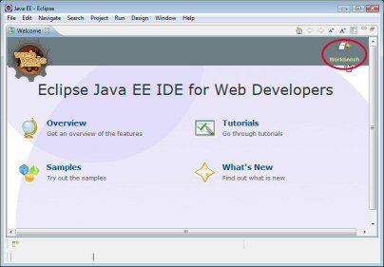
- Install the JBoss server
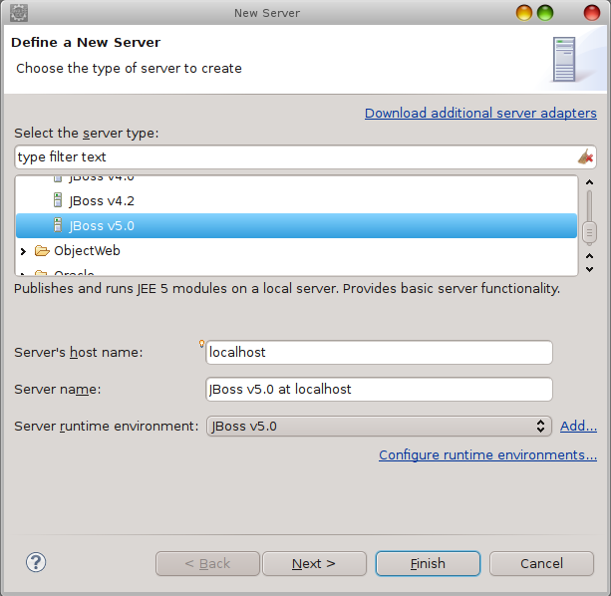

- Create Enterprise Application project
File > New > Enterprise Application Project
Project name: TestApplication
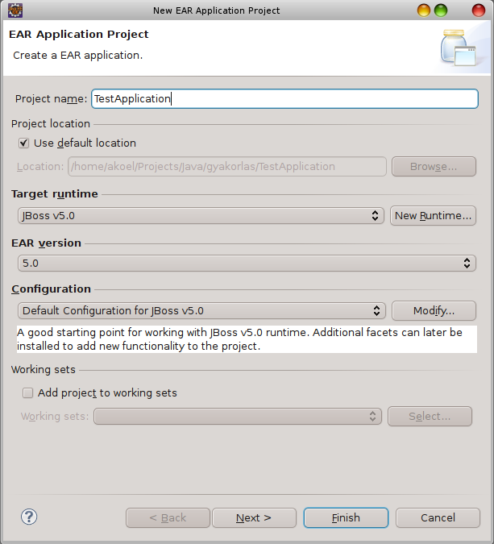

Next
New Module
Check “Application client module” and “EJB module” checkbox
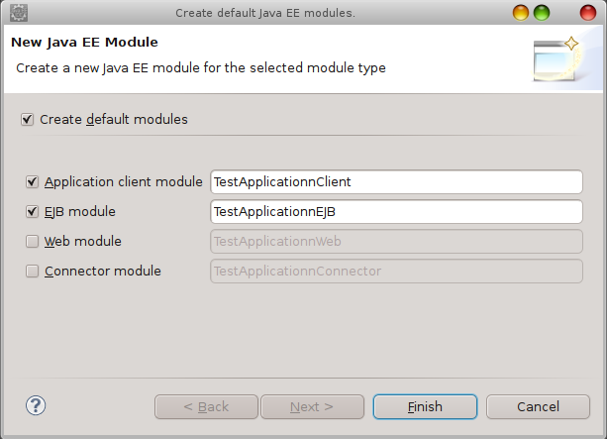

Finish – Two project are created
Check the “Generate application.xml deployment descriptor” checkbox
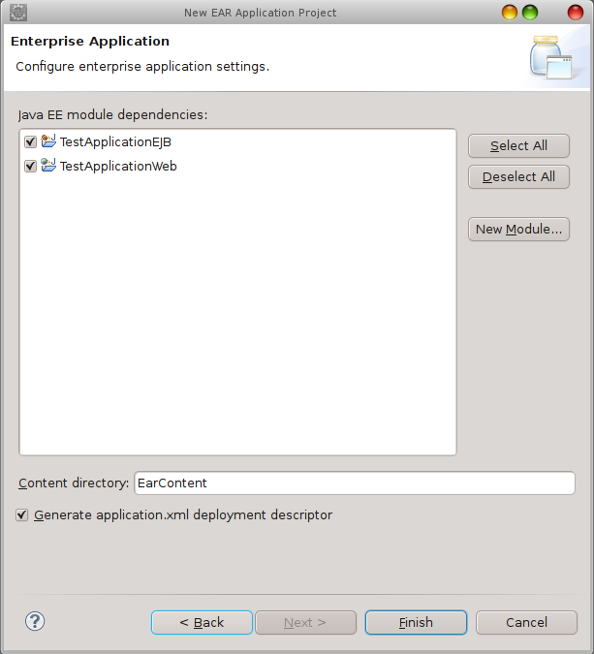

Finish

- Import some files
TestApplicationClient > Properties > java Build Path > Libraries > Add ExternalJARs...
$JBOSS_HOME/client/jbossall-client.jar
$JBOSS_HOME/client/jboss-ejb3-common-client.jar
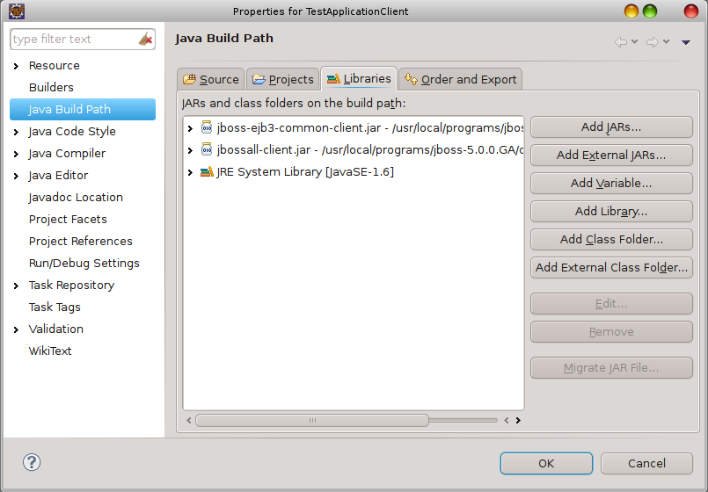

TestApplicationClient > Properties > Java Build Path > Project > Add..
Check “TestApplicationEJB” checkbox
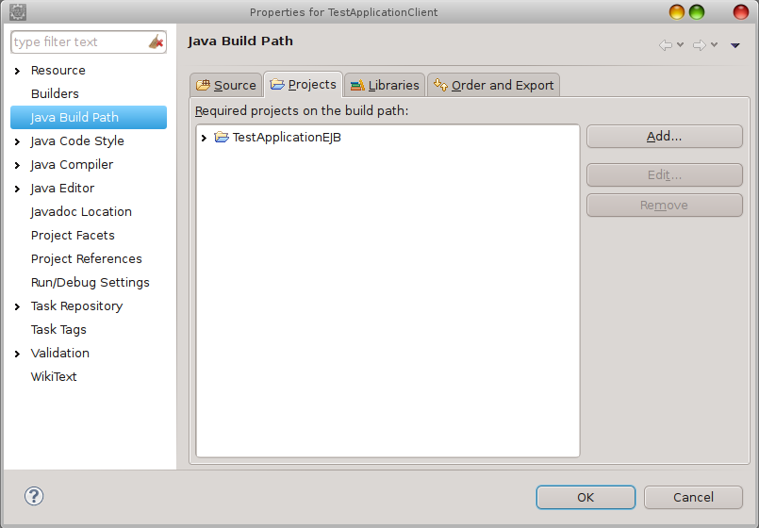

- Create EJB component – stateless session bean
TestApplicationEJB > New > Interface
Package: lesson.stateless
Name: HelloWorld
Finish

HelloWorld.java
package lesson.stateless;

public interface HelloWorld {
public String getMessage();
}

TestApplicationEJB > New > Class
Package: lesson.stateless
Name: HelloWorldBean
Finish

HelloWorldBean
package lesson.stateless;

import javax.ejb.Remote;
import javax.ejb.Stateless;

@Stateless
@Remote(HelloWorld.class)
public class HelloWorldBean implements HelloWorld {
public String getMessage() {
return "Hello EJB World";
}
}
- Create jndi.properties file in the root of the TestApplicationClient project

jndi.properties
java.naming.factory.initial = org.jnp.interfaces.NamingContextFactory
java.naming.factory.url.pkgs = org.jboss.naming:org.jnp.interfaces
java.naming.provider.url = localhost:1099
Ha ezt nem teszed meg, akkor a következő kódot kell beleilleszteni mondjuk a main() metódusba:

….
properties props = new Properties();
props.setProperty("java.naming.factory.initial","org.jnp.interfaces.NamingContextFactory");
props.setProperty("java.naming.factory.url.pkgs", "org.jboss.naming");
props.setProperty("java.naming.provider.url", "127.0.0.1:1099");
….

- Kliens program elkészítése
TestApplicationClient > New > Class
Package: lessonClient
Name: TestApplicationClient

TestApplicationClient.java
package lesson.client;

import java.io.FileInputStream;
import java.util.Properties;
import javax.naming.InitialContext;
import lesson.stateless.HelloWorld;

public class TestApplicationClient {

public static void main(String[] args) throws Exception {
Properties props = new Properties();
props.load(new FileInputStream("jndi.properties"));
InitialContext ctx = new InitialContext(props);
HelloWorld hello = (HelloWorld) ctx.lookup("TestApplication/HelloWorldBean/remote");
System.out.println(hello.getMessage());
}
}

- Deploy the EJB project

Két megoldás adódik a deploy-ra.
1. Jobbegér gomb a jBoss Runtime Server-en a Servers ablakban > Add and Remove..
2. Jobbegér gomb az EJB project-en > Run As → Run On Server

- Run the application

TestApplicationClient.java > Run As > JavaApplication

A konzolon látni kell, ha hiba nélkül futott le a program, egy “Hello EJB World” üzenet jelenik meg.

