EJB Web Application

- Start the Eclipse on a clear workspace
- Click on the Workbench
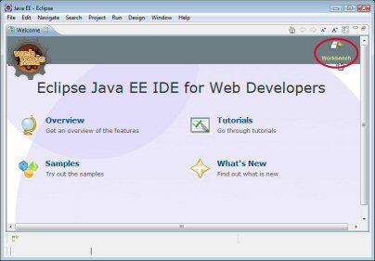
- Install the JBoss server
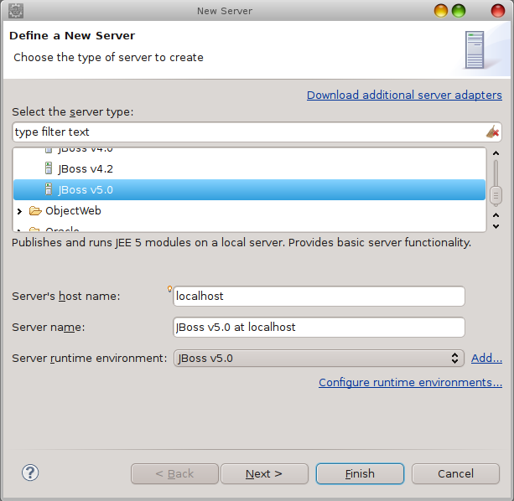
- Create Enterprise Application project
File > New > Enterprise Application Project
Project name: TestApplication
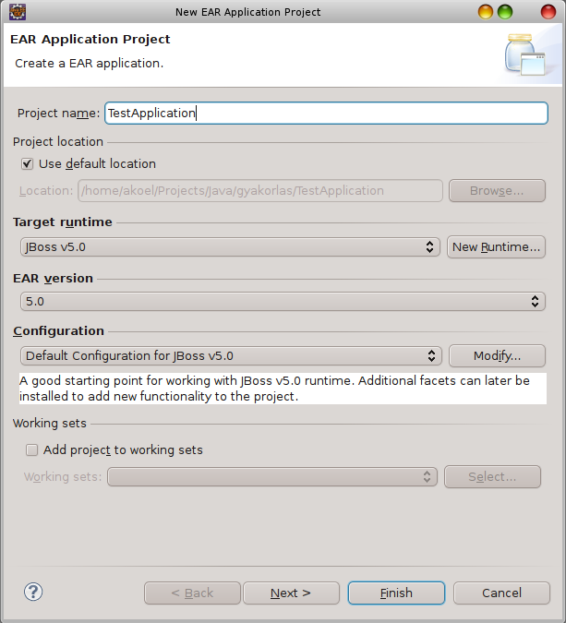

Next
New Module
Check “EJB module” and “Web module” checkbox

Finish – Two project are created
Check the “Generate application.xml deployment descriptor” checkbox
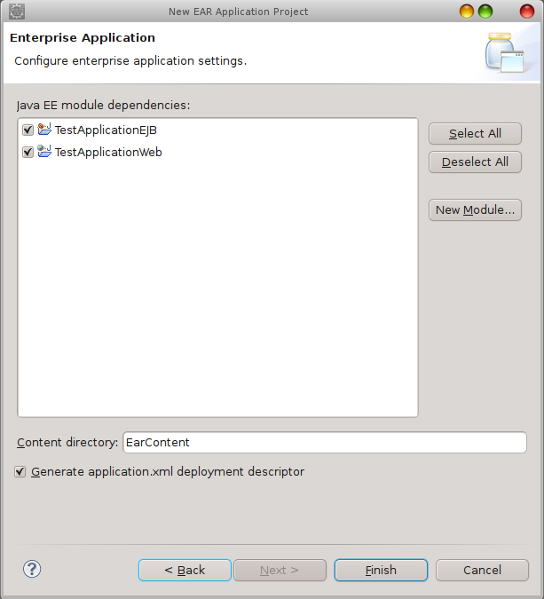

Finish – The 3rd project is created

- Create EJB component – stateless session bean
TestApplicationEJB > New > Interface
Package: lesson.stateless
Name: HelloWorld
Finish

HelloWorld.java
package lesson.stateless;

public interface HelloWorld {
public String getMessage();
}

TestApplicationEJB > New > Class
Package: lesson.stateless
Name: HelloWorldBean
Finish

HelloWorldBean
package lesson.stateless;

import javax.ejb.Remote;
import javax.ejb.Stateless;

@Stateless
@Remote(HelloWorld.class)
public class HelloWorldBean implements HelloWorld {
public String getMessage() {
return "Hello EJB World";
}
}
- Using the WEB Module as EJB Client

TestApplicationWeb > WebContent > New > JSP file
File name: index
Finish

index.jsp
<%@ page language="java" contentType="text/html; charset=UTF-8" pageEncoding="UTF-8"%>
<!DOCTYPE html PUBLIC "-//W3C//DTD HTML 4.01 Transitional//EN" "http://www.w3.org/TR/html4/loose.dtd">
<html>
<head>
<meta http-equiv="Content-Type" content="text/html; charset=UTF-8">
<title>Web Module used as EJB Client</title>
</head>
<body>
<!--
<a href="TestServlet">Click here to call the EJB component</a>
-->
<form action="${pageContext.request.contextPath}/TestServlet">
<input type="text" name="name" /><input type="submit" value="Submit" />
</form>
</body>
</html>

- Create the servlet component

TestApplicationWeb > Properties > Deployment Assembly > Manifest Entries > Add..
Select the TestApplicationEJB.jar
Finish

TestApplicationWeb > Properties > Java Build Path > Projects > Add...
Check the TestApplicationEJB
OK
OK

TestApplicationWeb > New > Servlet
java package: lesson.servlets
File name: TestServlet
Finish

TestServlet.java
package lesson.servlets;

import java.io.IOException;
import javax.naming.InitialContext;
import javax.naming.NamingException;
import javax.servlet.ServletException;
import javax.servlet.http.HttpServletRequest;
import javax.servlet.http.HttpServletResponse;
import lesson.stateless.HelloWorld;

public class TestServlet extends javax.servlet.http.HttpServlet implements javax.servlet.Servlet {
static final long serialVersionUID = 1L;

protected void doGet(HttpServletRequest request, HttpServletResponse response) throws ServletException, IOException {
try {
InitialContext ctx = new InitialContext();
HelloWorld hello = (HelloWorld) ctx.lookup("TestApplication/HelloWorldBean/remote");
System.out.println(hello.getMessage());
response.getWriter().write( hello.getMessage() + ": " + request.getParameter( "name" ));
} catch (NamingException e) {
e.printStackTrace();
}
}
}

egy másik lehetséges megoldás, ami sokkal egyszerűbb
package lesson.servlets;

import java.io.IOException;
import javax.ejb.EJB;
import javax.servlet.ServletException;
import javax.servlet.http.HttpServletRequest;
import javax.servlet.http.HttpServletResponse;
import lesson.stateless.HelloWorld;

public class TestServlet extends javax.servlet.http.HttpServlet implements javax.servlet.Servlet {
static final long serialVersionUID = 1L;

@EJB
HelloWorld hello;

protected void doGet(HttpServletRequest request, HttpServletResponse response) throws ServletException, IOException {

System.out.println(hello.getMessage());
response.getWriter().write( hello.getMessage() + ": " + request.getParameter( "name" ));
}
}

- Run the application

TestApplicationWeb > Run As > Run on Server > JBoss v5.0 at localhost
Finish
A consolon látni kell, hogy hiba nélkül indult el a szerver

- Test
Böngészőbe: http://localhost:8080/TestApplicationWeb/

Click on the Submit
Eredménykét a böngészőben ezt láthatod:

És a szerver consolján látni kell a következő sort:

