Install Tomcat server

- Start the Eclipse on a clear workspace
- Click on the Workbench
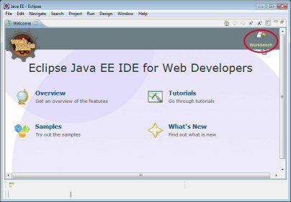
- Ha nem létezik a Server fül, akkor Window->Show View->Servers. És akkor megjelenik egy Server fül az alsó szekcióban.
- A Server fülön Jobbegérgomb->New->Server->Apache
- Select the needed Apache Tomcat version
- Click on the Download and Install button to download the Tomcat server
- Set its directory to install to
- Select one of already installed jdk version from a list for the JRE
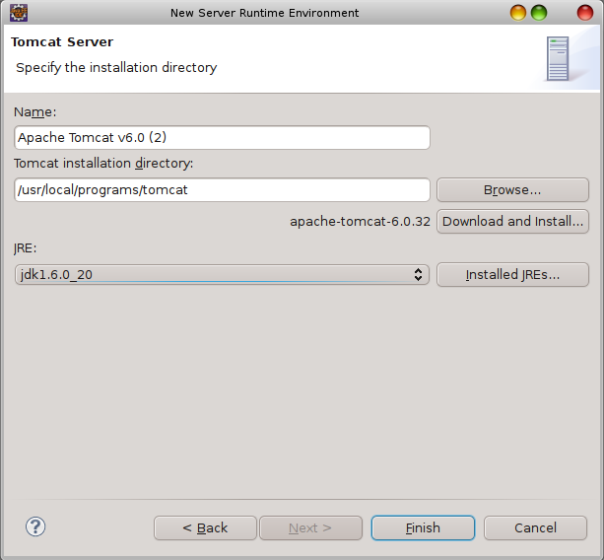
- Finish it. Ekkor létrejön a Server nevü project.
- A Server fülön lévő Tomcaten Jobbegérgomb->Start Hiba nélkül el kell hogy induljon.
- Duppla klikk a Server fülön lévő Tomcat serverre. Ekkor megjelenik az Editor területen a Tomcat server tulajdonsag adatlap.
- Keresd meg a Port Name szekcióban a HTTP/1.1 elemet és nézd meg a Port Number értékét. Ha nincs más http szerver a gépen, akkor ez az érték 80 ha van, akkor 8080. Mi most ezt az estet vesszük
- Egy Web böngészőbe írd be hogy http://localhost:8080
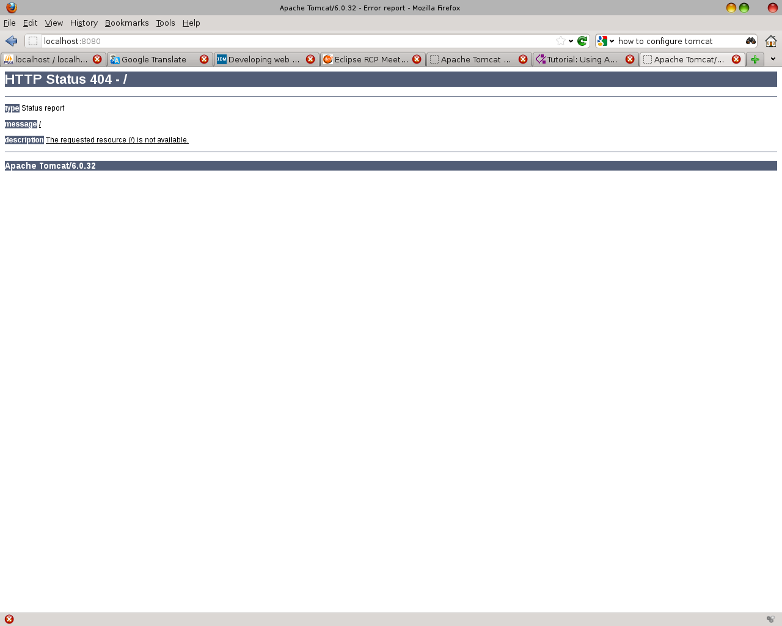
- Hiba van az oldalon, de legalább üzenetet kaptunk a Tomcat-től. Hurrá. A hiba oka az, hogy az Eclipse nem másolja be a saját tomcat servere alá automatikusan a Default Web Apps-okat. Ezt most kézzel kell megtenni, ha akarjuk, de nem feltétlenül szükséges. (ROOT, docs, examples, manager). A művelet, amit tennünk kell az a deploy. Ehhez nem kell mást csinálni, mint átmásolni a Tomcat server könyvtárából a webapps/ROOT könyvtárat az Eclipse workspace konyvtárába a .metadata\.plugins\org.eclipse.wst.server.core\tmp0\wtpwebapps könyvtárba
Általában a deploy azt jelenti, hogy be kell másolnunk a war fajlt az applikáció szerver webapps könyvtárába, ahol aztán a szerver automatikusan elvégzi a deploy műveletet és azt vesszük észre, hogy készít egy a war fájllal azonos nevü könyvtárat a webapps könyvtáron belül. Az undipeploy művelet pedig annyit jelent hogy kitöröljük a war fájlt, amit a szerver érzékel és törli a hozzá tartozó könyvtárat.
- A Web böngészőbe írd be újra, hogy http://localhost:8080
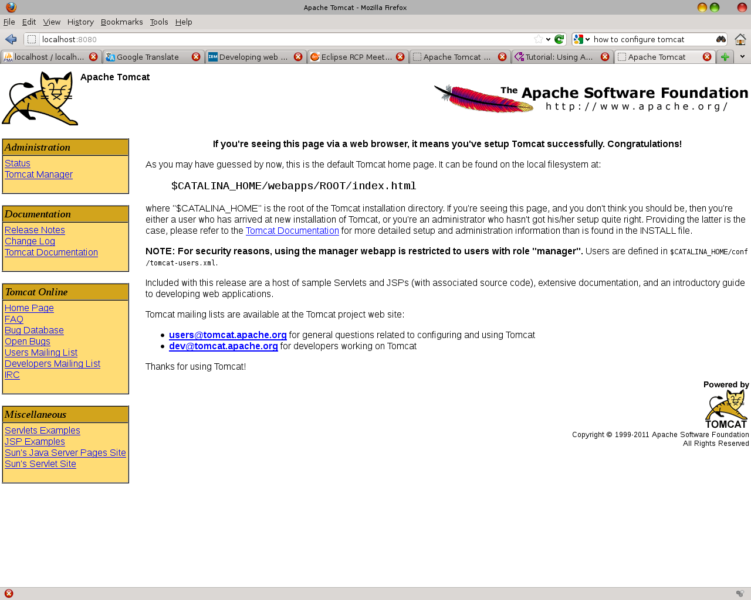

Import sample Application

- Helyezd el valahová a test-app.zip fájlt
- Inditsd el az Eclipse-t
- File->Import->General->Existing project
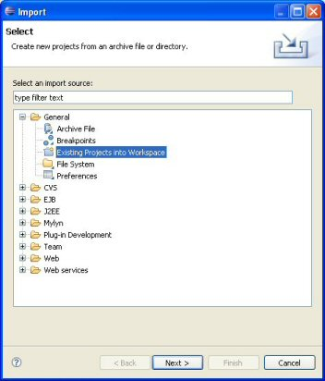
- Válaszd ki hogy az archivumból szeretnél importálni projectet, és az utvonalban add meg a test-app.zip elérési útvonalát.
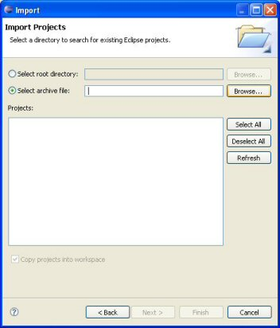
- A Server fülön a Tomcat-en Jobbegérgomb->Add and Remove projects
- Válaszd ki a test-app projectet az Available ablakból és nyomd meg az Add> gombot hogy átkerüljön a Configured ablakba
- Finish it
- Restart the Tomcat server
- Check the http://localhost:8080/test-app
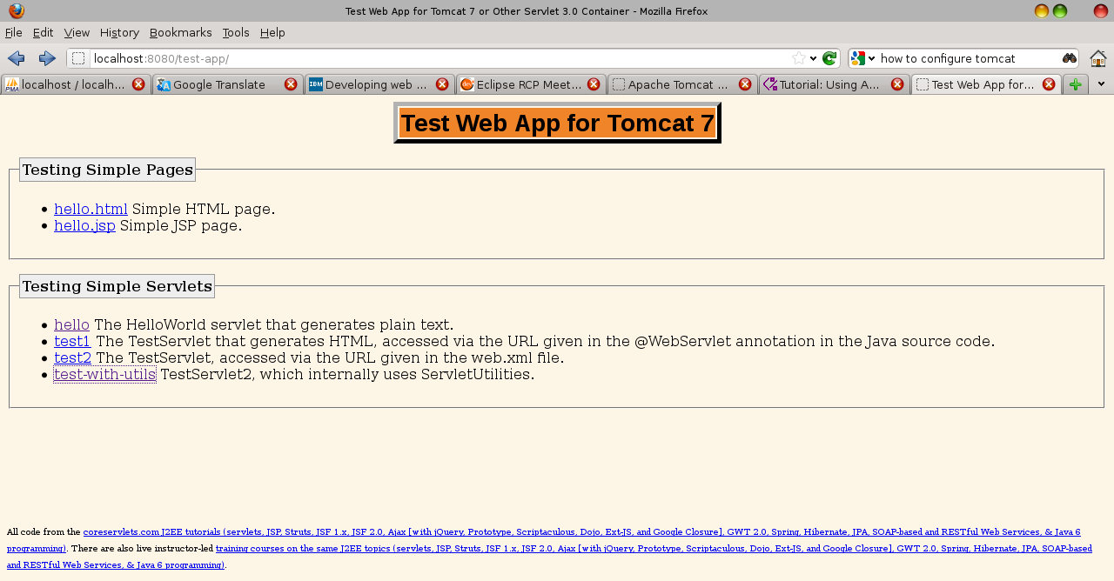
Create a new Web App

- Start Eclipse
- File->New->Project->Web->Dynamic Web Project
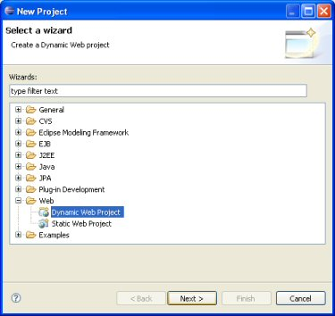
- Projectname: test
- Target runtime: Apache Tomcat v7.0
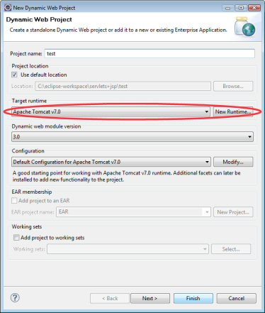

Configure Tomcat manager`s user name and password

- Check the $TOMCAT_HOME/conf/tomcat-users.xml fájl
- Set
<tomcat-users>
<role rolename=”manager-gui”/>
<user name=”admin” password=”admin” roles=”manager-gui”/>
</tomcat-users>
- Restart the Tomcat
- Now you can login: http://localhost:8080/manager/html

Install Axis2

- Download axis2.war.zip file
- Unzip it so you get axis2.war file
- Deploy it under Tomcat (lsd Install Tomcat Server 14. pont)
- Download axis2.bin.zip
- Unzip it and put it in a directory
- In the Eclipse Window->Preferences->Web Services->Axis2 Preferences->Axis2 Runtime
- Set the Axis2 runtime location to the axis2 binary folder
- Window->Preferences->Web Services->Axis2 Preferences->Axis2 Preferences
- Tick the Generate an interface for the skeleton checkbox

Create a “Buttom Up” Service (ResourceA)

- Install Tomcat
- Install Axis
- In the Eclipse Window->Preferences->Web Services -> Axis2 Preferences → Axis2 Runtime
- Set the Axis2 bin location
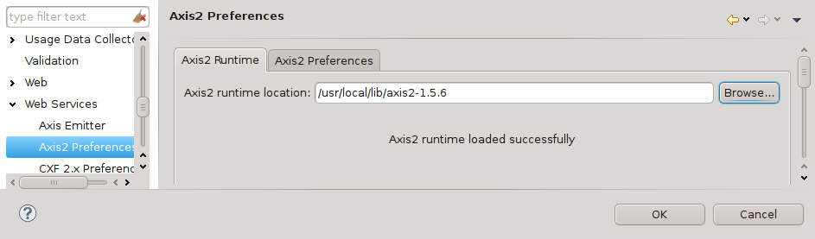
- Change the server runtime from Apache Axis to Axis2. Window->Preferences->Web Services -> Server and Runtime
- Set the server:
- Server runtime: Tomcat v7.0 Server
- Web service runtime: Apache Axis2
- Click on the Ok button
- File->New->Other->Web->Dynamic Web Project
- Project name: ResourceA
- Click on the New Runtime button of the Target runtime field. A New Server Runtime Environment window appears
- Select Apache Tomcat v7.0
- Tick Create a new local server checkbox
- Click on the Next button
- Clicking on the Browse... button select the Tomcat's directory
- JRE: jdk1.6.0_20
- Click on the Finish button. We get back to the New Dynamic Web Project window
- Dynamic web module version: 2.5
- Click on the Modify button of the Configuration field. A new Project Facets window appears
- On the Project Facets page set the followings:
- Tick the Axis2 Web Services checkbox
- Tick the JavaScript checkbox
- Leave ticked: Dynamic Web module 2.5
- Leave ticked: Java
- Save As... My Configuration for Apache Tomcat v7.0
- Click on the Ok button. We get back to the New Dynamic Web Project window
- The New Dynamic Web Project looks like this:
- 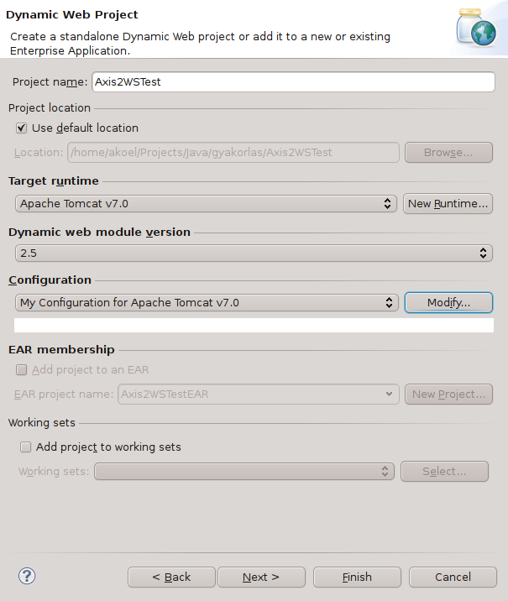
- Finish it. The ResourceA dynamic web and the Servers projects created
- Create a Class named MyService.java
package pkg;
public class MyService {
public MyService() {
}
public Boolean Configure(String param, String val){
return true;
}
public Boolean StartMe(){
return true;
}
public Boolean StopMe(){
return true;
}
public String getStatus(){
return "No status available!";
}
}

- Right mouse click on the class and Web Service->Create Web Service
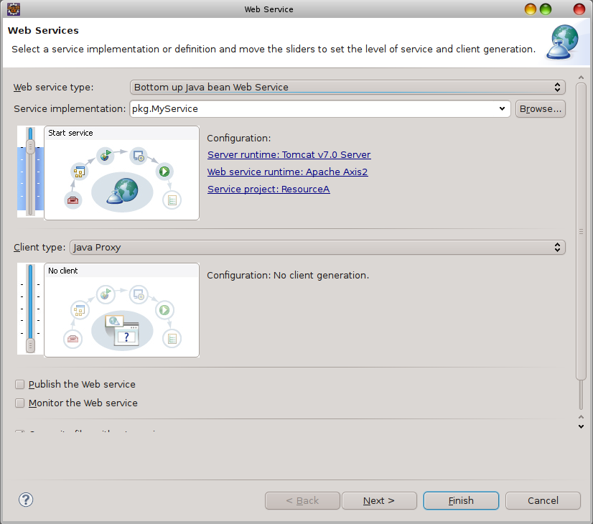
- Next
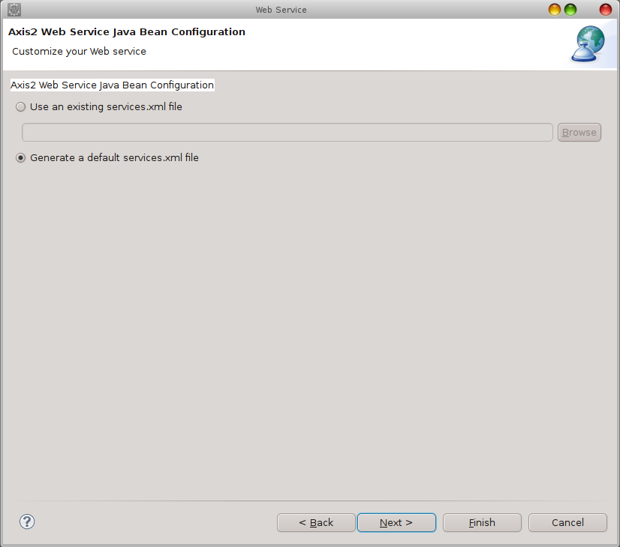
- Click on the Start server button. No error message expected
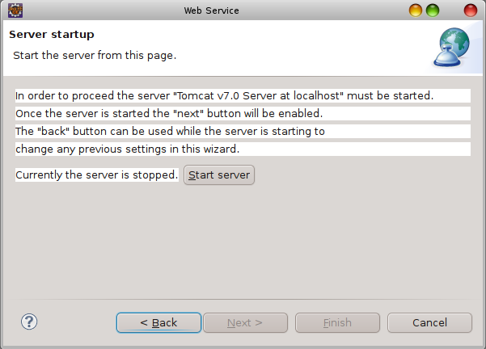
- Next
- On the Test Web Service page click on the Launch button
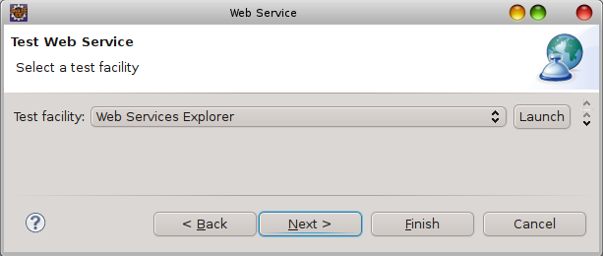
- Finish
- Lets check the service: http://localhost:8080/ResourceA/services/listServices
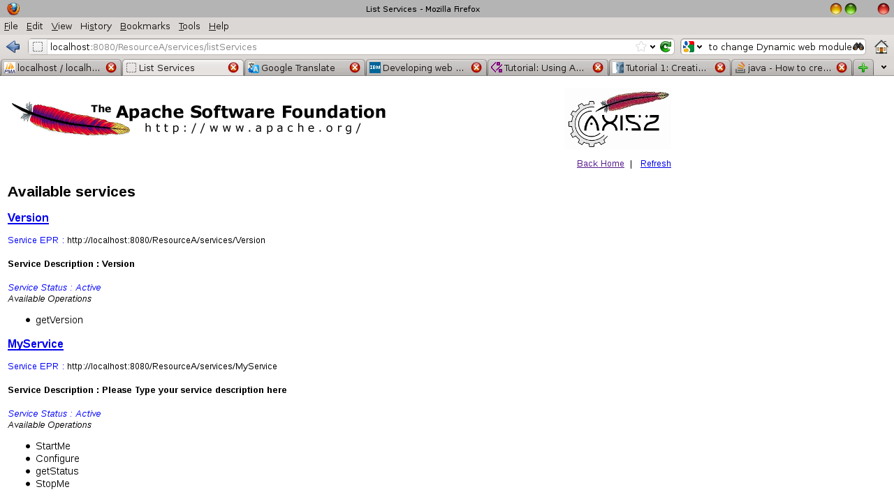
- Lets check an operation of the service: http://localhost:8080/ResourceA/services/MyService/getStatus
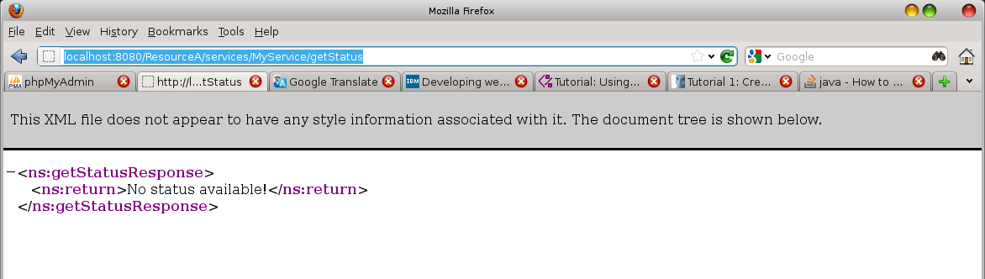
- Let's create our WAR file. In the Project Explorer find the ResourceA project Right-Mouse-Click-OnIt->Export->War file
- You can deploy your WAR file under the Tomcat, restart Tomcat and you can use the service az before.

Web Service Explorer

- Run->Launch the Web Services Explorer
- The Web Services Explorer page appears in the Editor area
- On the right top corner click on the WSDL Page icon
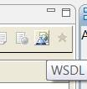
- On the left section click on the WSDL Main
- Type into the wsdl URL the wsdl address: http://localhost:8080/ResourceA/services/MyService?wsdl
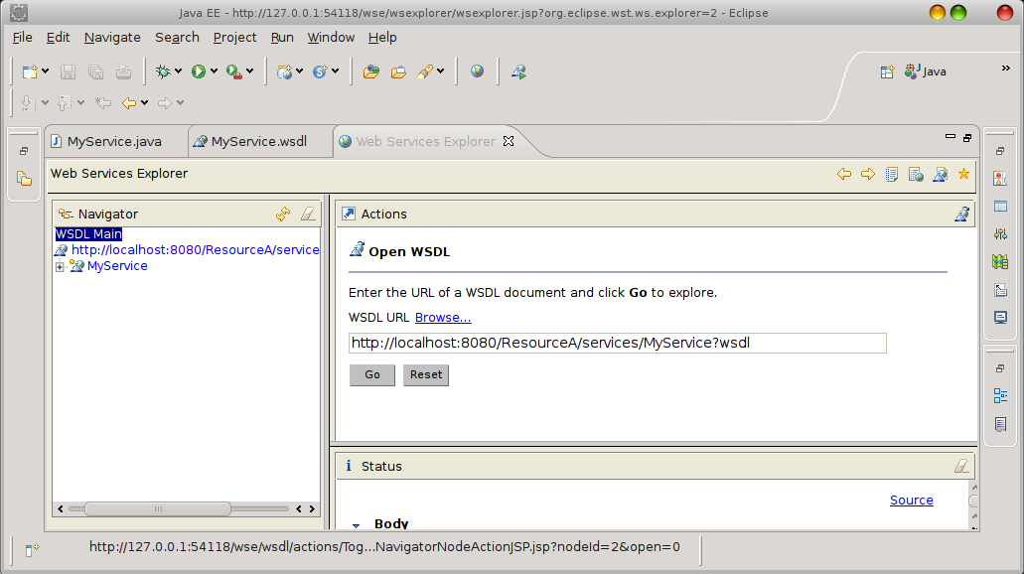
- Click on the Go button
- On the left section search for the MyService>MyServicSoap11Binding>Configure operation and click on it
- Add two parameters to the operation “a” and “b”
- Click on the Go button to evaluate the operation
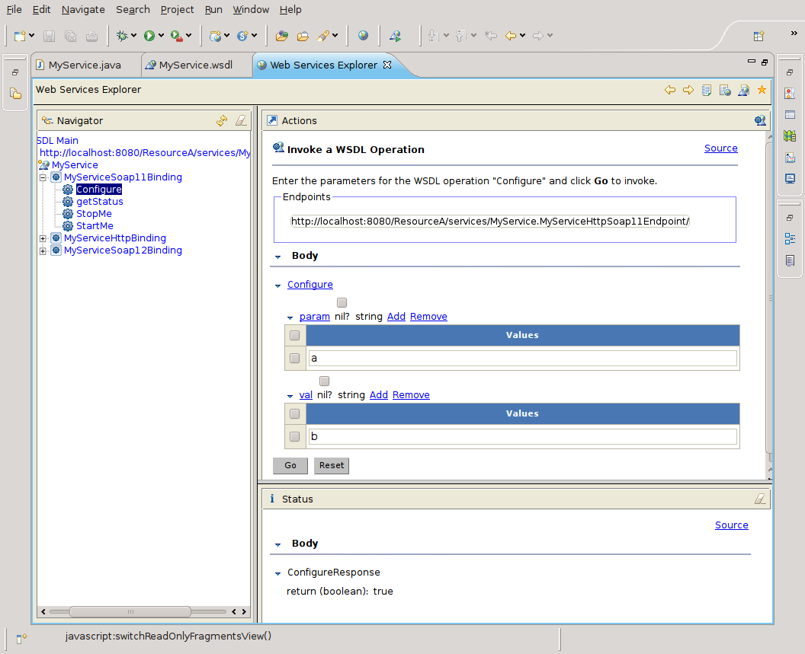

Create a “Top Down” Service

- Install Tomcat
- Install Axis
- In the Eclipse Window->Preferences->Web Services -> Axis2 Preferences → Axis2 Runtime
- Set the Axis2 bin location
- Change the server runtime from Apache Axis to Axis2. Window->Preferences->Web Services -> Server and Runtime
- Set the server:
Server runtime: Tomcat v7.0 Server
Web service runtime: Apache Axis2
- Click on the Ok button
- Lets create a project with the support of Axis2 features. File->New->Other...->Web->Dynamic Web Project
- Project name: Axis2WSTest
- Click on the New Runtime button of the Target runtime field. A New Server Runtime Environment window appears
- Select Apache Tomcat v7.0
- Tick Create a new local server checkbox
- Click on the Next button
- Clicking on the Browse... button select the Tomcat's directory
- JRE: jdk1.6.0_20
- Click on the Finish button. We get back to the New Dynamic Web Project window
- Dynamic web module version: 2.5
- Click on the Modify button of the Configuration field. A new Project Facets window appears
- On the Project Facets page set the followings:
Tick the Axis2 Web Services checkbox
Tick the JavaScript checkbox
Leave ticked: Dynamic Web module 2.5
Leave ticked: Java
Save As... My Configuration for Apache Tomcat v7.0
Click on the Ok button. We get back to the New Dynamic Web Project window
- The New Dynamic Web Project looks like this:
- Finish it. The Axis2WStest dynamic web and the Servers projects created
- Create a new folder inside the Axis2WSTest project called wsdl
- Inside the wsdl folder create a new file called AreaService.wsdl
- Copy the followings into the AreaSevice.wsdl file

<?xml version="1.0" encoding="UTF-8"?>
<wsdl:definitions xmlns:soap="http://schemas.xmlsoap.org/wsdl/soap/" xmlns:tns="http://tempuri.org/AreaService/" xmlns:wsdl="http://schemas.xmlsoap.org/wsdl/" xmlns:xsd="http://www.w3.org/2001/XMLSchema" name="AreaService" targetNamespace="http://tempuri.org/AreaService/">
<wsdl:types>
<xsd:schema targetNamespace="http://tempuri.org/AreaService/" xmlns:xsd="http://www.w3.org/2001/XMLSchema">
<xsd:element name="area" type="xsd:float"/>
<xsd:element name="parameters" type="tns:dimensions"/>
<xsd:complexType name="dimensions">
<xsd:sequence>
<xsd:element name="width" type="xsd:float"></xsd:element>
<xsd:element name="height" type="xsd:float"></xsd:element>
</xsd:sequence>
</xsd:complexType>

</xsd:schema>
</wsdl:types>
<wsdl:message name="CalculateRectAreaResponse">
<wsdl:part element="tns:area" name="area"/>
</wsdl:message>
<wsdl:message name="CalculateRectAreaRequest">
<wsdl:part element="tns:parameters" name="parameters"/>
</wsdl:message>
<wsdl:portType name="AreaService">
<wsdl:operation name="CalculateRectArea">
<wsdl:input message="tns:CalculateRectAreaRequest"/>
<wsdl:output message="tns:CalculateRectAreaResponse"/>
</wsdl:operation>
</wsdl:portType>
<wsdl:binding name="AreaServiceSOAP" type="tns:AreaService">
<soap:binding style="document" transport="http://schemas.xmlsoap.org/soap/http"/>
<wsdl:operation name="CalculateRectArea">
<soap:operation soapAction="http://tempuri.org/AreaService/NewOperation"/>
<wsdl:input>
<soap:body use="literal"/>
</wsdl:input>
<wsdl:output>
<soap:body use="literal"/>
</wsdl:output>
</wsdl:operation>
</wsdl:binding>
<wsdl:service name="AreaService">
<wsdl:port binding="tns:AreaServiceSOAP" name="AreaServiceSOAP">
<soap:address location="http://tempuri.org"/>
</wsdl:port>
</wsdl:service>
</wsdl:definitions>

- Tick Project->Build automatically checkbox if it is not checked already
- Lets Create the web service using the newly created wsdl by the web service creation wizard. First select the wsdl file in the Project Explorer
- Right-Mouse-Click-On->New->Other...->Web Services->Web Service. The Web Service window appears
- Web service type: Top down java bean Web Service
- Service definition: If we proceeded well this field is filled already wit the wsdl file
- Leave the Service definition scrollbar on the Start service level
- Set the Client type scrollbar to Test client level
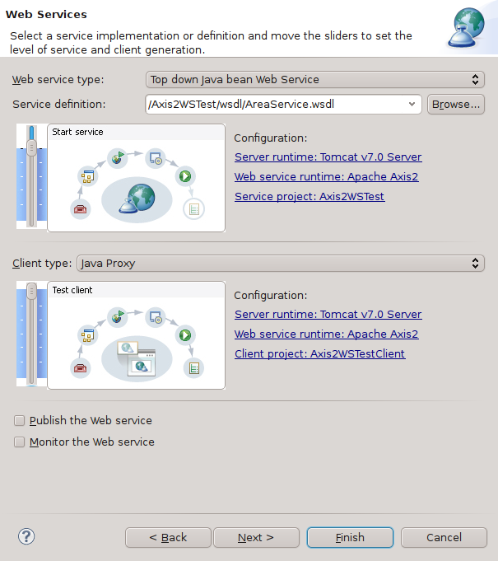
- Click on the Next button 2 times until you get to the Server startup page
- Click on the Start server button – Some seconds later the Next button will be active
- Click on the Next button to get to the Test Web Service page
- Click on the Launch button – On the web browser a new window opens and the wsdl monitor application appears on it
- Click on the Finish button.
- On the Editor area the Web Service Explorer tab appears and its content is the same wsdl monitor as is in the browser
- Lets modify the Skeleton. So select the AreaServiceSkeleton.java
- Change the calculateRectArea() method to the following:

public Area calculateRectArea( Parameters parameters) {
Area area = new Area();
area.setArea( parameters.getParameters().getWidth() * parameters.getParameters().getHeight() );
return area;
}

- Lets check out the result. There are three ways to do that.
-Test Web Service on in opened in the browser:
http://127.0.0.1:51489/wse/wsexplorer/wsexplorer.jsp?org.eclipse.wst.ws.explorer=0
Find out the CalculateRectArea Operation on the left side and find its two parameters on the right side. Type a value into the Width and an other value into the height field and click on the Go button. The correct value should appear in the Status window on the right bottom of the page
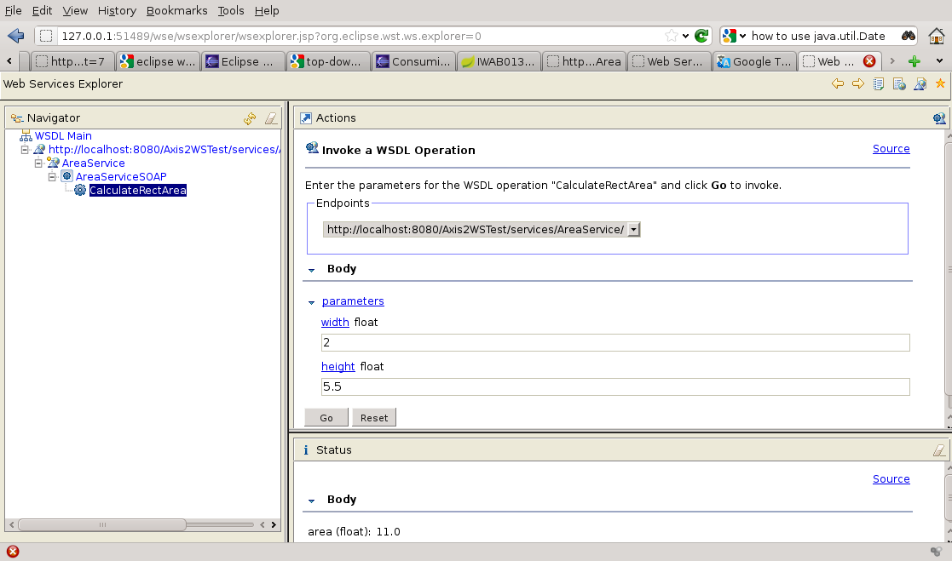

-Web Service Explorer tab in the Editor area in the Eclipse. It works the same as the Test Web Service

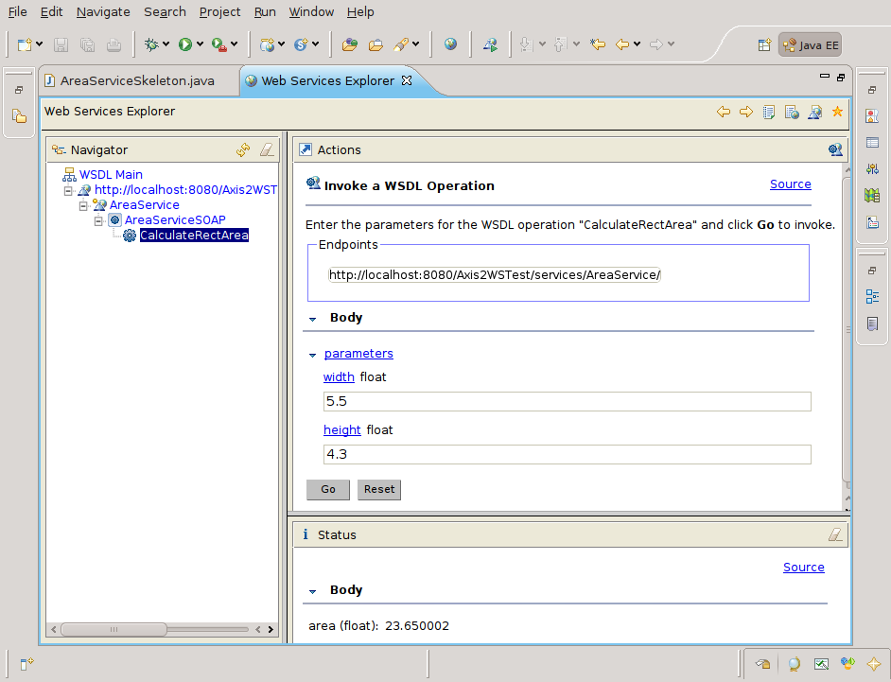

-Web browser: http://localhost:8080/Axis2WSTest/services/AreaService/CalculateRectArea?width=3&height=7
The result shuld be: <ns1:area>21.0</ns1:area>

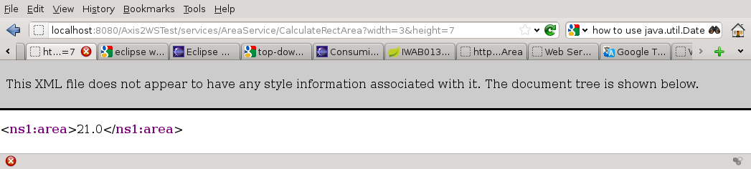

Create Web service application – Web server

- Install Tomcat
- Install Axis
- In the Eclipse Window->Preferences->Web Services -> Axis2 Preferences → Axis2 Runtime
- Set the Axis2 bin location
- Change the server runtime from Apache Axis to Axis2. Window->Preferences->Web Services -> Server and Runtime
- Set the server:
- Server runtime: Tomcat v7.0 Server
- Web service runtime: Apache Axis2
- Click on the Ok button
- Lets create a project File->New->Other...->Java Project
- Project name: wsServerExample
- Finish it
- File->New->Package
- Source folder: wsServerExample/src
Name: com.myfirst.wsServer
- Finish it
- File->New->Class
- Source folder: wsServerExample/src
Package: com.myfirst.wsServer
Name: SayHello
- Edit the SayHello.java file

package com.myfirst.wsServer;
import javax.jws.WebService;

@WebService

public class SayHello {
private static final String SALUTATION = "Hello";
public String getGreeting( String name ) {
return SALUTATION + " " + name;
}
}
- Lets generate the server code with Ant
- On the Project RightClick->New->File
- File name: build.xml
- Open it with Ant editor by RightClick->Open With->Ant Editor
- Edit the buld.xml file

<project default="wsgen">
<target name="wsgen" >
<exec executable="wsgen">
<arg line="-cp ./bin -keep -s ./src -d ./bin com.myfirst.wsServer.SayHello"/>
</exec>
</target>
</project>

- Run the Ant buls.xml file by RightClick->Run As->Ant Buld
- Ezt az eredményt kell kapnod:

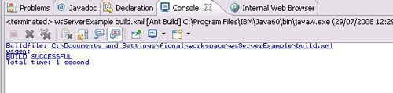

- Refresh (F5) the project. There should be a newly generated package and two java files

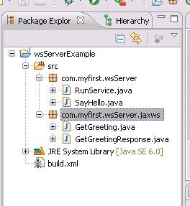

- Lets publish the service
- Create a new class under the com.myfirst.wsServer package and call it RunService.java. Edit it:

package com.myfirst.wsServer;
import javax.xml.ws.Endpoint;

public class RunService {

public static void main(String[] args) {

System.out.println("SayHello Web Service started.");
Endpoint.publish("http://localhost:8080/wsServerExample", new SayHello());
}
}
- On the RunService RightClick->Run As->Java Application You should see the result on the Console:

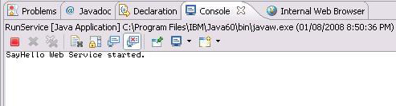

- You can check if it works well on a browser: http://localhost:8080/wsServerExample/services/SayHello?wsdl

Create Web service application – Web client

- Create a new simple java project. Name it: wsClientExample
- Create a new Package in the project. Name it: com.myfirst.wsClient
- Create a new file. Name it: build.xml
- Open it with an AntEditor. Edit it:

<project default="wsimport">

<target name="wsimport">

<exec executable="${java.home}/../bin/wsimport">

<arg line="-keep -s ./src -p com.myfirst.wsClient -d ./bin http://localhost:8080/wsServerExample?wsdl"/>

</exec>

</target>

</project>

- Run it as an Ant Build
- Make sure you get a BUILD successful message in the console
- Refresh the client project-You should see the newly generrated java codes

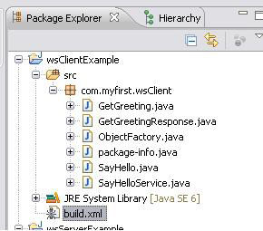

- Lets create the client applicant
- Create a new class under the com.myfirst.wsClient package. Name it: SayHelloClient.java. Edit it:

package com.myfirst.wsClient;
import javax.xml.ws.BindingProvider;

public class SayHelloClient {
public static void main(String args[]) {
SayHelloService shs = new SayHelloService();
SayHello sh = (SayHello) shs.getSayHelloPort();
((BindingProvider)sh).getRequestContext().put(BindingProvider.
ENDPOINT_ADDRESS_PROPERTY, "http://localhost:8080/wsServerExample");
System.out.println( ((BindingProvider)sh).toString() );
System.out.println(sh.getGreeting("Fiona"));
}
}

- Run the Client Application: On the SayHelloClient.java RightClick->Run As->Java Application
- Look at the console. The following should be appear there:

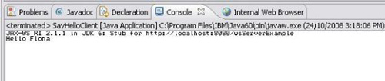

- Most hogy kész vagyunk az alapokkal, egy kicsit szofisztikáltabb Ant file-t készíthetünk
- default targetnek a “runClient”-et választottuk, aminek a “pouse” target a dependencije, tehát előtte a pause fog lefutni. De a pause-nak a “runServer” a dependencie, tehát előszőr lefut a runServer, majd a “pause” végül pedig a “runClient”.
Hogy a különböző exec-ek közül melyik fusson le, azt az OS property fogja eldönteni. Ezt pedig az os.name rendszerváltozó mondja meg.

<project default="runClient">
<echo>${os.name}</echo>

<!--
=================================
target: wsimport
================================= -->
<target name="wsimport" description="-->Read the WSDL and generate the required artifacts">
<exec executable="${java.home}/../bin/wsimport">
<arg line="-keep -s ./src -p com.myfirst.wsClient -d ./bin http://localhost:8080/wsServerExample?wsdl" />
</exec>
</target>

<!--
=================================
target: runServer
================================= -->
<target name="runServer" description="-->Runs the Web service server from a terminal">
<echo>
Running the following command from the terminal to run the server:
${java.home}/bin/java -cp "${basedir}/../wsServerExample/bin"
com.myfirst.wsServer.RunService
</echo>

<exec dir="${java.home}/bin/" executable="cmd" spawn="true" os="Windows XP" description="runs on XP">
<arg line="start cmd /K start cmd /K" />
<arg line='${java.home}/bin/java -cp "${basedir}/../wsServerExample/bin" com.myfirst.wsServer.RunService' />
</exec>
<exec executable="xterm" spawn="true" os="Linux" description="Runs on Linux">
<arg line="-e ${java.home}/bin/java -cp '${basedir}/../wsServerExample/bin' com.myfirst.wsServer.RunService"/>
</exec>
</target>

<!--
=================================
target: pause
================================= -->
<target name="pause" depends="runServer" description="--> Pauses briefly while the server starts">
<sleep seconds="5" />
</target>

<!--
=================================
target: runClient
================================= -->
<target name="runClient" depends="pause" description="--> Runs a Web service client from a terminal">
<echo>
Running the following command from the terminal to run the client:
${java.home}/bin/java -cp "${basedir}/bin"
com.myfirst.wsClient.SayHelloClient
</echo>

<exec dir="${java.home}/bin/" executable="cmd" spawn="true" os="Windows XP" description="Runs on XP">
<arg line="start cmd /K start cmd /K" />
<arg line='${java.home}/bin/java -cp "${basedir}/bin" com.myfirst.wsClient.SayHelloClient' />
</exec>
<exec executable="xterm" spawn="true" os="Linux" description="Runs on Linux">
<arg line="-hold -e ${java.home}/bin/java -cp '${basedir}/bin' com.myfirst.wsClient.SayHelloClient" />
</exec>
</target>
</project>

