Configure Browser to use Tor
http://linuxaria.com/howto/gnome-anonymous-browsing-with-tor

This solution is for allowing you to browse home pages which are allowed to browse users having IP address from a specific country. Using this solution is not safe for you to hide.

1. Install Tor

$ sudo apt-get install tor

2. Configure the Tor
In the /etc/tor/torrc fájl uncomment the following directives:

ControlPort 9051
CookieAuthentication 0

With these 2 options we set the port on which Tor will listen for local connections from Tor controller applications, and we tell to Tor that we don’t need an authentication, so any program can control Tor (don’t do this on a shared computer or server)

ExitNodes {hu}

With this option you can claim for an IP from a specific country, if it is possible

3. Restart the tor server

$ sudo /etc/init.d/tor restart

4. Configure the Browser
In the Browser configure a Manual Proxy using SOCKS.
In Firefox: Hamburger menu>Preferences>Advanced>NetworkSetting
In Chrome: Hamburger menu>Settings>Network Change Proxy settings

SOCKS Host: 127.0.0.1 Port: 9050

Restart the browser

5. Try out if the browser uses Tor
In the browser check the following URL: https://check.torproject.org/
You should see something like this:

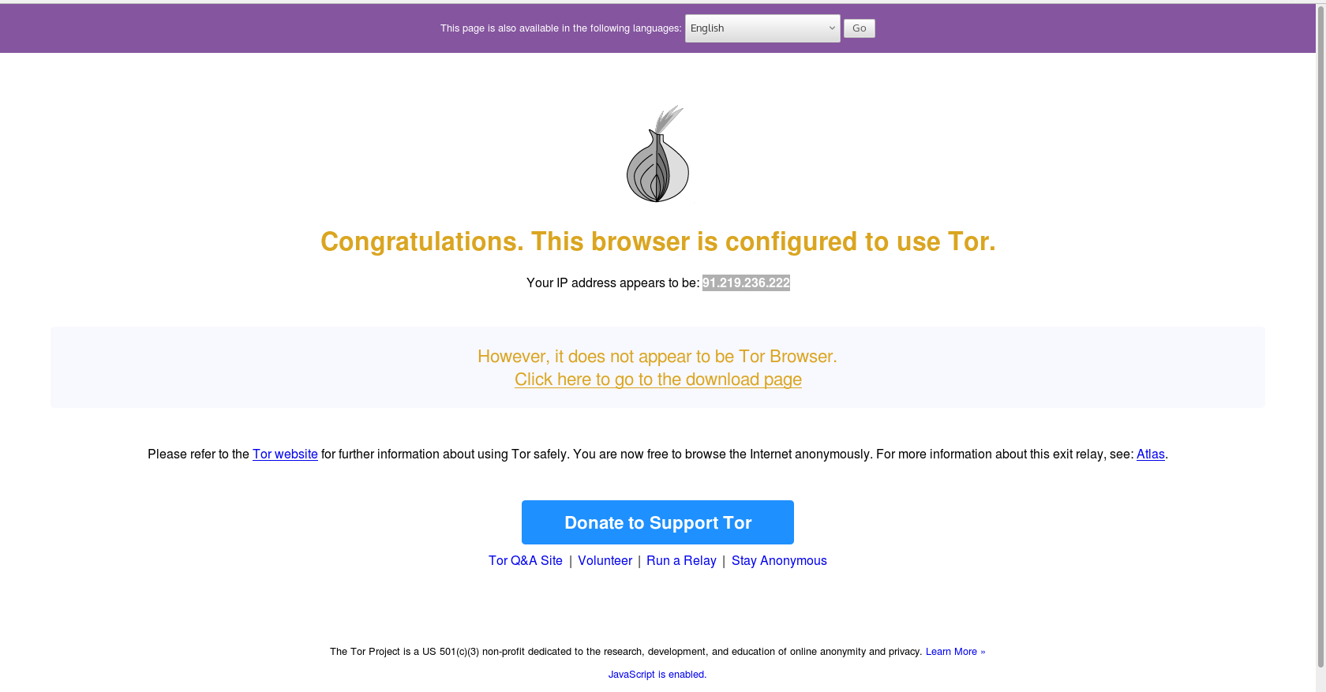

The message says that if you really want to hide yourself the you should use the optimized Tor-Browser instead.

6. Start a new session - Change the IP

$ echo -e 'AUTHENTICATE ""\r\nsignal NEWNYM\r\nQUIT' | nc 127.0.0.1 9051
250 OK
250 OK
250 closing connection

This command changes the IP address.

