Pipelight plugin
http://askubuntu.com/questions/668340/pipelight-silverlight-not-working-in-firefox
The Pipelight is an implementation of the Microsoft Silverlight. The plugin works for the Firefox.

1. Uninstall old version

$ sudo apt-get remove pipelight

2. Install new version

sudo apt-add-repository ppa:pipelight/stable
sudo apt-get update
sudo apt-get install --install-recommends pipelight-multi

To enable the Microsoft fonts you have to accept the license terms. So the appearing screen you should
2.1 click on the Tab to get the <OK> button to be in focus
2.2 Click on the Enter to push the <OK> button
2.3 On the next screan select the <Yes> button clicking on the Tab (or the <- button)
2.4 Click in the Enter to push the <OK> button
On the installation process the wine will be installed if it has not been already installed.

3. Install the Silverlight plugin
Close the Firefox

sudo pipelight-plugin --update
sudo pipelight-plugin --enable silverlight
sudo pipelight-plugin --create-mozilla-plugins

Under the installation the user will be asked if he accepts 2 licence (Microsoft Silverlight 5.1 and mpg2splt.ax). Type Y to accept it
After this process please wait for some minutes. On the X11 a window appears saying the Silverlight is installing

4. Check the existence of the plugin in the Firefox
Start the Firefox
Use the following url in the address field in the Firefox: about:plugins
You should see something similar on the page:
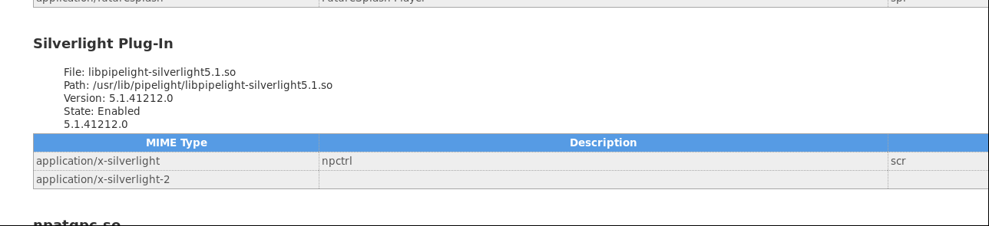

5. Reanable the plugin
If the plugin does show up on the plugin page then disable and again enable the plugint

sudo pipelight-plugin --disable silverlight
sudo pipelight-plugin --enable silverlight

6. Test the plugin
On the following url you can test the silverlight plugin: http://fds-team.de/pipelight/

And/or get to the following page: https://www.microsoft.com/silverlight/iis-smooth-streaming/demo/
On the top of the Firefox canvas a question appears asking if you allow the Silverlight. Click on the Allow button.

If the Silverlight plugin does not work then you should see the circled icon in the canvas:
