Java

- Access modifiers
Private
{Method, Variable, Constructor} Can be accesse within the declared class iteself
{Class, Interface} Can not be applied
Default
{Methods, Variables} Can be access in the Package and in the Class
Protected
{Methods, Variables, Constructors} Can be access in Subclass, Package and Class
{Class, Interface} Can not be applied
Public
{Class, Methods, Constructor, Interface} Accessable from any other class

Modifier | Class | Package | Subclass | World
public | Y | Y | Y | Y
protected | Y | Y | Y | N
no modifier | Y | Y | N | N
private | Y | N | N | N

- Variable types

Local variables
- Declared in methods, constructors or blocks.
- Created when the method, constructor or block is entered and will be destroyed once it exits
- Access modifiers cannot be used
- Are visible only within the declared method, constructor or block
- There is no default value, so they should be declared and an initial value should be assigned
Instance variables
- Declared in a class, but outside a method, constructor or any block.
- Created when an object is created with the use of the keyword 'new' and destroyed when the object is destroyed
- Can be declared in class level before or after use.
- Access modifiers can be given
- Are visible for all methods, constructors and block in the class. Normally, it is recommended to make these variables private.
- Have default values. For numbers the default value is 0, for Booleans it is false and for object references it is null. Values can be assigned during the declaration or within the constructor.
Class/static variables
- Known as static variables are declared with the 'static' keyword in a class, but outside a method, constructor or a block.
- There would only be one copy of each class variable per class, regardless of how many objects are created from it.
- Rarely used other than being declared as constant.
- Created when the program starts and destroyed when the program stops
- Default values are same as instance variables.
- Can be accessed by calling with the class name. ClassName.VariableName

- Try/Catch

try{
int a = 5/0;
}catch( Exception e ){
System.err.println("Catched exception");
return;
}finally{
System.err.println("...but this block is executed anyway");
}

- Thread

Implements Runnable
public class R implements Runnable{

@Override
public void run() {
//Do what you want
}

public static void main(String[] args){
(new Thread(new R())).start();
}
}

Subbclass of the Thread
public class R extends Thread{
@Override
public static void run(){
//Do what you want
}

public void main( String[] args ){
(new R()).start();
}
}

Sleep the Thread
try{
Thread.sleep( 1000 );
}catch( InterruptedException e){
}

- Synchronization
More than 1 thread tries to use one resource
Resolution: monitor
A monitor can be considered as a building which contains a special room. The special room can be occupied by only one customer (thread) at a time. The room usually contains some data and code.
If a customer wants to occupy the special room, he has to enter the Hallway (Entry Set) to wait first. Scheduler will pick one based on some criteria (FIFO). If he suspended for some reason, he will be sent to the wait room, and be scheduled to reenter the special room later.
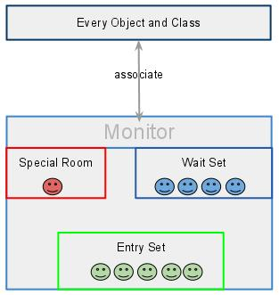
Every object and class is logically associated with a monitor. If one thread owns a lock on some data, then, no others can obtain that lock until the thread that owns the lock releases it.
Lets keep the common resources in a synchronized block. Only one thread can go into that block at a time. The others who attempted to access to it have to wait until the one finishe its job.

synchronized (object reference expression) {
//code block
}

class Table {
void printTable(int n) {
synchronized (this) {// synchronized block
for (int i = 1; i <= 5; i++) {
System.out.println(n * i);
try {
Thread.sleep(400);
} catch (Exception e) {
System.out.println(e);
}
}
}
}// end of the method
}

public class TestSynchronizedBlock2 {
public void main(String args[]) {
final Table obj = new Table();// only one object
Thread t1 = new Thread() {
public void run() {
obj.printTable(5);
}
};
Thread t2 = new Thread() {
public void run() {
obj.printTable(100);
}
};
t1.start();
t2.start();
}
}

- Interface-Abstract
Interface
- Interfaces gives the idea what is to be done but not how it will be done.
- interface should be implemented using keyword “implements”
- Java class can implement multiple interfaces
- An interface can extend another Java interface only,
- Variables declared in a Java interface are by default final.
- Members of a Java interface are public by default.
- Java 8 facilitates to define default and static methods in interface

Abstract
- A Java abstract class should be extended using keyword “extends”
- Java class can extend only one abstract class
- An abstract class can extend another Java class and implement multiple Java interfaces
- Variables declared in a abstract class may contain non-final variables
- Members of a Java abstract class can have the usual flavours of class members like private, protected, etc.
- Abstract classes may contain abstract declarations, concrete implementations, or both
- Abstract class can have abstract and non-abstract methods

- Overloading - Overriding

Overloadning
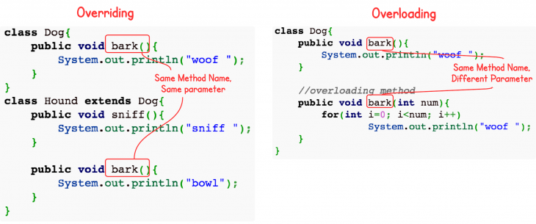
Overloading occurs when two or more methods in one class have the same method name but different parameters.
Overriding
Overriding means having two methods with the same method name and parameters (i.e., method signature). One of the methods is in the parent class and the other is in the child class. Overriding allows a child class to provide a specific implementation of a method that is already provided its parent class.

- OOP concepts

  - Abstraction
Abstraction is used to manage complexity.
Software developers use abstraction to decompose complex systems into smaller components.
Abstraction means working with something we know how to use without knowing how it works internally.
We can work with an abstract data type by using its interface without concerning ourselves with its implementation.
  - Inheritance
Inheritance is the process by which one object acquires the properties of another object. This is important because it supports the concept of hierarchical classification. An object only needs to define those qualities that make it unique and inherit its general attributes from its parent.
  - Polymorhizm
Polymorphism means one name, many forms.
It allows one interface to be used for a general class of actions.
In Java, it describes a language’s ability to process objects of various types and classes through a single, uniform interface
Polymorphism in Java has two types: Compile time polymorphism (static binding) and Runtime polymorphism (dynamic binding).

Satic Polymorphism
Static polymorphism is achieved through method overloading. Method overloading means there are several methods present in a class having the same name but different types/order/number of parameters.
At compile time, Java knows which method to invoke by checking the method signatures. So, this is called compile time polymorphism or static binding.

Dynamic Polymorphism
Suppose a sub class overrides a particular method of the super class. Let’s say, in the program we create an object of the subclass and assign it to the super class reference. Now, if we call the overridden method on the super class reference then the sub class version of the method will be called.

class Vehicle{

public void move() {
System.out.println("Vehicle can move");
}
}

class Motorbike extends Vehicle{

public void move() {
System.out.println("Motorbike can move and accelerate too");
}
}

class Test{

public static void main(String[] args){
Vehicle vh = new Motorbike(); // "Motorbike can move and accelerate too"Encapsulation is the mechanism that binds together code and the data it manipulates, keeping both safe from outside interference and misuse.
vh.move();

vh = new Vehicle();
vk.move() // "Vehicle can move"
}
}

  - Encapsulation
Encapsulation is the mechanism that binds together code and the data it manipulates, keeping both safe from outside interference and misuse.
The power of encapsulated code is to hide the complexity of the implementation, exposing an interface that everyone knows how to access it and thus use it regardless of the implementation details. In Java, the basis of encapsulation is the class, defining attributes and methods along with access modifiers to restrict the audience of each one.
Encapsulation in Java is a mechanism of wrapping the data (variables) and code acting on the data (methods) together as a single unit. In encapsulation, the variables of a class will be hidden from other classes, and can be accessed only through the methods of their current class. Therefore, it is also known as data hiding.
To achieve encapsulation in Java:
- Declare the variables of a class as private.
- Provide public setter and getter methods to modify and view the variables values.

- Design patterns
Design patterns represent the best practices used by experienced object-oriented software developers. Design patterns are solutions to general problems that software developers faced during software development. These solutions were obtained by trial and error by numerous software developers over quite a substantial period of time.
  - Adapter - Wrapper
Adapter is about creating an intermediary abstraction that translates, or maps, the old component to the new system. Clients call methods on the Adapter object which redirects them into calls to the legacy component. This strategy can be implemented either with inheritance or with aggregation.
Below, a legacy Rectangle component's display() method expects to receive "x, y, w, h" parameters. But the client wants to pass "upper left x and y" and "lower right x and y". This incongruity can be reconciled by adding an additional level of indirection – i.e. an Adapter object.
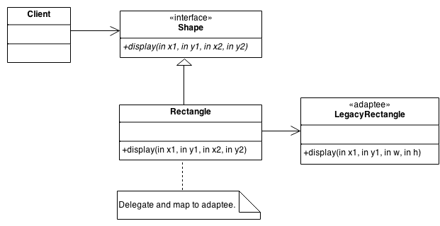
  - Factory Pattern
In Factory pattern, we create object without exposing the creation logic to the client and refer to newly created object using a common interface.
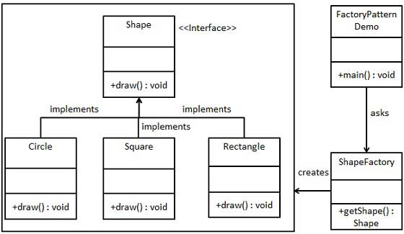
  - Singleton
This pattern involves a single class which is responsible to create an object while making sure that only single object gets created. This class provides a way to access its only object which can be accessed directly without need to instantiate the object of the class.
public class SingleObject {

//create an object of SingleObject
private static SingleObject instance = new SingleObject();

//make the constructor private so that this class cannot be instantiated
private SingleObject(){}

//Get the only object available
public static SingleObject getInstance(){
return instance;
}

public void showMessage(){
System.out.println("Hello World!");
}
}

  - Iterator
This pattern is used to get a way to access the elements of a collection object in sequential manner without any need to know its underlying representation.
public class NameRepository implements Container {
public String names[] = {"Robert" , "John" ,"Julie" , "Lora"};

@Override
public Iterator getIterator() {
return new NameIterator();
}

private class NameIterator implements Iterator {

int index;

@Override
public boolean hasNext() {

if(index < names.length){
return true;
}
return false;
}

@Override
public Object next() {

if(this.hasNext()){
return names[index++];
}
return null;
}
}
}
  - Observer
Observer pattern is used when there is one-to-many relationship between objects such as if one object is modified, its depenedent objects are to be notified automatically.
public class NameRepository implements Container {
public String names[] = {"Robert" , "John" ,"Julie" , "Lora"};

