General Test questions

- 7 Software Testing Principles
If you were to test the entire possible combinations project EXECUTION TIME & COSTS would rise exponentially. We need certain principles and strategies to optimize the testing effort
Exhaustive testing is not possible: we need optimal amount of testing based on the risk assesment of the application. (kockázatelemzés)
How do you determine the risk?
Defect Clustering: Pareto principle (20-80 rule) For many events, 80% of the effects come from 20% of the causes.
To Software Testing: 80% of the problems are found in 20% of the modules.
With experience you can identify such risk modules.
!BUT! This approach has it own proble: If the same test are repeted over and over again, eventually the same test cases will no longer find new bugs.
Pesticide Paradox: Repetitive use of the same pesticide lead to the insects developing resistance to the pesticide.
Same set of repetivive tests will be useless for discovering new defects.
To overcome this, the test cases need to be regularly reviewed and revised, adding new, different test cases
Testing shows presence of defects: !but! cannot prove that there are no defects..
So the Testing reduces the probability of undiscovered defects remaining in the software but it is not a proof of correctness.
Absence of Error: !BUT! It does not talk about the absence of defects.
Just because testing didn’t find any defects in the software, it doesn’t mean that the software is ready to be shipped.
Were the executed tests really designed to catch the most defects? or where they designed to see if the software matched the user’s requirements?
Early Testing: Testing should start as early as possible in the Software Development Life Cycle. The later you found the defect the more expensive
So that any defects in the requirements or design phase are captured in early stages.
Testing is context dependent: the way you test an e-commerce site will be different from the way you test a commercial off the shelf application.
You might use a different approach, methodologies, techniques and types of testing depending upon the application type

- Other principles
Testing must be done by an independent party: Testing should not be performed by the person or team that developed the software since they tend to defend the correctness of the program.
Assign best personnel to the task: Because testing requires high creativity and responsibility only the best personnel must be assigned to design, implement, and analyze test cases, test data and test results
Test for invalid and unexpected input conditions as well as valid conditions: The program should generate correct messages when an invalid test is encountered and should generate correct results when the test is valid
Keep software static during test: The program must not be modified during the implementation of the set of designed test cases
Provide expected test results if possible: A necessary part of test documentation is the specification of expected results, even if providing such results is impractical
- Software quality
The term quality involves two complementary aspects:
- Quality of Design
how well software is designed
It is the quality which the producer or supplier is intending to offer to the customer.
It should take into consideration the customer's requirements.
Quality of design is usually indicated by completeness and correctness of specifications, drawings, catalogues, etc. and is measured with fitness for use.
- Quality of Conformance
how well the software conforms to that design/specification
is the level of the quality of product actually produced and delivered through the production or service process of the organization as per the specifications or design
It is often described as the ‘fitness for purpose’ of a piece of software.

An another school distinguishes other two groups
- Functional Quality
- non-Functinal Quality
- Test types
Depending on its objectives, testing will be organized differently. Hence there are four software test types:
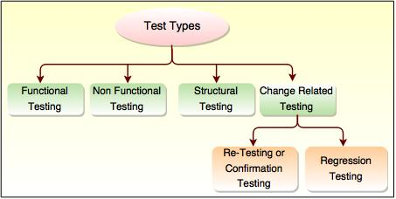

- Functional vs. Non-functional testing
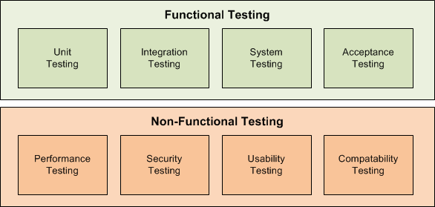
Unit Testing: testing of small snippets of code (functions/methods). It may be considered as (white-box) functional testing.
Integration Testing: when you put two or more pieces of (sub)modules or (sub)systems together and see if they play nicely together.
System Testing: testing SW as a whole. This is pretty much "Integration testing of all pieces together".
Acceptance Testing: did we build what the customer asked for actually? Of course, Acceptance Testing should be done throughout the lifecycle, not just at the last stage, where you realise that the customer wanted a sportscar and you built a van
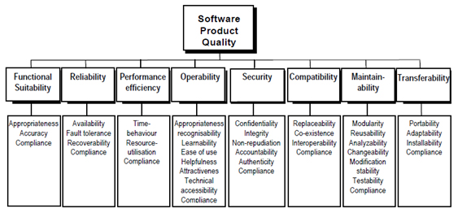
ISO 25010 as a model for specifying non-functional requirements
- Structural testing
The structural testing is the testing of the structure of the system or component.
Structural testing is often referred to as ‘white box’ or ‘glass box’ or ‘clear-box testing’ because in structural testing we are interested in what is happening ‘inside the system/application’.
During structural testing the tester is concentrating on how the software does it. For example, a structural technique wants to know how loops in the software are working. Different test cases may be derived to exercise the loop once, twice, and many times. This may be done regardless of the functionality of the software.
- Compliance testing
It is a type of non-functional software testing.
It is related with the IT standards followed by the company and it is the testing done to find the deviations from the company prescribed standards.
It determines,whether we are implementing and meeting the defined standards.
Its basically an audit of a system carried out against a known criterion.
- Verification and Validation
Validation: "Are we building the right product?" The software should do what the customer really requires.
Fit for use (consumers view of quality)
Helyes-e a specifikáció

Validation is the process of evaluating the final product to check whether the software meets the business needs. In simple words the test execution which we do in our day to day life are actually the validation activity which includes smoke testing, functional testing, regression testing, systems testing etc…

validation is concerned with checking that the system will meet the customer’s actual needs
Following activities are involved: Testing like black box testing, white box testing, gray box testing etc.
carried out by testing team.
It is basically manually checking the documents and files like requirement specifications etc.

Verification: "Are we building the product right?" The software should conform to its specification.
Conforms to requirements/specifications (Producer view of quality)
A rendszer megfelel-e a specifikációnak

Verification is a process of evaluating the intermediary work products of a software development lifecycle to check if we are in the right track of creating the final product.
What are the intermediary products? Well, These can include the documents which are produced during the development phases like, requirements specification, design documents, data base table design, ER diagrams, test cases…

Verification is concerned with whether the system is well-engineered, error-free, and so on
Following activities are involved: Reviews, Meetings and Inspections.
Carried out by QA team to check whether implementation software is as per specification document or not.
It is basically checking of developed program based on the requirement specifications documents & files.

Both are used to finds a defect in different way, Verification is used to identify the errors in requirement specifications & validation is used to find the defects in the implemented Software application.

- Verification is Static Testing where as Validations is Dynamic Testing.
- Verification takes place before validation.
- Verification evaluates plans, documents, requirements and specifications, where as Validation evaluates product.
- Verification inputs are checklist, issues list, walkthroughs and inspection, where as in Validation testing of actual product.
- Verification output is set of documents, plans, specifications and requirement documents where as in Validation actual product is output.

Having thus carefully distinguished the two terms, my advice to V&V practitioners was then to forget about the distinction, and think instead about V&V as a toolbox, which provides a wide range of tools for asking different kinds of questions about software. And to master the use of each tool and figure out when and how to use it. Here’s one of my attempts to visualize the space of tools in the toolbox:

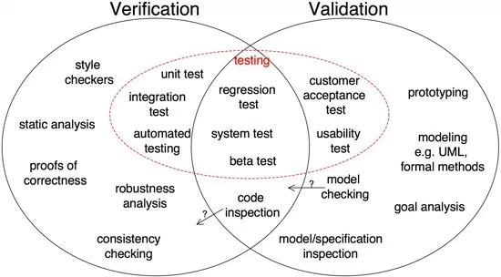

- Mistake, Error, Bug, Failure
ISTQB: error, mistake = human error – human activity in which en incorrect result is created
ISTQB bug, defect, fault = program error – error in the code which results in the softwre being unable to meet the expected bahaviour.

A mistake in coding is called error ,error found by tester is called defect, defect accepted by development team then it is called bug, build does not meet the requirements then it Is failure
A human being can make an error (mistake), which produces a defect (fault, bug) in the program code, or in a document.
If a defect in code is executed, the system may fail to do what it should do (or do something it shouldn't), causing a failure
error/mistake(human made) → defect/bug (mistake in a code/document) → failure. (executed defect)
sources of failures:
- System specification, plan, implementation error
- incorrect use
- environmental factors
- deliberate demage
- consequence of previous errors

- QA, QC, Software Testing
QA -Quality Assurance: Planned and systematic way of monitoring the quality of process which is followed to produce a quality product.
QC -Quality Control: Finds the defects and suggests improvements. The process set by QA is implemented by QC. QC is responsibility of the Testers.
Software Testing: The process of ensuring that product which is developed by the developer meets the user requirement. The motive to perform testing is to find the bugs and make sure that the get fixed.
- QA engineer and a QA analyst and Tester
QA Analyst monitoring the entire testing process. And uses metrics to measure the software quality
QA tester validates any particular software or application is working correctly according to specifications or not
A Tester's focus: the number of test cases passed.
The QA Analyst's goal: identifying defects
- Test objectives
- Finding defects which may get created by the programmer while developing the software.
- Gaining confidence in and providing information about the level of quality.
- To prevent defects.
- To make sure that the end result meets the business and user requirements.
- To ensure that it satisfies the BRS that is Business Requirement Specification and SRS that is System Requirement Specifications.
- To gain the confidence of the customers by providing them a quality product.
- What is the purpose of testing?
Software Testing is the process of assuring that product which is developed by the manufactured by developer is meeting the user requirement.
The motive to perform testing is to find the bugs and make sure that they get fixed.
The purposes of testing are following:
- Quality assurance, Verification and Validation
- To find the bugs before the product is released to customer.
- To improve the quality of the product
- The Purpose of Testing is to evaluate that the product is according to requirements
If the tests are well designed and they pass then we can say that the overall level of risk in the product has been reduced.
If any defects are found, rectified, and subsequently successfully tested then we can say that the quality of the software product has increased.
A tesztelés kimutatja azokat a programhibákat melyek működés során meghíbásodást eredményezhet. A programhibák megtalálása segít megérteni a működés során felmerülő kockázatokat, kijavításuk pedig emeli a termék minőségét. + Kiváltóok elemézést végezve segíti a fejlesztési folyamat tökéletesítését hogy a jövőben kevesebb hibát kövessünk el.
- Test Metrics
Software Metrics are used to measure the quality of the projekt
Test Metrics are used to,
- Take the decision for next phase of activities such as, estimate the cost & schedule of future projects.
- Understand the kind of improvement required to success the project
- Take decision on process or technology to be modified etc.
In software testing, Test Metric is referred to the standard of test measurement. They are the statistics narrating the structure or content of a testing. It contains information like
Total test
Test run
Test passed
Test failed
Tests deferred
Test passed the first time
- Why do you measure software
Determine the quality of the current product
Predict qualities of the product
Improve quality of the product

Purpose of measuring:
- Cost saving
- Customer satisfaction
- Employee satisfaction
- Quality
- What is severity and priority of bug
Priority: concern with application from the business point of view. It answers: How quickly we need to fix the bug? Or How soon the bug should get fixed? (Low, Medium, High)
Severity: concern with functionality of application. It deals with the impact of the bug on the application. (Critical, Major, Moderate, Minor, Cosmetic)

- High Priority and Low Severity: Company logo is not properly displayed on their website.
- High Priority and High Severity: Suppose you are doing online shopping and filled payment information, but after submitting the form, you get a message like "Order has been cancelled."
- Low Priority and High Severity: If we have a typical scenario in which the application get crashed, but that scenario exists rarely.
- Low Priority and Low Severity: There is a mistake like "You have registered success" instead of successfully, success is written.

- Positive testing
Positive testing is a testing process where the system validated against the valid input data. In this testing tester always check for only valid set of values and check if an application behaves as expected with its expected inputs.
The main intention of this testing is to check wheter software application not showing error when not supposed to and showing error when supposed to.
Only execute the positive scenario.
Positive Testing always tries to prove that a given product and projekt always meets the requirements and specifications.
Example: Consider a scenario where you want to test an application which contains a simple textbox to enter age and requerements say that it should take only integers values. So here provide only positive integer values to check wheter it is working as expected or not is the Positive Testing.

- Negative testing
Negative Testing is testing process where the system validated against the invalid input data. A negative test checks if an application behaves as expected with its negative inputs.
The main intention of this testing is to check wheter software application not showing error when supposed to and showing error when not supposed to.
Only execute the test cases for only invalid set of input data.
Negative testing is a testing process to identify the inputs where system is not designed or un-handled inputs by providing different invalid.
The main reason behind Negative testing is to check the stability of the software application against the influences of different variety of incorrect validation data set.
Example: Consider a same above age text box example. So here provide the characters like „abcd” in the age textbox and check the behaviour of application, either it should show a validation error message for all invalid inputs of system should not allow to enter a non integer values.

- Data-driven testing
Data for Inputs are from file (for example CSV) or database and test steps are executed by automated testing using the data.

- Alpha and Beta testing

Alpha Testing | Beta Testing
Alpha testing performed by Testers who are usually internal employees of the organization | Beta testing is performed by Clients or End Users who are not employees of the organization
Alpha Testing performed at developer's site | Beta testing is performed at client location or end user of the product
Reliability and security testing are not performed in-depth Alpha Testing | Reliability, Security, Robustness are checked during Beta Testing
Alpha testing involves both the white box and black box techniques | Beta Testing typically uses black box testing
Alpha testing requires lab environment or testing environment | Beta testing doesn't require any lab environment or testing environment. Software is made available to the public and is said to be real time environment
Long execution cycle may be required for Alpha testing | Only few weeks of execution are required for Beta testing
Critical issues or fixes can be addressed by developers immediately in Alpha testing | Most of the issues or feedback is collected from Beta testing will be implemented in future versions of the product
Alpha testing is to ensure the quality of the product before moving to Beta testing | Beta testing also concentrates on quality of the product, but gathers users input on the product and ensures that the product is ready for real time users.

- Black box testing
Black Box Testing is a software testing method in which the internal structure/ design/ implementation of the item being tested is NOT known to the tester.
Mainly applicable to higher levels of testing: Acceptance Testing, System Testing
- White box testing
White Box Testing is a software testing method in which the internal structure/ design/ implementation of the item being tested is known to the tester.
Mainly applicable to lower levels of testing: Unit Testing, Integration Testing
- Gray Box Testing
Hybrid of black box and white box testing. The test engineer has the knoledge of coding section of the component and designs test cases or test data, based on system knowledge. This konowledge is less than the knowledge of white box testing.
- Unit test vs. Functional test
Unit tests tell a developer that the code is doing things right; functional tests tell a developer that the code is doing the right things.
- Unit test
When it fails it tells you what piece of your code needs to be fixed
Developers business
Tests smallest unit of the functionality – Method/Function – given a class with a particular state
Focuses on one particular fetature
The test does not know anything about the structure of the software, we test units isolated.
Any kind of dependecy that is slow should be Mocked.
- Acceptance – Overall test
When it fails it tells you that the application is not doing what the customer expects it to do.
QA`s business
To ensure that the functionality meets their requirements
- Functional test
QA`s business
Tests a particular feature for correctness.
Does not concern about intermediate/side effects
- Integration test
Integration testing is black box testing. Integration testing focuses on the interfaces between units, to make sure the units work together.
For integration testing we ensure that all units testing of the each component is performed earlier. Integration testing begins only after the unit testing.
The purpose of integration testing is to ensure different components of the application interact with each other. So that, components work as per the customer requirements. Test cases are developed with the purpose of exercising the interfaces between the components. Integration testing is considered complete, when actual results and expected results are same
When it fails it tells you that the piece of your application is not working together as expected.
QA`s business
No Mock
Does not prove that the complete feature works
- Regression test
Verifies that software which was previously developed and tested still performs the same way after it was changed or interfaced with other software.
Changes may include software enhancements, patches, configuration changes, etc.
The purpose of regression testing is to ensure that changes such as those mentioned above have not introduced new faults. One of the main reasons for regression testing is to determine whether a change in one part of the software affects other parts of the software.
- Smoke test
A smoke tester will select and run a subset of test cases that cover the most important functionality of a component or system, to ascertain if crucial functions of the software work correctly.
When used to determine if a computer program should be subjected to further, more fine-grained testing.
Alternately, it is a set of tests run on each new build of a product to verify that the build is testable before the build is released into the hands of the test team.
- Specification-driven testing
To test the functionality of software according to the user requirements. In this, tester inputs multiple data and monitors the outputs from, the test object. In this testing tester evaluate the showstopper bugs which break the major functionality of the application. This type of testing requires test plan and test
- Fuzz testing
Testing application by entering invalid, unexpected, or random data to the application. This testing is performed to ensure that application is not crashing when entering incorrect and unformated data.
- Exploratory testing
Testing an application without a test plan and test script.
In exploring testing test explore the application on the basis on his knowledge. The tester has no knowledge about the application previously. He explores the application like an end user and try to use it. While using the application his main motive is to find the bugs which are in the application.
- Backward compatibility testing
Examines performace of latest software with older versions of the test environment.
- Assertion Testing
Verifying if the conditions confirm the product requirements.
- Difference between Regression testing and Retesting?
Retesting is carried out to check the defects fixes
Regression testing is performed to check whether the defect fix have any impact on other functionality.
- In lack of time what do you test?
If there is no test manager in the team, then testers decide themselves what they will check at first
- The most important functionality due to the aim of product.
- The functionality that is the most visible to users.
- The one that influences security to the biggest extent.
- The functionality that has the biggest financial influence on users.
- How do you decide you have tested enough?
The principle of testing says that exhaustive testing is impossible. i.e. testing everything is not feasible.
We cannot test till all the defects are debugged and removed, it is simply impossible. We have to stop testing and ship the software. We can decide when to stop is testing based on following points:
- When bug rate falls below certain level. For example there is only 5 Major bug but there no Critical/Blocker
- When there is no time or budget.
- When Test coverage is more than 80%.
- Risk Analysis
- Disadvantage to manual software testing
- Takes huge amount of time and resources (human and machine)
- Exhausting process that can end up inaccuracy, missed issues, lack of clarity

- What criteria do you consider for automating a test
- How often does the test need to be executed?
- Needs to use a large set of data
- How much time does automating this test will save me
- How important is the test to the business.
- How likely is it that this test catches a defect
- How likely is that the feature of functionality will break
- How risky is the impact of a functionality break

- Do not automate
- Unstable software: If the software is still under development
- The part which will be run once in a while
- Code and document review
- Tests that need to be verified visually
- Tests that need to be executed quickly
- Test whithout predictable result

- What are Pros and Cons of automating tests at UI layer
- Pros: Can check UI functionality where it is not possible to test otherwise
- Pros: Can cover end-to-end flows that communicate with 3rd party system
- Pros: UI automated tests simulate user interaction so it validates user journey and flows
- Cons: UI automated test can be very fraigle-UI changes but functionality does not
- Cons: Slow
- Cons: Slow → Limits the test cases
- Cons: Depends on a 3rd party tool or vendor
- Cons: takes too much time to construct the test

- The key challenges of software testing
- Application should be stable enough to be tested.
- Testing always under time constraint
- Understanding requirements, Domain knowledge and business user perspective understanding
- Which tests to execute first?
- Testing the Complete Application
- Regression testing
- Lack of skilled testers.
- Changing requirements
- Lack of resources, tools and training
- What type of tests you perform on the web based application?
- Functionality Testing.
- Usability Testing.
- Navigation Testing.
- Configuration and Compatibility testing.
- Reliability and Availability Testing.
- Performance Testing.
- Load and Stress Testing.
- Security Testing
- Tracebality Matrix
It links the Business Requirements to the corresponding Functional Requirement right up the the corresponding Test Cases
- If the Test case failes, tracebality helps determine the corresponding functionality easily
- Helps to ensure that all requriments are tested
- Benchmark Testing
Bechmark is a set standard that helps to determine the quality of the product or service.
You could benchmark a software product or service to assess its quality.
Benchmark Testing is a type of testing done to give repeatable set of quantifiable result from which present and future software releases for specific functionality can be baselined or compared.
- How to Estimate Testing effort ?
Time Estimation method for Testing Process:
Step 1 : count number of use cases (NUC) of system
Step 2 : Set Avg. Time Test Cases(ATTC) as per test plan
Step 3 : Estimate total number of test cases (NTC)
Total number of test cases = Number of Use Cases X Avg. Test Cases per a use case
Step 4 : Set Avg. Execution Time (AET) per a test case
Step 5 : Calculate Total Execution Time (TET)
TET = Total number of test cases * AET
Step 6 : Calculate Test Case Creation Time (TCCT)
Usually we will take 1.5 times of TET as TCCT
TCCT = 1.5 * TET
Step 7 : Time for Re-Test Case Execution (RTCE) this is for retesting
Usually we take 0.5 times of TET
RTCE = 0.5 * TET
Step 8 : Set Report generation Time (RGT)
Usually we take 0.2 times of TET
RGT = 0.2 * TET
Step 9 : Set Test Environment Setup Time (TEST)
It also depends on test plan
Step 10 : Total Estimation time = TET + TCCT+ RTCE + RGT + TEST + some buffer.
- What is Testware?
Testware is test artifacts like test cases, test data, test plans needed to design and execute a test
- What is the difference between build and release?
Build: It is a number given to Installable software that is given to the testing team by the development team.
Release: It is a number given to Installable software that is handed over to the customer by the tester or developer

Eg "9.4.123.2" (Release Number.Version Number.Build Number.Patch Number)
- Bug triage?
A bug triage is a process to Ensure bug report completeness
- Assign and analyze the bug
- Assigning bug to proper bug owner
- Adjust bug severity properly
- Set appropriate bug priority
- What are the tests activities that you want to automate in a project?
- Functional tests: Identify some P1 and P2 cases which are most critical for project success and operations and automate them. After every new build, these scripts will assure the fixes does not broke any of the critical functionality.
- Regression test suites: Test the need to be run after each build.
- Performance tests: Identical test the need to be run on different browser.
- Stress tests
- Load tests

- Software Development Life Cycle (SDLC)
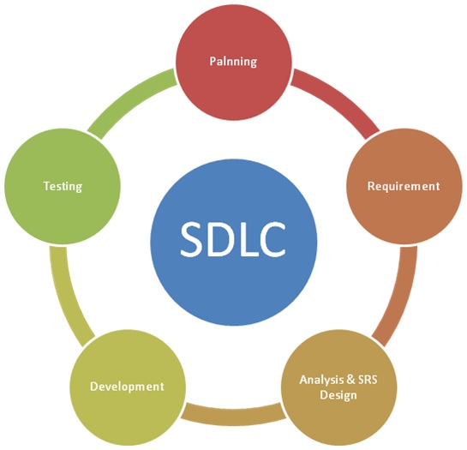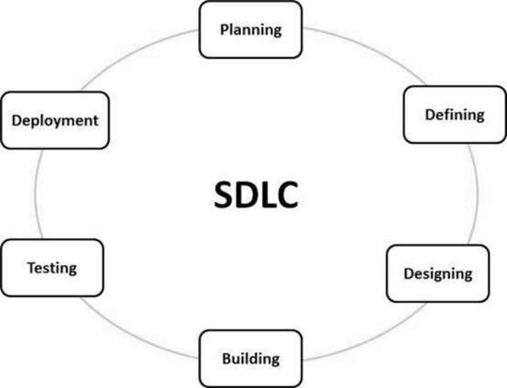
Most important and popular SDLC models:

  - Waterfall Model
Linear sequential flow. Any phase in the development process begins only if the previous phase is complete. No overlap
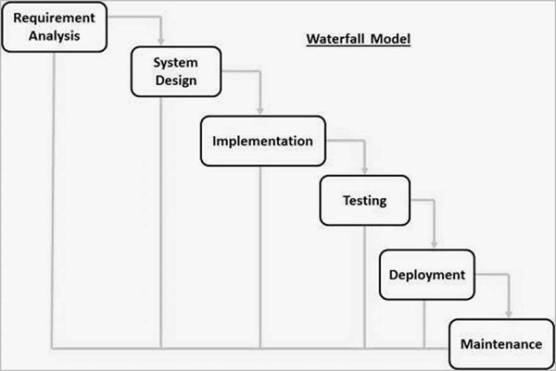
When the requirements are very clearly known, documented and not subject to change then we can follow the waterfall model.

  - V-Model
The V-Model is an extension of the waterfall model and is based on the association of a testing phase for each corresponding development stage. This means that for every single phase in the development cycle, there is a directly associated testing phase. This is a highly-disciplined model and the next phase starts only after completion of the previous phase.
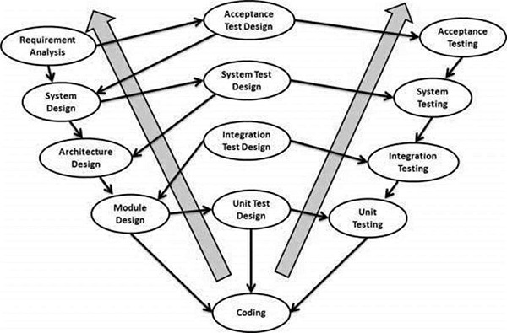
Most of the companies follow the V mode for the development because this model includes both verification and validation activities and testing is involved in earlier phase
  - Iterative Model
Iterative process starts with a simple implementation of a small set of the software requirements and iteratively enhances the evolving versions until the complete system is implemented and ready to be deployed.
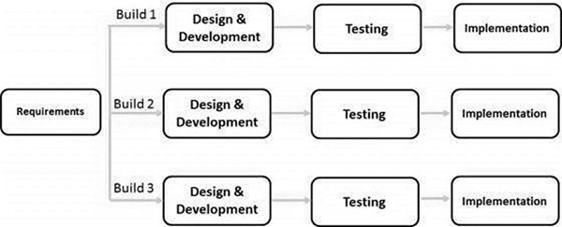
Iterative model can be used to build application where requirement changes after a period of times or application features or added on with smaller release. When the client is ready for the delivery of the product in parts or phases.
  - Spiral Model
The spiral model combines the idea of iterative development with the systematic, controlled aspects of the waterfall model. This Spiral model is a combination of iterative development process model and sequential linear development model i.e. the waterfall model with a very high emphasis on risk analysis. It allows incremental releases of the product or incremental refinement through each iteration around the spiral
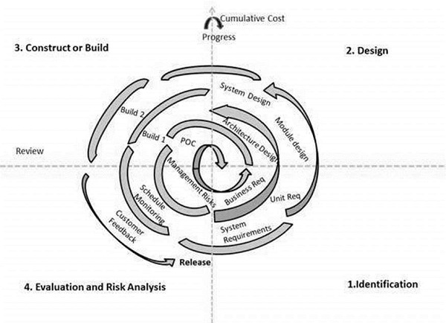
  - Big Bang Model
We do not follow any specific process. The development just starts with the required money and efforts as the input, and the output is the software developed which may or may not be as per customer requirement.
This Big Bang Model does not follow a and there is very little planning required. Even the customer is not sure about what exactly he wants and the requirements are implemented on the fly without much analysis.
Usually this model is followed for small projects where the development teams are very small.
  - Agile Model
Combination of iterative and incremental process models with focus on process adaptability and customer satisfaction by rapid delivery of working software product.
Agile Methods break the product into small incremental builds. These builds are provided in iterations. Each iteration typically lasts from about one to three weeks.
Every iteration involves cross functional teams working simultaneously on various areas like
- Planning
- Requirements Analysis
- Design
- Coding
- Unit Testing and
- Acceptance Testing.
At the end of the iteration, a working product is displayed to the customer and important stakeholders.
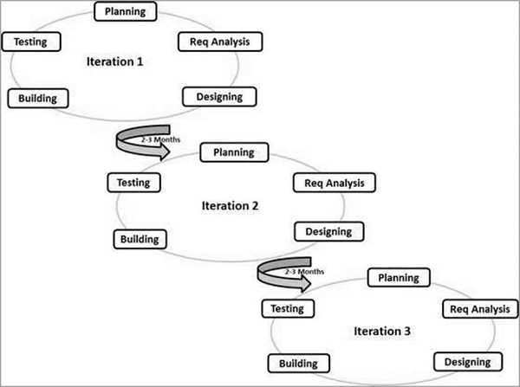
Iterative approach is taken and working software build is delivered after each iteration. Each build is incremental in terms of features; the final build holds all the features required by the customer.
  - RAD Model
  - Software Prototype Model

- Agile & Scram
Agile software development refers to a group of software development methodologies based on iterative development, where requirements and solutions evolve through collaboration between self-organizing cross-functional teams.
Agile development refers to any development process that is aligned with the concepts of the Agile Manifesto.
Scrum is a subset of Agile. It is a lightweight process framework for agile development.
A “process framework” is a particular set of practices that must be followed in order for a process to be consistent with the framework. (For example, the Scrum process framework requires the use of development cycles called Sprints, the XP framework requires pair programming, and so forth.)
“Lightweight” means that the overhead of the process is kept as small as possible, to maximize the amount of productive time available for getting useful work done.
A Scrum process is distinguished from other agile processes by specific concepts and practices, divided into the three categories of Roles, Artifacts, and Time Boxes.

- Testing Frameworks
A framework is considered to be a combination of set protocols, rules, standards and guidelines that can be incorporated or followed as a whole so as to leverage the benefits of the scaffolding provided by the Framework.
In a very simple language, we can say that a framework is a constructive blend of various guidelines, coding standards, concepts, processes, practices, project hierarchies, modularity, reporting mechanism, test data injections etc. to pillar automation testing. Thus, the user can follow these guidelines while automating application to take advantages of various productive results.
Take a note that a testing framework is always application independent that is it can be used with any application irrespective of the complications (like Technology stack, architecture etc.) of the application under test. The framework should be scalable and maintainable.
Advantage of Test Automation framework
- Reusability of code
- Maximum coverage
- Recovery scenario
- Low-cost maintenance
- Minimal manual intervention
- Easy Reporting

Most popular Test Automation Frameworks
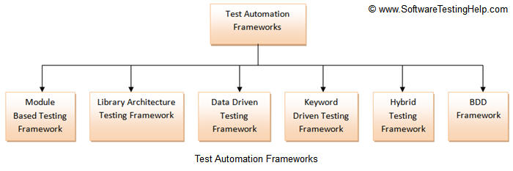
  - Module Based Testing Framework
Module based Testing Framework is based on one of the popularly known OOPs concept – Abstraction. The framework divides the entire “Application Under Test” into a number of logical and isolated modules. For each module, we create a separate and independent test script. Thus, when these test scripts took together builds a larger test script representing more than one modules.


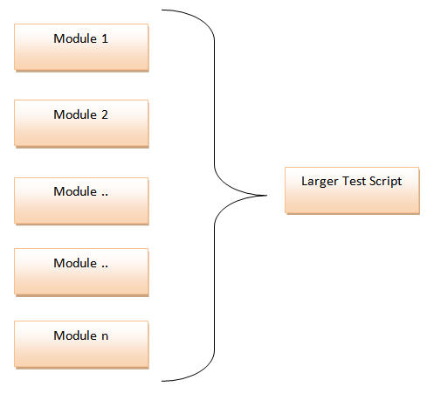

Pros:
- The framework introduces the high level of modularization which leads to easier and cost-efficient maintenance.
- The framework is pretty much scalable
- If the changes are implemented in one part of the application, only the test script representing that part of the application needs to be fixed to leave all the other parts untouched.
Cons:
- While implementing test scripts for each module separately, we embed the test data (Data with which we are supposed to perform testing) into the test scripts. Thus, whenever we are supposed to test with a different set of test data, it requires the manipulations to be made in the test scripts.
  - Library Architecture Testing Framework
It is built on Module Based Testing Framework with some additional advantages. Instead of dividing the application under test into test scripts, we segregate the application into functions or rather common functions can be used by the other parts of the application as well.
The basic fundamental behind the framework is to determine the common steps and group them into functions under a library and call those functions in the test scripts whenever required.
For example the login steps can be combined into a function and kept into a library. Thus all the test scripts those require to login the application can call that function instead of writing the code all over again.
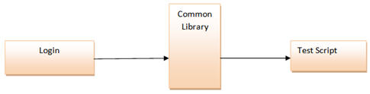

Pros:
- As we create common functions that can be efficiently used by the various test scripts across the Framework. Thus, the framework introduces a great degree of re-usability
Cons:
- With the introduction of libraries, the framework becomes a little complicated.
- The test data is still lodged into the test scripts, thus any change in the test data would require changes in the test script as well
  - Data Driven Testing Framework
While automating or testing any application, at times it may be required to test the same functionality multiple times with the different set of input data. Thus, in such cases, we can’t let the test data embedded in the test script. Hence it is advised to retain test data into some external database outside the test scripts.
Data Driven Testing Framework helps the user segregate the test script logic and the test data from each other. It lets the user store the test data into an external database. The external databases can be property files, xml files, excel files, text files, CSV files, ODBC repositories etc.
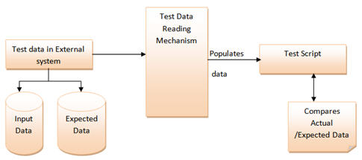

Pros:
- Any change in the test data matrix would not hamper the test script code.
- reduces the total number of scripts required to cover all the possible combinations of test scenarios.
- Increases flexibility and maintainability
Cons:
- The process is complex and requires an extra effort to come up with the test data sources and reading mechanisms.
- Requires proficiency in a programming language that is being used to develop test scripts
  - Keyword Driven Testing Framework
The Keyword driven testing framework is an extension to Data driven Testing Framework in a sense that it not only segregates the test data from the scripts, it also keeps the certain set of code belonging to the test script into an external data file.
The keywords and the test data are stored in a tabular like structure and thus it is also popularly regarded as Table driven Framework. Take a notice that keywords and test data are entities independent of the automation tool being used.
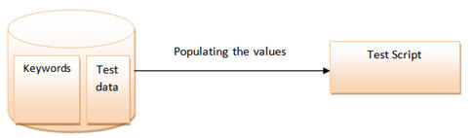

Pros:
- Doesn’t require the user to possess scripting knowledge
- A single keyword can be used across multiple test scripts
Cons:
- The framework becomes complicated gradually as it grows and a number of new keywords are introduced.
  - Behavior Driven Development Framework
Behavior Driven Development framework allows automation of functional validations in easily readable and understandable format to Business Analysts, Developers, Testers, etc. Such frameworks do not necessarily require the user to be acquainted with the programming language. There are different tools available for BDD like cucumber, Jbehave etc.

Components of Automation Testing Framework
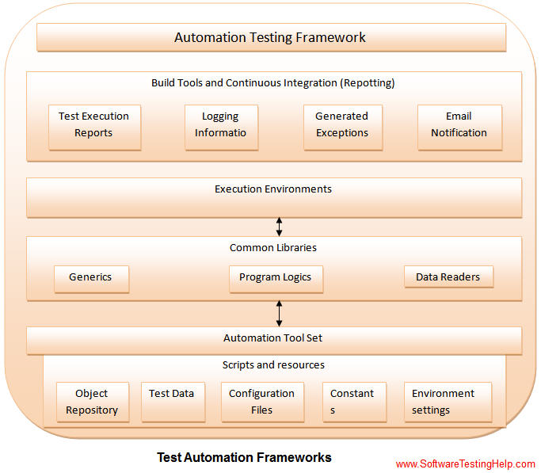
- Object Repository: Object Repository acronym as OR is constituted of the set of locators types associated with web elements.
- Test Data: The input data with which the scenario would be tested and it can be the expected values with which the actual results would be compared.
- Configuration File/Constants/ Environment Settings: The file stores the information regarding the application URL, browser-specific information etc. It is generally the information that remains static throughout the framework.
- Generics/ Program logics/ Readers: These are the classes that store the functions which can be commonly used across the entire framework.
- Generics/ Program logics/ Readers: These are the classes that store the functions which can be commonly used across the entire framework.

- Gherkin
Gherkin is a line-oriented language that uses indentation to define structure.

feature: some terse yet descriptive text of what is desired
scenario: some_determinable_business_situation
Given some_precondition
When some_action
Then some_testable_outcome_is_achived
feature:

- Test Plan
https://www.guru99.com/what-everybody-ought-to-know-about-test-planing.html
A test plan is a detailed document that outlines the test strategy, Testing objectives, resources (manpower, software, hardware) required for testing, test schedule, Test Estimation and test deliverables.
Importance of Test Plan

How to write Test Plan
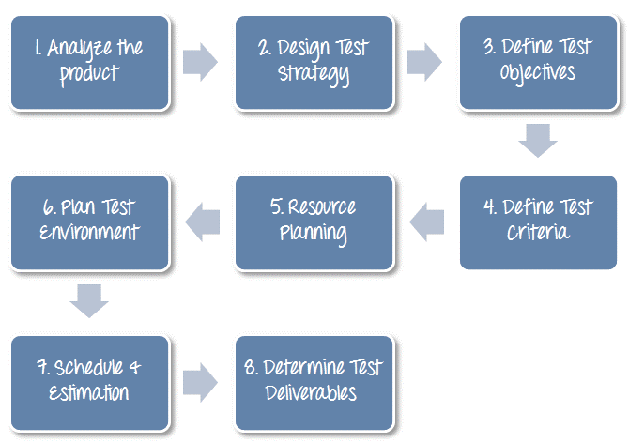

Analize the Product
Develop Test Strategy
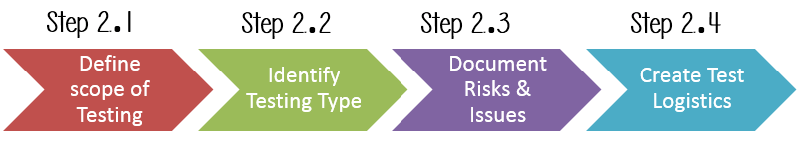
Define Scopo of Testing
Identify Test Type
Document Risk and Isues
Create Test Logistics
Define Test Objective
Define Test Criteria
Resource Planning
Plan Test Environment
Schedule and Estimation
Test Deliverables

