Nascom 2 - CPM switch board

Introduction
This add-on for the NASCOM 2 provides a Dual Boot facility between the standard NASSYS monitor and CP/M operating system. It sits on the LKS1 socket and controls which of the connections are make or broken.

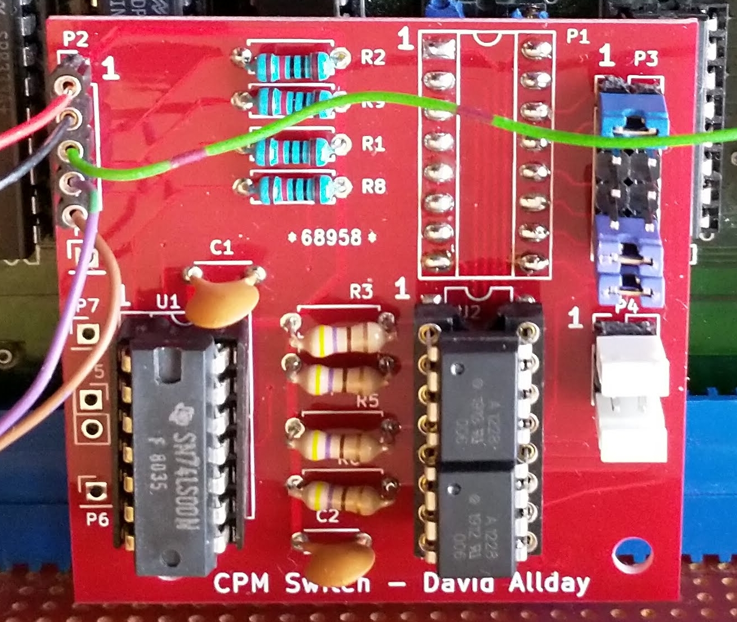

The Reason.

I wanted a single switch that would enable/disable the Nascom 2 onboard memory and allow me to use the full 64k of memory for CP/M. What was needed was some circuit that could turn on or off the memory select lines on LKS1.

I first tried using logic gates to achieve this, using various combination of logic gates. But although they worked there seemed to be some instability in the selection process, especially with the Nascom video ram. Accessing video ram rapidly showed some strange affects on the screen output.

After that I tried some “Solid State Relays” which use a MOSFET circuit and provide a low ON resistance. As an experiment O used standard resistors in the links on the Nascom 2 LKS1, and everything worked fine with a resistance of about 100ohms, so I assumed that the 10ohm ON resistance of a MOSFET relays should be fine. The actual units I picked were ASSR-1228-002E from uk.farnell.com, partly due to their ON resistance value and partly due to cost.

Connections to the Board.

The board is designed to sit in the LKS1 link block on the Nascom 2 main board and control which of the on board memory blocks are active.

There are 5 “flying leads” that need to be connected to the PCB.
The first 2 are the 5v and 0V lines needed to provide power to the PCB.
There are also 3 switch lines that are used to determine which memory blocks are active. The control lines all have pull up resistors so only need to be pulled low by the switches.
If you always want the Nascom ROM/RAMs active when Nassys is active then you do not need to connect switch 1 or switch2 as they will be activated by the pull-up resistors.

CPMSwitch – is the main control switch.
When not connected, with the help of the pull up resistor, it turns on the NASMON and VWRAM lines.
U2A connects pin 1 to pin 16 and U2B connects pin 2 to pin 15.
It also enables the circuits attached to Switch1 and Switch2.
When connected to GND – it turns OFF the NASMON and VWRAM lines.
It also disables the circuits attached to Switch1 and Switch2.

Switch1
This is only active when CPMSwitch is not GND.
It controls U3A which will be closed when high or Not Connected
It can be used to activate either
BankA for 0x1000 and/or 0X2000
Basic Rom for 0xE000

Switch2
This is only active when CPMSwitch is not GND.
It controls U3B which will be closed when high or Not Connected
It can be used to activate either
BankB for 0xB000 and/or 0xC000 and/or 0xD000
Basic Rom for 0xE000

Connector Blocks on the PCB.
Pin Connectors P3 and P4 are used to control the action of switch1 and switch2.

P3 – Select Address
P3 is used to select which of the address lines from LKS1 pins 9 to 16 are to be used for Switch 1 and which for Switch 2. You can decide to connect none or many.

P4 – Select Ram/Rom bank
P4 is used to select which of the Nascom 2 Ram/Rom memory banks are activated by the selections made by P3.

P5, P6 – Spare NAND gate
These connectors can be used to make use of the spare NAND gate or the 2 pins on P5 can be attached to ground, see P7.

P7, P8 – Ground pins
These have been added to provide ground connections if using test equipment.

Some standard setting for P3 and P4
Switch 1 to activate Nascom 2 Bank A
Nascom Bank A connect
P3 pin 1 to 2 for 0x1000 } you can connect both if needed
P3 pin 3 to 4 for 0x2000 }
P4 pin 6 to 5

Switch 1 to activate the Basic ROM chip
Basic ROM connect
P3 pin 6 to 4
P4 pin 6 to 4

Switch2 to activate Nascom 2 Bank B
Nascom Bank B connect
P3 pin 7 to 8 for 0xB000 }
P3 pin 9 to 10 for 0xC000 } You can connect all 3 if required.
P3 pin 11 to 12 for 0xD000 }
P4 pin 1 to 2

Switch 2 to activate the Basic ROM chip
Basic ROM connect
P3 pin 6 to 8
P4 pin 4 to 2

Non standard connections
You can of course cross connect different connectors in P3 and P4 to achieve other effects but the ones above are easy to achieve using the 2 pin jumper connectors like those used to select options on the older PC motherboards.

Circuit Schemas

Original test circuit using logic gates, which was not stable especially for the VWRAM.

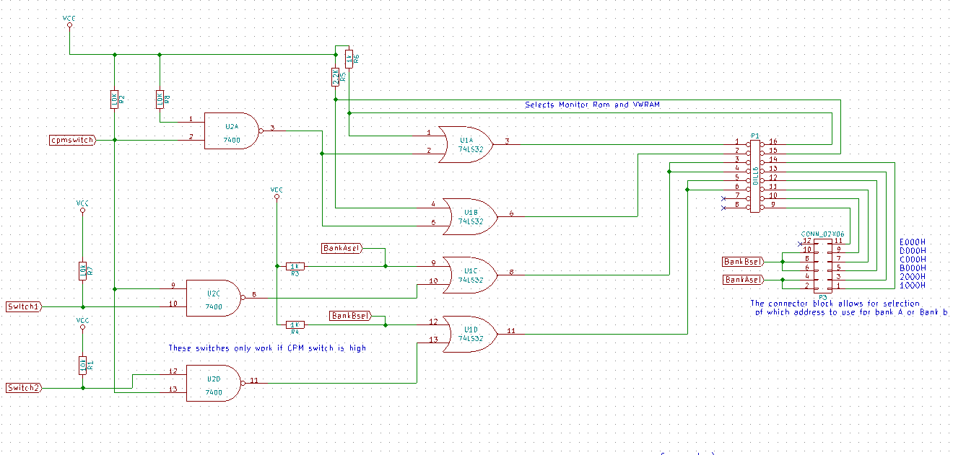
The new design using “Solid State Relays”

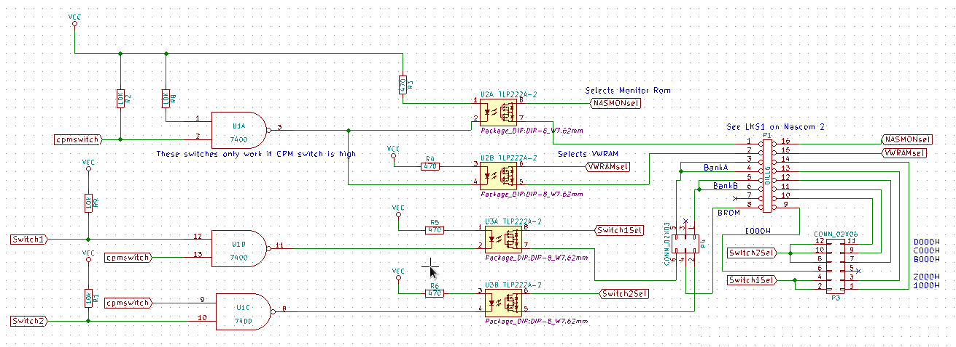

Part list
This is the part list for the CPMSwitch PCB board. You will also need to provide switches and wire to connect to the board.

R1 10k resistor
R2 10k resistor
R3 470 ohm resistor
R4 470 ohm resistor
R5 470 ohm resistor
R6 470 ohm resistor
R7 not used
R8 10k resistor
R9 10k resistor

C1, C2 0.1uF decoupling capacitor

U1 74LS00 Quad NAND gate
U2, U3 ASSR-1228-002E dual MOSFET Solid State Relays.
You can probably use any MOSFET Solid State Relay with a reasonably low “on” resistance and a matching pinout. Probably even the single relay chips.

P1 - 16 pin (2x8) turned pin PCB header plug
Needed to plug into LKS1 on the Nascom 2 board.
P2 - 5 pin 0.1” pitch (1x5) connector - the type depends on how you wish to connect to it.
I used SIL socket.
P3 - 6 pin 0.1” pitch (2x3) male pin connector
P4 - 16 pin 0.1” pitch (2x8) male pin connector
A number of 2 pin jumper connectors to use on P3 and P4

Optional
P5 – 2 pin 0.1” pitch (1x2) pin connector
P6 – 1 pin 0.1” pitch (1x1) pin connector
P7 – 1 pin 0.1” pitch (1x1) pin connector
P8 – 1 pin 0.1” pitch (1x1) pin connector

Change History

12Oct2020 | David Allday | 1st Edit.

