**Virtual C-arm Simulator Instructions**

**Left Controller Right Controller**

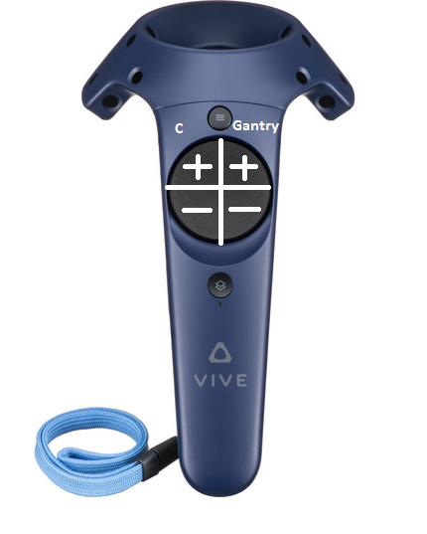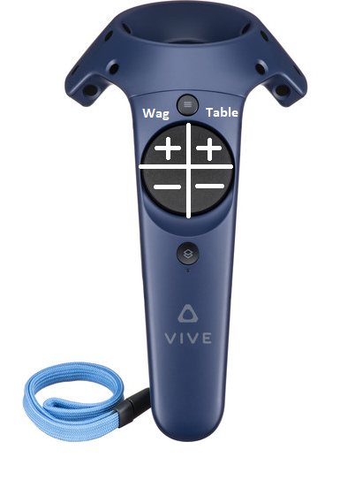

**Full AP - L4 Full Lateral – L4 Left Scotty Dog – L4**

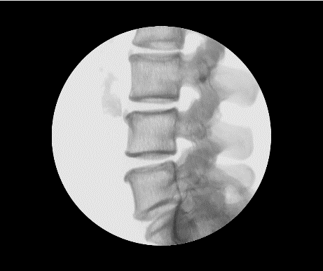

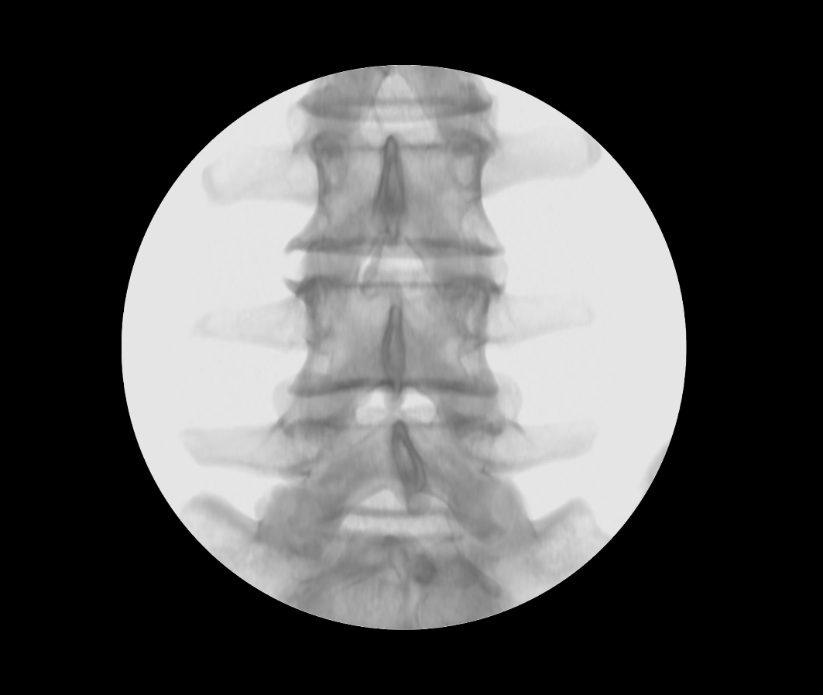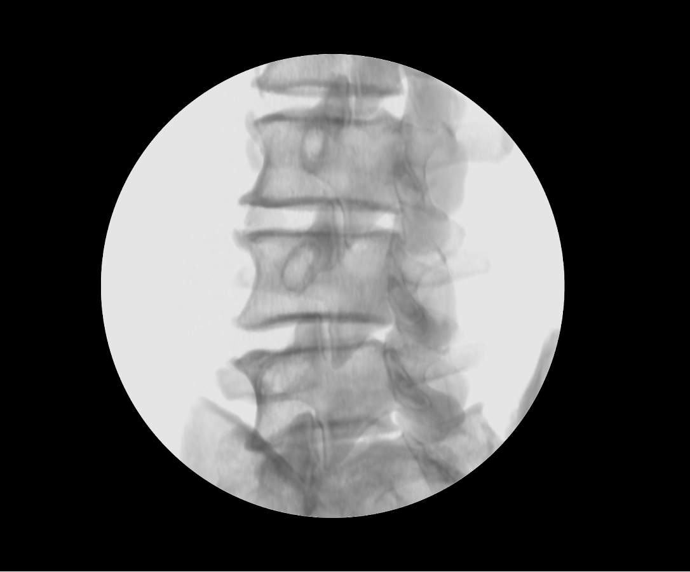

**You are tasked with acquiring 9 images (3 of each view above) using the Virtual C-arm. Use the vive controls as shown above to control the Carm. Use the *Left*** **trigger to shoot fluoro and the right trigger to collect the image once you are satisfied. The current view you are to collect will be displayed on the fluoro display.**