Quality Control for Metal Casting Product
2023-11-20
Final Report
Dallen Huang

Introduction

In manufacturing, casting is a critical process where liquid material is poured into molds to form specific shapes. However, this process often encounters casting defects - unwanted irregularities like blowholes, pinholes, burrs, and shrinkage defects. These defects can compromise the quality of the final product.

Traditionally, identifying these defects has relied on manual inspection, a method that's both time-intensive and prone to human error. This lack of precision can lead to significant issues, including the potential rejection of entire product batches, causing substantial financial losses.

The project aims to modernize this inspection process by developing an automated system using deep learning. This system is designed to detect accurately and efficiently casting defects, thereby enhancing the quality control measures in manufacturing. By implementing this advanced technology, we anticipate not only a reduction in inspection time but also an increase in the accuracy and reliability of defect detection.

Data Overview

The dataset comprises 7,348 grey-scaled images of submersible pump impellers viewed from the top. Each image is 300x300 pixels in size, with image augmentation already applied. Additionally, the dataset includes a set of 512x512 pixel grey-scaled images without augmentation, consisting of 519 ‘ok_front’ (non-defective) and 781 ‘def_front’ (defective) impeller images. Stable lighting, ensured through special arrangements, was crucial for capturing these images.

Data Source: https://www.kaggle.com/datasets/ravirajsinh45/real-life-industrial-dataset-of-casting-product

Exploratory Data Analysis

Data Breakdown

The dataset was divided into three subsets:

Training Set: Comprised of 6,633 images, accounting for 76.7% of the total data. It showed a defective percentage of 56.66%.

Testing Set: Included 715 images, representing 8.27% of the dataset, with a defective percentage of 63.36%.

Non-Augmented Set: Consisted of 1,300 images, forming 15.03% of the data, with a defective percentage of 60.08%.

The distribution of defective images across these subsets was fairly consistent, falling within the range of 56.67% to 60.08%.

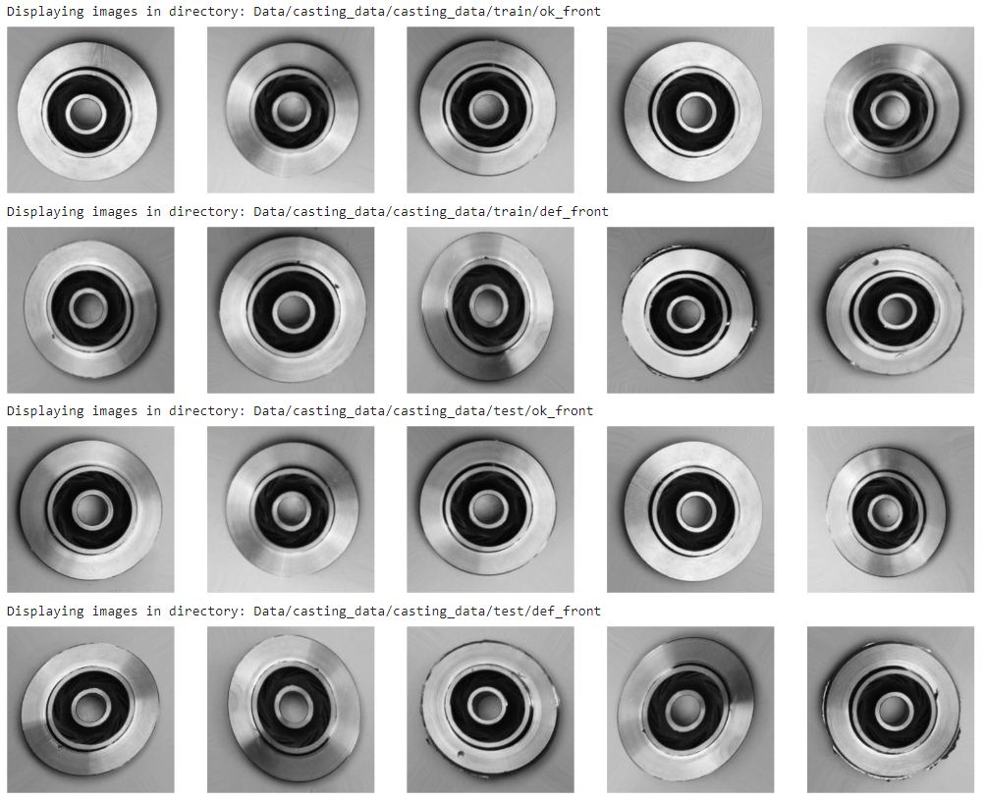
Image Review
Picture 1. Sample Images

The dataset consists of top-view images of submersible pump impellers, but they were not captured at a perfect 90-degree angle. Each image is in grayscale with a round boundary and features multiple concentric circles. The dataset captures a variety of casting defects, including blowholes, pinholes, burrs, shrinkage defects, mold material defects, pouring metal defects, and metallurgical defects, among others.
Some images appear to have been augmented with techniques such as random rotation, zoom, or flipping. Width and height shifts may not be appropriate as the images were taken with the intent of centering the circle in the middle of the image frame. Applying random brightness adjustments is not suitable since it could compromise the consistency of lighting conditions, which is essential for capturing these images. Such inconsistencies could potentially affect the accuracy of the machine learning model's performance in defect detection.

Image Resizing
The non-augmented images, initially at a resolution of 512x512, were resized to 300x300 to align with the augmented image set. This was achieved using a function that iterated over the images, resizing and saving them to a specified directory.

Subset Adjustment
To balance the representation of non-augmented images and align the sizes of validation and testing sets, we transferred a portion of the testing set to the validation set. This adjustment enhanced the variation within the validation set.

Data Processing and Training
The data training phase of the project involved developing and refining a deep learning model tailored for the automated inspection of casting products. This process was crucial for achieving high accuracy in identifying defects while ensuring the model can generalize effectively to new, unseen data.

Data Preparation
ImageDataGenerators were created for training, validation, and testing sets. Each generator rescaled the images by a factor of 1/255 and converted them to grayscale. The target size for all images was set to 300x300, and the generators were linked to their respective dataset directories.
- Training Generator: Processed 6,633 images across two classes.
- Validation Generator: Handled 1,005 images across two classes.
- Testing Generator: Managed 1,000 images across two classes.

Model Initializations
Three models were developed and iteratively improved upon:
- Model 1: A conventional convolutional neural network (CNN) with multiple convolutional, pooling, and dense layers.
- Model 2: An advanced CNN featuring dropout layers and L2 regularization, aimed at reducing overfitting.
- Model 3: A sophisticated CNN incorporating batch normalization and an optimized architecture, balancing the strengths of the previous models.

Training and Evaluation
Model 1
- Exhibited a final training accuracy of 99.43% after 10 epochs.
- Achieved a peak validation accuracy of 94.70%.
- Demonstrated an accuracy of 84.80% on unseen test data, with a loss of 1.8783.
Model 2
- Utilized early stopping and checkpoints to monitor validation loss.
- Peaked in performance at Epoch 23 with a validation accuracy of 92.54% and a test accuracy of 80.30%.
- Showed a notable reduction in test loss to 0.6520 at Epoch 23.
Model 3
- Focused on further reducing overfitting and enhancing generalization.
- Evaluated at different epochs, with Epochs 9 and 12 standing out.
- Epoch 9 displayed a validation accuracy of 92.24% and a test accuracy of 81.70%, with a lower test loss of 1.4000 compared to Epoch 12.

Conclusion
The training process revealed that while all models performed competently, Model 2 at Epoch 23 emerged as the most effective, balancing high accuracy with a lower loss. This model is best suited for the project's objective of predicting 'ok' or 'defective' labels for future products due to its ability to generalize well to new data. The selected model was saved as 'CQC_4_Final_Model' for integration into the quality control process.

Future Steps
- Continuous Monitoring and Training: Regular assessments and updates of the model with new data will be crucial to maintain its effectiveness.
- Enhancement with More Data: Expanding the dataset over time will help in further refining the model's accuracy and generalization capabilities.
- Application Integration: The model will be integrated into the quality control process, aiming to augment efficiency and reliability in the inspection of casting products.
Reference
1. Ravirajsinh45. (Year Published). Real-life Industrial Dataset of Casting Product. Kaggle. Retrieved from https://www.kaggle.com/datasets/ravirajsinh45/real-life-industrial-dataset-of-casting-product

