UL Mini Project

Principal Component Analysis of Wine Data

Project By:
Dalon Francis Lobo
Lokesh Sharma
Sunpreet Singh

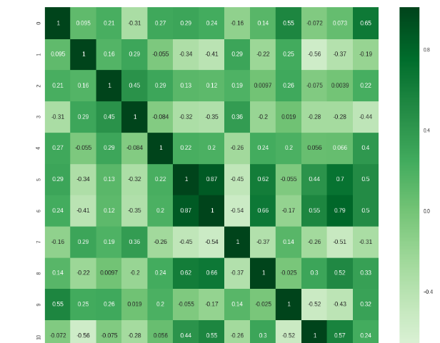

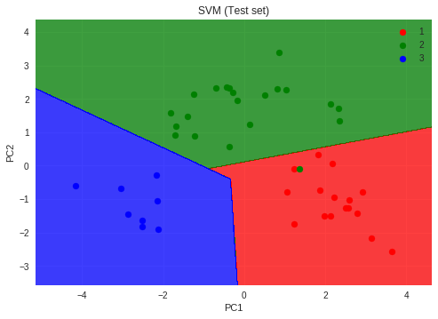
Content:
Table of Contents
Principal Component Analysis of Wine Data 1
Project By: 1
Problem Description: 3
Attribute definition 3
Steps: 4
Step 1: Standardizing the 13-dimensional dataset 4
Step 2: Constructing the covariance matrix 4
Step 3: Decomposing the covariance matrix into its eigenvectors and eigenvalues 5
Step 4 & 5: Selecting k eigenvectors 5
Step 6: Projection matrix W 6
Step 7: Transform the dataset 7
Conclusion: 7
Constructing a classification model 8

Problem Description:
Applying Principal Component Analysis (PCA) on the Wine data set.
PCA involves following broad level steps –
1. Standardize the d-dimensional dataset.
2. Construct the covariance matrix.
3. Decompose the covariance matrix into its eigenvectors and eigenvalues.
4. Select k eigenvectors that correspond to the k largest eigenvalues, where k is the dimensionality of the new feature subspace (k≤d)
5. Construct a projection matrix W from the "top" k eigenvectors.
6. Transform the d-dimensional input dataset x using the projection matrix W to obtain the new k-dimensional feature subspace
Dataset is acquired from
https://archive.ics.uci.edu/ml/machine-learning-databases/wine/wine.data

Attribute definition
1st attribute is class identifier (1-3). Other attributes are below:
- Alcohol
- Malic acid
- Ash
- Alcalinity of ash
- Magnesium
- Total phenols
- Flavanoids
- Nonflavanoid phenols
- Proanthocyanins
- Color intensity
- Hue
- OD280/OD315 of diluted wines
- Proline
So we will consider 13 attributes for PCA.

Steps:

Step 1: Standardizing the 13-dimensional dataset
We will use the StandardScaler class from sklearn.preprocessing library to standardize the dataset.
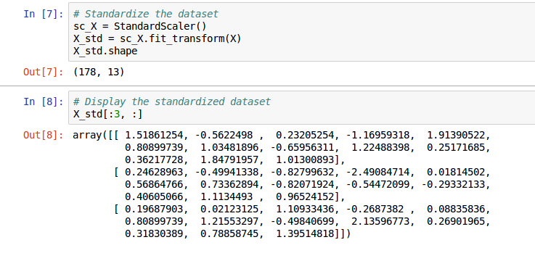

Step 2: Constructing the covariance matrix
We will use cov function from numpy module to find the covariance matrix.
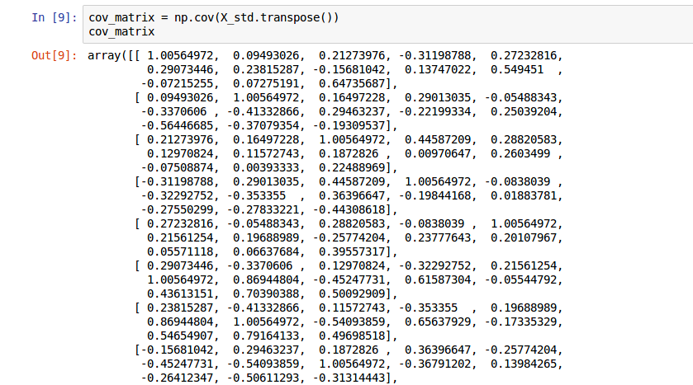

Step 3: Decomposing the covariance matrix into its eigenvectors and eigenvalues
To do this we will use linalg.eig from numpy module.
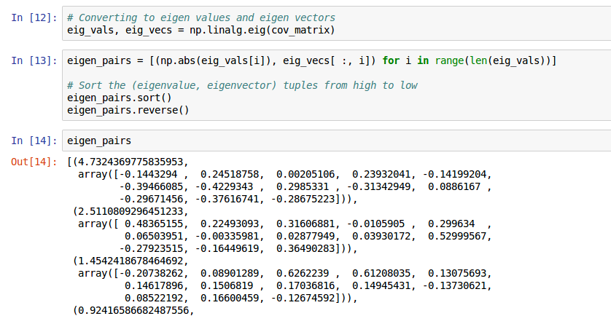

Step 4 & 5: Selecting k eigenvectors
Select k eigenvectors that correspond to the k largest eigenvalues, where k is the dimensionality of the new feature subspace (k ≤ d)
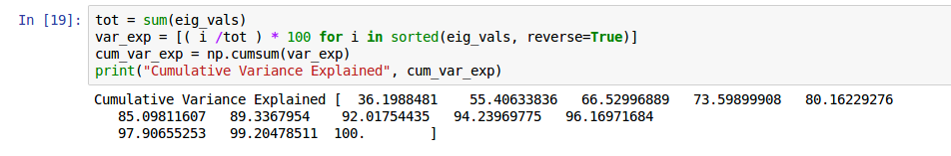
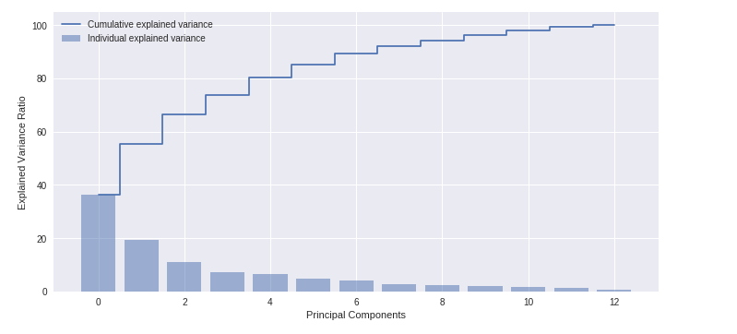
Cumulative graph is below:

Step 6: Projection matrix W
Constructing a projection matrix W from the "top" 7 eigenvectors.
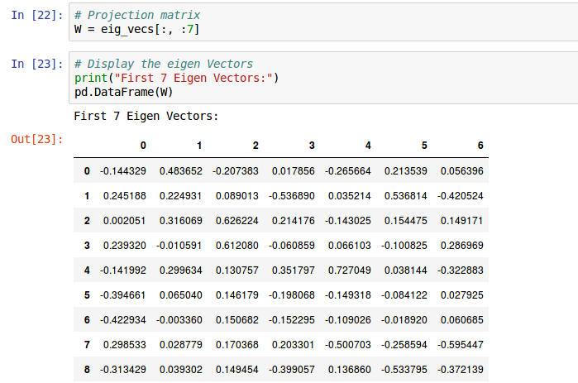
Here, we are reducing the 13-dimensional feature space to a 7-dimensional feature subspace, by choosing the "top 7" eigenvectors with the highest eigenvalues to construct our d×k-dimensional eigenvector matrix W.

Step 7: Transform the dataset
Transforming the 13-dimensional input dataset x using the projection matrix W to obtain the new 7-dimensional feature subspace.
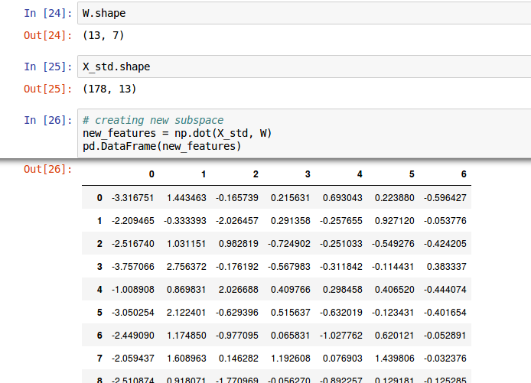

Conclusion:
Using PCA, we were able to reduce the huge 13 dimensional dataset to 7 dimensional subspace, by retaining 89.33% of the variance of the original dataset.
We used 6 steps to apply Principal Component Analysis on our dataset.
This can also accomplished using PCA implementation from scikit-learn. Ex: from sklearn.decomposition import PCA as sklearnPCA

Constructing a classification model
- Using SVM to classify the wine dataset to 3 classes
- Applied PCA and reducing the dimentionality to just 2
- These 2 Principal Components explained total variance of 56.02% of the total variance in the dataset
- The SVM model was able to get a accuracy of 97.77%
