SLE Mini Project
Predict The Acceptance Of Personal Loan

Project By:
Anuj kumar
Dalon Francis Lobo
Jyothi H N
Pankaj Kumar
Satish Kaushik
Venkat

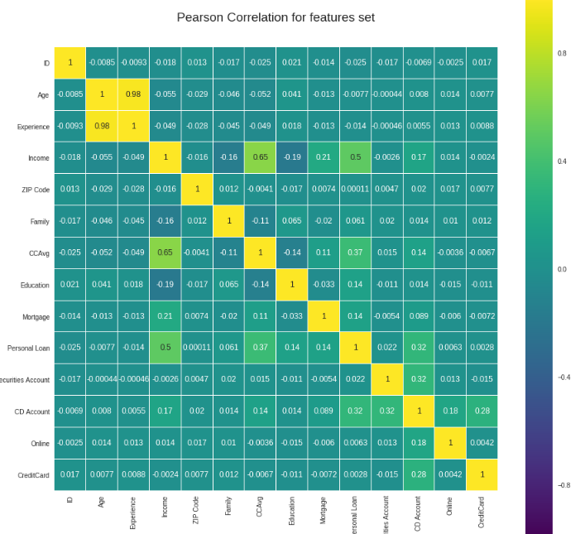
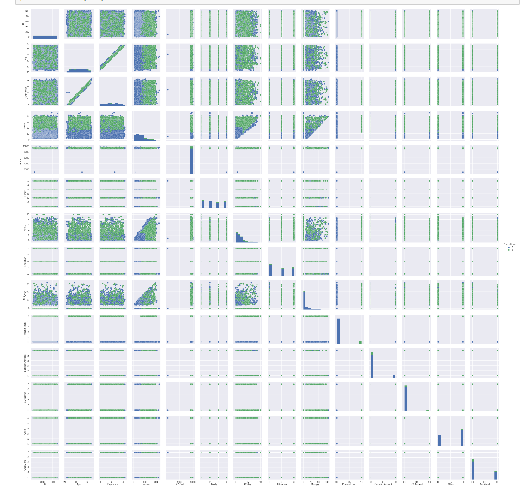

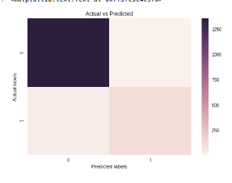
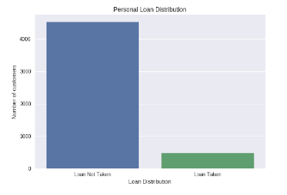

Content:
Table of Contents
Project By: 1
Problem Description: 3
Univariate Analysis 4
Bivariate Analysis 4
Pair Plot Analysis 6
Analysis of Target Variable 7
Insights 7
Decision Tree Classifier Vs KNN Classifier 7
Ensemble techniques to improve the performance 8
Conclusion 8

Problem Description:

This case is about a bank (Thera Bank) which has a growing customer base. Majority of these customers are liability customers (depositors) with varying size of deposits. The number of customers who are also borrowers (asset customers) is quite small, and the bank is interested in expanding this base rapidly to bring in more loan business and in the process, earn more through the interest on loans. In particular, the management wants to explore ways of converting its liability customers to personal loan customers (while retaining them as depositors). A campaign that the bank ran last year for liability customers showed a healthy conversion rate of over 9% success. This has encouraged the retail marketing department to devise campaigns with better target marketing to increase the success ratio with minimal budget.
In this note book, we will build a model that will help the department to identify the potential customers who have higher probability of purchasing the loan. This will increase the success ratio while at the same time reduce the cost of the campaign.
We have data on 5000 customers and each have 14 features each. Fortunately there are no null values in the data.
Description of the data set:
- ID: Customer ID
- Age: Customer's age in completed years
- Experience: Number of years of professional experience
- Income: Annual income of the customer ($000)
- ZIPCode: Home Address ZIP code.
- Family: Family size of the customer
- CCAvg: Average spending on credit cards per month ($000)
- Education: Education Level. 1: Undergrad; 2: Graduate; 3: Advanced/Professional
- Mortgage: Value of house mortgage if any. ($000)
- Personal Loan: Did this customer accept the personal loan offered in the last campaign?
- Securities Account: Does the customer have a securities account with the bank?
- CD Account: Does the customer have a certificate of deposit (CD) account with the bank?
- Online: Does the customer use internet banking facilities?
- CreditCard: Does the customer use a credit card issued by UniversalBank?
The number of customers who accepted the personal loan that was offered to them in the campaign is merely 480 customers. That implies the success ratio is 9.6%. Our target will be to increase this success ratio.

Univariate Analysis
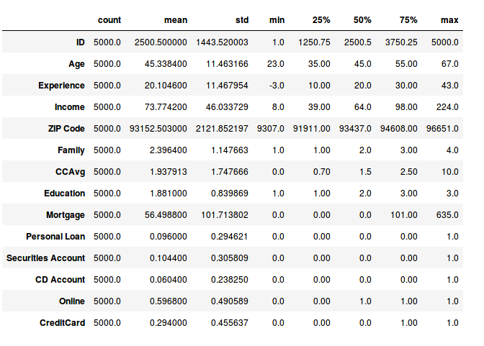
Age feature is normally distributed with mean = median
- Experience feature has some missing values, because experience cannot be negative
- Income is right skewed
- Average Family size of the customer is around 2 people
- Average credit card spending per month is slightly right skewed
- Morgage distribution seams to have an outlier

Bivariate Analysis
Constructing Pearsons correlation heatmap using seaborn module.
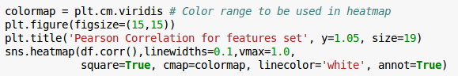

The output is below:
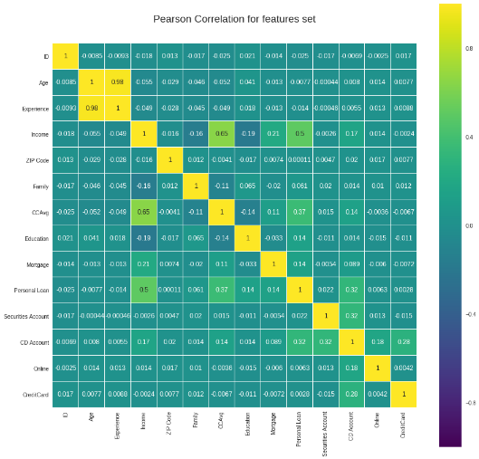
- There is a very strong positive correlation between Age and Experience
- And a weak positive correlation between CCAverage and Income
All these analysis tells us that we could potentially keep Age or Experience.

Pair Plot Analysis
The pair plot gives us pictorial representation of the distribution
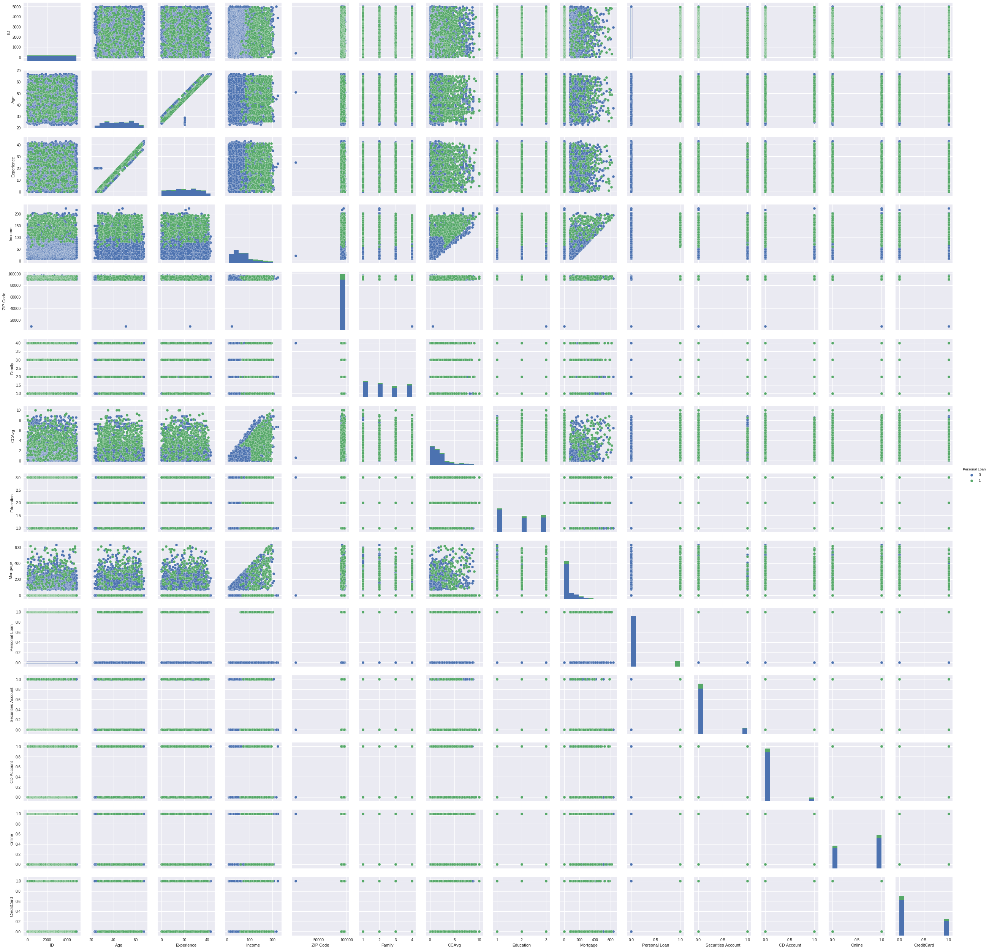

Analysis of Target Variable

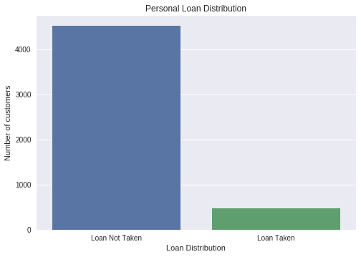
Insights

- The data is strongly biased towards customer that have not take the loan
- Only 9.6% of the customers have taken the loan

Decision Tree Classifier Vs KNN Classifier
Decision Tree accuracy score = 97.54%
KNN accuracy = 90.42%
- We will use Decision Tree classifier with entropy criterion because is gives much better accuracy over KNN.
- Decision Trees are also very flexible, easy to understand, and easy to debug.
- KNN doesn't know which attributes are more important i.e. when computing distance between data points (usually Euclidean distance or other generalisations of it), each attribute normally weighs the same to the total distance. This means that attributes which are not so important will have the same influence on the distance compared to more important attributes.

Ensemble techniques to improve the performance
We have a good accuracy score using DT, but we also have to keep in mind the fact that the data we have is highly biased. We will try to get better accuracy using some of ensemble techniques.
We used Random Forest Classifier from scikit learn module of python.
The best accuracy was obtained with a maximum tree depth =17 and number of trees = 19
This confusion matrix heat map sums up the result
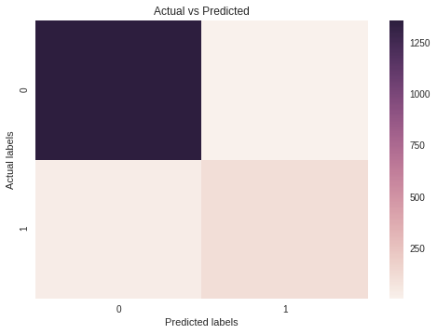

Conclusion

We got a very good accuracy using the Random Forest Classifier. The main challenge with this data is that the given data is highly biased toward Loan Not Taken. This can be fixed by collecting more samples.

