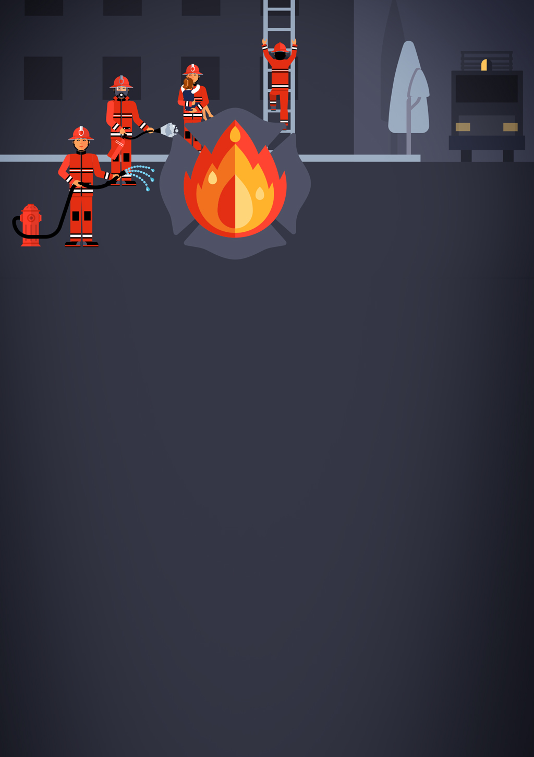

Polimi on fire!

Figure 1

Game Design Document



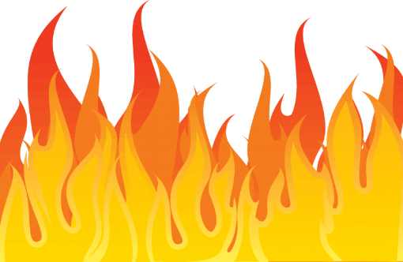



Index

Figure 2

1. **Introduction**
   1. **Game Concept**
   2. **Principal Characteristiscs**
   3. **Game Gender**
   4. **Public of the game**
   5. **Visual Style**
   6. **Game Scope**
2. **Game mechanics**
   1. **Gameplay**
   2. **Story**
   3. **Map Generation**
   4. **Characters**
   5. **Enemies**
   6. **Movement and physics**
   7. **Controls**
3. **Interface**
   1. **Videogame FlowChart**
   2. **Menu**
   3. **Credits**
   4. **Profile selection**
   5. **Character selection**
   6. **Difficulty selection**
   7. **Punctuation**
   8. **Level end**
4. **Art**
   1. **Art 2D**
   2. **Art 3D**
   3. **Audio**
5. 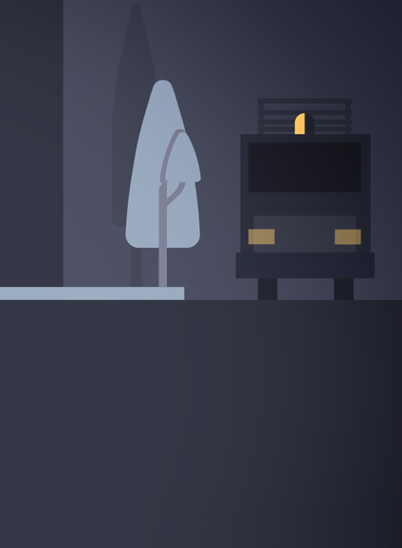**Introduction**
   1. **Game Concept**

Polimi on fire is a 3d non endless running videogame. The player must control an student of Polimi that has to scape through the main buldings of the university which are completely on fire. The player will have to dodge several obstacles and dont touch the fire that will be in some parts of the university.

The game is based on the popular 2011 mobile game, Temple Run, but it differes in some kay apects as Temple Run was and endless running game and Polimi on Firea has a map with a final. Also in our game its possible to turn left or right and modify the route of the level, making a different experience everytime.

* 1. **Principal Characteristiscs**

Developers: Politecnico Milano

Publishers: Politecnico Milano

Artists:

Series: Polimi On Fire!

Engine: Unity

Platforms: PC

Release: 2022

Genre:Non Endless Runner

Mode:Single Player



* 1. **Game Gender**

The game gender is based in the game gender endless runner but with some variations, we call this gender as non endless runner as the screen has an end. It also impruves teh genre as you can make new movements to the right or to the left and vary the level to be able to have new experiences.

* 1. **Public of the game**

The public of the game is a casual public that want wants to play a simple game easily witohut having to memorize complex instructions for playing.

The public is also every university student, specially every student of Politecnico Milano, as they would have the possibility see their university on fire and skip the exams.

* 1. **Visual Style**

We tried to make a cartoon visual style without trying to be realistic. It is a game that uses the graphics technique , Cell Shading. As the game has this type of visual style it can be played with low specs computers. It also makes a simple and casual graphics style that is more apropiate to the game, than a realistic graphics.

* 1. **Game Scope**

We can resume the scope of the game in a simple index:

Mechanical needs = High

Story needs = Low

Aesthetics = Medium

Technology = Medium



1. **Game mechanics**
   1. **Gameplay**

We can sum the actuall gameplay with some in game captures of the real gameplay

* 1. **Story**

**The story of the game is simple and its not really relevant on this game.   
You are an student of the university Politecnico Milano, you are going to assist to a really difficult exam when suddenly the fire alarm starts to ring, and you start to see a lot of fire and smoke… Polimi is on fire. You need to go out the university and survive, but be careful the university is full of obstacles and you must be fast and dodge them, even a simpe crash with a locker could be fatal**

* 1. **Map Generation**

**The map is generated automatically and randomly. Once the player has reached a part of the map, new parts are loaded to avoid having a huge map loaded in the ram of the computer and having low FPS or crashes.**

**The map is composed of several pieces, each piece is a put randomly crating the sensation of passing through new places.**

* 1. **Characters**

Apart form the main characer, there are not other characters.

* 1. **Enemies**

The enemies of this game are only the obstacles of the university, as some lockers, the architectural design of the university and obviously the fire.

You just have to dodge them and scape from them. There are not human enemies or similar in this game

* 1. **Movement and physics**

The player can do two types of movements, the dodge and turn left or right.

The dodge movement is a simple dodge to the left or to the rigth to avoid crashing with the obstacles or fire of the game.

The other movement is only used whhen you have to change the direction in a corner of the map, with this movement you can go left or right, you should be carafuk where you go because if you turn to the wrong direction you will crash with the wall and lose the game

* 1. **Controls**

**This game is controlled with a keyboard.**

**The keys of these games are the usuall WASD controls. In this game only the A and the D are used, W and S are not neccesary as there is not vertical movement.**

**We also use the navigation keys of the keyboard to make some changes of direction, to the right or to the left.**

**The space key is used to jump and avoid other obstacles.**

1. **Interface**
   1. **Videogame FlowChart**



* 1. **Menu**
  2. **Credits**
  3. **Profile selection**
  4. **Character selection**
  5. **Difficulty selection**
  6. **Punctuation**

The punctuation of the game is located above the screen in a fire extinguisher icon.

You can see the punctuation in every moment of the screen. The punctuation increases as long as you are not defeated by the level. If you dodge some obstacles you also might get extra punctuation

* 1. **Level end**

The level ends when you reach the emergency exit of the floor of the university. When you reach that point you might see your final punctuation and a funny easter egg depending on you punctuation.

1. **Art**
   1. **Art 2D**
   2. **Art 3D**
   3. **Audio**