Phumblr - Photo Stumbler

Times have changed - today people discover new cities and places in an explorative way instead of reading travel guides. However they don’t want to miss all the special and unique locations. Phumblr notificaties you kindly if you stumble across a high frequent photographed area. By showing you a handfull of the most popular photographies and relevant Wikipedia headlines on the SmartWatch you can dicide by your own if you want to take a clother look or not...

Heatmap based on 750,000 Photos

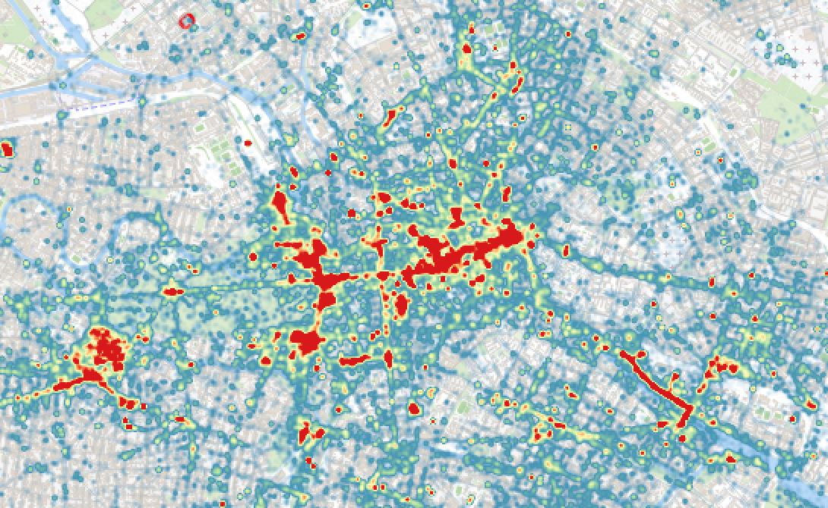

Hotspots (more than 500 photos within a distance of 50 meters)

