#### WILLAMETTE BASIN GUIDE

**STANDARD OPERATING PROCEDURES (SOP)**

#### FOR RESERVOIR CONTROL CENTER

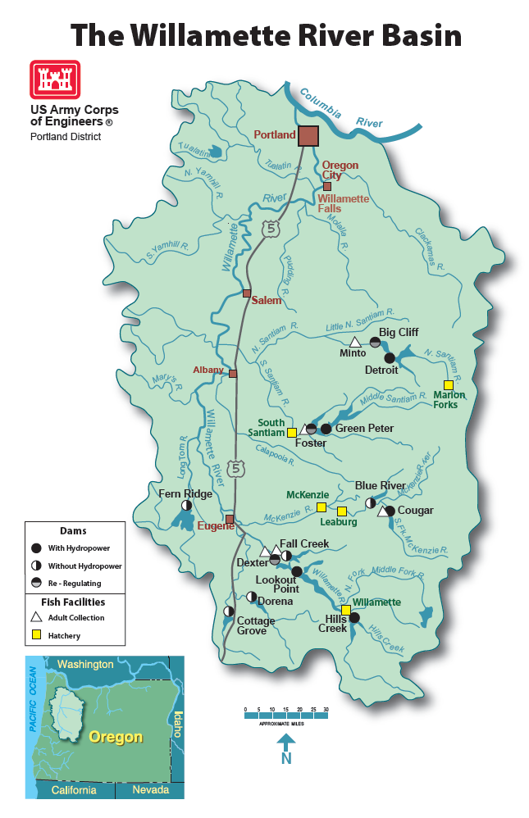

# **OVERVIEW**

The Willamette Basin contains 13 projects that are variously used for flood control, power, recreation, fish and wildlife, and irrigation. These projects also aid to improve downstream water. ***It is important to remember that the number one seasonal priority for the Corps is flood control*.** All other purposes are secondary with the order of importance varying depending on circumstances. There are two levels of flood control that the Corps is concerned with:

**Primary flood control** is designed to effectively control all historical floods other than the 1861 flood (essentially accommodate up to the 100-year flood event).

**Secondary flood control** is designed to effectively control the 1861 flood (about a 300-year flood) which means to accommodate 90% of the inflows of the 1861 flood at each dam.

During a high water event, projects use the available storage to store water and control releases to maintain downstream control points below bankfull. When the projects fill above their scheduled rule curve, the goal is to bring the project back down to the rule curve within 10 days without exceeding bankfull at downstream control points. This is not always possible as new storms can produce higher inflow and discharges downstream of the projects.

There are three types of projects in the Willamette River system: base load projects, non-power projects, and power projects.

The **base load** projects are on-line all the time and are not used for peaking. *Hills Creek* and *Cougar* are base load projects.

**Non-power** projects have no generating capability.  *Blue River, Fern Ridge, Cottage Grove, Dorena,* and *Fall Creek* are non-power projects.

The **power projects** generate power for peaking purposes and have a re-regulation project immediately downstream and are as follows: **Lookout Point***/Dexter,* **Green Peter***/Foster,* and**Detroit***/Big Cliff*. The re-regulation projects purpose is to smooth out flows downstream of the power projects. They will run steady, much like the baseload projects, with their pool level varying on a daily cycle. RCC calculates BPA how much water is available for the day and BPA then determines how the unit hours will be distributed (shaped) for power peaking. Regarding system emergencies, Detroit and Green Peter with all units condensed could respond to a system frequency drop immediately with up to 180+ MW available depending on pool elevation. This would not be the situation with Foster as it would take 15 minutes to get a unit up if only one was generating.

There are 2 well-known rules for regulating the Willamette projects that have been passed on from regulator to regulator:

1. Don’t make increases in releases until the **rain hits the ground** (this is not always true!)

2. When things start flooding, **close the gates and have a “glass of wine”** (formerly a ”martini” then a “margarita” then a “beer.” How times change our beverage of preference)

## 

# **COORDINATION**

The following is an SOP between Portland District’s Reservoir Regulation Section (NWP) and the Willamette Valley Control Room Operations Staff. It is a “living” document and is used to optimize operation coordination:

* **Willamette Projects Standard Operating Procedure** **For Reservoir Operations**

The relationship between NWP and project operators is crucial in ensuring efficient operation and optimum flood control protection. The intent of this SOP is to define roles and responsibilities and has been fully coordinated with the project operators. In general, NWP has the responsibility for Willamette Basin system wide flood control, developing daily schedules, and coordinating requests for special operations with other agencies. The operators are responsible for local flood control, meeting project operating criteria, schedule implementation, project emergencies and forwarding requests to NWP for special operations.

**ROUTINE OPERATIONS AND SCHEDULES, OTHER THAN “HIGH WATER”**

* NWP will pre-coordinate any operations related to Endangered Species Act, fishery, power, or other special operations with the appropriate agencies outside the Corps.
* NWP invites project operator input during pre-coordination including schedule flexibility.
* Listed below is protocol (general guidelines) for coordinating project schedules. NWP will notify operators that schedules have been sent and operators will have approximately 1 hour to respond with input at which time schedules are considered acceptable. NWP and project operators should use best efforts to coordinate or notify of changing conditions, which may affect previously coordinated schedules.
* If an emergency is declared, operators are to follow project protocol and notify NWP of the situation. If during non-duty hours, consult duty list home or cell phone number of the regulator on duty.

**--------------------------------------------------------------------------------------------------**

# 

# **WINTER TIME OPERATIONS**

* Flood control is the primary purpose during the winter. NWP will pre-coordinate flood control and any other operations related to Endangered Species Act, fishery, power, or special operations with appropriate agencies outside the Corps.
* For example, heavy precipitation or rising inflows may necessitate a change in project release to provide optimum flood control. This would require either NWP or project operators to notify and coordinate such changes. Communication is critical; and NWP welcomes input from project operators regarding flood control operations, schedules, and schedule flexibility. It may be impractical to send a schedule for each change. In this case, the project operators are to notify NWP of any changes so that system flood control is taken into consideration.

# **HIGH WATER CONDITIONS**

* NWP or Project Operators will coordinate or notify for potential changes to schedule
* NWP and Projects will collaborate on course of actions
* NWP will send schedule and allow 1 hour for operator input if time and conditions permit
* If time or conditions do not permit for schedule to be sent, NWP and project operators will decide on course of action considering local and system flood control
* NWP will keep project informed of regulators on duty and numbers for cell phones

# **LINE OF COMMAND**

There are official and unofficial lines of command. The official line of command is used for special operation requests from the public, outside agencies (except for outages from BPA), or RCC requests. For the Willamette Basin, coordination usually flows in the following order:

|  |  |  |  |  |
| --- | --- | --- | --- | --- |
| STATE OF OREGON | OTHER FEDERAL |  | CORPS OF ENGINEERS | |
| DISTRICT | DIVISION |
| OWRD  ODFW  FIELD-ODFW | USFWS  NOAA-F | CENWP-PE-HR  PE-RRF  OP-PN (PV)  PROJECTS | RCC |

Mary Karen Scullion and Bruce Duffe (CENWP-PE-HR) are the official contacts at Portland District. NWP will usually contact OWRD (Oregon Water Resources Department) who will coordinate with ODFW (Oregon Department of Fish & Wildlife).

Ian Chane or Greg Taylor (Willamette Valley Project office at Lookout Point) can be contacted for fish issues.

Joe Donnell (at LOP), Tom Voldbaek (at FOS) and Dave Bardy (at LOP) like to be notified about coordination of special operations involving the Valley projects.

Typically, NWP (Scullion) contacts Greg Taylor or Ian Chane for fish regulations. Coordination of schedules can also be unofficial or official. For instance, NWP may call the projects to make adjustments to releases for expediency and then send out the scheduling on the CBT later as the official protocol calls for. During a storm, flow changes are often made over the phone and may not be backed up with a teletype later due to frequent changes.

# **SUMMARY OF DAILY ACTIVITIES AND WORK SCHEDULE**

There can be multiple daily conference calls. During very wet winters there may be a morning weather call, as early as 8:00 am, a morning situation update with the Willamette Project, and a daily briefing call at 1:00. With drier or routine conditions, even in the winter, there is only one regularly scheduled briefing call per week, at 1:00 pm on Thursday. The RFC usually calls by 9:00 to tell us that the CHPS model is ready. The regulations should be input into the model based on the forecasted inflows (not on actual schedules). The CHPS model should be run and approved, if possible, by 9:30 – 10:00 am so RFC can put out their official forecasts, and RCC provide hours to BPA. Additional runs can, and should be made, during high flow periods including weekends. Project release schedules should be completed and sent out before noon, if possible.

Aside from the Willamette Homepage, the Willamette regulator relies on a number of spreadsheets. These provide data summaries and graphics.

# **Daily Data Entry/Routine**

1. Update the Daily Spreadsheet. At least once a week copy the summerblk worksheet to the worksheet of the same name in summberblk-graphs.
2. Check all available data first thing in the morning, prior to any briefing.
3. Evaluate gage and weather data, make a general assessment of conditions for focus areas in the basin, or the whole basin for big, basin-wide storms.
4. Run CHPS model after they call to say the calibration is complete
5. Evaluate run and caucus with the regulation team for a plan of action.
6. Rerun CHPS model with new regulations – see if forecast flows at downstream gages are within limits
7. Calculate generation hours and call BPA’s 3-shift hydro desk if the schedule is for the next day, or the real-time hydro desk if you are making a change to today’s schedule.
8. Complete baseload and non-power schedules, and power schedules once BPA calls back with the generation schedule.

# **SCHEDULES**

During the summer, schedules are usually made twice weekly, currently on Mondays and Thursdays, coinciding with the short-term CHPS model. The Monday schedule will be used for Tuesday through Thursday, and the Thursday schedule will be used for Friday through Monday. During the fall, winter and spring, schedules will be made more often, sometimes daily. Schedules incorporate the previous night’s weather and the forecasted inflows. Try not to change releases until conditions warrant (i.e. increased flows at control points or rises in inflows), unless good judgment deems it necessary. When precipitation is forecasted, the schedules can be made daily for the following day. This cuts down the need to put out schedule revisions, because each day is evaluated and forecasts usually change.

Communication

-BPA:

Baseload Projects: Needs generation (MW), release changes

Power Projects: Needs number of unit hours so they can prepare the generating schedule.

-Projects:

Notify projects of release changes

-Willamette Valley Project Office

Notify of special operations requests and changes

* Regulation Schedule

Things to consider when determining schedule for project releases:

* Check inflow and outflow, compute inflow if necessary using latest 6 hour time period. There is a convenient inflow calculator worksheet in the spreadsheet Will_Schedules_2011.xlsm
* Check storage in relation to rule curve/filling schedule. During the fall draft, the power project should not be spilled if it is below the rule curve. *Do not stray too far above or below the curve*.
* During high water: the goal is to be back to the rule curve in 10 days, if possible, using normal or maximum releases while staying below bank-full conditions at the control points.
* What weather and inflows are forecasted? Do we have to evacuate sooner?
* Check minimum/maximum release requirements for normal and special operations.
* Keep in mind tailwater restrictions and outflow increase or reduction rates.
* Compute the amount a discharge necessary to get back to rule curve (high flow) or to ensure there is adequate inflow to meet filling rates for filling schedule.
* Use hourly generation reports and power unit curves (Turbine Calculator.xlsm) to obtain latest generation rates.
* Compute/model when to reduce to minimum release so the project will not draft below the minimum conservation curve.

# **SPECIAL PROJECT CONCERNS**

When creating a schedule, the staffing and project characteristics should be considered.

Lookout Point/Dexter: Releases from Hills Creek, Lookout Point, Dexter, Fall Creek, Cottage Grove, Dorena, Fern Ridge, Cougar and Blue River are all done from LOP Control Room. This office is staffed 24 hours with two 12-hour shifts. Shift changes are at 0500 and 1700 hours. Only one operator is generally on per shift. They can be extremely busy! Operators have requested that no spillway gate changes be made after dark for safety reasons.

Dexter pool range is 690-691 ft under the IRRM (formerly from 690.3 ft – 695.0 ft). The Will_Scheds.xls program has conditional formatting to highlight if the pool goes out of range. Try to maintain the range at all times, even if a new power schedule has to be coordinated with BPA.

Foster/Green Peter: Foster Control Room runs Green Peter remotely and is staffed 24 hours with two 12-hour shifts. Shift changes are at 0700 and 1900 hours. During the spring/summer time frame, the operators try to limit flow increases out of Foster to 100-150 cfs per hour for protection of fisherman and flow decreases to 150 cfs per hour for protection of juvenile fish.

Detroit/Big Cliff: Detroit Control Room runs Big Cliff remotely and is staffed 24 hours with two 12 hour shifts. Shift changes are at 0530 and 1730 hours. When Detroit reaches elevation 1541.0, all spill changes are made at the spill gates (not by remote). Thus, schedules should not have spill changes during the night hours. (This eliminates the safety concern of being trapped in the elevator or having to climb the 450’ of stairs to make a change.) If it is necessary to change the Detroit spill in the evening, the operators are able to make the change, but prefer not to. Big Cliff generation and spill is done by remote from the Control Room, so this rule does not apply.

Cougar/Blue River: The Lookout Point Control room makes changes at Cougar. As a courtesy and if possible, it is nice to let the operator know of impending changes in the morning so the operator can notify EWEB (Leaburg Dam) of upcoming changes

*A note regarding spillways*: Dexter, Big Cliff, and Foster spillways gates are operable from the control room. Dorena and Cottage Grove are uncontrolled once the lake elevation has reached the spillway. Hills Creek, Blue River, Fall Creek and Cougar spillways have never been used to pass water. The spillways are designed for maximum flood events (PMF). Additionally, the Cougar spillway would wash out the powerhouse access road. The Hills Creek spillway would wash out the powerhouse. The Blue River channel spillway has erosion concerns. Downstream of the Fall Creek spillway is excellent habitat for Oregon Chub and other critters. If the spillway is needed at any of the power projects, the *spillways are not remote controlled*. Only the regulating outlets (RO’s) are remote controlled.

# **SCHEDULES AND THE CBT WEB MESSENGER**

In late summer 1998, RCC switched from flow schedules sent via teletypes to flow schedules sent via the web. Despite being electronic, the process of sending a schedule via the CBT Web Messenger is still known as “sending a teletype.”

**OVERVIEW OF WILLAMETTE SCHEDULING**

Example schedules may be found in the EC-HR mailbox in the Willamette schedules folder.

Example Non-Power Schedule:

XXXXXXXXXXXXXXXXXXXXXXXXXXXXXXXXXXXXXXXXXXXXXXXXXXXXXXXXXXX

APW R 042811 1601 NO LOP CGR FOS NPD NPB NPP NPC

WILLAMETTE NON-POWER PROJECTS

SCHEDULE FOR: FRI - MON, 29 APR - 2 MAY 2011

.

PROJECT : APROX TOTAL RELEASE EFFECTIVE

----------- -------------------- ------------------

FALL CREEK : RELEASE = 650 CFS 1000 HRS 28 APRIL

CONTINUE REFILL AT A RATE OF 425 CFS

MINIMUM FLOW = 80 CFS

MAXIMUM FLOW = 1000 CFS

APPLY DAILY AND HOURLY BIOP RAMP RATES WITH EACH FLOW CHANGE.

**************************************************************

COTT GROVE : RELEASE = 350 CFS 1000 HRS 28 APRIL

CONTINUE REFILL AT A RATE OF 135 CFS

MINIMUM FLOW = 80 CFS

MAXIMUM FLOW = 1000 CFS

APPLY DAILY AND HOURLY BIOP RAMP RATES WITH EACH FLOW CHANGE.

**************************************************************

DORENA : RELEASE = 1260 CFS 1000 HRS 28 APRIL

CONTINUE REFILL AT A RATE OF 300 CFS

MINIMUM FLOW = 190 CFS

MAXIMUM FLOW = 2000 CFS

APPLY DAILY AND HOURLY BIOP RAMP RATES WITH EACH FLOW CHANGE.

**************************************************************

BLUE RIVER : RELEASE = 550 CFS 1000 HRS 28 APRIL

CONTINUE REFILL AT A RATE OF 325 CFS

MINIMUM FLOW = 50 CFS

MAXIMUM FLOW = 1000 CFS

APPLY DAILY AND HOURLY BIOP RAMP RATES WITH EACH FLOW CHANGE.

**************************************************************

FERN RIDGE : RELEASE = 640 CFS 1000 HRS 28 APRIL

PASS INFLOW AND MAINTAIN POOL BETWEEN 373.2 - 373.5 FT

MINIMUM FLOW = 50 CFS

MAXIMUM FLOW = 2000 CFS

APPLY DAILY AND HOURLY BIOP RAMP RATES WITH EACH FLOW CHANGE.

**************************************************************

MAXIMUM 24-HR RAMP RATE IS 1.0 FT OR 50% FLOW REDUCTION IN 24 HOURS AT DOWNSTREAM GAGE.

MAXIMUM DAYTIME HOURLY RAMP RATE IS 0.2 FT AT DOWNSTREAM GAGE.

MAXIMUM NIGHT-TIME HOURLY RAMP RATE IS 0.1 FT AT DOWNSTREAM GAGE.

DAYTIME FLOW CHANGES ARE PREFERRED BUT NIGHT TIME CHANGES ARE ALLOWED.

IT IS OPTIMAL TO SPREAD INCREMENTAL CHANGES ACROSS A 24 HOUR PERIOD.

APPLY DAILY AND HOURLY BIOP RAMP RATES WITH EACH FLOW CHANGE.

XXXXXXXXXXXXXXXXXXXXXXXXXXXXXXXXXXXXXXXXXXXXXXXXXXXXXXXXXXXX

Example of a Baseload Schedule:

XXXXXXXXXXXXXXXXXXXXXXXXXXXXXXXXXXXXXXXXXXXXXXXXXXXXXXXXXXX

APW R 042811 1604 BS LOP CGR FOS BPA NPD NPB NPP NPC

WILLAMETTE BASE LOAD PROJECTS

X

------------------------------------------------------------

HILLS CREEK:

SCHEDULE FOR: FRI - MON, 29 APR - 2 MAY 2011

APROX GEN TURBINE SPILL TOTAL EFFECTIVE TIME

----------- --------- ------- ------- ----------------

34.0 1570 0 1570 1000 HRS 28 APRIL

28.0 1300 0 1300 0800 HRS 29 APRIL

20.0 1000 0 1000 1000 HRS 29 APRIL

------------------------------------------------------------

COUGAR:

SCHEDULE FOR: FRI - MON, 29 APR - 2 MAY 2011

APROX GEN TURBINE SPILL TOTAL EFFECTIVE TIME

----------- --------- ------- ------- ----------------

0.0 100 750 850 1000 HRS 28 APRIL

------------------------------------------------------------

CONTINUE PREFERENTIAL FISH PASSAGE THROUGH REG OUTLET

OPERATE TURBINE AT SPEED NO LOAD

OPERATE WEIRS 3,6,9 WITH A 0.2-0.9 FT HEAD DIFFERENTIAL

WITH WEIRS 8-12 FT BELOW WATER SURFACE ELEVATION

*REGULATING OUTLET SHOULD BE AT APPROX 1.25 FT OPEN

------------------------------------------------------------

X

SCHEDULE FOR TEMP. CONTROL:

GATE NUMBER ELEVATION EFFECTIVE

----------- --------- ----------------

PS1 1440.2 FEET 14 HRS 07 MARCH

RG1, RG2 1504.5 FEET 14 HRS 07 MARCH

GATES 1,4,7 1600.0 FEET 10 HRS 25 APRIL

GATES 2,5,8 1640.0 FEET 10 HRS 26 APRIL

GATES 3,6,9 1664.0 FEET 10 HRS 28 APRIL

GATES 3,6,9 *1666.0 FEET 12 HRS 29 APRIL

XXXXXXXXXXXXXXXXXXXXXXXXXXXXXXXXXXXXXXXXXXXXXXXXXXXXXXXXXXXX

Sometimes changes to schedules are so minor the Regulator may just want to cut and paste an already sent schedule into the CBT messenger, edit, and send it. However, to create most power schedules, such as the one below, the power project worksheet helps significantly. BPA specifies unit schedules in the form “0 for 6, 1 for 3, 0 for 8, 2 for 3, 0 for 4.” These numbers are entered on the “power” sheet along with starting elevations, local flows and project flows, and a program is then run to change this data into a schedule on the “text” sheet like the one below:

XXXXXXXXXXXXXXXXXXXXXXXXXXXXXXXXXXXXXXXXXXXXXXXXXXXXXXXXXXX

APW R 042511 1144 PW LOP FOS DET NPP NPD NPB BPA

WILLAMETTE POWER AND RE-REG PROJECTS:

------------------------------------

X

X

LOP - DEX SCHEDULE FOR TUE - THU, 26 APR - 28 APR 2011

X

POWER PROJECT * REREG PROJECT

HOURS #UNTS SPILL TURB * OUTFLOW GEN. ELEV.

00= * 690.7

0 - 24 = 2 0 5440 * 5500 0.0 690.7

TOT UNIT HRS=48 RLS= 5440 *RLS= 5500 LOCAL= 5

X

X

GPR - FOS SCHEDULE FOR TUE - THU, 26 APR - 28 APR 2011

X

POWER PROJECT * REREG PROJECT

HOURS #UNTS SPILL TURB * OUTFLOW GEN. ELEV.

00= * 616.1

0 - 5 = 0 50 0 * 2560 8.2 615.4

5 - 10 = 2 0 3690 * 2560 8.2 616.4

10 - 17 = 0 50 0 * 2560 8.2 615.4

17 - 22 = 2 0 3690 * 2560 8.2 616.4

22 - 24 = 0 50 0 * 2560 8.2 616.1

TOT UNIT HRS=20 RLS=1537. *RLS= 2560 LOCAL=1000

1. OPERATE FISH WEIR 24 HOURS A DAY

2. PASS INFLOW AT FOSTER TO MAINTAIN A RANGE FROM 615 - 617 FT

-THE PREFERRED RANGE IS 615.5-616.5 FT.

3. FOSTER OUTFLOW RANGE IS 1,500 - 10,000 CFS

4. ADJUST OUTFLOWS USING BIOP RAMP RATES.

MAX RAMP UP IS 0.2 FT/HR AT SSFO

MAX RAMP DOWN IS 0.2 FT/HR (DAY) and 0.1 FT/HR (NIGHT) AT SSFO

MAX DAILY RAMP DOWN RATE IS 1 FT/DAY AT SSFO.

6. FOSTER UNIT 1 OOS FOR ANNUAL MAINTENANCE

EST RTS 1600 HRS 21 MAY

X

X

DET - BCL SCHEDULE FOR TUE - THU, 26 APR - 28 APR 2011

X

POWER PROJECT * REREG PROJECT

HOURS #UNTS SPILL TURB * OUTFLOW GEN. ELEV.

00= * 1191.0

0 - 6 = 1 0 2040 * 2950 16.1 1187.1

6 - 10 = 2 0 4080 * 2950 17.1 1192.1

10 - 18 = 1 0 2040 * 2950 16.1 1187.2

18 - 22 = 2 0 4080 * 2950 17.1 1192.2

22 - 24 = 1 0 2040 * 2950 16.9 1191.0

TOT UNIT HRS=32 RLS= 2720 *RLS= 2950 LOCAL= 235

ADJUST BCL OUTFLOW TO MAINTAIN BCL BETWEEN 1182-1193 FT.

MAX RAMP UP IS 0.2 FT/HR AT BCLO

MAX RAMP DOWN IS 0.2 FT/HR (DAY) and 0.1 FT/HR (NIGHT) AT BCLO

MAX DAILY RAMP DOWN IS 0.5 FT/DAY

MINIMUM OUTFLOW AT BCL IS 1500 CFS FOR SPAWNING STEELHEAD.

XXXXXXXXXXXXXXXXXXXXXXXXXXXXXXXXXXXXXXXXXXXXXXXXXXXXXXXXXXXX

# **FLOOD CONTROL (FLOOD DAMAGE REDUCTION) (FLOOD RISK MITIGATION)**

The primary flood season usually lasts from November to February. The basic plan for flood protection is to maintain the reservoir at or below the seasonal flood control rule curve. The Willamette basin is known to be flashy and conditions can drastically change very quickly.

# **General Flood Plan**

For small floods, which are the most common and do not threaten to fill the reservoir, regulation is fairly simple*. The plan is to keep the control points below bankfull and store the water in the projects*. Project outflows are reduced as downstream control points approach bank full conditions. Outflows will remain at minimum flow until the downstream control points recede back to within bank full conditions; at which time the project will increase outflow to maintain bank full conditions until all stored flood water has been evacuated. It is a general rule to be back to the curve within 10 days, if possible.

Each project’s Water Control Manual, as well as in other references, has a normal and maximum rate of increase or decrease of outflow changes. When a project gets too full and inflows are still high, a set of special flood regulation curves are used. These “special curves” permit a gradual increase of the reservoir release instead of a sudden large spill, such as would occur if the reservoir were to fill before the end of the flood using the normal release schedule.

# **SPECIAL CASES**

Here are some general items to remember during high water:

All Projects: Do not spill if the project is *below* the rule curve.

Power Projects: (HCR, LOP, CGR, GPR, DET) When the projects are in secondary flood control space, we do not usually spill to get back to the curve. If the project is *above* the rule curve, but *below* the primary flood control point, draft at full powerhouse capacity.

Dorena: Normal maximum release is 5000 cfs, but if the pool is rising quickly and it looks like special curves might be necessary, increases can be made early to 7000 cfs. Going up to 7000 cfs early can help prevent going to 13000 cfs (as required by special curves). A release of 5000 cfs brings water to the banks of the downstream trailer park and 7000 cfs puts water into the yards. No houses should be damaged with a 7000 cfs release. If flows are going to be increased above 5000 cfs, be sure to call Christie Johnson or Tamara Schroeder to have someone check on the status of the trailer park.

If the project is not going to special curves, but you are having problems drafting, coordination can be done to take releases up to 6500 cfs. Bengtson, the Lookout Point operators, and Joe Donnell should all be notified and included in discussions. This was done in November 1998 and did not cause any problems downstream, however care was taken to keep Goshen below bankfull levels.

Dexter: There used to be a dike downstream of Dexter that had problems when releases were above 15,000 cfs at Dexter. This dike has been repaired and there are no longer any problems.

Fern Ridge: Call Dave Bardy if we plan on exceeding 4650 cfs at Monroe. Long Tom River capacity is 4000 cfs downstream of Fern Ridge. Normal evacuation rate from Fern Ridge is 3,000 cfs, but outflows can be taken up to 4,000 cfs if needed, but pre-coordinate with Dam Safety. Maximum RO release is 3,000 cfs. If the reservoir is above the elevation of the spillbay crest, it is important to put at least 500 cfs through the RO and the rest through the spillway to minimize downstream erosion. To minimize manual spillbay gate changes it is a good idea to split a flow of 4000 cfs as follows: 1,500 cfs through the RO and 2,500 cfs through the spillbay resulting in 1000 cfs in flexibility via remote RO control from LOP.

When project flows exceed 2,500 cfs OD-V staff should visually inspect the stilling basin, Clear Lake Bridge abutments, and downstream embankments. Recommended inspections every other day during the high discharge period.

Inflow and outflow gage readings may be suspect. The forebay gage changes slowly since the pool is so large and shallow, making unreliable inflow calculations. The outflow readings are suspect at very high rates of discharge, although the USGS re-measured and updated the ratings in 2006 during high water. Vegetative encroachment along the channels may have complicated accurate gage readings, but as of 2008 most of the vegetation has been cleared.

Critical constrictions along the Long Tom river include the bridge at Highway 36 at Cheshire, the Stroda structure, and a park on the West bank at Monroe.

- Winter storms in January 2006 caused releases as high as 6,000 cfs and flow was split between the spillbay and RO – again with a minimum RO flow of 500 cfs. The goal was to regulate Monroe below flood stage (9 ft or 6,800 cfs). While trying to evacuate stored flood water, Monroe was pushed to bankfull (8.5 ft or 5,700 cfs). FRNO outflow was more accurately reported via XConnect – the USGS reported lower flow which was incorrect.

- The NWS indicates that action stage at Monroe is 8.5 ft, flood stage is 9 ft, and major flood stage is 12 ft. 9.54 ft was reached on 1/18/06.

Foster: Pass inflow from Foster and GPR for as long as possible while maintaining WTLO below bankfull (18,000 cfs).

1. If it looks like WTLO will rise above bankfull, shut off Green Peter and pass inflow from Foster.

1. If Foster inflow exceeds 10,000 cfs, begin storing into Foster and maintain releases at 10,000 cfs. If Foster fills too full and inflows are not receding, follow special curves.
2. When inflows have dropped and downstream control points have peaked, draft Foster out at 12,000 – 15,000 cfs (whatever keeps WTLO at or below bankfull). If Green Peter is also quite full and there is another storm approaching, draft Green Peter and Foster concurrently. Remember that evacuation flows should not go above bankfull or result in a flow greater than that caused by runoff from the uncontrolled area during the previous flood. If the projects have used less than 50% of flood control space, downstream points should not be taken to bankfull conditions while evacuating.
3. When Foster has reached the rule curve, continue the 12,000 – 15,000 cfs and draft out Green Peter.
4. Inflow to GPR can be estimated from the Quartzville gage (QCCO) whereas 2xQCCO = GPR inflow with a 2-hour travel time from the gage to the lake.
5. Local flow to FOS can be estimated from the South Santiam at Cascadia (SSCO) and Wiley Ck (WNFO) gages whereas SSCO + ½ WNFO = FOS inflow with a 2-hour travel time from the SSCO gage to the lake.
6. Balancing between GPR RO flow and GPR spillway flow during high water events can give the night operator more flexibility with flow changes – he’ll change flows through the RO since the spillway gate setting can only be changed during daylight hours when someone else is on site.

Detroit: Fishermen’s Bend (a trailer park) is located a few miles downstream of Big Cliff and they have problems when BCL releases are more than 12,000 cfs. When releases are up to 15,000 cfs, no homes are damaged, but the access road is flooded. Usually when the flows rise, residents from Fishermen’s Bend call the operators for information on flows. The operators do have one resident’s number and said that they would call him if they knew flows were going to go above 12,000 cfs. There is no official protocol for this situation. There can be a public relations challenge. The operators have been forwarding calls to the Portland District PAO office.

HCR/LOP: Hills Creek and Lookout Point should be kept near the same percent full during high water so that neither one is full while the other is empty.

# **SPECIAL REGULATION CURVES**

During a flood, the reservoirs can fill before inflows have dropped off. Without the special regulation curves the project might continue to release minimum flows and then suddenly increase releases to passing inflow as soon as the project was full. Instead, the special regulation curves can be used to help determine the appropriate releases from the project to keep the project from filling too high and to help protect downstream control points from abrupt high releases. Each project has it’s own set of special curves.

# **RULE CURVES**

This curve specifies the reservoir levels that the projects need to be at to comply with mandated levels of flood protection. The rule curves specify reservoir levels throughout the year along with:

* maximum flood control space required during the major flood season,
* filling rates to reach summertime maximum conservation pool,
* fall draft rates to meet minimum flood control pool, and
* primary and secondary flood control points.

**Reservoir authorizations and operations**

Congress originally authorized the construction of the U.S. Army Corps of Engineers’ Willamette Valley projects for the purposes of flood damage reduction and navigation. While flood damage reduction remains the highest priority authorization for the Fern Ridge project, Congress later added the operational purposes of irrigation, water quality, recreation and fish and wildlife.

Based on project authorizations, the Corps developed a water control diagram for the operation of each project in the valley. The diagram reflects the anticipated uses of water in the basin and the Corps’ legal responsibilities and limitations regarding operation of the reservoirs. This diagram and the associated operational goals, limitations and requirements are typically compiled in a Water Control Manual. Reservoir regulators use the manual as a reference document.

**Explaining the rule curve**

For multipurpose projects, the water control diagram includes a flood damage reduction rule curve. Using hydrologic inflow analysis, the Corps designed the rule curve to manage for the 100-year storm event, which has a one percent probability of occurring in any year.

The rule curve shows the maximum elevation to which the Corps can operate a reservoir during the year, with the exception of real-time flood operations. The Corps may operate under the levels indicated by the rule curve. Each rule curve indicates that the water level in the reservoir must be maintained at minimum levels whenever possible from December 1 through January 31 for the purpose of flood damage reduction. This allows adequate space to store and manage water during wet winter months.

On February 1, the Corps begins gradually filling reservoirs with the goal of having it full by mid-April to mid-May. Each reservoir may fill at a rate no faster than shown in the rule curve, unless managing for downstream floods. In late summer, the Corps begins gradually draining the reservoir to regain capacity for flood damage reduction. The rule curve, including observed inflow and precipitation levels, is available for public reference at <http://www.nwd-wc.usace.army.mil/nwp/graphics/gifs/frn.gif>. Additional information on reservoir regulations can be found at <http://www.nwd-wc.usace.army.mil/nwp/>.

**Managing summer water levels**

Water levels may vary between mid-April and early September, depending on inflow to the reservoir, required releases for authorized purposes and surface evaporation. For Fern Ridge, there are legal requirements to release a minimum amount of water into the Long Tom River downstream of the reservoir. These releases help maintain water quality, support fish and wildlife and provide for purchased irrigation water. In order for the reservoir to fill for maximum summer conservation use, sufficient seasonal runoff must occur to balance or overcome the required releases and evaporation.

Once water reaches the highest achievable level during the filling period, the Corps operates each reservoir for conservation purposes, including recreation and environmental uses, and keeps it as full as possible. However, the releases mentioned above, combined with surface water evaporation during the drier summer months, typically result in a “draw down” over the course of the summer.

**Background**

* Projects designed to “effectively” control the 1861 Flood.
* Projects control 25% of the runoff area in the Willamette Basin.
* Willamette Basin has 13 projects: 11 storage dams and 2 re-regulation dams.

Storage by Project

|  |  |  |
| --- | --- | --- |
| **Project** | **Storage (Ac-Ft)** | **% of Total** |
| Lookout Point | 337,240 | 20% |
| Detroit | 300,720 | 18% |
| Green Peter | 268,250 | 16% |
| Hills Creek | 200,200 | 12% |
| Cougar | 155,180 | 9% |
| Fall Creek | 115,460 | 7% |
| Fern Ridge | 109,620 | 6% |
| Blue River | 85,550 | 5% |
| Dorena | 70,510 | 4% |
| Cottage Grove | 29,790 | 2% |
| Foster | 29,710 | 2% |

Project Objectives

* Small Floods: Keep downstream control points below bank full by storing water. When inflows drop evacuate the water at a rate that keeps the control points below the point they were during the peak.
* Large Floods: Utilize project storage to lower the peak at the control points.

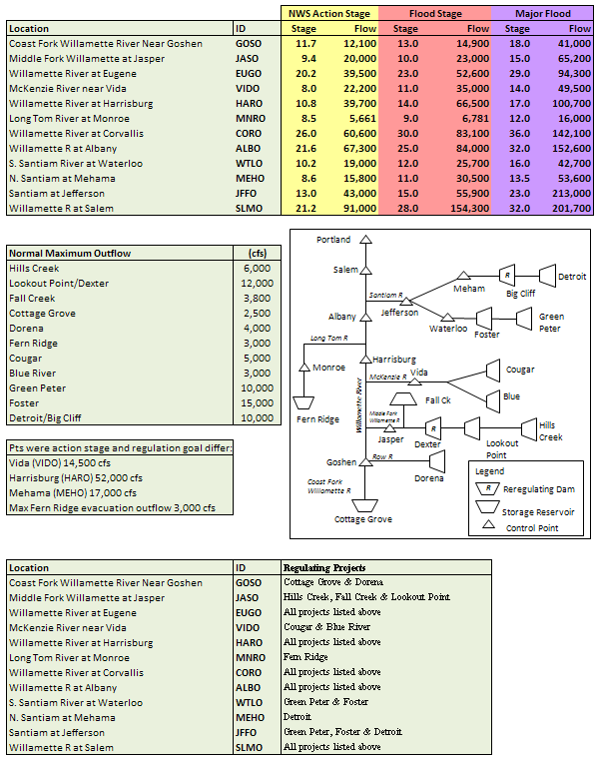

**FLOOD TEAM**

* Reservoir Control Center (Northwestern Division Office)
* Reservior Regulation and Water Quality (Portland District)
* National Weather Service - River Forecast Center
* Project operators (Lookout Point, Detroit, and Foster)
* Hydraulics and Hydrology Branch

**River Forecast Center**

* Forecasts river levels and the timing of peaks.
* Issues flood warnings on controlled and uncontrolled streams, incorporating regulation decisions from RCC.
* Updates flood forecasts as often as every 6 hours during a flood.

**Portland District Reservoir Regulation**

* Regulators make the release decisions using the forecast for guidance, but rely on actual data and developing trends. (“Don’t make a change until the rain hits the ground!” ~ Al Nissila). KEEP IN MIND THAT THE WINTER TRAVEL TIME FROM LOOKOUT POINT TO SALEM IS NEARLY TWO DAYS. IF A BIG STORM EVENT IS FORECAST THREE DAYS OUT, CUTS DEFINITELY MAY BE MADE IN THE SOUTHERN PROJECTS BEFORE THE “RAIN HITS THE GROUND.”
* Changes may be made every hour at the 13 projects in response to changing conditions.
* Reservoir Regulation go to 24-hr operations as necessary.

**Project Operators**

* Give advice and support to the regulators – they are the eyes and ears in the Valley.
* Control rooms are staffed 24-hrs, so basin is watched at all times.
* Often give the first warning call to RCC if inflows begin to rise.
* Can also provide warnings to local emergency management folks.

**CENWP-EC-HR staff**

* WM staff provides support through data collection and phone answering.
* Can help regulators during 24-hr operations when RCC staff levels are stretched.
* Give RFC Flood Warning information to concerned callers.

**CHPS Model**

* CHPS is the interactive forecasting model for the Willamette Basin.
* Has a 6-hour time step and forecasts flow from projects down to Portland.
* RCC inputs project regulation based on the forecasted inflows. The model is then ran and regulation is routed downstream for forecasted flows at control points.
* Can be ran more than once a day if RFC is changing their forecast or RCC is changing their regulation.
* Regulators can run CHPS from home.
* Output is not given to the public.

**DWOPPER** (Colunbia River Harbor Forecast)

* Incorporates RFS, Bonneville outflows, and Astoria tide tables to forecast harbor stages at Portland and Vancouver.
* Used to create Portland harbor official forecasts.
* Modified output is available on the Internet: [Columbia Harbor Forecast](https://npr71.nwd-wc.usace.army.mil/rccweb/RCCLIST/RVFPH.txt)

**Official Flood Warning**

* Give peak flows at various points and the time the peak will occur.

Official warnings and flood status are now on the Internet:

<http://www.nwrfc.noaa.gov/>

* Information can be given to the public and is often disseminated from this office.
* It is important to read from the most recent flood warning.

Special Curves

* Are used when the reservoir is approaching full and inflows are still high.
* Theory is to gradually increase outflows to slow reservoir fill rate to avoid “Fill and Spill” situation.

Are used as guidelines to help determine appropriate releases. Regulators still must use best judgement.

See each individual Water Control Manual for more information.

BF 3000 cfs

FS 4000 cfs



Op <12000 cfs FB Trailer Pk

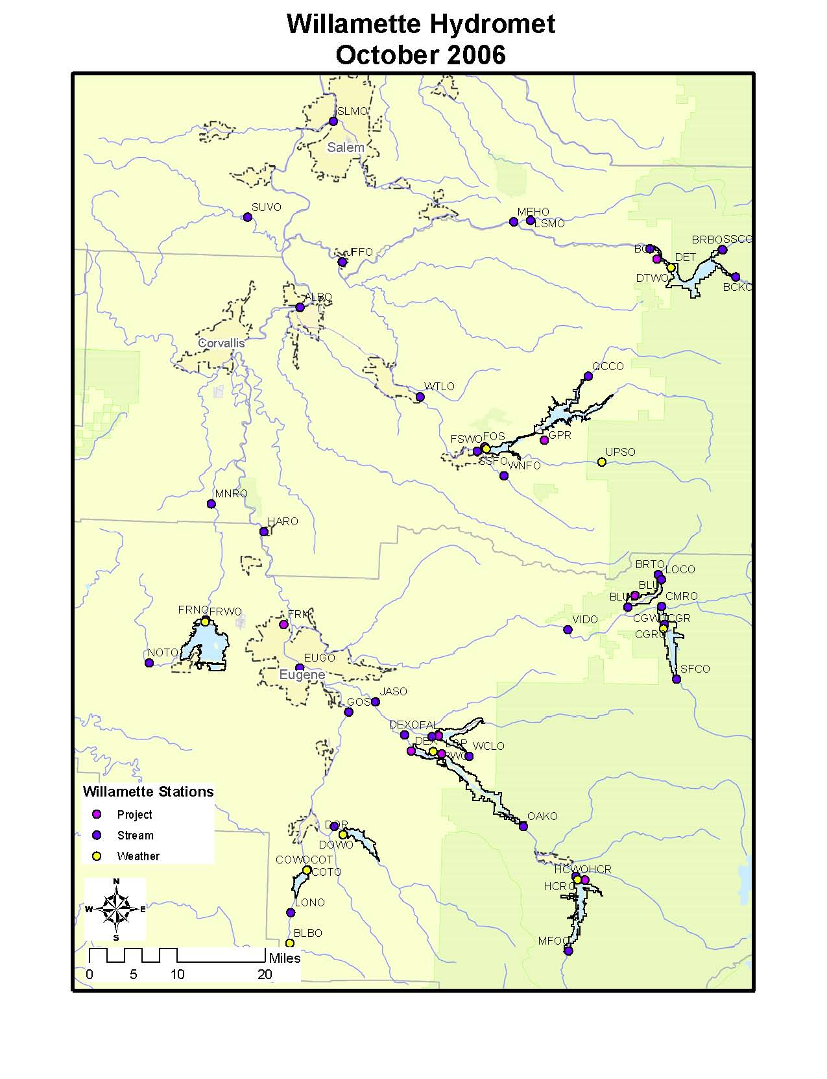

This schematic shows all Willamette Hydromet Stations and id’s as they appear in x-connect and CROHMS. Operators at LOP, FOS and DET can query any gage. The system is connected by radio transmission via repeaters to NWP, whom can also query gages.

# **SPRING/SUMMER AUGMENTATION**

Waters within the Willamette Basin contain listed salmonoid species. The Willamette Project is being operated in accordance with two Biological Opinions issued by National Marine Fisheries Service and U.S. Fish and Wildlife Service. The BiOp listed minimum mainstem flows, tributary flows and ramp rates (Tbls 1 through 3 and 5) and the priority of reservoir drawdown for mainstem flow augmentation is listed in Table 4. These are included and discussed in the annual conservation plan.

Table 1. Minimum mainstem flows for all but drought years.

| **Period** | **ALBANY** | **SALEM** | **SALEM** |
| --- | --- | --- | --- |
|  | **Minimum Instantaneous**  **Flow (cfs)** | **Minimum Weekly Flow Threshold (cfs)** | **Minimum Instantaneous Flow (cfs)** |
| April |  | 17,800 | 14,300 |
| May |  | 15,000 | 12,000 |
| 1-15 June | 4,500 | 13,000 | 10,500 |
| 16-30 June | 4,500 | 8,700 | 7,000 |
| July | 4,500 | 6,000 |  |
| 1-15 Aug | 5,000 | 6,000 |  |
| 16-31 Aug | 5,000 | 6,500 |  |
| September | 5,000 | 7,000 |  |
| October | 5,000 | 7,000 |  |

Table 2. Transition periods for reducing minimum mainstem flow thresholds.

|  |  |
| --- | --- |
| **Transition Period** | **Transition Flow at Salem** |
| 27 April – 3 May | 17,800 – 15,000 cfs |
| 28 May – 3 June | 15,000 – 13,000 cfs |
| 12 – 18 June | 13,000 – 8,700 cfs |
| 27 June – 3 July | 8,700 – 6,000 cfs |

Table 3. Minimum and maximum flow objectives below Willamette Basin dams.

|  |  |  |  |  |  |  |  |  |  |  |
| --- | --- | --- | --- | --- | --- | --- | --- | --- | --- | --- |
| **Minimum Flow (cfs)** | |  |  |  |  |  |  |  |  |  |
| 2010 | **BCL** | **FOS** | **DEX** | **HCR** | **FAL** | **CGR** | **BLU** | **FRN** | **COT** | **DOR** |
| 1/1/2010 | 1200 | 1100 | 1200 | 400 | 50 | 400 | 50 | 30 | 50 | 100 |
| 2/1/2010 | 1000 | 800 | 1200 | 400 | 50 | 400 | 50 | 50 | 75 | 190 |
| 3/1/2010 | 1000 | 800 | 1200 | 400 | 50 | 400 | 50 | 50 | 75 | 190 |
| 3/16/2010 | 1500 | 1500 | 1200 | 400 | 50 | 400 | 50 | 50 | 75 | 190 |
| 4/1/2010 | 1500 | 1500 | 1200 | 400 | 80 | 400 | 50 | 50 | 75 | 190 |
| 5/1/2010 | 1500 | 1500 | 1200 | 400 | 80 | 400 | 50 | 50 | 75 | 190 |
| 5/16/2010 | 1500 | 1100 | 1200 | 400 | 80 | 400 | 50 | 50 | 75 | 190 |
| 6/1/2010 | 1200 | 1100 | 1200 | 400 | 80 | 400 | 50 | 50 | 75 | 190 |
| 7/1/2010 | 1200 | 800 | 1200 | 400 | 80 | 400 | 50 | 30 | 50 | 100 |
| 7/16/2010 | 1000 | 800 | 1200 | 400 | 80 | 400 | 50 | 30 | 50 | 100 |
| 9/1/2010 | 1500 | 1500 | 1200 | 400 | 200 | 400 | 50 | 30 | 50 | 100 |
| 10/16/2010 | 1200 | 1100 | 1200 | 400 | 50 | 400 | 50 | 30 | 50 | 100 |
| 12/1/2010 | 1200 | 1100 | 1200 | 400 | 50 | 400 | 50 | 30 | 50 | 100 |
| 12/31/2010 | 1200 | 1100 | 1200 | 400 | 50 | 400 | 50 | 30 | 50 | 100 |
|  |  |  |  |  |  |  |  |  |  |  |
| **Maximum Flow (cfs)** | |  |  |  |  |  |  |  |  |  |
| 9/1/2010 | 3000 | 3000 | 3500 | 0 | 400 | 580 | 0 | 0 | 0 | 0 |
| 9/30/2010 | 3000 | 3000 | 3500 | 0 | 400 | 580 | 0 | 0 | 0 | 0 |

Table 4. Project hierarchy when augmenting for mainstem flow goals.

| **No Augmentation** | **Primary Spring Augmentation**  **(April – June 30)** | **Summer/Fall Augmentation**  **(July 1 – Oct 31)** |
| --- | --- | --- |
| Fern Ridge | Green Peter  (outflow up to 3000 cfs)  (Monitor interim draft limits to ensure adequate storage for fall spawning flows) | Lookout Point /  (outflow up to 2700 cfs) |
| Detroit  (above elev 1546 ft is adequate for recreation thru Sept 7) | Cougar  (above elev 1635 ft)  (up to 500 cfs spill unless above rule curve) | Cougar  (above elev 1635 by Sep 7 and elev 1532 ft by Oct 31) |
| Foster | Lookout Point /  (Dexter outflow up to 2700 cfs) | Hills Creek |
| Dexter | Hills Creek  (Dexter outflow up to 2700 cfs) | Green Peter  (Foster outflow of 1500 cfs from Sep 1 – 30; 1100 cfs Oct 1 – Jan 31) |
| Big Cliff | Blue River  (above elev 1330 ft) | Blue River |
|  | Fall Creek  (above elev 780 ft) | Fall Creek  (above elev 780 ft) |
|  | Dorena  (above elev 825 ft) | Dorena  (above elev 825 ft) |
|  | Cottage Grove  (above elev 779 ft) | Cottage Grove  (above elev 779 ft) |

Table 5. Ramp Rates

|  |  |
| --- | --- |
| Daytime max hourly ramp rate | 0.2 ft/hr |
| Night time max hourly ramp rate | 0.1 ft/hr |
| Daily Ramp Rate | The least of: 50% flow or 0.5 ft at d/s gage |

# **NORMAL SPRING & EARLY SUMMERTIME OPERATIONS**

May and June can bring flashy rain showers that need to be watched. All the projects are usually full in May, so there is limited space. It is very important to keep an eye on the spring weather.

Hills Creek: Essentially pass inflow and maintain pool between 1541.0 – 1541.5’. Watch the elevation of the pool and try to keep it below 1542.0’. Keep in mind that large increases in releases move downstream and turn into LOP inflows. When balancing spring flow augmentation, it is better to keep HCR full and augment from LOP. There is a lot of recreation at HCR and not so much at LOP.

Minimum release = 300 cfs but ODFW prefers a min release of 450 cfs

Lookout Point: Lookout Point is used to augment mainstem flows at Albany and Salem. Outflow typically ranges between 2500 – 3000 cfs and refill is not guaranteed.

Dexter: Maintain tailwater restriction of 0.5’/day maximum change (especially during the recession). If spill is necessary, spill across as many of the 7 bays as possible to reduce Total Dissolved Gas (TDG) levels. Spillbay 1 is not remote controlled, but can be manually set if needed. If possible, use Bays 2 - 7 before Bay 1. Spilling on Bay 1 may affect adult salmon attraction to the fish ladder. The following spill guidance was provided to the operators in 1998.

|  |  |  |  |  |  |  |  |
| --- | --- | --- | --- | --- | --- | --- | --- |
|  | **Total Spill At Dexter (in cfs)** | | | | | | |
| **Spillbay** | **1200** | **1800** | **2400** | **3000** | **3600** | **4200** | **4800** |
| **1** | - | - | - | - | - | 600 cfs | 600 cfs |
| **2** | - | - | 600 cfs | 600 cfs | 600 cfs | 600 cfs | 700 cfs |
| **3** | 600 cfs | 600 cfs | 600 cfs | 600 cfs | 600 cfs | 600 cfs | 700 cfs |
| **4** | 600 cfs | 600 cfs | 600 cfs | 600 cfs | 600 cfs | 600 cfs | 700 cfs |
| **5** | - | 600 cfs | 600 cfs | 600 cfs | 600 cfs | 600 cfs | 700 cfs |
| **6** | - | - | - | 600 cfs | 600 cfs | 600 cfs | 700 cfs |
| **7** | - | - | - | - | 600 cfs | 600 cfs | 700 cfs |

Fall Creek: Pass Inflow as long as possible and maintain pool between 830.0 – 830.5’. Fall Creek is a widely used recreation project so try to keep the project as full as possible.

Maximum release (Sept – mid-Nov) = 1000 cfs (if possible)

Cottage Grove: Pass inflow and maintain the pool between 789.5 – 790.0’. If the pool rises above 791.0’ the pool will free-flow over the spillway.

Dorena: Pass inflow and maintain the pool between 831.5 – 832.0’.

Fern Ridge: Pass inflow and maintain the pool between 373.3 – 373.5’. Support minimum flows at Monroe. Fern Ridge is a widely used recreation project so try to keep the project as full as possible. There is also a lot of wildlife and plant life in the reservoir, so don’t go above 373.5’.

MNRO minimum flow = 50 cfs (May/June) and 30 cfs (July/August) for downstream irrigators. The Long Tom River is a long, diked canal with much seepage, so it does not help Salem flows to augment from Fern Ridge.

Blue River: Balance augmenting mainstem flows with the water stored behind Blue River with water stored behind other projects such as Cougar and Lookout Point. Don’t draft BLU first then move to another reservoir. Watch interim draft limits.

Cougar: The Biop lists 300 cfs as the minimum flow but Jeff Ziller always requested flows between 400 – 450 cfs to keep water in some of the side channels. This also works well with the turbines since 300 cfs is below the lower cavitation limit. Early reservoir drawdown is necessary to achieve the low maximum outflow required by the Biop of 580 cfs in September. It is good to target being slightly above the low water boat ramp (Slide Creek and Echo Park Ramps, elev 1635 ft) after Labor Day to maximize recreation opportunities in the reservoir.

Green Peter: Stored Water in Green Peter must be used cautiously to ensure that enough water remains in the fall to meet the Spawning requirements. The outflows required by the BiOp are much higher than inflow in the summer and fall which makes the reservoir draft quickly. It is best to be full in May then stay on minimum outflow all summer. Interim draft limits and Res Sim modeling will help determine how much volume to use for mainstem augmentation. If the reservoir drafting close to the interim draft limits, the increase to the fall spawning minimum flow will be coordinated with NMFS to be delayed until mid-Sept or until the fish show up.

Foster: After the fish weir operation, pass inflow and maintain pool between 636.0 – 637.0’. Fill Foster prior to Memorial Day weekend so that there is time to sweep the pool. Coordinate with Tom Voldbaek prior to surcharging the pool to elev 638.5 ft. because if they aren’t ready for the extra woody debris that surcharging puts in the reservoir operations will be unhappy wity regulation staff.

Detroit: Pass inflow for as long as possible while the maintaining pool between elev. 1563.0 – 1564.0 ft. Detroit is a widely used recreation project so try to keep the project as full as possible. Maintain the BiOp minimum flows but notify management if forecast indicate dropping below 1546 ft (critical elevation for marinas) before Labor Day weekend.

**Boat Ramp Elevations Maximum Conservation Pool Elev.**

Middle Fork Willamette River Basin

Hills Creek 1541 ft

1520 ft Bingham Landing

1507 ft CT Beach Park

1441 ft Packard Creek

Lookout Point 915 ft (IRRM)

900 ft Black Canyon (confirmed by USFS Mid Fork 11/3/11) 925 ft (normal)

911 ft Meridian Park

911 ft Hampton Landing

821 ft Signal Point

Dexter 691 ft (IRRM)

684 ft Lowell Park (confirmed visually by State Parks 6/3/10) 695 ft (normal)

684 ft Dexter Park

Fall Ck 830 ft

822 ft Cascara Campground (confirmed by State Parks 6/2/10)

803 ft Winberry Creek Park

689 ft North Shore Ramp

Long Tom River Basin

Fern Ridge 373.5 ft

368 ft Perkins Peninsula

367 ft French Ridge Shores

365 ft Richardson Park

364 ft Orchard Point Park

McKenzie River Basin

Cougar 1690 ft

1635 ft Slide Creek

1635 ft Echo Park

Blue River 1343 ft (IRRM)

1330 ft Lookout Boat Launch 1350 ft (normal)

1295 ft Saddle Dam

**Boat Ramp Elevations Maximum Conservation Pool Elev.**

Coast Fork Willamette River Basin

Dorena 832 ft

820 ft Harms Park

765 ft Baker Bay

Cottage Grove 790 ft

779 ft Wilson Creek

745 ft Lakeside Park

South Fork Santiam River Basin

Green Peter 1010 ft

970 ft Whitcomb Creek (confirmed by Linn Co. Parks 11/4/11)

919 ft Thistle Creek

Foster 637 ft

631 ft Calkins Park

619 ft Gedney

613 ft Sunnyside

North Fork Santiam River Basin

(elevations below confirmed by Detroit State Park 11/1/11)

Detroit 1563.5 ft

1556 ft Detroit Lake State Park Boat Ramp D

1540 ft Mongold East Boat Ramp

1546 ft Kane’s Marina (minimum elevation for boat moorage)

1543 ft Hoover Boat Ramp

1542 ft South Shore Boat

1534 ft Mongold Main Boat Ramp

1541 ft Cove Creek Boat Ramp

1530 ft Detroit Lake State Park Boat Ramp G

1450 ft Mongold Low-water Boat Ramp

# **NORMAL FALL DRAWDOWN OPERATIONS**

Fall drawdown doesn’t necessarily begin on 1 September as suggested by the rule curves. Many projects will be below their maximum conservation pool by the end of August. Pool levels are kept up, if possible, for Labor Day, so drawdown may be delayed a few days. Remember that the Salem flow target in September is raised to 7000 cfs. For the last several years we have put out press releases regarding fall drawdown.

Hills Creek: Project is usually drafted at full powerhouse capacity (1500 cfs) or 925 cfs above inflow, which ever is more appropriate.

Lookout Point: Project drafts hard through the summer and targets elevation 880.0’ by Labor Day. The low pool ensures outflows can be held at or below, 2500 cfs in September and October.

Dexter: Maintain 2500 cfs during September and October. Boat races can extend into September. In order to hold pool flat at 693.0’ – 694.0’ run LOP turbines at a reduced rate of generation (2500 cfs/unit) for 24 hours and maintain steady release out of Dexter.

Fall Creek: Maintain a maximum release of 1000 cfs in September – mid-November, if possible. The State prefers 800 cfs to aid in juvenile passage.

Cottage Grove: Do not stray too far above the rule curve because the project is so small. Also, downstream irrigators do not expect flows to be increased until after Labor Day. Pump damage can occur if releases are increased while irrigators are still in water. 1ft operating range once at minimum conservation pool.

Dorena: There is Reed Canary Grass in the top 7’ of the reservoir where many small fish reside (mostly catfish, bass, and perch juveniles). If the pool drops too quickly, the fish cannot find their way out of the grass, so drawdown must be limited to 0.5’/day until elevation 825.0’ is reached. That corresponds to a flow of 436 cfs above inflow. Dorena project is not very big, so it is important to stay close to the rule curve. 1ft operating range once at minimum conservation pool.

Fern Ridge: This is the last project to begin drafting and Christie Johnson likes to put out a public release a few weeks before outflows are increased. The public release warns the recreational users, the marinas, and the downstream irrigators. Try to avoid starting the drawdown until a Monday or Tuesday. The press release usually indicates several target releases and target dates. It is implied that we usually do intermediate ramps to get at target releases. For example we may be at minimum flow of 50 cfs with a target of 400 cfs by 1 October. Previous to 1 October, we would ramp up 50 to 200 to 300 and then 400 cfs using daily time steps. Therefore it is probably a good idea to let Christie know during our press release that this will most likely be the case. Otherwise irrigators will call to request reductions in flows to pull their equipment. This has happened in 1999 and 2000. Additionally, there is a 0.5 ft operating range once at minimum conservation pool.

Blue River: Drawdown does not need to start if project is below the rule curve. Time outflow increases with the intersection of the rule curve. 1ft operating range once at minimum conservation pool.

Cougar: Maintain 580 cfs through September and increase to full powerhouse capacity in October. (see Fish Notes)

Green Peter: Increases are usually made in September to avoid going above 1500 cfs at Foster in September through mid-October. A gradual increase in flows works well so releases can be evaluated as the fall progresses. At times the rule curve may be intersected 1-2 weeks before Foster Reservoir drafts (15 October, see below). It is probably best to have a least one week time between increases at Green Peter before ramping up Foster.

Foster: Maximum release of 1500 cfs is the target in September and October. The project may be kept high through mid-October if the hatchery requests it. In the past few years, drawdown has been delayed until 15 October at which time drawdown is accelerated (675 cfs more than inflow) in order to catch up to the rule curve by around 24th of October. After the 24th the normal drawdown rate becomes 270 cfs more than inflow. The reason for a higher pool is that the hatchery intake is within the top 4’ of Foster pool and it pulls warmer water into the hatchery. The warm water is essential for maximum growth rate for the juveniles.

After the Foster pool is drawn down, try to maintain a starting elevation between 613 - 614 feet. This will ensure that the S. Santiam hatchery intake valve is kept under water. The lower valve entrance is at elevation 610 feet.

Detroit: A gradual increase in releases allows the project to stay a little above the rule curve for a few weekends beyond Labor Day, while keeping it safe for downstream users. The State (ODFW) has requested flows stay between 1500 – 2500 cfs from September to 15 October. There is some concern for the downstream fish facility at the higher flows.

# INFORMATION ABOUT FISH

Dexter: There is a hatchery downstream of Dexter. In the spring (March) they may request 2000 cfs for a few days for hatchery smolt release.

Foster: The last remaining run of winter steelhead is above Foster Dam. For the last several decades the fill schedule has been modified to keep the Foster pool at elevation 614.0’ (just above minimum conservation pool) from 15 April to 15 May. The low pool (drawdown) combined with spill has been relatively successful in moving juveniles downstream in the spring. Water is released from Green Peter over a few days to fill Foster before Memorial Day weekend.

The South Santiam Fish Hatchery is located immediately downstream of Foster. They have special restrictions at certain times of the year for adults and juveniles regarding minimum and maximum flows.

Fern Ridge: Cutthroat trout live in the Long Tom River downstream of Fern Ridge. The State is very concerned with ramp-rates, and low flows.

Fall Creek: Chinook fingerlings are reared in the Fall Creek reservoir and are released each fall. In order for the fish to exit the reservoir safely, the draft schedule has been modified. In the past the reservoir has been dropped below Minimum Conservation Pool (to near 700.0’) by October 15. The low head combined with a maximum release of 400 cfs keeps the juveniles from hitting the far wall of the stilling basin and being injured. The water from the project can be jetted into the concrete wall at the end of the stilling basin and kill juveniles. This special operation was abandoned in 1998 and summer minimums of 150 cfs and maximum flows of 1000 cfs in September – October were adopted. Some years the 150 cfs minimum cannot be maintained without drafting the pool drastically. In that case, a compromise can be reached with ODFW to alternate between 150 cfs for several days and the normal minimum of 30 cfs (or an agreed lower flow) for several days.

Blue River: Because Blue River is one of the first project to augment flows, the reservoir begins drafting early. A temperature control tower was authorized but never built.

Cougar: Listed Bull trout are in Cougar reservoir and downstream which means all special operations need to be coordinated. Spring Chinook migrate to the McKenzie so flows are restricted in the fall to force them to spawn lower in the gravel so the eggs won’t be de-watered in the spring.

Detroit: The Minto fish collection facility downstream of Big Cliff will be rebuilt in 2011-2012 and special operations for Minto will not be required.

# **AER**

The Corps is a member of the PNCA (Pacific Northwest Coordination Agreement) along with BPA, PGE, and other hydroelectric players to make sure all power needs are met in the Pacific Northwest. The PNCA hired the Northwest Power Pool to conduct on-going studies to maintain fairness and reliability in the hydropower system. The NPP runs a study that keeps track of “accounting” of group members’ rights to power and water, while making sure everybody meets the system load. Twice a month the PNCA members are asked to submit data for the AER (Actual Energy Regulation) for their projects. The AER is necessary for the Northwest Power Pool to determine the regulation of the projects and the water that will be sent downstream to the next party. An AER is also required for the Willamette power projects.

**CALCULATIONS**

# **6 Hour Inflow Calculations**

1. Determine change in storage

*LakeStoragecurrent – LakeStorage6 hours ago = ΔStorage*

If ΔStorage is positive, project is filling.

If ΔStorage is negative, project is drafting.

2. Convert storage from kaf to ksfd knowing that 1 ksfd = 1 kcfs for 24 hrs

*ΔStorage(in kaf)* = *ΔStorage(in ksfd)*

3. Compute inflow

*Inflow(in kcfs) = ΔStorage(in ksfd) + Outflow (in kcfs)*

# **Calculate Number of Unit Hours/Local Flows at Power Projects**

1. Determine number of unit hours based on average Rereg outflows and Spill

 = *No. of Unit Hours*

2. Round Down Unit Hours to Whole Number and Calculate Local Flows

*Locals = Avg Rereg Outflow(cfs) – (UnitHrs * Capacityturbine) – Spill*Hrs*

# **Calculate FillRate (or Draftrate)**

1. Determine Change in Storage to Get to Rule Curve

*LakeStoragecurrent – LakeStoragedesired = ΔStorage(kaf)*

2. Find Rate of Fill (or Draft) in cfs/day Knowing Number of Days to Get to Desired Storage

 = *DraftRate (cfs/day)*

# 

# **Key Project Statistics for Flood and Drawdown/Refill**

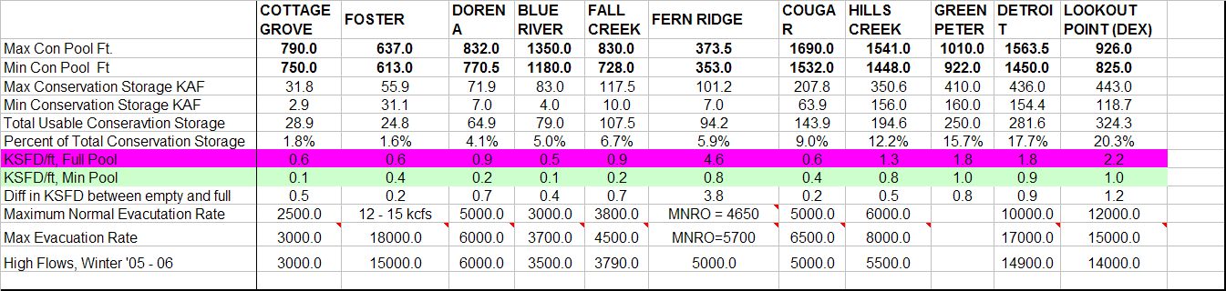

**Reservoir-Stats.pdf**

**The following two tables are the same – just different presentations.**

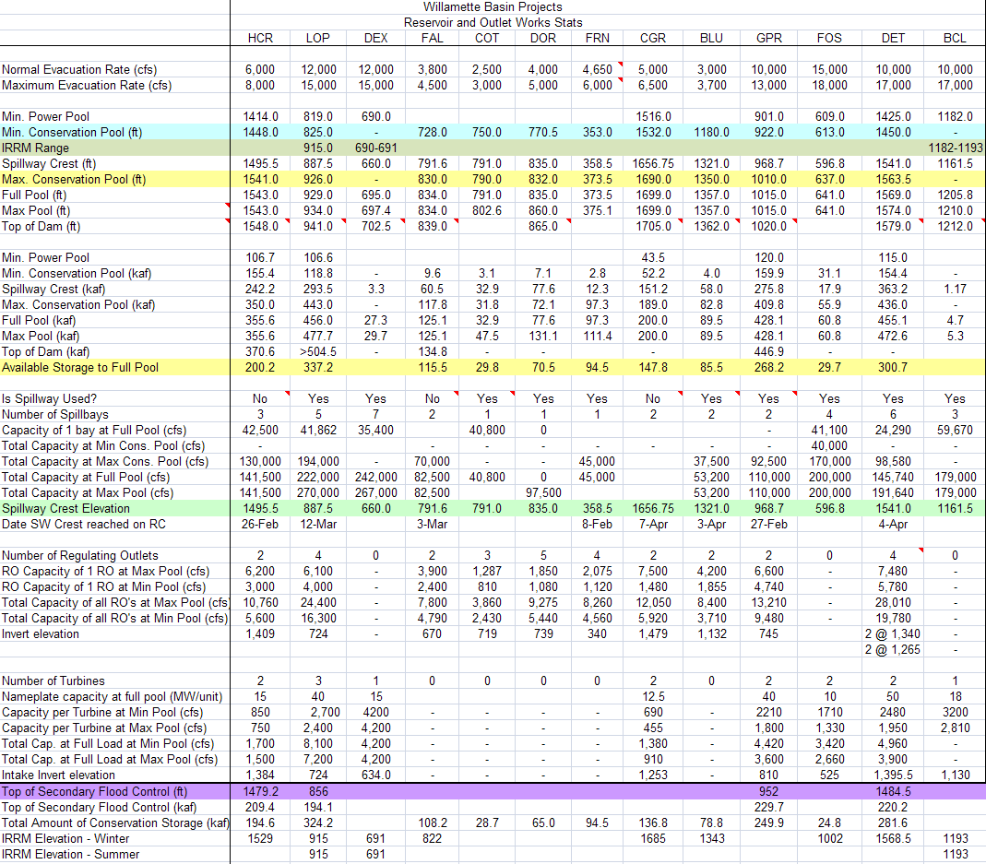

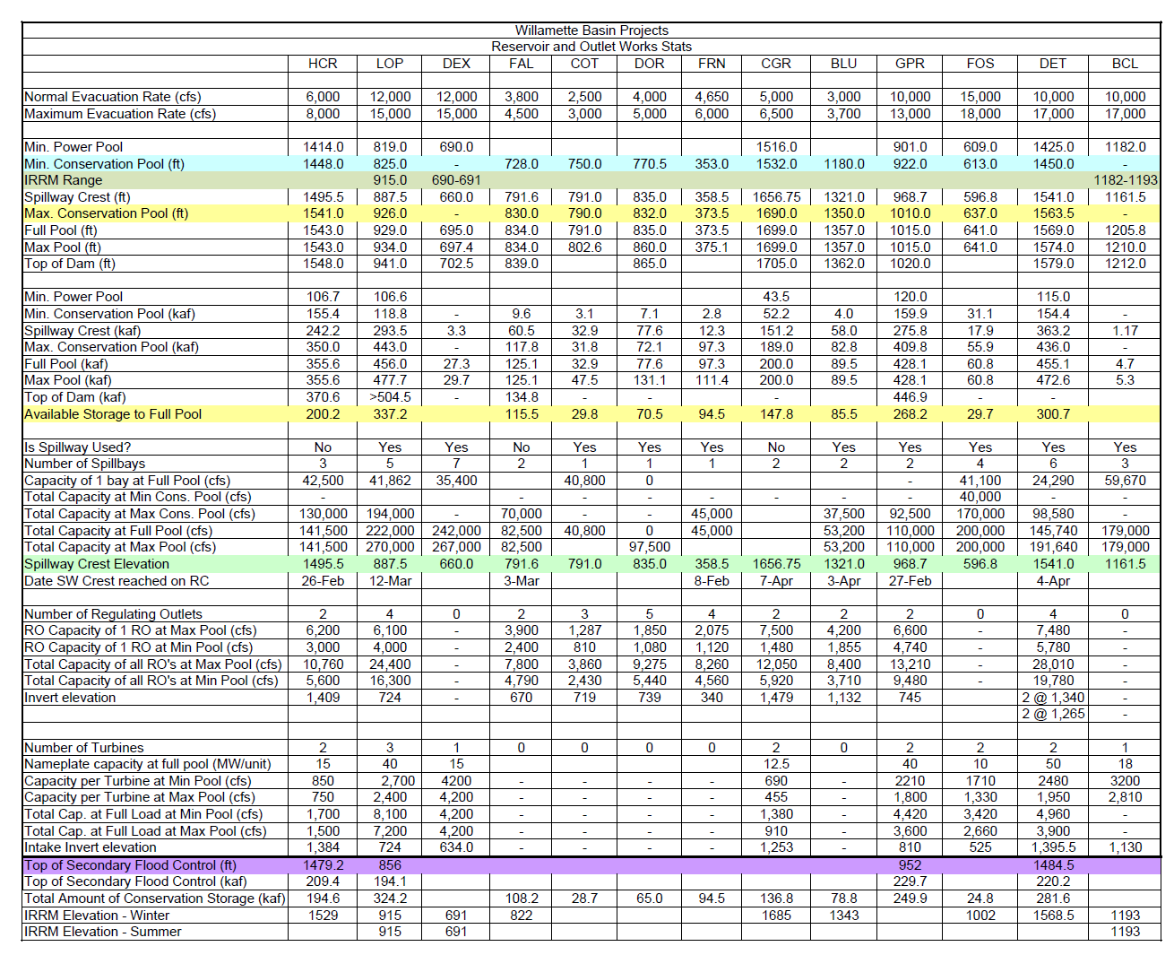

# **WILLAMETTE BIOLOGICAL OPINION AND SUPPLEMENTAL BIOLOGICAL ASSESSMENT FOR FLOW MANAGEMENT**



Information Included:

RAMP RATES

MINIMUM AND MAXIMUM FLOWS FOR FISH

FALL CREEK WINTER DRAWDOWN

MAINSTEM FLOW METHODOLOGY

INTERIM DRAFT LIMIT METHODOLOGY

RELEASE OF CONTRACTED STORED WATERS / MINIMUM PROJECT OUTFLOW REQUIREMENTS

**Running CHPS (Community Hydrologic Prediction System)**

<http://public.deltares.nl/display/FEWSCOM/Welcome>

<http://public.deltares.nl/display/FEWSDOC/Home>

1. Log into VNC viewer – IP address and username provided by NWRFC.
2. Right Click to get a menu – CHPS or FAVO – CHPS IFD is the interactive display mode. RRC
3. Batch is the old batch method of running the forecast.
4. Login to Master Controller, PTRMC00 Server, Full Profile
5. Check the Current System Time (lower left hand corner) – It should be set to 12:00 GMT. If it is set to 18:00 GMT double click over the words Current System Time and reset to 12:00 GMT
6. Forecasts that have been finished will have a green box checked. Unfinished forecasts are a white folder.
7. To undock a plot, first click on the plot icon (top left) 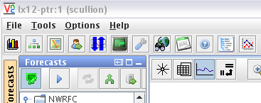
8. This will launch a duplicate of the plot you’re in. You can then undock it by clicking on the folder and moving it to the new desired location.
9. The buttons will tell you what they are if you hover over them.
   1. Green Monitor under Forecasts means that I’m in forecast mode.
   2. Blue Arrow goes to next segment.
   3. Double Green arrow will re-run that segment
   4. Arrow with two tails will re-run all segments
   5. File cabinet with horizontal green arrow – run approved forecast.
10. Running the approved forecast puts the new modifications on the master server for dissemination to all of the forecasters and also to the public once they send it out. The Corps receives the forecast in the database at the same time as the RFC sends it to the web.
11. To put in the regulation you first need to be in the right group – Red Willamette or Reg Rogue.
12. Go to the Modifiers tab and click on the top-most SSARREG (click on that word). If there is more than one SSARREG line, click on the top one since it is the active mod.

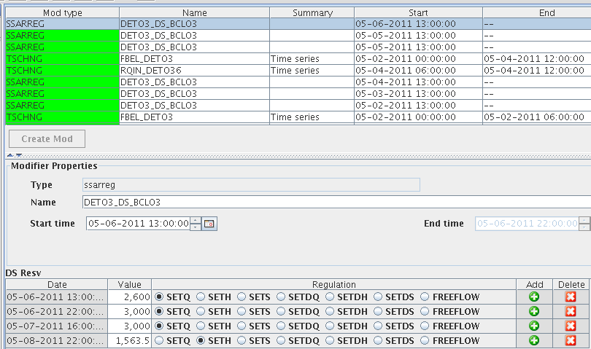

This is an example mod of increasing flow the setting a reservoir elevation.

Set Q = Set a flat flow (cfs)

Set H = Set a reservoir elevation (height - ft)

Set S = Set a reservoir storage (ac-ft)

Set DQ = Set a change in flow (cfs) SetDQ=0 is to pass inflow SetDQ=500 is to store 500 cfs

Set DH and DS are also setting a change in height or storage.

Freeflow is defined as freeflow over the spillway. The spillway tables are defined in CHPS. When we actually operated Foster as freeflow during spillway gate repair we coordinated with the RFC to ensure that the freeflow table in the model was correct. Freeflow is typically not used in modeling.

Most typically used regs: Set Q, Set DQ=0, Set DQ = (fill and draft rates in spring and fall), Set H = (desired height to maintain or to achieve in the future).

Once the mod is entered you would apply and then re-run that segment.