CHAP : VRP HUAWEI

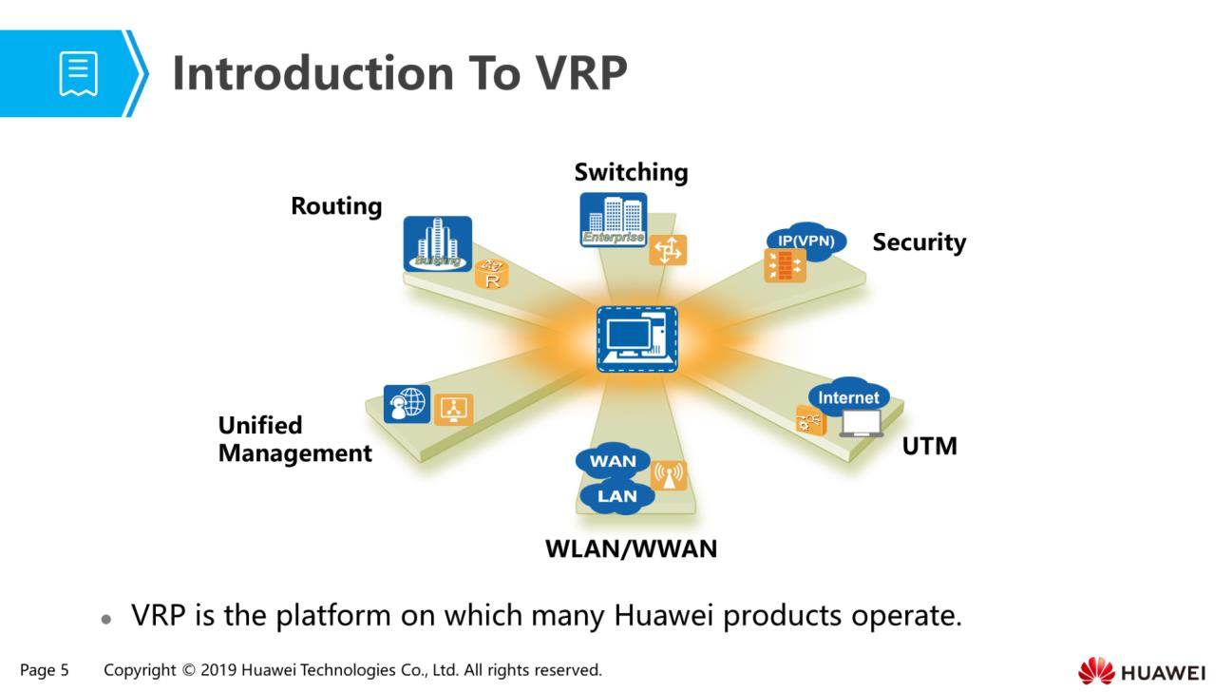
The Versatile Routing Platform (VRP) represents the foundation of many of Huawei
products including routers and switches. Its design has been through many
evolutions to enable continuous improvement of data management and
forwarding,

VRP a été crée en 1998 et est utilisé jusqu’aujourd’hui;on distinque 5 versions,1 ,2,3,5 et 8 et c’est la version 8 qui est utilisée actuellement

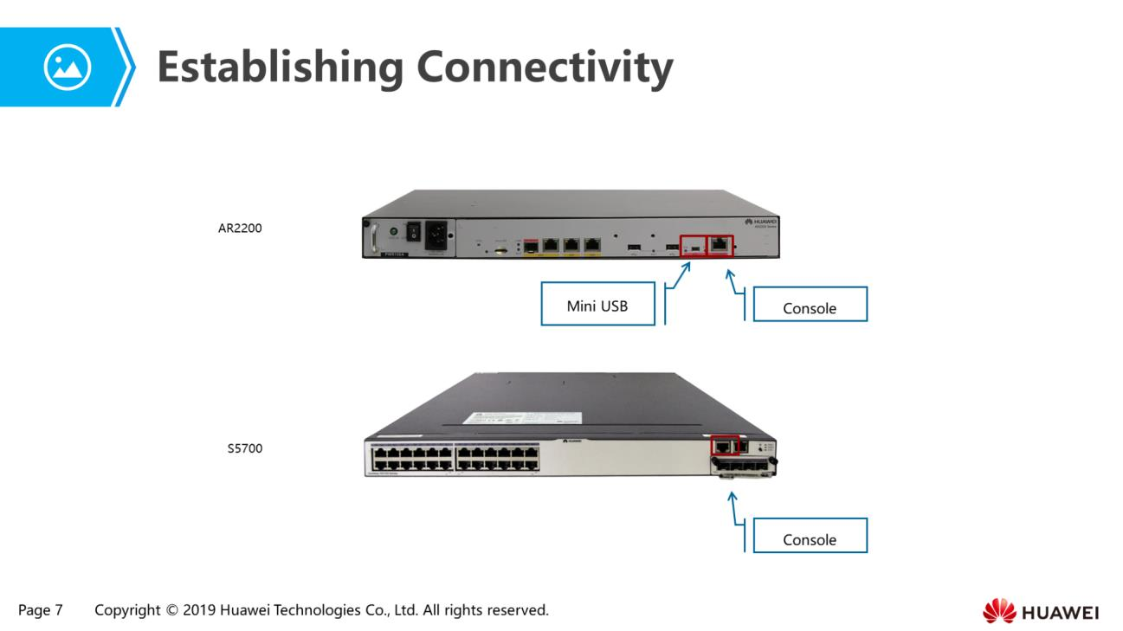
AR series enterprise routers (AR) include the AR150, AR200, AR1200, AR2200, and
AR3200. They are the next-generation of Huawei products, and provide routing,
switching, wireless, voice, and security functionality

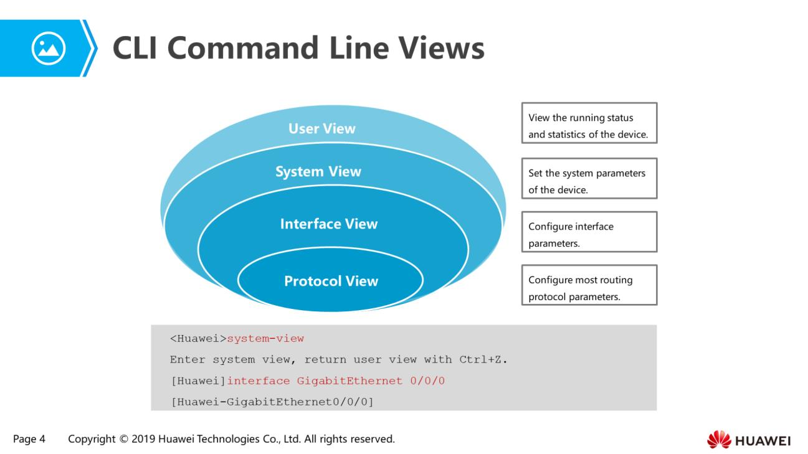
The command line views can be determined based on the parenthesis, and
information contained within these parenthesis. The presence of chevrons
identifies that the user is currently in the User View, whereas square brackets show
that a transition to the System View has occurred.

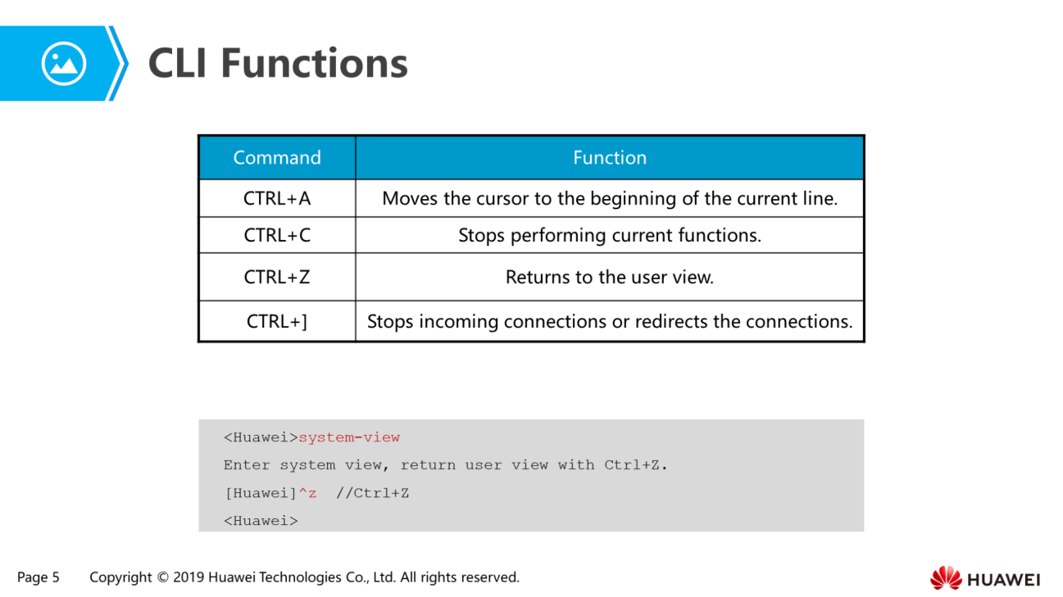
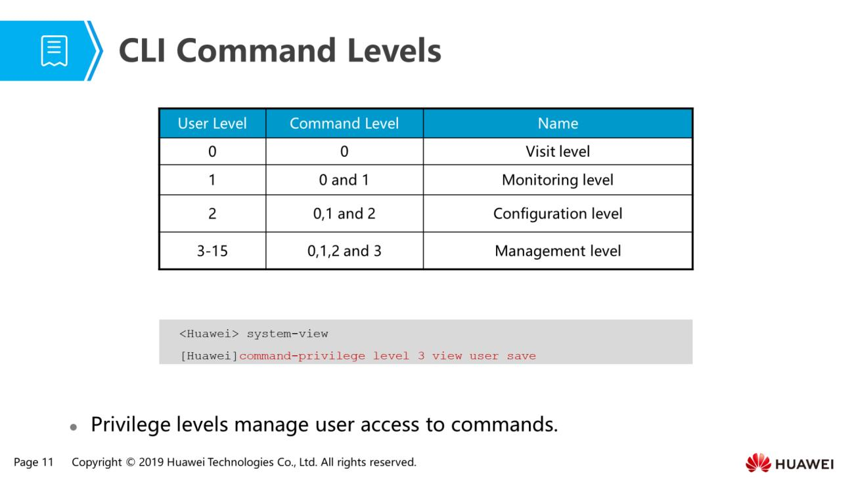
Two common forms of user interface
implemented are the console interface (CON) and the virtual teletype terminal
(VTY) interface.It should be
noted that the console interface by default uses the non-authentication mode.

