## Lesson 11

index Reading**:** ***An Introduction to Statistical Methods and Data Analysis*,** Chapters 7.3, 10.3 and 10.5**.**

## Sample Homework Problem:

1. Problem 7.25 (7.32 in 5th ed) a, c (skip b) (Note that the p-value in the Minitab output corresponds to the p-value of a two-tailed test. (You need to make appropriate adjustment to find the p-value for the one-tailed test.)
2. Problem 10.78 (10.78 in 5th ed)

**Partial Solutions:**

1. **Problem 7.32**.

We provide solution first to c and then to a.

**c**) Both samples are normally distributed. Therefore, the required conditions have been met for the inferences and we may use F-test to compare the variances of the two portfolio in a.

|  |
| --- |
|  |

* + 1. To formally test, we want to conduct the following hypothesis test, Ho: σ²1 = σ²2, Ha: σ²1 < σ²2 (one-sided left-tailed test). Use α = 0.05.

|  |
| --- |
| Homogeneity of Variance Response Returns  Factors Portfolio  ConfLvl **95.0000**  Bonferroni confidence intervals for standard deviations    Lower Sigma Upper N Factor Levels  2.35242 **3.59629** 7.2417 10 Portfolio 1  3.89800 **5.95912** 11.9996 10 Portfolio 2    F-Test (normal distribution)  Test Statistic: **2.746**  P-Value : **0.148**  Levene's Test (any continuous distribution)  Test Statistic: 3.512  P-Value : 0.077 |

Using results from part c, we know that the data from both populations may come from normal distribution and it is correct to make inference based on the F-Test. In this case we cannot reject Ho (F = 0.364; p = 0.074) at α = 0.05 level. P-value for one-sided test is (p-value for two-sided test / 2) = 0.148/2 = 0.074. Therefore, we conclude there is not enough evidence to suggest that portfolio2 has a higher risk than portfolio1.

Note that for this problem, the hypothesis is one-sided whereas Minitab output is for a two tailed test. We thus need to make adjustment to obtain the p-value of the one tailed test.

1. **Problem 10.78**
2. The percentage of rats with one or more tumors for each of three treatment groups are Control 10/100 = 10%, Low Dose 14/100 = 14%, High Dose 19/100 = 19%.
3. Set up the hypotheses:

Ho: Number of tumor and rat group are independent.

Ha: Number of tumor and rat group are dependent.

α = 0.05.

How to enter data into Minitab:

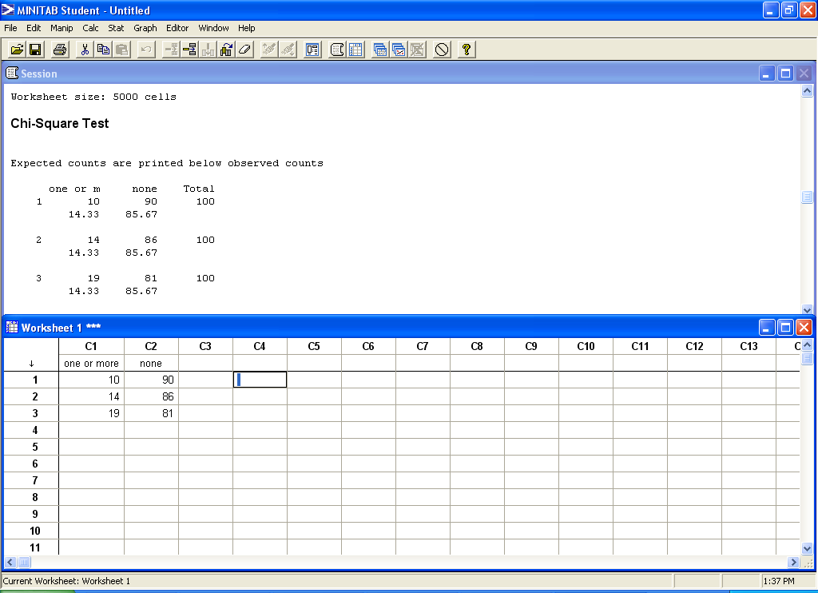

Output from Minitab:

|  |
| --- |
| Expected counts are printed below observed counts  one or m none Total  1 10 90 100  14.33 85.67  2 14 86 100  14.33 85.67  3 19 81 100  14.33 85.67  Total 43 257 300  Chi-Sq = 1.310 + 0.219 +  0.008 + 0.001 +  1.519 + 0.254 = 3.312  DF = 2, P-Value = 0.191 |

Test statistic is χ² = ∑ [ (nij – Eij)²/Eij ] = 3.312 with df = (r – 1)(c - 1) = 2*1 = 2, and P-value = 0.191. Since the *p*-value = 0.191 > 0.05 = α, we fail to reject the null hypothesis. Therefore, there is no sufficient evidence of a difference in the proportion of rats having one or more tumors for the three rat groups, i.e. the population proportions for each group are identical.

1. There does not seem to be a drug-related problem regarding tumors for this drug product since we failed to reject the null hypothesis in part (b).

**Practice Homework:** (Please do not submit these problems): 7.23 (7.27 in 5th ed), 10.23(a)(c) (10.31, 10.32 in 5th ed are similar), 10.42 (10.60 in 5th ed), and 10.67 (10.67 in 5th ed).

**Submit the following Homework Problems to “Dropbox for HW 11”**

1. A study was conducted to compare the variability in strengths of 1-inch square sections of a synthetic fibre produced under two different procedures. A random sample of 9 squares from each process was obtained and tested.

1. Plot the data for each sample separately.
2. Is the assumption of normality warranted?
3. If permissible from part(b), use the following data to test the research hypothesis that the population variances corresponding to the two procedures are different. Use α = 0.10.

|  |  |  |  |  |  |  |  |  |  |
| --- | --- | --- | --- | --- | --- | --- | --- | --- | --- |
| Procedure 1 | 74 | 90 | 103 | 86 | 75 | 102 | 97 | 85 | 69 |
| Procedure 2 | 59 | 66 | 73 | 68 | 70 | 71 | 82 | 69 | 74 |

(Part (a) refers to plotting the data so that one can answer part (b). For part (c), use Minitab to perform the appropriate test and draw a conclusion using the p-value from the relevant output.)

1. The plot is below:



1. The normality conditions are met since all the data points lie within the bands.
2. Both samples are normally distributed. Therefore, the required conditions have been met for the inferences and we may use F-test to compare the variances of the two procedures.

The Minitab printout for the test for equal variances is as follows:

Sample N StDev CI

Procedure 2 9 6.2405 (3.99936, 13.3039)

Procedure 1 9 12.4074 (7.95151, 26.4507)

Individual confidence level = 97.5%

Tests

Test

Method Statistic P-Value

F 0.25 0.069

The hypotheses are:

*Ho*:*σ*1^2 − *σ*2^2 = 0  
*Ha*: *σ*1^2 − *σ*2^2 ≠ 0

In this example, the *p*-value for the F-test = 0.069 < α = 0.1, so we reject the null hypothesis and conclude that the two procedures are different.

2. Problem 6.43 (6.39 in 5th ed) (a) (b) (Note: You first check whether you may use 2-sample t-test. Then use Minitab to perform the Test of Equal Variances to check whether you should use the pooled or non-pooled 2 sample t-test. Finally, use Minitab to perform the 2-sample t test to answer the question.)

Whether we can use 2-sample t-test:

Assumption 1: Are these independent samples? Yes, since the samples from the two jets that are not related.

Assumption 2: Are these large samples or a normal population? We have *n*1 < 30, *n*2 < 30. We do not have large enough samples and thus we need to check the normality assumption from both populations.



From the normality plots, we conclude that both populations may come from normal distributions.

Assumption 3: Do the populations have equal variance? We will perform the Test of Equal Variances in Minitab:

**Test for Equal Variances: Wide-Bodied, Narrow-Bodied**

Method

Null hypothesis All variances are equal

Alternative hypothesis At least one variance is different

Significance level α = 0.05

F method is used. This method is accurate for normal data only.

95% Bonferroni Confidence Intervals for Standard Deviations

Sample N StDev CI

Wide-Bodied 15 4.71442 (3.30876, 7.9907)

Narrow-Bodied 12 7.86619 (5.31926, 14.5407)

Individual confidence level = 97.5%

Tests

Test

Method Statistic P-Value

F 0.36 0.075

Since the p-value > alpha = 0.05, we fail to reject the null hypothesis and use the pooled variance 2 sample t-test

Pooled variance 2 – sample t test

**Two-Sample T-Test and CI: Wide-Bodied, Narrow-Bodied**

Two-sample T for Wide-Bodied vs Narrow-Bodied

N Mean StDev SE Mean

Wide-Bodied 15 110.20 4.71 1.2

Narrow-Bodied 12 118.37 7.87 2.3

Difference = μ (Wide-Bodied) - μ (Narrow-Bodied)

Estimate for difference: -8.17

95% CI for difference: (-13.19, -3.14)

T-Test of difference = 0 (vs ≠): T-Value = -3.35 P-Value = 0.003 DF = 25

Both use Pooled StDev = 6.2986

A. Since the p-value = 0.003 < α = 0.05, we reject the null hypothesis. At 5% level of significance, the data provides sufficient evidence that the mean of the two jets are different.

B. 95% CI for μ (Wide-Bodied) - μ (Narrow-Bodied): (-13.19, -3.14)

C. There could be a large number of factors affecting the noise level such as manufacturer, hours of usage, age etc. The samples should be taken by controlling factors other than the body type. There could also be pairing if the same manufacturer makes both then we can get narrow and wide of similar age, hours of usage etc.

3. A law student believes that the proportion of registered Republicans in favor of additional tax incentives is greater than the proportion of registered Democrats in favor of such incentives. The student acquired independent random samples of 200 Republicans and 200 Democrats and found 109 Republicans and 86 Democrats in favor of additional tax incentives. Use these data to test H0: π1 – π2 ≤ 0 versus Ha: π1 – π2 > 0. Give the level of significance for your test. (10.26 in 5th ed) (Use Minitab)

Here π1 proportion refers to republican and π2 refers to democrats. Adding the data to minitab and set the alternative to “greater than”

**Test and CI for Two Proportions**

Sample X N Sample p

1 109 200 0.545000

2 86 200 0.430000

Difference = p (1) - p (2)

Estimate for difference: 0.115

95% lower bound for difference: 0.0333288

Test for difference = 0 (vs > 0): Z = 2.30 P-Value = 0.011

Fisher’s exact test: P-Value = 0.014

Since p-value = 0.011 < α (assumed 0.05 as not given in problem) = 0.05, we reject the null hypothesis and conclude that at 5% level of significance, the data provides sufficient evidence that the proportions of republican support is greater than the democrat support.

4. Problem 10.65 (10.65 in 5th ed) (Use Minitab, refer to Sample Problem 2 to see how to input data into Minitab)



Ho : Opinion of union membership and actual membership are independent.

Ha : Opinion of union membership and actual membership are dependent.

α = 0.01

**Tabulated Statistics: Union Membership, Opinion**

Rows: Union Membership Columns: Opinion

Favor Indifferent Opposed All

Members 140 42 18 200

70.00 21.00 9.00 100.00

66.67 17.50 12.00 33.33

23.33 7.00 3.00 33.33

70 80 50

Nonmembers 70 198 132 400

17.50 49.50 33.00 100.00

33.33 82.50 88.00 66.67

11.67 33.00 22.00 66.67

140 160 100

All 210 240 150 600

35.00 40.00 25.00 100.00

100.00 100.00 100.00 100.00

35.00 40.00 25.00 100.00

Cell Contents: Count

% of Row

% of Column

% of Total

Expected count

Pearson Chi-Square = 162.795, DF = 2, P-Value = 0.000

Likelihood Ratio Chi-Square = 163.815, DF = 2, P-Value = 0.000

Test statistic is χ² = ∑ [ (nij – Eij)²/Eij ] = 162.795 with df = (r – 1)(c - 1) = 1*2 = 2, and P-value = 0.000. Since the *p*-value = 0.000 < 0.01 = α, we reject the null hypothesis. Therefore, there is sufficient evidence of a difference in the opinion of people who are already members.

5. For Problem 10.65, provide a hand computation to the chi-square Statistics and its degrees of freedom.

We have been given:



For row 1, column 1 the estimated expected number of occurrences is

Eij = (row 1 total) * (column 1 total) / grand total = 200 * 210 / 600 = 70

Similar calculations for all cells yield the data below:



Ho : Opinion of union membership and actual membership are independent.

Ha : Opinion of union membership and actual membership are dependent.

Test statistic is χ² = ∑ [ (nij – Eij)²/Eij ] = ((140-70)^2/70) + ((42-80)^2/80) + ((18-50)^2/50) + ((70-140)^2/140) + ((198-160)^2/160) + ((132-100)^2/100) = 162.795

DF = (r-1) (c-1) = 1*2 = 2

6. Problem 10.80 (10.80 in 5th ed) (Please note that the first cell on the upper left corner explains that the second entry of each cell is the expected cell numbers. The output is given in p.568 of the textbook. The purpose of this problem is to familiarize you with SAS output )

1. The expected values from the output are:

|  |  |  |  |  |
| --- | --- | --- | --- | --- |
|  | Years of Education | | | |
| Years on First Job | 0–4.5 | > 13.5 | 4.5–9 | 9–13.5 |
| 0-2.5 | 17.902 | 26.342 | 20.971 | 23.784 |
| 2.5–5 | 24.138 | 35.517 | 28.276 | 32.069 |
| 5–7.5 | 16.695 | 24.566 | 19.557 | 22.181 |
| > 7.5 | 11.264 | 16.575 | 13.195 | 14.966 |

1. Setup the hypothesis as follows:

Ho : “length of time on first job’’ is not related to the variable “amount of education”

Ha : “length of time on first job’’ is related to the variable “amount of education”

Test statistic is χ² = ∑ [ (nij – Eij)²/Eij ] = 57.830 with df = 9, and P-value = 0.001.

1. P-level from the SAS output is 0.001
2. Since the *p*-value = 0.001 < 0.05 = α, we reject the null hypothesis. Therefore, there is sufficient evidence to indicate “length of time on first job’’ is related to the variable “amount of education”.

7. Learning at home: M. Stuart et al. studied various aspects of grade-school children and their mothers. One of the questions dealt with the children’s knowledge of nursery rhymes. The following data were obtained:

. Nursery Rhyme knowledge

|  |  |  |  |
| --- | --- | --- | --- |
| Social status | A few | Some | Lots |
| Middle class | 7( ) | 13( ) | 16( ) |
| Working | 8( ) | 11( ) | 18( ) |

Hand compute the expected counts at each cell and then use Minitab to find out the chi-square statistic and the p-value of the test. Check whether one can use the chi-square test of independence and conduct the test at α = 0.05

We have been given:

|  |  |  |  |  |
| --- | --- | --- | --- | --- |
| Social status | A few | Some | Lots | Totals |
| Middle class | 7( ) | 13( ) | 16( ) | 36 |
| Working | 8( ) | 11( ) | 18( ) | 37 |
| Totals | 15 | 24 | 34 | 73 |

For row 1, column 1 the estimated expected number of occurrences is

Eij = (row 1 total) * (column 1 total) / grand total = (36*15)/73 =

Similar calculations for all cells yield the data below:

|  |  |  |  |  |
| --- | --- | --- | --- | --- |
| Social status | A few | Some | Lots | Totals |
| Middle class | 7((36*15)/73 ) | 13((36*24)/73 ) | 16((36*34)/73 ) | 36 |
| Working | 8((37*15)/73 ) | 11( (37*24)/73 ) | 18((37*34)/73 ) | 37 |
| Totals | 15 | 24 | 34 | 73 |

After completing the calculations, we get:

|  |  |  |  |  |
| --- | --- | --- | --- | --- |
| Social status | A few | Some | Lots | Totals |
| Middle class | 7(7.40 ) | 13( 11.84 ) | 16( 16.77 ) | 36 |
| Working | 8( 7.60 ) | 11(12.16 ) | 18(17.23 ) | 37 |
| Totals | 15 | 24 | 34 | 73 |

Can we use Chi-Square: Some statisticians hesitate to use the chi-square test if more than 20% of the cells have expected frequencies below five, especially if the p-value is small and these cells give a large contribution to the total chi-square value.

In our case all the expected values are > 5 therefore we can use the test.

Ho : social status and nursery rhyme knowledge are independent.

Ha : social status and nursery rhyme knowledge are dependent.

Using Minitab, we get:

**Tabulated Statistics: Social status, Rhyme Knowledge**

Rows: Social status Columns: Rhyme Knowledge

A few Some Lots All

Middle class 7 13 16 36

19.44 36.11 44.44 100.00

46.67 54.17 47.06 49.32

9.59 17.81 21.92 49.32

7.40 11.84 16.77

Working 8 11 18 37

21.62 29.73 48.65 100.00

53.33 45.83 52.94 50.68

10.96 15.07 24.66 50.68

7.60 12.16 17.23

All 15 24 34 73

20.55 32.88 46.58 100.00

100.00 100.00 100.00 100.00

20.55 32.88 46.58 100.00

Cell Contents: Count

% of Row

% of Column

% of Total

Expected count

Pearson Chi-Square = 0.337, DF = 2, P-Value = 0.845

Likelihood Ratio Chi-Square = 0.338, DF = 2, P-Value = 0.845

Test statistic is χ² = ∑ [ (nij – Eij)²/Eij ] = 0.337 with df = (r – 1)(c - 1) = 1*2 = 2, and P-value = 0.845. Since the *p*-value = 0.845 > 0.05 = α, we fail to reject the null hypothesis. Therefore, there is not sufficient evidence to indicate that social status and nursery rhyme knowledge are dependent.