Stat 500 Practice Exam for Midterm 2

Note that the purpose of this practice exam is to let you know about the format for the midterm. It does not indicate the length of or the subject that will appear on the midterm.

- A doctor is interested in estimating the percentage of blood donor member that have blood type A. Identify the population of interest to the doctor. Is this an estimation problem or hypothesis testing problem?

- A rancher is interested in estimating how many hours his tractor will run on a full tank of gas. A random sample of n=25 tanks of gas was monitored and the number of hours recorded for each tank. The average number of hours that the tractor ran for one tank of gas was found to be 23.6, with a standard deviation of 0.8. Using the Normal Probability Plot, we have checked that the sample may come from a Normal Distribution. Construct a 90% confidence interval for the mean number of hours for a tank of gas.

- In a study of radio listening habits, a station owner would like to estimate the average number of hours that teenagers spend listening each day. It is reasonable to assume that it ranges from 0 to 6 hours. How many teenagers should he sample so that he can estimate the average number of hours to within 0.5 hours with 94% confidence?

- In order to check the normality assumption, we obtain the following normal probability plot of the sample using minitab. We can conclude that the normality assumption is violated. ( T F )

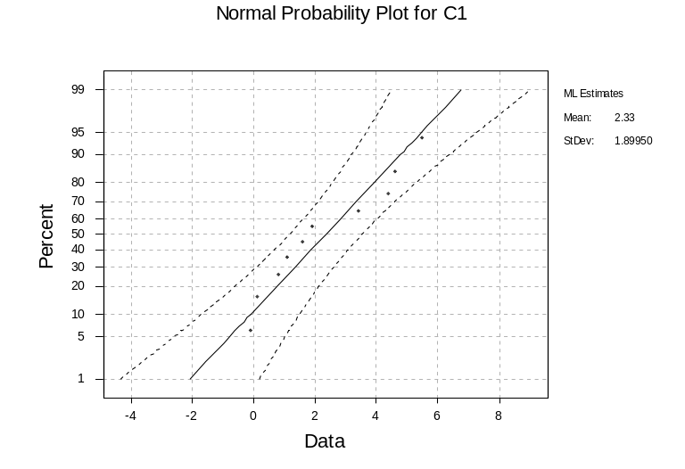
- In a study of radio listening habits, a station owner would like to estimate the proportion of teenagers that listen to radio for at least one hour each day. Last year, the proportion is 0.3. The setup cost of sampling is high and he does not want to set up to sample again. How many teenagers should he sample so that he can estimate this year’s proportion to within 0.1 with 90% confidence?

- A researcher want to estimate the proportion of U.S. employees that “play hooky”, that is, call in sick at least once a year when they simply need time to relax. A poll was taken of 1000 and 200 respond ‘yes’. Use these data to obtain a 95% confidence interval for the population proportion .

- What is a type I error? What is a type II error?

- An expert claims that the proportion of people with blood type O is 0.25. Out of 40 randomly sample people, 8 have blood type O. Can one conclude that the proportion of blood type O is different from 0.25?

