Lesson 8 - Homework
Notes:
- The answers to the problems will be posted on Sunday after the due date. To view the answers, click on the Homework Solutions link in the menu bar to the left.
1. (10 pts; 5 pts each) Answer “true” or “false” for each question.
a. To prove that µ = µ₀ with Type I error .05, we must select a sample and fail to reject the null hypothesis H₀: µ = µ₀ using α = .05.
FALSE – just means we don’t have enough evidence to reject null. There is no proof in the procedure.
b. If we reject the null hypothesis at the α = .05 level, then we should also reject it at the α = .01 level.
FALSE. The rejection region for .05 level is larger than the region for .01 level. So there is an intermittent area where this is not true.
2. (10 pts) Administrative officials at a large state university are concerned that the freshman students living in off-campus housing facilities have significantly lower grade point averages (GPA) than the GPA for the whole freshman class. After the fall semester, the all-freshman average GPA was 2.3 (on a 4-point system). Because it was not possible to isolate grades for all students living in off-campus housing by university records, a random sample of 200 off-campus freshmen was obtained by tracing students through their permanent home addresses. The sample mean GPA was 2.24 with a standard deviation of .31. Do the data present sufficient evidence to indicate that the average GPA for all off-campus freshmen is lower than the all-freshmen average of 2.3? Use α = .05.
Set up the null and alternative hypotheses. No need to perform the test. Make sure that you specify the correct parameter in the hypotheses.
Answer:
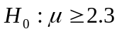 (or 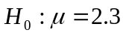)
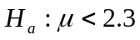
This is a one-sided test and.
yBar = 2.24, s = .31, N=200
3. (10 pts) In a statistical test about µ, the null hypothesis was rejected. Based on this conclusion, which of the following statements are true?
a. A Type I error was committed.
b. A Type II error was committed.
c. A Type I error could have been committed.
d. A Type II error could have been committed.
e. It is impossible to have committed both Type I and Type II errors.
f. It is impossible that neither a Type I nor a Type II error was committed.
g. Whether any error was committed is not known, but if an error was made, it was Type I.
h. Whether any error was committed is not known, but if an error was made, it was Type II.
The highlighted line items (c, e and g) are TRUE
4. (20 pts; 4 pts each) Complete the following statements (more than one word may be needed).
a. If we take all possible samples (of a given large sample size) from a population, then the distribution of sample means tends to be ____NORMAL_____ and the mean of these sample means is equal __population mean_______.
b. The larger the sample size, other things remaining equal, the _narrower____ the confidence interval.
c. The larger the confidence coefficient, other things remaining equal, the __wider___the confidence interval.
d. The statement “If random samples of a fixed size are drawn from any population (regardless of the form of the population distribution), as n becomes larger, the distribution of sample means approaches normality,” is known as the _Central Limit Theorem_____________.
e. By failing to reject a null hypothesis that is false, one makes a __Type II_____ error.
5. (10 pts) The FDA has to determine whether to let a certain drug go to the market. There are two hypotheses:
- The drug has severe side effects.
- The drug has no severe side effects.
How will you set up the hypotheses? Give a brief explanation.
The null hypothesis: The drug has severe side effects.
The alternative hypothesis: The drug has no severe side effects.
Explanation: We should set the hypotheses up in a way so that Type I error is more serious. Here we put " The drug has severe side effects " in 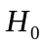 since we consider false rejection of H_{o} is a more serious error than failing to reject H_{o}.

6. (20 pts) Fancorp (a consulting firm) claims that “less than half of franchises are owned by husband-wife team.” A simple random sample of 32 franchise owners shows that 12 are owned by husband-wife team. Can you conclude Fancorp’s claim at α = 0.05? (Use p-value approach)
(Hint: the hypothesis one wants to reject is usually the null hypothesis and the hypothesis one wants to conclude is usually the alternative hypothesis (research hypothesis).)
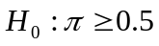 (or 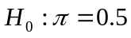)
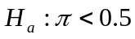
This is a one-sided test and.
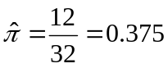
Test Statistic: Z* = (0.375 – 0.5) / sqrt(0.5*0.5/32) = -1.41421

P-value=P(z < -1.41421) > .0793
Since P-value >, we fail to reject the null hypothesis and conclude that the Fancorp’s claim is not supported by the evidence provided.
7. (20 pts) A toothpaste manufacturer wants to establish that their sales have more than 32% of the market. Set up the null and alternative hypotheses for the toothpaste manufacturer. Out of a random sample of 40 toothpaste purchases, 19 are from this manufacturer. Can you conclude the toothpaste manufacturer’s claim at α = 0.024? (use p-value approach)
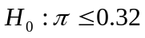 (or 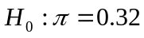)
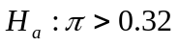
This is a one-sided test and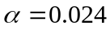
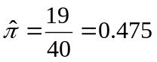
Test Statistic: Z* = ( - π_{o}) /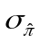, where = √[ π_{o} (1 - π_{o}) / n] =
= (0.475 – 0.32) / sqrt(0.32*0.68/40) = 2.102

P-value=P(z > 2.102) = 1 – P( z <= 2.102) = 1 - .9821 = 0.0179
Since P-value < α = 0.024, we reject the null hypothesis and conclude that the manufacturer’s claim is valid.

Reading: An Introduction to Statistical Methods and Data Analysis, chapters 5.4, 5.7, and 10.2.
Practice problems and its solutions:
Practice problem 1: The benign mucosal cyst is the most common lesion of a pair of sinuses in the upper jawbone. In a random sample of 800 males, 35 persons were observed to have a benign mucosal cyst.
a. Would it be appropriate to use a normal approximation in conducting a statistical test of the null hypothesis H₀: π ≥ .096 (the highest incidence in previous studies among males)? Explain.
b. Conduct a statistical test of the research hypothesis H_{a}: π <.096 by computing the p-value manually and drawing a conclusion using the p-value approach.
Solution to practice problem 1:
a. 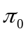=0.096, n=800
Since 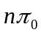=800(0.096) =76.875>5, 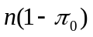=800(0.904) =723.2>5, the normal approximation would be appropriate.

b. 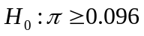 (or 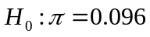)
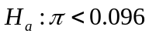
This is a one-sided test and.
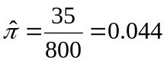
Test Statistic: 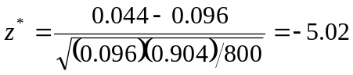
P-value=P(z<-5.02)<0.0001
Since P-value<, we can reject the null hypothesis and conclude that the incidences of benign mucosal cyst among males is significantly less than 0.096 at .
Practice problem 2: Some mushrooms were found in a forest. You do not know much about whether those are poisonous. There are two hypotheses:
  - The mushrooms are poisonous and can not be eaten
  - The mushrooms are not poisonous and can be eaten
How will you set up the hypotheses? Give a brief explanation.
Solution to practice problem 2:
The null hypothesis: the mushrooms are poisonous and can not be eaten.
The alternative hypothesis: the mushrooms are not poisonous and can be eaten.
Explanation: We should set the hypotheses up in a way so that Type I error is more serious. Here we put "the mushrooms are poisonous and can not be eaten" in since we consider false rejection of H_{o} is a more serious error than failing to reject H_{o}.

