Homework 9 Solution

- Let π=percentage of householder had Bachelor's degree or more had incomes below the poverty level
H₀: π>=0.108
H_{a}: π<0.108
T.S.: z=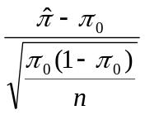
R.R.: for α=0.01, reject H₀ if z<-2.326
From the problem:
=11/378=0.0291 and 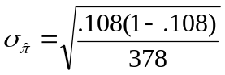=.0160
z= (.0291-.108)/.016=-4.94<-2.326
So, we conclude families whose householder had a Bachelor's degree or more had a lower percentage earning incomes below the poverty level than the national percentage of 10.8%.

- let π= percentage of home buyers purchasing single-family houses
H₀: π=0.831
H_{a}: π≠0.831
T.S.: z=
Based the problem:
=151/200=.755 and 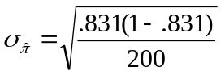=.0265
z=(.755-.831)/.0265=-2.868
p-value=2 P(Z≥|-2.868|)=0.004<0.021
So, we conclude that this year's percentage of home buyers purchasing single-family houses is different from the 1995 figure of 83.1%

- The normality test:
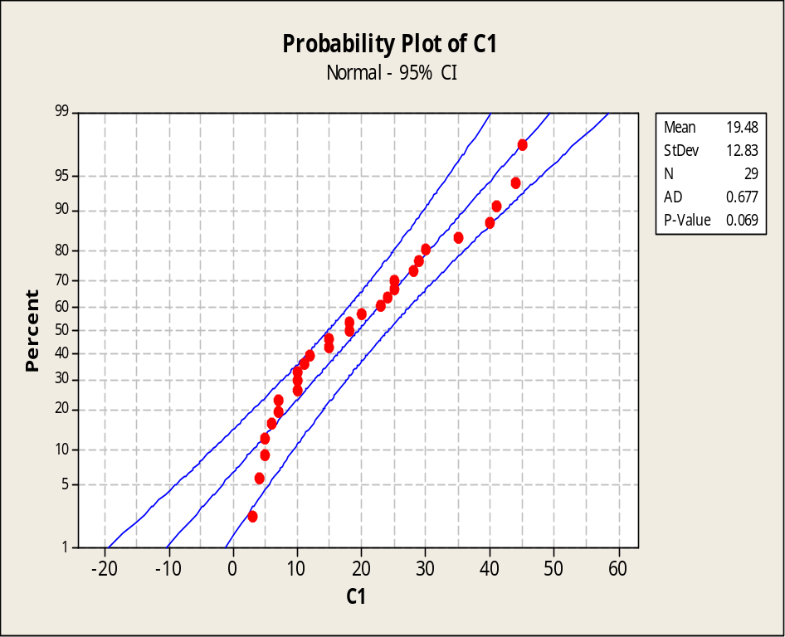
The P-value of the normality check is 0.069, so we do not reject the assumption of normality.

One-Sample T: C1

Test of mu = 30 vs < 30
99%
Upper
Variable N Mean StDev SE Mean Bound T P
C1 29 19.4828 12.8331 2.3830 25.3620 -4.41 0.000

Yes, we can reject the owner’s claim at 0.01 level.

- Let μ be the mean age US commercial jets
H₀: μ>=18
H_{a}: μ<18
We will reject null if t<=-t_{.05,35}=-1.69

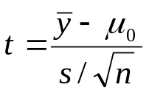=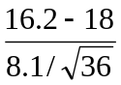=-1.33>-1.69

So, we can’t reject the null hypothesis that the mean age of US jets is more than 18 years

H₀: μ=29
H_{a}: μ≠29
We will reject null if |t|>t_{α/2, n-1}=2.76

=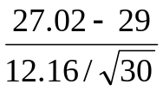=-0.89<2.76
So, we failed to reject the null, there is no evidence to doubt the supervisor’s claim.

When the test is run to the standard 95% we get the following:
One-Sample T: C1

Test of mu = 675 vs not = 675

Variable N Mean StDev SE Mean 95% CI T P
C1 30 711.700 84.151 15.364 (680.278, 743.122) 2.39 0.024

In this case we reject the null hypothesis of equivalence.

We will use one sample t-test. We can estimate sigma with (55-49)/4 =1.5. We want to calculate a difference of 1 oz, so that is entered as the difference. The target power is given as 80%.

Power and Sample Size

1-Sample t Test

Testing mean = null (versus not = null)
Calculating power for mean = null + difference
Alpha = 0.01 Assumed standard deviation = 1.5

Sample Target
Difference Size Power Actual Power
1 30 0.8 0.806362

According to Minitab, a sample size of 30 bottles is needed.

