Stat 500: Practice Midterm 1

Note that the purpose of this practice exam is to let you know about the format for the midterm. It does not indicate the length of or the subjects that will appear on the midterm.

- T F In a box plot, if one whisker is longer than the other, the data is skewed in the direction of
the long whisker.

- T F Probability of intersection of two events is the product of probabilities of the individual
events.

3. Which one or more of the following (a)-(g) is NOT a characteristic of a normal distribution? If all are characteristics, select (h).

- bell-shaped
- mound-shaped
- symmetrical about the median
- centered at the mode
- extends from – ∞ to + ∞
- most of the area is within the interval (μ - 3σ, μ + 3σ)
- unimodal
- all of the above are characteristics of normal curves

4. Data Set 1: 7.2, 5.1, 8.4, 6.3, 9.1
Data Set 2: 7.2, 5.1, 8.4, 6.3, 9.1, 70.8

- Find the mean and median for each of the above data sets.
Mean of Data Set 1 is 7.22, median is 7.2
Mean of Data Set 2 is 17.8, median is 7.8

- Why does the median change very little from set to set, while the mean changes considerably? Explain.
Mean of a data set is highly influenced by an extreme observation whereas median is not.
- Find the sample range.
Sample range of Data Set 1 is 4.0
Sample range of Data Set 2 is 65.7

- Find the approximate value (NOT EXACT) of the sample standard deviation (s) for data set 1.
s ≈ R/4 = 1
- Using part (4), find the percentage of observations within one standard deviation of the mean for data set 1 (i.e. the interval x ± s). What do you conclude from it?
Only 40% of the data fall within the interval (6.22, 8.22). Explanation: either the data set is too small to apply the empirical rule or R/4 is not a good estimate for s if the data set is too small.

Use with Questions 5-8: The following graph represents the side by side box plots of the GPA of the females and males in the UC Davis.

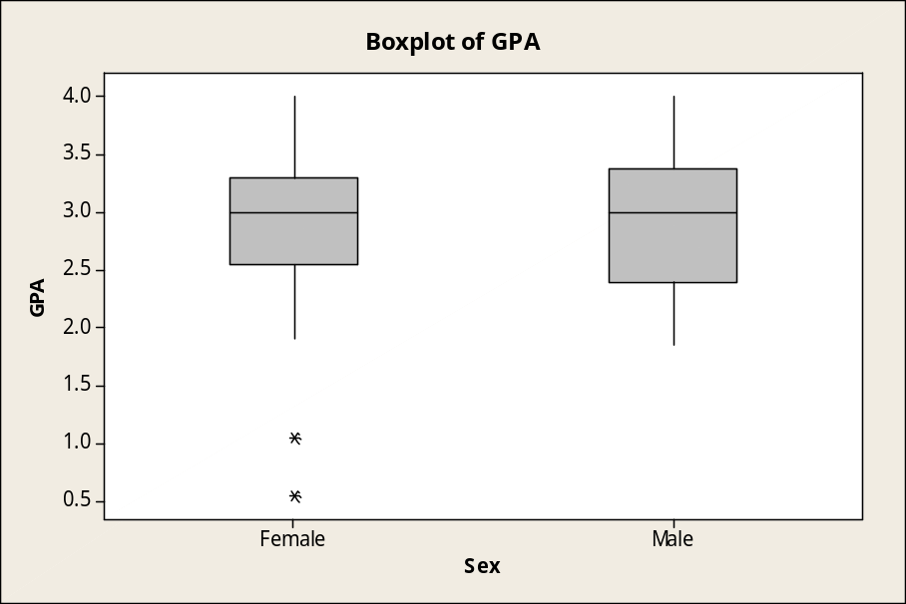

Question 5: The variable of interest (GPA) is
- quantitative B. categorical

Question 6: Which of the following statements is true? When comparing the sample of the males and the females, the two populations:
A. have about the same value of the IQR (Inter-Quartile Range)
B. have about the same value of the minimum
C. have about the same value of the median
D. have about the same number of outliers

Question 7: Which of the following statements is true? When comparing the two samples:
A. both are skewed to the right
B. both have about the same value for Q₁
C. the females have a higher value of Q₃.
D. both have about the same value of the maximum.

Question 8: Which of the following statements is true for the combined population of males and females?
A. 50% of all the GPAs lie between 2 and 3
B. 50% of all GPAs lie between 3 and 4
C. 25% of all GPAs are below 2.0
D. 25% of all GPAs are above 3.5
9. A married man watches a certain television show (event M) with probability 0.4 and a married woman watches a certain television show (event W) with probability 0.5. The probability that a man watches the show, given that his wife does, is 0.7.

Find the probability that (A VENN DIAGRAM MIGHT HELP):

- A married couple watches the show.
- A wife watches the show given that her husband does
- Exactly one spouse of a married couple watches the show

Are M and W independent events? Justify your answer.

P(M) = 0.4, P(W) = 0.5, P(M|W) = 0.7

- 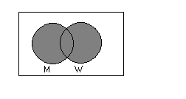P(M∩W) = P(W) ⋅ P(M|W) = 0.35

- P(W|M) = P(W∩M) = 0.35 = 0.875
P(M) 0.4

- P(W∩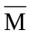) + P(M∩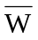) = P(W U M) - P(M∩W) =
P(W) – P(M∩W) + P(M) – P(M∩W) = 0.2

P(W∩M) = 0.35 ≠ P(M) ⋅ P(W) W, M not independent

10. A new cough medicine has probability 0.85 of curing a person’s cough. 20 are given the new cough medicine. What is the probability that

- All 20 are cured of their coughs?
- None of the 20 is cured of their coughs.

(DEFINE YOUR EVENTS/RANDOM VARIABLES CLEARLY TO GET FULL CREDIT!)

Y = number of persons cured out of 20 when given new medicine
Y has a binomial distribution with n = 20, π = 0.85,

(a) P(Y = 20) = 20! (0.85)²⁰ ⋅ (0.15)⁰ = 0.85²⁰ = 0.03876
20! 0!
(b) P(Y = 0) = 20! (0.85)⁰ ⋅ (0.15)²⁰ = 0.15²⁰ = 3.3 × 10⁻¹⁷
0! 20!

Note: one can also use Minitab to figure out these probabilities

11. In a consumer satisfaction study, a random sample of 8 customers of a restaurant is selected and they are asked whether they are satisfied with their dining experience. The restaurant has claimed that more than 70% of the customers are satisfied.

- Of the 8 people polled, what is the expected value (mean value）for the number of favored opinion?
- If out of the 8 people polled, only 2 are satisfied, do you think that there is strong reason to suspect the statement that more than 70% of the customers are satisfied? Explain.

(Note: probability less than 0.05 is considered strong reason, otherwise, not strong reason).
1) E(Y) = 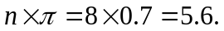

2) Under the assumption that 70% of the customers are satisfied, the one-tailed probability to observe 2 or less successes is

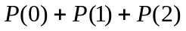

=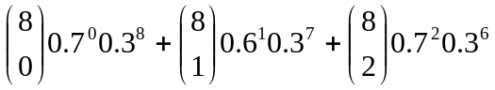.
The result is .) Since this probability is smaller than 0.05, there is strong reason to doubt the restaurant’s claim.

(Note that using empirical rule for this problem is not that good since when number of failures is less than 5, Normal approximation does not work here .)

One can also use Minitab to figure out the probabilities.

12. The weight of each chocolate chip cookie follows a normal distribution with mean 3 oz and standard deviation 1 oz. Find the probability that the mean of 9 cookies is more than 3.1 oz.

Mean of sample mean = 3, standard deviation of sample mean = 1/√ (9) = 1/3

P(Y-bar >3.1) = P( (Y-bar – 3)/.333) > (3.1-3/.333) ) = P(Z>.3) =1-.6179=.3821

or 38.21%

