Stat 500 Solution- HW1
- (10 pts) Provide information about yourself.
- Problem 1.3 (10 pts)
  - The population of interest is the number of children in households that receive welfare support in a particular city.
  - The sample is the number of children in the 400 households randomly selected from the city welfare rolls.
  - The mean number of children that receive welfare support in households that receive welfare support in a particular city.
  - A measure of the reliability of the inferences is important since the sample is only a small proportion of the population, it is necessary to evaluate what the mean number of children for any other randomly sampled 400 households may be.
- Problem 2.8 (15 pts)
    - No. The survey that the interviewers asked the person to show them the peanut butter container should be more accurate since it does not rely on the respondent’s memory of which rand was purchased.
    - Both surveys may have survey nonresponse bias because an entire segment of population (those not at home) cannot be contacted. Also, both surveys may have interviewer bias resulting from the way the question is posed (e.g., tone of voice). In addition, for the first survey, results may be biased by the respondent’s ability to recall correctly which brand was purchased. For the second survey, it may be biased by the respondent’s unwillingness to show the interviewer the peanut butter jar, or by the respondent not recognizing that the peanut butter purchased was lowfat.
4. (20 pts) In a study of the relationship for senior citizens between physical activity and frequency of colds, participants were asked to monitor their weekly time spent in exercise over a five-year period and the frequency of colds. The study demonstrated that a negative statistical relation exists between time spent in exercise and frequency of colds. The investigator concluded that increasing the time spent in exercise is an effective strategy for reducing the frequency of colds for senior citizens.
- Were the data obtained in the study observational or experimental (scientific) data?
The data were from an observational study because the investigators did not control factors in the study environment such as the time spent in exercise (not set by the investigator). People were merely asked to provide their weekly time spent in exercise and the frequency of colds over a five-year period.
- Comment on the validity of the conclusions reached by the investigator.
Many other factors may have influenced the study. In particular, other factors could have attributed to a decrease in frequency of colds other than time spent exercising (Observational study cannot make cause and effect conclusion).
- Identify two or three factors that might affect both the time spent in exercise and the frequency of colds for senior citizens simultaneously.
A couple of factors affecting both time spent in exercise and the frequency of colds for senior citizens simultaneously could have been overall health and physical condition of the respondent. A healthier person is probably less likely to catch colds and someone who is more physically inclined will probably be able to exercise for a longer period of time. Other factors may include age, financial means, etc…
- How might the study be changed so that a valid conclusion about “causal” relationship between the amount of exercise and the frequency of colds be reached?
A designed experiment is expected to determine the causality. The study could have been randomized in order to make valid conclusions about the causal relationship between amount of exercise and frequency of colds. For example, the experimenter could have randomized one-half of the subjects to receive minimal exercise (control) and the other half to exercise regularly (treatment).
5. (20 pts) The variable of interest is categorical and we can use pie chart and bar chart as graphical methods.
The following is the pie chart. We have selected the option so that the slices are arranged in decreasing volume. The frequency of each slice is labeled.
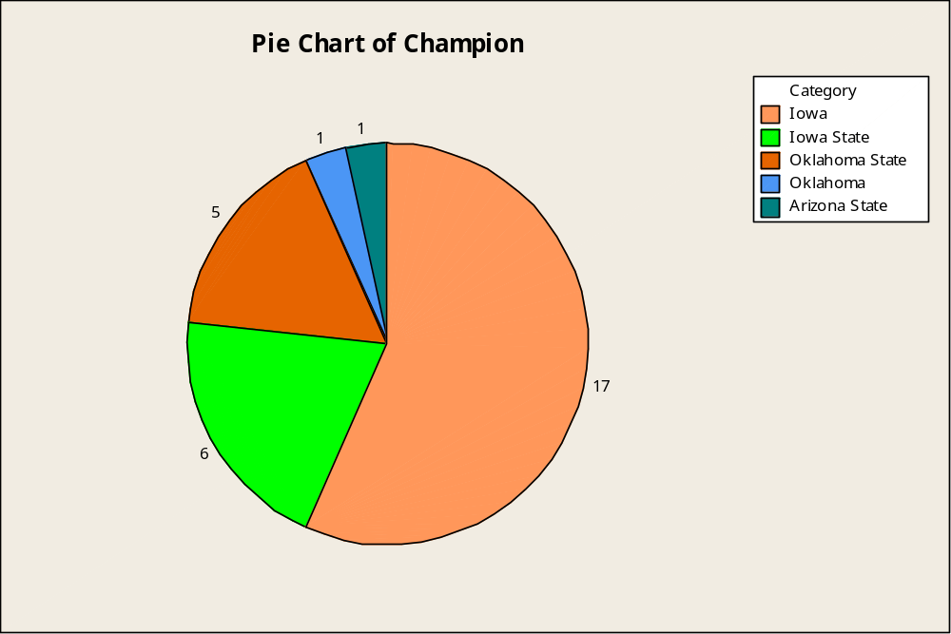

The following is the bar chart for the data. We have selected the option to arrange the categories in increasing y.
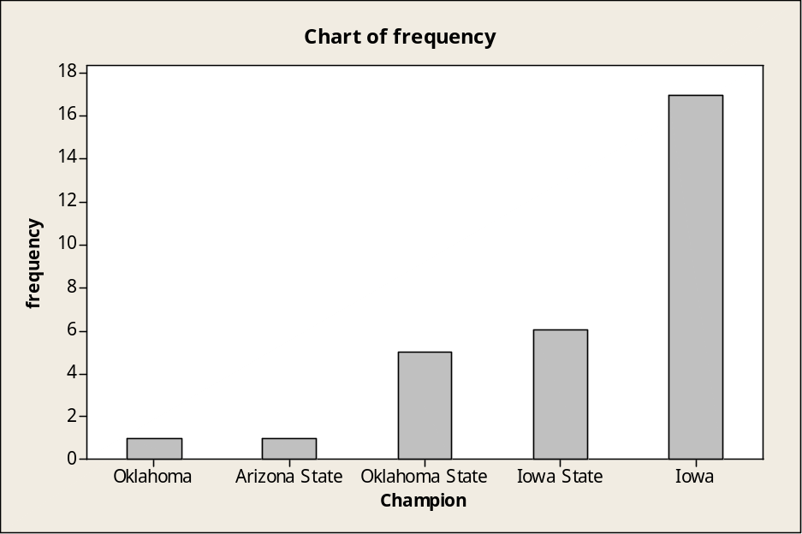
6. (25 pts)
a. Frequency histogram for Soprano and Alto:
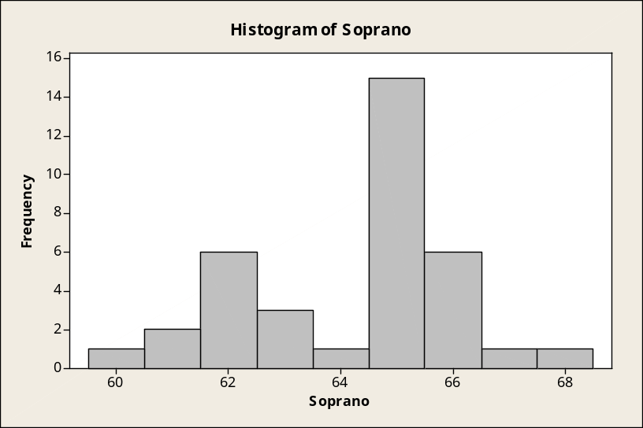
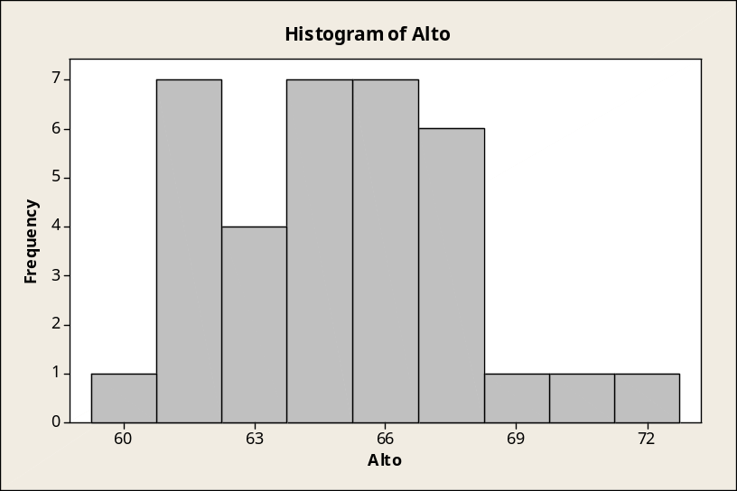
b. Relative frequency histogram for Soprano and Alto:

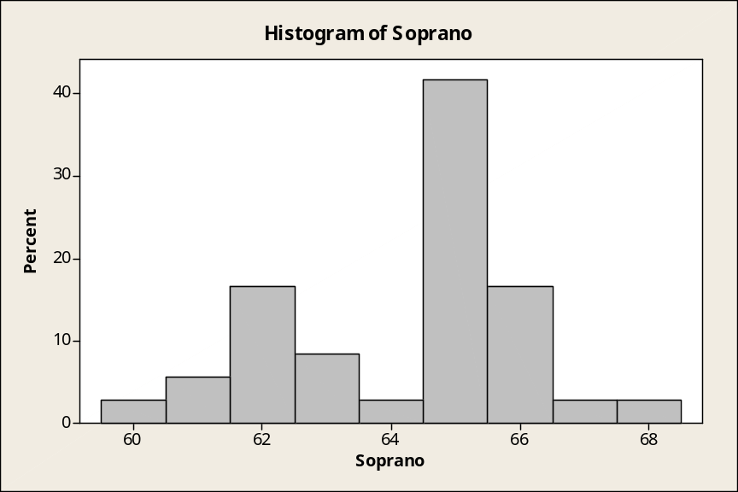
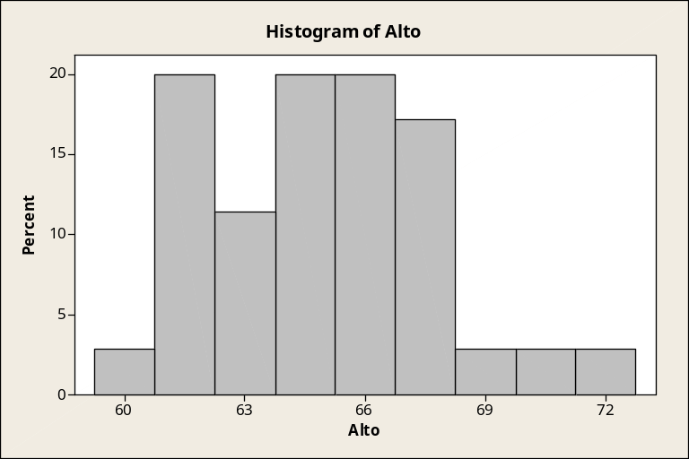

c. Draw stem-and-leaf diagram for each type of singer (Soprano, Alto, Tenor, Bass). Use the stem-and-leaf diagrams to find the median height of each group.
For soprano, the median is 65, which is in the line with parenthesis in the beginning.
For Alto, the median is 65, which is in the line with parenthesis in the beginning.
For Tenor, the median is 68.5, which is just taking average of 68 and 69.
Note: Since the median is not a value on any of the leafs, there is no parenthesis shown in the first column.
For Bass, the median is 71, which is in the line with parenthesis in the beginning.
Stem-and-Leaf Display: Soprano, Alto, Tenor, Bass

Stem-and-leaf of Soprano N = 36
Leaf Unit = 0.10

1 60 0
3 61 00
9 62 000000
12 63 000
13 64 0
(15) 65 000000000000000
8 66 000000
2 67 0
1 68 0

Stem-and-leaf of Alto N = 35
Leaf Unit = 0.10

1 60 0
5 61 0000
8 62 000
12 63 0000
15 64 000
(4) 65 0000
16 66 0000000
9 67 0000
5 68 00
3 69 0
2 70 0
1 71
1 72 0

Stem-and-leaf of Tenor N = 20
Leaf Unit = 0.10

1 64 0
2 65 0
5 66 000
7 67 00
10 68 000
10 69 0
9 70 00
7 71 00
5 72 00
3 73 0
2 74 0
1 75
1 76 0

Stem-and-leaf of Bass N = 39
Leaf Unit = 0.10

2 66 00
2 67
8 68 000000
11 69 000
19 70 00000000
(6) 71 000000
14 72 000000
8 73 000
5 74 0
4 75 0000

