Stat 500 Solution- HW2
1) Problem 3.32(15pts)
- Mean = 8.04, Median = 1.54.
- For terrestrial feeder: Mean = 15.01, Median = 6.03
For aquatic feeder: Mean = 0.38, Median = 0.375.
- The mean is more sensitive to extreme values than is the median. On the other hand, the median is a “resistant” statistic, which it is not affected by the large observations.
- For the terrestrial feeder data, the median is more appropriate compared to the mean, because there are some extreme values in the data set of terrestrial feeder.
For aquatic feeder, either mean or median is appropriate since the data set is relatively symmetric.

2) (10pts)
a. No. Although trimmed mean is a good measure of the central location, trimming a certain % of the data has a great effect on the standard deviation of the estimates. Thus one cannot trim a certain % of the data and carry on analysis to make inference about the central location.

b. No, trimming a certain % of the data will change the dispersion of the data set.

3) 3.55 (15 pts)
- Supplier 1: Mean = 189.23, s = 2.96
Supplier 2: Mean = 156.28, s = 3.30
Supplier 3: Mean = 203.94, s = 8.96
- Dot plot is used. Here, dot plot is the most appropriate because it clearly reveals the differences among the three groups. 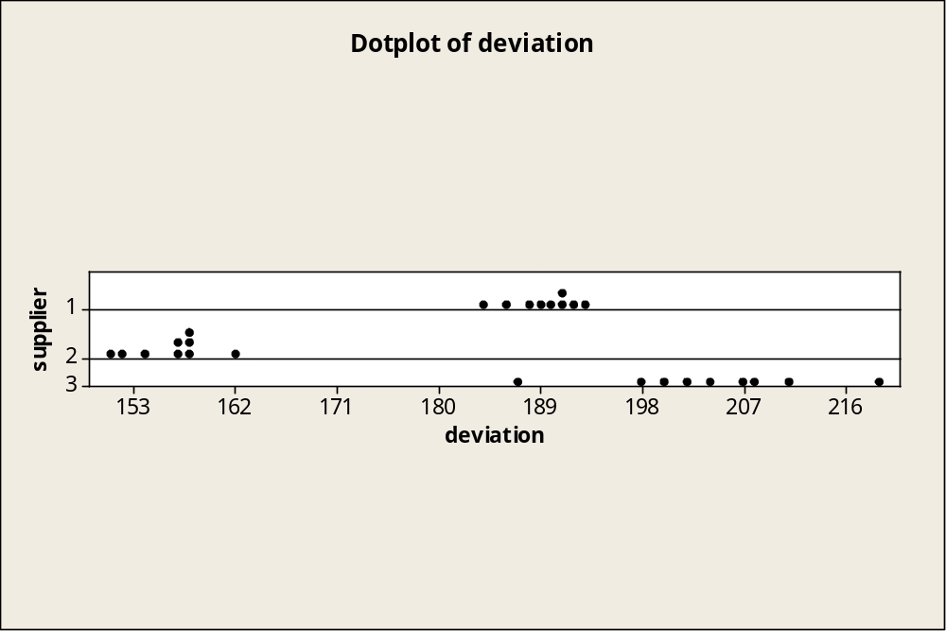
- From both part a) and part b), we observe that Supplier 2 has the lowest average deviation and Supplier 3 has the largest variation of the deviations.
- Supplier 2 is closest to the target value due to the lowest average deviation. In addition, its variation is not bad, one of the two with smaller variations.
4) Problem 3.58 (20pts)
- Mean = 57.5, Median = 34.0.

- The median appears to represent well the center of the data because of a few very large values in the data.

- Range = max observation – min observation = 273, s = 70.2.

- Using the range approximation, srange/4 = 273/4 = 68.25. It is fairly close to the true value (70.2) obtained in part c); the error is only 2.8%.

- The total number of observation = 34.

Interval | Number in Interval | Percentage | Empirical
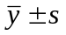= (-12.7, 127.7) | 28 | 82.35% | 68%
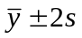= (- 82.9, 197.0) | 32 | 94.12% | 95%
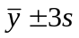= (-153.1, 268.1) | 33 | 97.06% | 99.7%

These percentages do not match the Empirical Rule very well.

- The main reason why the percentages from part (e) do not match the Empirical Rule is that the distribution for demands between failures is highly right skewed. The Empirical Rule’s validity relies on the assumption that the data has a “mound-shaped” (or “bell-shaped”) symmetrical distribution.

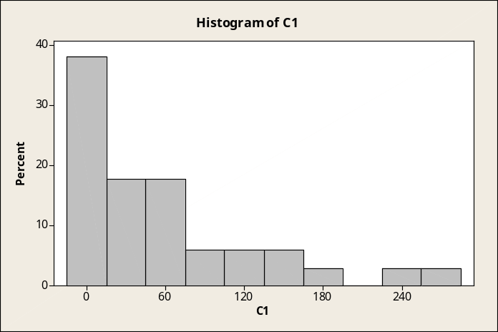
(Can use histogram or boxplot, etc, so far as the student knows to check the mound shape)

5) Problem given in handout (15pts)
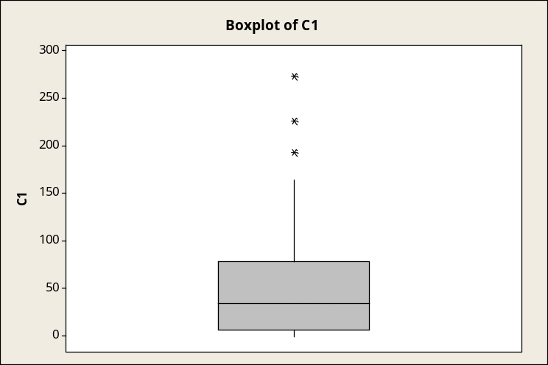
- Skewed to the right.
- 193, 226, 273
- Median is closer to the lower quartile. There are 50% of the data between upper and lower quartiles, with 25% on either side of the median. There is less width in between the median and lower quartile so the density there is higher.

6) Problem 3.60 (10pts)
- Price per roll: Mean = 0.9196, s = 0.4233;
Cost per sheet: Mean = 0.01132, s = 0.00551748.

- Using Coefficient of variability (CV) to see which is variable.
For price per roll, CV = 100*(0.4233/0.9196) = 46.03%;
For cost per sheet, CV =100*(0.00551748/0.01132) = 48.74%.
So the cost per sheet is slightly more variable than the price per sheet.
(I will give full credits if you calculate the right CV’s but conclude that they are almost the same. Indeed, the difference between them is only 2 percents.)

The 6th edition has an error in the entry: for Brand 21, the entry for cost per sheet 0.0011 should be 0.0110. We will accept the answer for cost per sheet as: mean = 0.01091, s = 0.0059 and CV = 54.08 %.

- Coefficient of variability (CV) would be the better way of comparing the variability of price per roll and price per sheet. CV value is unit free and reports variability relative to the magnitude of the mean of the data.

7. (15pts)
a)
Descriptive Statistics: Soprano

Variable N N* Mean SE Mean StDev Minimum Q1 Median Q3
Soprano 36 3 64.250 0.312 1.873 60.000 62.250 65.000 65.000

Variable Maximum
Soprano 68.000
Approximate value of s: (68-60)/4= 2
Descriptive Statistics: Alto

Variable N N* Mean SE Mean StDev Minimum Q1 Median Q3
Alto 35 4 64.886 0.472 2.795 60.000 63.000 65.000 67.000

Variable Maximum
Alto 72.000
Approximate value of s: (72-60)/4=3

Descriptive Statistics: Tenor

Variable N N* Mean SE Mean StDev Minimum Q1 Median Q3
Tenor 20 19 69.150 0.719 3.216 64.000 66.250 68.500 71.750

Variable Maximum
Tenor 76.000
Approximate value of s: (76-64)/4=3

Descriptive Statistics: Bass

Variable N N* Mean SE Mean StDev Minimum Q1 Median Q3
Bass 39 0 70.718 0.378 2.361 66.000 69.000 71.000 72.000

Variable Maximum
Bass 75.000
Approximate value of s: (75-66)/4=2.25
Accordingly, the approximate value of s gives a good estimation of s.

b)
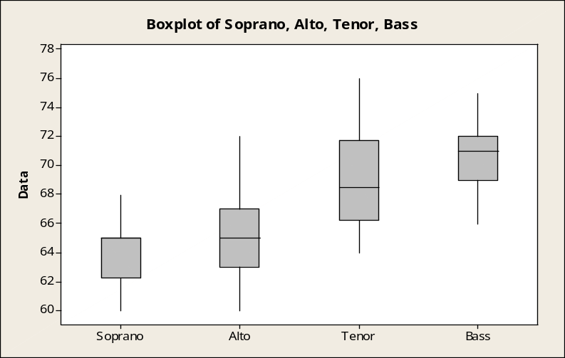
The median of the four types of data increases from soprano to bass. Now we discuss the skewness of the middle 50% of the data. For the data of soprano, the median is close to the upper quartile and is left skewed. In terms of the data of alto, the median is slightly closer to lower quartile, but it’s generally symmetric. For the data of tenor, the median is close to lower quartile, and it’s right skewed. For data of bass, the median is closer to upper quartile, and it’s left skewed.

