Stat 500 Solution- HW4

- (15 pts; each 5 pts)
Binomial with n = 12 and p = 0.4
x P( X = x )  0 0.002177  1 0.017414  2 0.063852  3 0.141894  4 0.212841  5 0.227030  6 0.176579  7 0.100902  8 0.042043  9 0.012457  10 0.002491  11 0.000302  12 0.000017 | x P( X <= x )  0 0.00218  1 0.01959  2 0.08344  3 0.22534  4 0.43818  5 0.66521  6 0.84179  7 0.94269  8 0.98473  9 0.99719  10 0.99968  11 0.99998  12 1.00000
a) P (Y ≤ 2) = 0.08344
b) P (Y > 2) = 1 − P (Y ≤ 2) = 1 − 0.08344 = 0.91656
c) P (Y > 3) = 1 – P (Y ≤ 3) = 1 – 0.22534 = 0.77466 or
P (Y > 3) = P (Y > 2) –P (Y = 3) = 0.91656 - 0.141894 = 0.77466

2) (15 pts; each 5 pts)
- P(y >4) = P(y = 5) + P(y = 6) + P(y = 7) = 0.05+0.05+0.05 = 0.15
- P( y ≤ 2) = P(y = 0) + P(y = 1) + P(y = 2) = 0.1 + 0.2 + 0.3 = 0.6
- It is a binomial problem with n=5 and success rate π = P(y > 4) = 0.15. We are interested in
P(X = 3) = 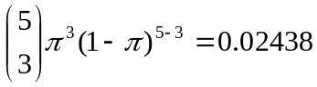.
3) Problem on handout (10 pts; each 5 pts)
Binomial with n=9 and p=0.3
x P( X = x)  0 0.040354  1 0.155650  2 0.266828  3 0.266828  4 0.171532  5 0.073514  6 0.021004  7 0.003858  8 0.000413  9 0.000020 | x P( X <= x)  0 0.04035  1 0.19600  2 0.46283  3 0.72966  4 0.90119  5 0.97471  6 0.99571  7 0.99957  8 0.99998  9 1.00000

a) P(X=2)=0.266828
b) P(X6)=0.021004 + 0.003858 + 0.000413 + 0.00002=0.025295
or 1-P(X5)=1-0.97471=0.02529

4) Problem 4 (10 pts)
n=10, =satisfactory or excellent/good=0.10+0.75=0.85
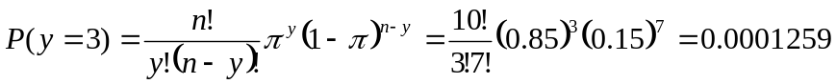

5) Problem 4.63(15 pts)
Due the symmetry of the normal distribution, we have
P (-z₀ < z < z₀) = 0.95 ⇒ 2 × P (z > z₀) = 0.05 ⇒ P (z > z₀) = 0.025
⇒ 1 − P (z ≤ z₀) = 0.025 ⇒ P (z ≤ z₀) = 0.975 ⇒ z₀ = 1.96 from Table 1.

6) Problem 4.72 of the 6th edition (which is problem 4.76 of the 5th edition) (20pts; 10 pts each)
- From Table 1, z_{.90} = 1.28 because the area closest to probability 0.90 is 0.8997. ⇒ The 90th percentile, y_{.90} = u + z_{.90}σ = 500 + 1.28 × 100 = 628. Therefore, a score of 628 or above is required to join the club.
- To find z_{.40}, since the area closest to this value in the standard normal curve table is 0.4013, corresponding to z = -0.25. ⇒ z_{.40} = -0.25. ⇒ y_{.40} = u + z_{.40}σ = 500 + (- 0.25) × 100 = 475. Therefore, a score of 475 separates the top 60% of the population from the bottom 40%. This value, y_{.40} = 475, is called the 40th percentile of the population.

7) (15pts)
Binomial problem with n=9, π ≥0.4 for female. We consider the case when π =0.4:
P(one or fewer are female ) = P(X≤2) = P(X=0) + P(X=1) + P(X=2) = 0.0101+0.0605+0.1612 = 0.2318
There is no strong evidence to doubt that the proportions is 0.4 or more since P(X≤2) is not that small (note that 0.2318>0.05).

