Statistics 500.002: Summer 2014
Project Instructions

Name: Team 06 / Daljeet Maken

Project Report Guidelines

- All students will submit an individual report by 8/12 and team project by 8/13 to the appropriate dropboxes. Students are encouraged to submit the same project for the individual and team submissions but they may also be different. E-mail me by 8/12 if your two submissions are different. The project grade is computed as the sum of individual and team project grades.

- The report will be in Microsoft Word. Minitab outputs must be included wherever necessary to justify your conclusions. There must be a cover page with your names and the project title.

- Late penalty: 10% off for each day.

- Only one team report needs to be submitted by each team.

Project Description

Use the data collected from a class at University Park campus of Penn State University which is stored in the Minitab project called ourdata.mpj. The data collection form for this data set is also posted separately for your reference. You may use Minitab whenever appropriate. The first part deals with data cleaning. Then you proceed to perform statistical procedure to draw inferences about one or more parameters of interest to you.

- You will use descriptive methods such as graphical methods to locate entry mistakes for quantitative variables that you may use for the inference part. Note that data may be outliers but not errors. A data entry mistake may be a head circumference of 20 cm since it is not a realistic measurement for an adult head circumference. You only need to provide one such quantitative variable for this question and detail how you resolve the problem. However, when you proceed to work on the other problems, you should use the data that had been cleaned by you. Note that if you determine to remove a data value that is a clear error, you should replace it by * in Minitab, denoting missing data. The reason is if you eliminate the whole row when only one variable has a mistake, you would also be removing useful information for other variables.

Data Entry Mistakes

The box plots for the various columns are:
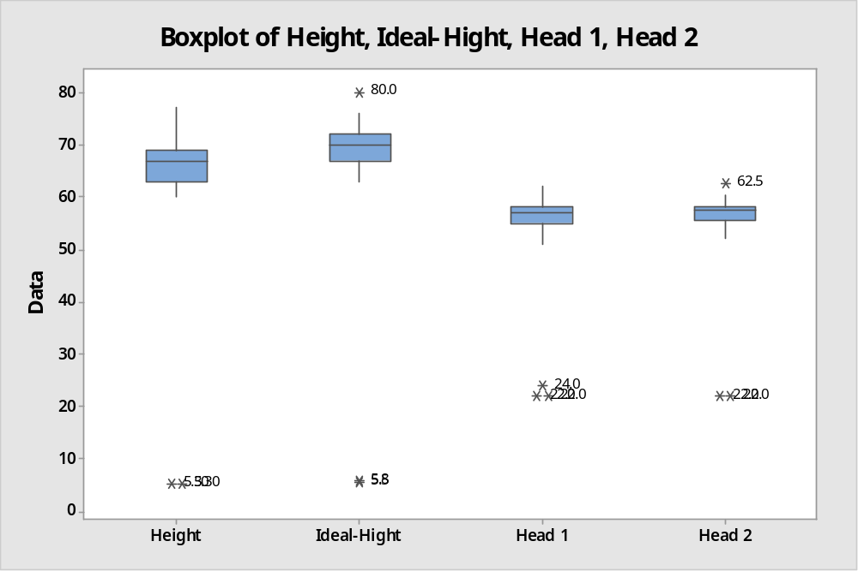

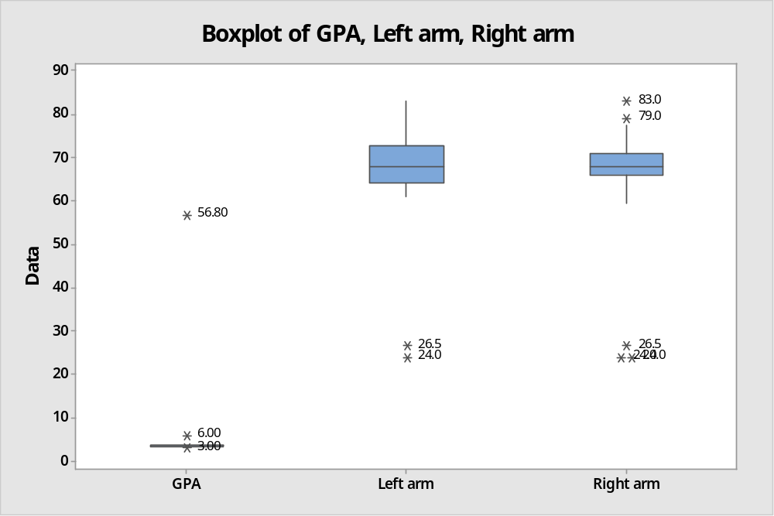

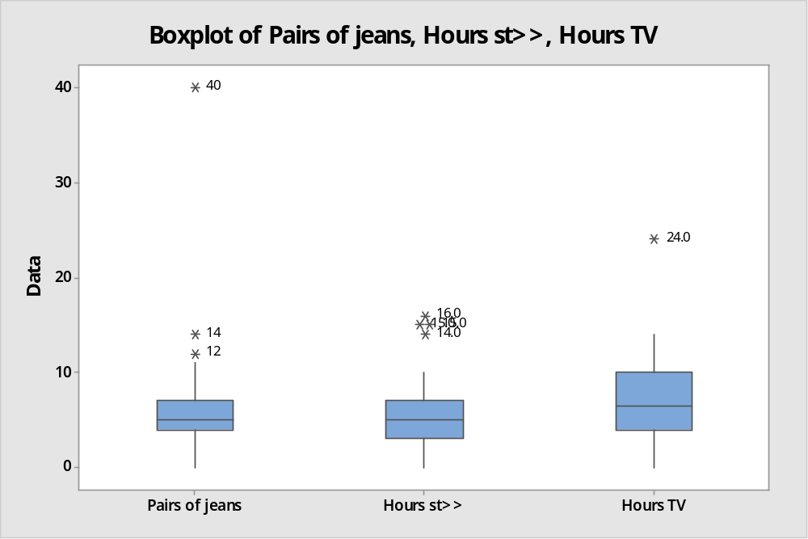

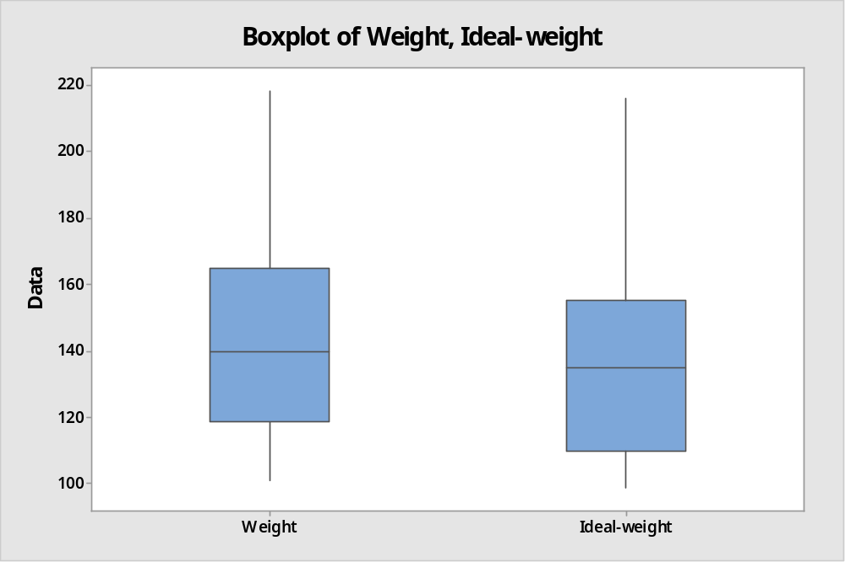

The data indicates the following mistakes:
- The height column has two entries with values 5.3 each. We have marked these entries with a *.
- The ideal-height column also has issues in the same rows as the height. The values are: 5.8 and 5.5. We have marked these entries with a *.
  - There is another outlier row of ideal height= 80. Kept this data since it is plausible
- There is a GPA row with 56.8. We have marked these entries with a *.
- There are three rows with head 1 size between 22 and 24. Also two rows have head 2 as 22. We have marked these entries with a *.
- One entry for column Hours TV is 24 (assuming the unit is hrs, this is an error). Not marked this entry with * as it is plausible. (not replaced these entries with *)
- In the arm length columns (Left Arm, Right Arm) there are values 26.5 and 24. There is one row where the left arm and right arm are far apart (Left: 74 and Right: 24). What do you think about this? Could it be an error or can it be on account of disabled adults? (not replaced these entries with *)

Resolutions of Data Entry Mistakes
We have marked the entries highlighted above with a *.
- Use a graphical method to locate entry errors for qualitative variables you may use in the following problems. You only need to give one example of a qualitative variable with entry error and you should detail how to fix the problem.

Mistakes:
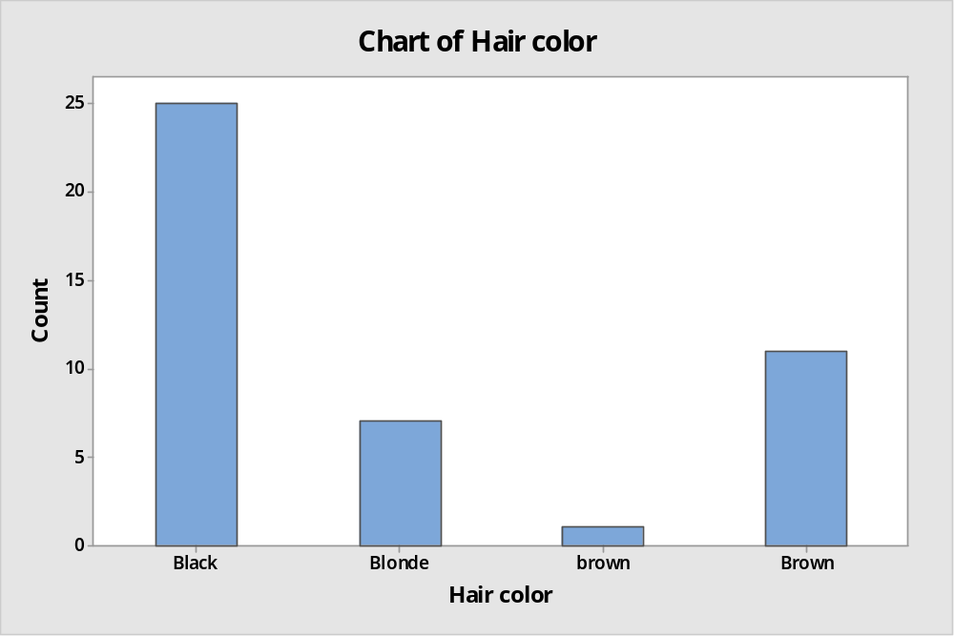
As shown in the bar graph for Hair Color, we have entries for color brown and Brown (difference in case). We will change all the entries with brown to be Brown. So we will get the bar chart as:

Corrected:
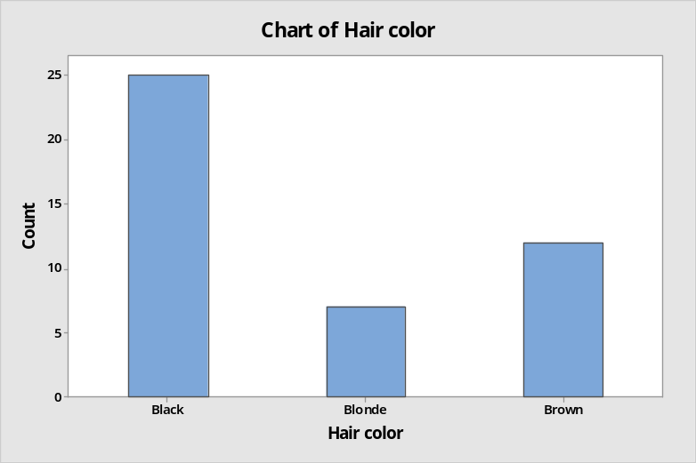

We also have issues with column: Hub Food
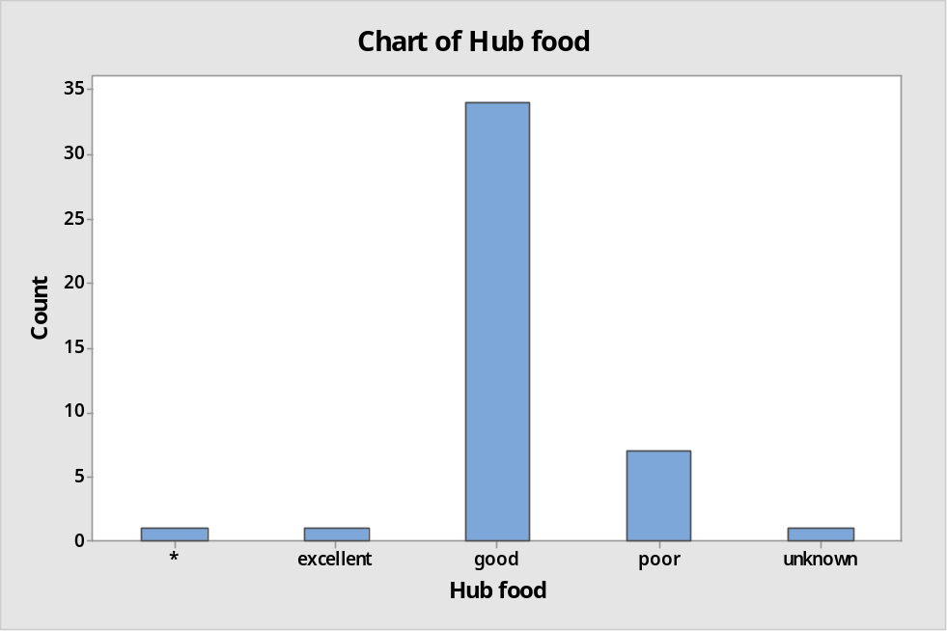

The data entry form has no entry for unknown, but we have occurrences for this value. We will mark these as *.

We again have issues with having same value in different cases within the race column:
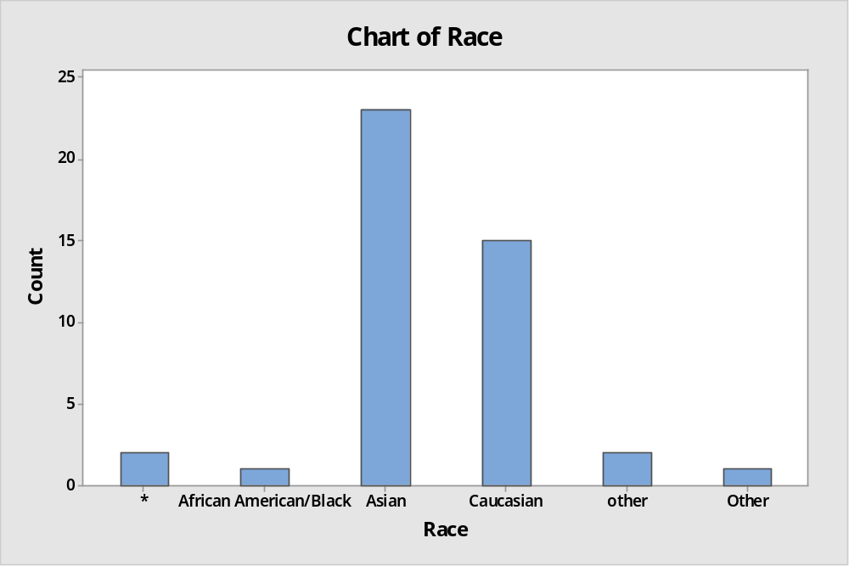
We will change all “other” to “Other”

There are many discrepancies in the column “Chart of College”. This type of column is best handles by providing options.
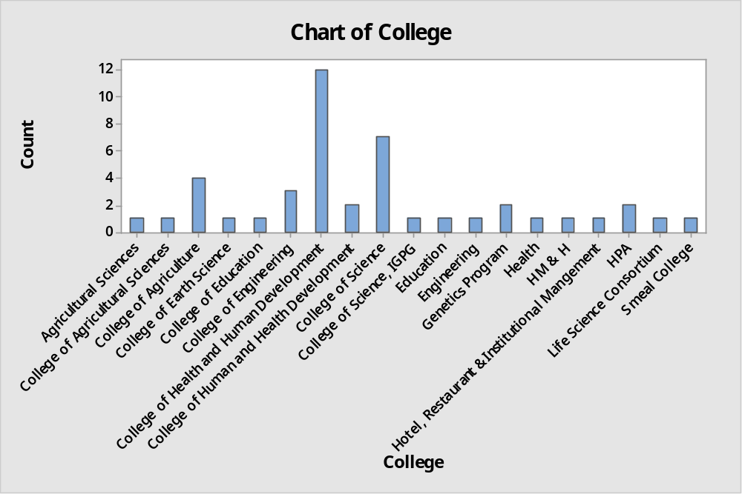

There are numerous entries that refer to same entity but are entered differently (incorrectly):
- Agricultural Sciences, College of Agricultural Sciences, College of Agriculture. Merged as College of Agricultural Sciences
- Education and College of Education. Merged as College of Education
- Engineering and College of Engineering. Merged as College of Engineering
- College of Health and Human Development vs College of Human and Health Development. There is also an entry marked “Health”. Merged all as College of Human and Health Development
- College of Science vs College of Science, IGPG. Merged as College of Science
The bar chart after making the above corrections is:
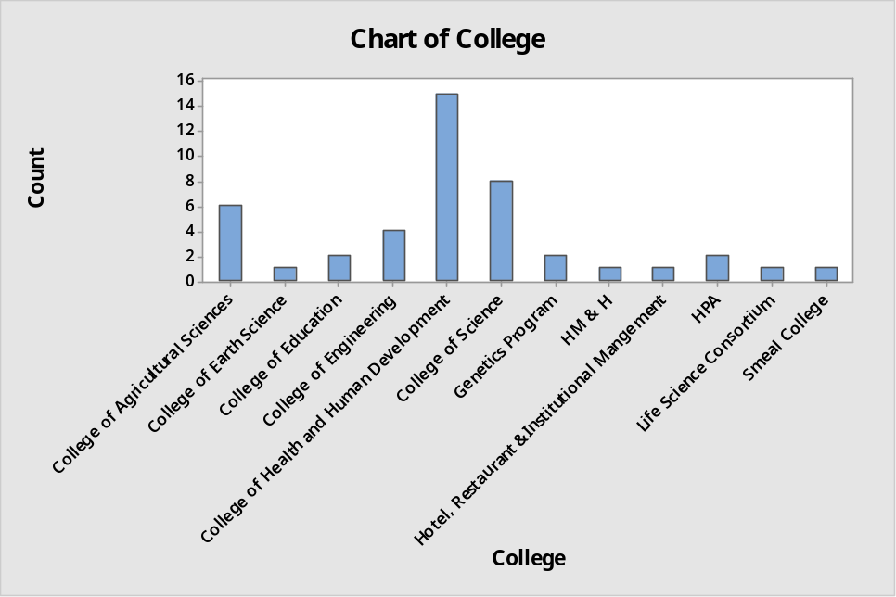

- Test of two means, independent samples: Consider a scenario where a two-sample t-test is the appropriate tool of analysis. Set up a hypothesis for a one-tailed test. Show your work on checking the assumptions in order to use the two-sample t-test. Also, give some justifications for using the separate variances test or the pooled variances test that you use. What is the p-value of the test? Draw a conclusion for α=0.01. Give an interpretation of the interval. (Note: two-sample t-test is for independent samples, two measurements from the same subject usually form paired data, not independent samples)

Hypothesis: In general male students tend to be taller than female students i.e. μ(F) - μ(M) < 0

Whether we can use 2-sample t-test:

Assumption 1: Are these independent samples? Yes, since the samples are from male and female students so they are not related.

Assumption 2: Are these large samples or a normal population?

Descriptive Statistics: Height

Variable Gender N N* Mean SE Mean StDev Minimum Q1 Median
Height * 1 0 68.000 * * 68.000 * 68.000
F 23 2 64.674 0.646 3.099 60.000 62.500 64.000
M 18 0 69.958 0.696 2.952 66.000 68.000 69.000

Variable Gender Q3 Maximum
Height * * 68.000
F 67.000 73.000
M 71.250 77.000

We have number of males = 18 < 30, number of females = 23 < 30. We do not have large enough samples and thus we need to check the normality assumption from both populations.

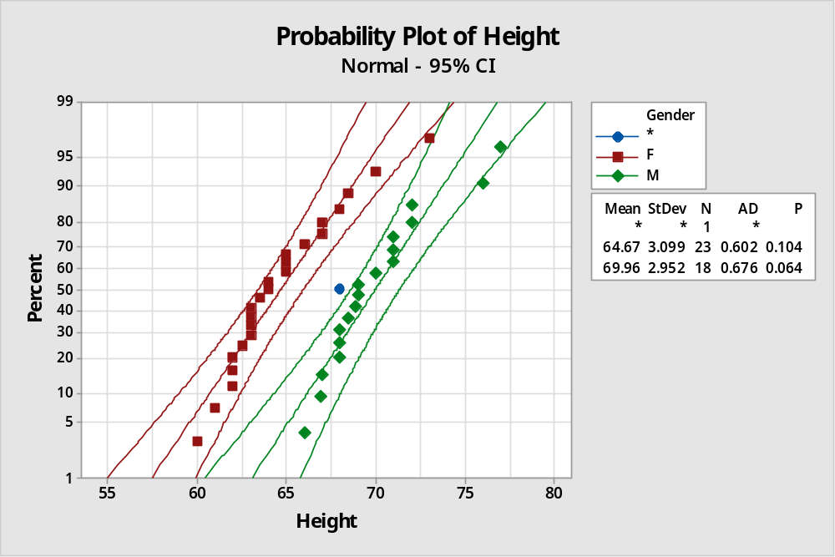

From the normality plots, we conclude that both populations may come from normal distributions.

Assumption 3: Do the populations have equal variance? We will perform the Test of Equal Variances in Minitab:

Test for Equal Variances: Height versus Gender

Method

Null hypothesis All variances are equal
Alternative hypothesis At least one variance is different
Significance level α = 0.05

F method is used. This method is accurate for normal data only.

95% Bonferroni Confidence Intervals for Standard Deviations

Gender N StDev CI
* 1 * ( *, *)
F 23 3.09915 (2.31413, 4.62847)
M 18 2.95248 (2.13063, 4.71579)

Individual confidence level = 97.5%

Tests

Test
Method Statistic P-Value
F 1.10 0.850

The p-value = 0.850 > α = 0.01, so we fail to reject the null hypothesis and assume equal variance.

Next we perform the two sample t test with pooled variance in minitab:

Two-Sample T-Test and CI: Height, Gender

Two-sample T for Height

Gender N Mean StDev SE Mean
F 23 64.67 3.10 0.65
M 18 69.96 2.95 0.70

Difference = μ (F) - μ (M)
Estimate for difference: -5.284
95% upper bound for difference: -3.675
T-Test of difference = 0 (vs <): T-Value = -5.53 P-Value = 0.000 DF = 39
Both use Pooled StDev = 3.0361
Since the p-value = 0.000 < α = 0.01, we reject the null hypothesis. At 1% level of significance, the data provides sufficient evidence that the mean height of male students is greater than the mean height of the female students.

- Test of two means, paired samples: Consider a scenario where a paired t-test is the appropriate tool of analysis. Set up a hypothesis for a two tailed test. Show your work on checking the assumptions in order to use the paired t-test. What is the p-value of the test? Draw a conclusion for α=0.05.

Hypothesis: All students want to weigh different than their current weight i.e. µ(Ideal Weight) ≠ µ(Weight) or µ(Ideal Weight) - µ(Weight) ≠ 0

We can assume normal distribution since the sample size > 30 and the probability plot of the difference is as follows:
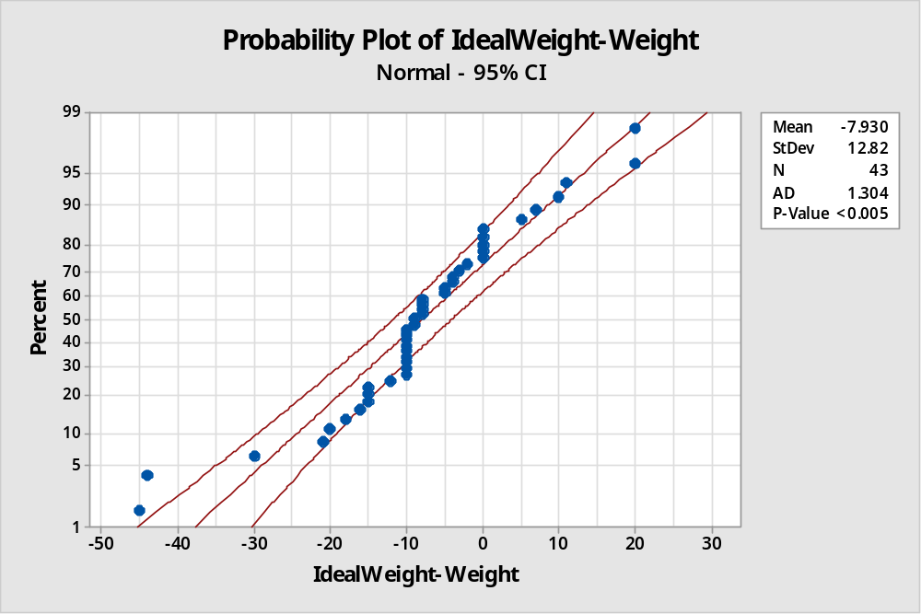

The plot suggests that the differences may come from a normal distribution. We can proceed with a paired t-test.

Set up the hypotheses:
H0 : µ(Ideal Weight) - µ(Weight) = 0 versus Ha : µ(Ideal Weight) - µ(Weight) ≠0

Paired T-Test and CI: Ideal-weight, Weight

Paired T for Ideal-weight - Weight

N Mean StDev SE Mean
Ideal-weight 43 136.35 27.98 4.27
Weight 43 144.28 29.05 4.43
Difference 43 -7.93 12.82 1.96

95% CI for mean difference: (-11.88, -3.98)
T-Test of mean difference = 0 (vs ≠ 0): T-Value = -4.06 P-Value = 0.000

Based on the Minitab output above, we have computed t value = - 4.06 with the p-value < 0.001 for the one-tailed test. Since p-value < 0.001 < 0.05, we can reject the null hypothesis and conclude the alternative. We conclude that the ideal-weight of the student is on average different than their actual weight.

- Suppose you want to test whether on an average graduate students want to weigh less than what their weights actually are. How many students would you sample so that you may get a power of 0.80 if the minimum detectable difference is 1 lb and α=0.05?
(Pay attention to estimation of the sample standard deviation, whether the data is paired or independent. Is this a one-tailed or a two tailed test?)

The hypothesis to test here is µ(Ideal-Weight) < µ(Weight) or equivalently µ(Ideal-Weight) - µ(Weight) < 0. This is one-tailed test.

Setup the hypothesis:
H0 : µ(Ideal-Weight) >= µ(Weight) or µ(Ideal-Weight) - µ(Weight) >= 0
Ha : µ(Ideal-Weight) < µ(Weight) or µ(Ideal-Weight) - µ(Weight) < 0

Here we are working with a single sample of differences rather than a single sample of y-values. Therefore we will need n samples with each providing their weight and ideal-weight. For a One-Sided test we can calculate the number of samples by using:
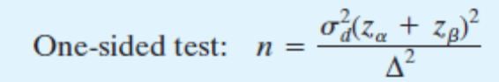

Δ = -1 (since alternate is <), β = 1 – power = 0.2, α=0.05
Since we are talking about paired data, the sample standard deviation to be used here will be for the difference = µ(Ideal-Weight) - µ(Weight)

Descriptive Statistics: IdealWeight-Weight

Variable N N* Mean SE Mean StDev Minimum Q1 Median
IdealWeight-Weight 43 1 -7.93 1.96 12.82 -45.00 -12.00 -9.00

Variable Q3 Maximum
IdealWeight-Weight 0.00 20.00
From the descriptive statistics we get sample standard deviation = 12.82

Using Minitab > Power and Sample Size > Paired t (with alternate <)

Power and Sample Size

Paired t Test

Testing mean paired difference = 0 (versus < 0)
Calculating power for mean paired difference = difference
α = 0.05 Assumed standard deviation of paired differences = 12.82

Sample Target
Difference Size Power Actual Power
-1 1018 0.8 0.800181

So we get the sample size = 1018. We will have to get the weight and ideal-weight of atleast 1018 students to get the desired result.
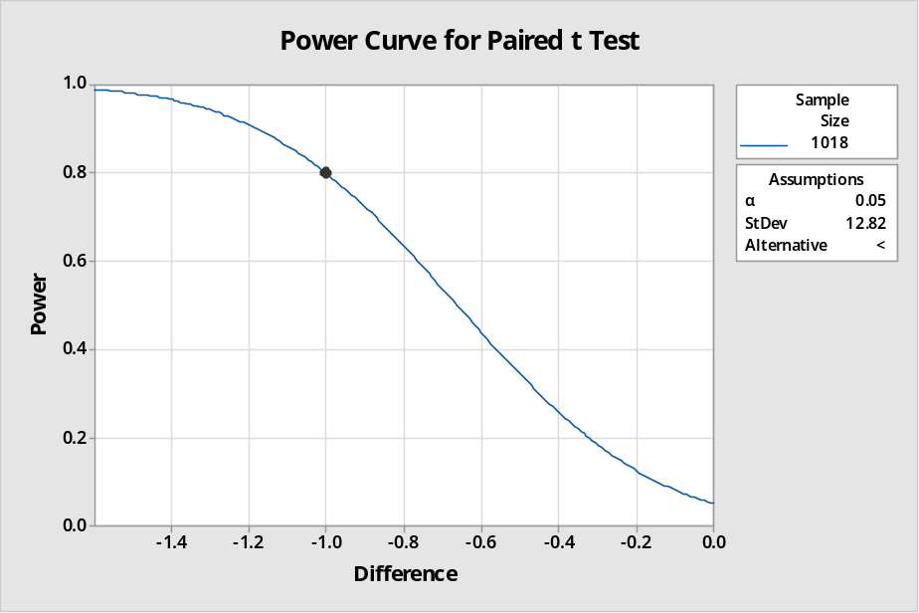

- Pick two qualitative variables that you are interested in and give a scenario for using the chi-square test of independence. Perform the hypothesis test and draw a conclusion for α=0.05. Check conditions to see whether you can use the chi-square test.

The qualitative variables we have chosen are Gender and Hair Dyed?. Since it is customary to define the rows using the explanatory variable and the columns using the response variable, we will make the following selections:
Explanatory variable: Gender
Response variable: Hair Dyed?

Setup the hypothesis:
Null Hypothesis: The two categorical variables i.e. Gender and ‘Hair Dyed?’are independent.
Alternative Hypothesis: The two categorical variables i.e. Gender and ‘Hair Dyed?’are dependent.

The cross-tabulation from minitab is as follows:

Tabulated Statistics: Gender, Hair dyed?

Rows: Gender Columns: Hair dyed?

no yes All

* 1 0 1
F 13 12 25
M 15 3 18
All 29 15 44

Cell Contents: Count
We will exclude the row with * as that represents missing data.

Before we proceed to the chi-square test of independence, we evaluate the condition for using the Chi-square Test. The condition used by some statisticians is to not use the chi-square test if more than 20% of the cells have expected frequencies below five. Let’s check our table:
Tabulated Statistics: Gender_Excl Missing, Hair dyed?_Excl Missing

Rows: Gender_Excl Missing Columns: Hair dyed?_Excl Missing

no yes All

F 13 12 25
16.279 8.721

M 15 3 18
11.721 6.279

All 28 15 43

Cell Contents: Count
Expected count

So we can see that all of our expected counts are > 5
Further, when performing chi-square test of association on rows excluding the missing data, we get:

Tabulated Statistics: Gender_Excl Missing, Hair dyed?_Excl Missing

Rows: Gender_Excl Missing Columns: Hair dyed?_Excl Missing

no yes All

F 13 12 25
16.279 8.721
0.6605 1.2329

M 15 3 18
11.721 6.279
0.9174 1.7124

All 28 15 43

Cell Contents: Count
Expected count
Contribution to Chi-square

Pearson Chi-Square = 4.523, DF = 1, P-Value = 0.033
Likelihood Ratio Chi-Square = 4.781, DF = 1, P-Value = 0.029

We can see that Chi-Sq = 0.6605 + 1.2329 + 0.9174 + 1.7124 = 4.5232
DF = 1, P-Value = 0.033
Since the P-Value = 0.033 < α = 0.05, we reject the null hypothesis and conclude that Gender and ‘Hair Dyed?’ are dependant.

