Lesson 7 - Homework
Notes:
- The answers to the problems will be posted on Sunday after the due date. To view the answers, click on the Homework Solutions link in the menu bar to the left.
- You need to check necessary conditions, e.g. sample size larger than 30 or normality, before proceeding to compute the t-intervals. When sample size is larger than 30, one does not need to check for Normality since sample mean (do not confuse it with the population) has a Normal distribution by Central Limit Theorem.
- When sample size is larger than 30, one does not need to check for Normality since population does not need to have Normal distribution and yet sample mean will be normal. One only needs to use boxplot to check for extreme outliers. (One can use t-procedure to estimate population mean when sample size is large and there is no extreme outliers )
1. (20 pts, each 5 pts) Problem 5.38 in 6th edition (which is problem 5.52 in 5th edition) -Use Minitab to find the interval, do not hand compute.
The 6th edition does not have part d and thus it is included here:
d. How would your inference change by using a 98% confidence interval in place of the 95% confidence interval?
- The minitab output below shows that the band is: 7.896 and 10.304
Variable N Mean StDev SE Mean 95% CI
reading 20 9.100 2.573 0.575 (7.896, 10.304)
- The plot looks like:
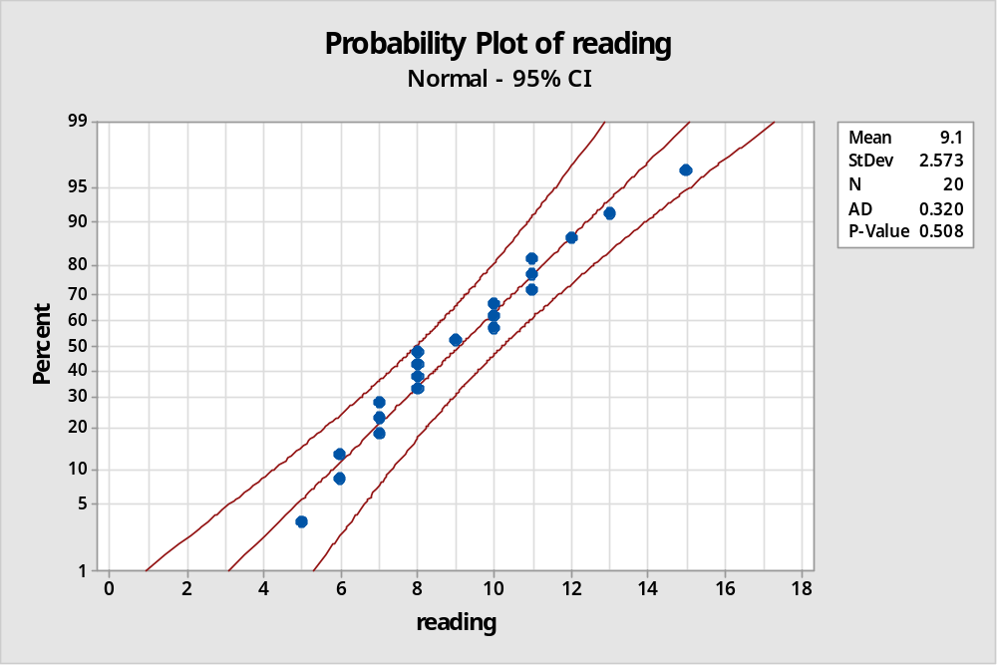
The underlying data is Normal since all the data values lie within the band.
- 95% confidence interval lies between 7.896 and 10.304 implying that there is a 1 in 20 chance that the confidence interval will not contain the population average in multiple samplings.
- When the confidence threshold is 98%, the interval itself will broaden (7.639, 10.561) since now there can only be 1 in 50 chance of not capturing the true population average in multiple samplings. Therefore as the confidence threshold is increased the interval will broaden.
2. (10 pts) Hand compute to find the answer to part a of the previous problem 1.
We have been given: 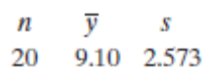
95% CI = yBar ± t0.25 * s / √n
= between 9.1 - (2.093 * 2.573 / sqrt(20)) and 9.1 + (2.093 * 2.573 / sqrt(20))
= between 7.895812772 and 10.30418723
3. (15 pts, each 5 pts) Problem 5.63 in 6th edition (which is problem 5.78 in 5th edition) – parts a, b, c only (Skip part d, which should be handled by a one-tailed test, use minitab to find the t-value for 37 degrees of freedom, point estimate refers to sample mean, standard deviation of the point estimate refers to the standard deviation of sample mean which is also called standard error).
Given yBar = 28.7 and SD of sample = 3.8, N=38, df=37
- The point estimate of mean = 28.7
- SD of point estimate of mean = s / sqrt(N) = 3.8 / sqrt(38) = 0.6164414
- Using minitab, we get the interval as: (27.451, 29.949)
N Mean StDev SE Mean 95% CI
38 28.700 3.800 0.616 (27.451, 29.949)
We can also calculate this using the formulae. From minitab, the t-value for 0.975 with df=37
P( X ≤ x ) x
0.975 2.02619
We can use this in the formula, 95% CI = yBar ± t0.025 * s / √n
= between 28.7 – 2.026 * 3.8 / sqrt(38) and 28.7 + 2.026 * 3.8 / sqrt(38)
= between 27.45108972 and 29.94891028
4. (10 pts) Answer “true” or “false” for each question.
a. If a larger number of random samples are selected and we form the 95% confidence interval for each sample mean, the population mean will lie in about 95% of these confidence intervals. TRUE
b. If sample size is larger than 30, there is a 95% chance that the sample mean equals the population mean. FALSE
c. If a very large number of random samples are selected, there is a 95% chance that one of the sample means is equal to the population mean. FALSE
d. The 95% confidence interval around a given sample mean is wider than the 90% confidence interval around that mean. TRUE
5. (15 pts, each 5 pts) A test was conducted to determine the length of time required for a student to read a specified amount of material. The students were instructed to read at the maximum speed at which they could still comprehend the material because a comprehension test would be given on the material. Sixteen third-grade students were randomly selected from a large school district, and the results of their test are as follows (in minutes):
25 18 27 29 20 19 25 24 32 21 24 19 23 28 31 22
a. Estimate the mean length of time required for all third-grade students to read the material, using a 95% confidence interval.
b. What is the population for which the confidence interval in part (a) is applicable?
c. Provide an interpretation of the confidence interval computed in part (a).
- We have: Mean = 24.19, SD = 4.32, n = 16, t0.025 (df=15) = 2.131
95% CI = yBar ± t0.025 * s / √n
= between 24.19 – 2.131 * 4.32 / sqrt(16) and 24.19 + 2.131 * 4.32 / sqrt(16)
= between 21.88852 and 26.49148
- The population of third-grade students from the selected large school district.
- 95% confidence interval lies between 21.88852 and 26.49148 implying that there is a 1 in 20 chance that the confidence interval around the sample mean will not contain the population average in multiple samplings. Stated differently, if a larger number of random samples are selected from the 3rd grade of this school district and we form the 95% confidence interval for each sample mean, the population mean will lie in about 95% of these confidence intervals.
6. (15 pts) The city housing department wants to estimate the average rent for rent-controlled apartments. They need to determine the number of renters to include in the survey in order to estimate the average rent to within $80 using a 92% confidence interval. From past results, the rent for controlled apartments ranged from $400 to $1600 per month. How many renters are needed in the survey? (only need to use the crude method)
We have α=1−0.92=0.08, so Zα/2=Z0.04=1.75 and E = 80
Also, range = 1600 – 400 = 1200 and σ ≈ R / 4 = 1200 / 4 = 300
So with crude method: n = (Zα/2)^2 . σ^2 / E^2
= 1.75^2 * 300^2 / 80^2
= 43.06641 or 44 renters
7. (15 pts) If the level of confidence in above question is increased to 98%, what sample size is needed? (only need to use the crude method)
We have α=1−0.98=0.02, so Zα/2=Z0.01=2.326 and E = 80
Also, range = 1600 – 400 = 1200 and σ ≈ R / 4 = 1200 / 4 = 300
So with crude method: n = (Zα/2)^2 . σ^2 / E^2
= 2.326 ^2 * 300^2 / 80^2
= 76.082 or 77 renters
Reading: An Introduction to Statistical Methods and Data Analysis, chapters 5.7, 5.2, and 5.3
Practice problem: Consumer reports tested 15 brands of vanilla yogurt and found the following numbers of calories per serving: 160, 200, 220, 230, 120, 180, 140, 130, 170, 180, 80, 120, 100, 170, 190. Place a 90% confidence interval on the average number of calories per serving for vanilla yogurt. Use Minitab to find the interval. Do not hand compute.
Solution:
a. The sample size is small n=15(less than 30). So first we need to use the normal probability plot in Minitab to check if this sample comes from a normal distribution.

Minitab Commands for drawing the normal probability plot:
Minitab>Graph>Probability Plot

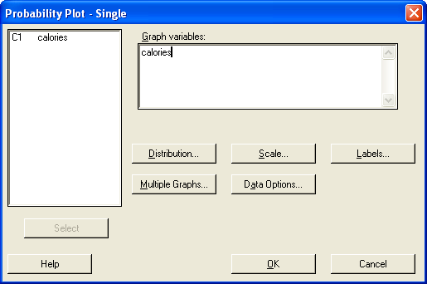

Output is:

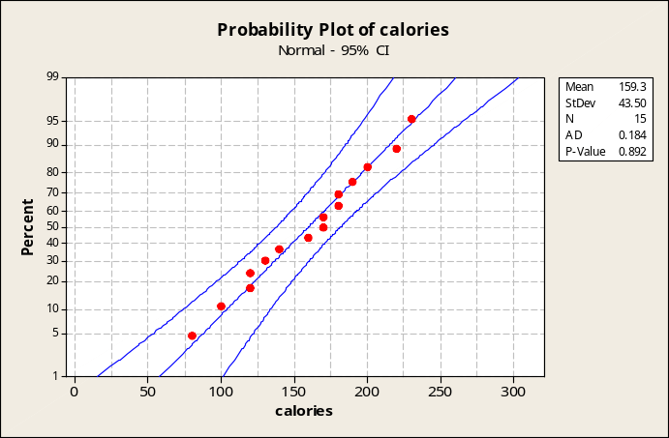

Conclusion: The normal probability plot above suggests that the data are normally distributed since the data all fall within the band.

b. The 90% t confidence intervals can be used here because the data is normal distributed.
Minitab Commands for finding the one-sample t-interval:

Minitab>Stat>Basic Stat>1-Sample t
Get into Options and change the confidence level to the needed one:

(note that for now you can ignore the test mean part since that deals with testing)

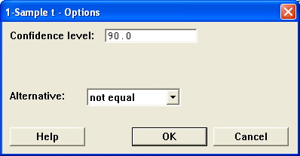

Minitab will give you the following output:
One-Sample T: calories

Variable N Mean StDev SE Mean 90% CI
calories 15 159.333 43.502 11.232 (139.550, 179.116)

Conclusion: we are 90% confident that the average number of calories per serving for vanilla yogurt is between 139.55 and 179.116 calories.

