Lesson 12
Reading: An Introduction to Statistical Methods and Data Analysis, Chapters 11.1, 11.2, 11.3, 11.4, 11.7
Sample Homework Problem:
The following data are 11 randomly selected people’s maximum heart rate (Y) and their age (X):

Age | 30 | 38 | 41 | 38 | 29 | 39 | 46 | 41 | 42 | 24 | 49
Rate | 186 | 183 | 171 | 177 | 191 | 177 | 174 | 176 | 171 | 196 | 168

- Plot the data. Does a linear equation relating Y to X appear plausible?
- What is the regression equation?
- Interpret the coefficient of X in the context of this problem.
- Locate the residual standard deviation.
- Will you use the regression equation to predict the maximum heart rate of a person who is 4 years old? If so, what is the value.
- Calculate a 95% confidence interval for the true slope.
- Compute R² and give an interpretation for it

Solution:

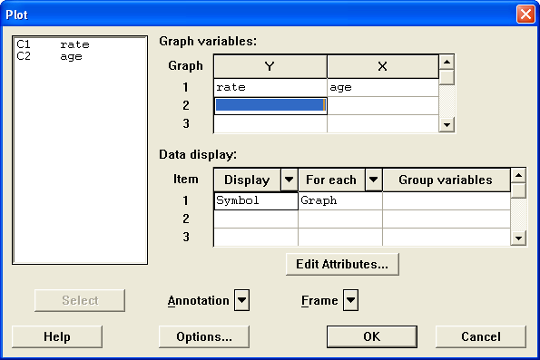
- Plot the data:

Minitab> Graph > Plot
The output is:

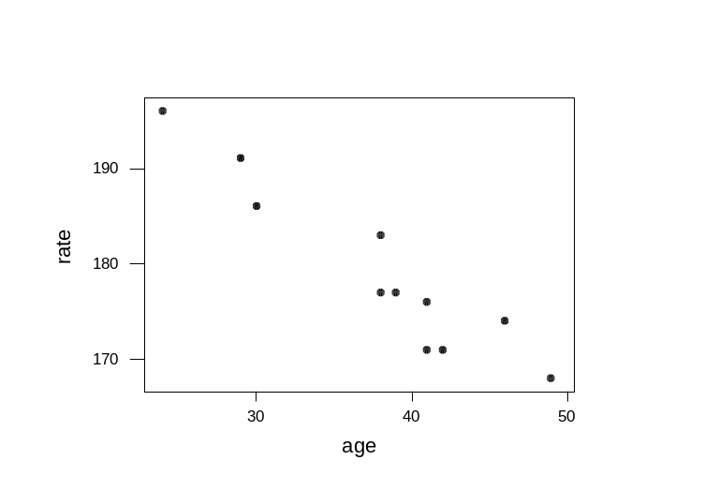

Based on the above scatter plot, we can see that the relationship between X and Y looks linear.
Using Minitab to find the regression equation:

Stat > Regression > Regression
Choose rate as the response and age as the predictor, we get the output:

Regression Analysis

The regression equation is
rate = 222 - 1.12 age
Predictor Coef StDev T P
Constant 221.663 4.902 45.22 0.000
age -1.1230 0.1271 -8.84 0.000

S = 3.009 R-Sq = 89.7% R-Sq(adj) = 88.5%

Analysis of Variance

Source DF SS MS F P
Regression 1 707.40 707.40 78.11 0.000
Residual Error 9 81.51 9.06
Total 10 788.91

- Thus the regression equation is: rate = 222 – 1.12 age

- The coefficient of X is the coefficient of age, which is –1.12. The coefficient is the slope of the regression equation which means: for every one year increase in age, the estimated increase in maximum heart rate is: -1.12 (equivalently, the estimated decrease in maximum heart rate is 1.12.)

- The residual standard deviation is the estimate of the standard deviation of the error term. It is provided by minitab, denoted as “s” . We can see that from the minitab output, S = 3.009 .

- No, because age = 4 is out of scope of the X-values in the data that are used to obtain the regression equation. It would be inappropriate to extrapolate the maximum heart rate using the regression equation for a person who is 4 years old.

- To find a 95% confidence interval for the true slope, we see that 1- α = .95,
α = .05, α/2 = .025, for regression equation with one predictor variable,
df = n-2 = 11-2 = 9, t_{0.025, 9} = 2.262. (s[β₁]) is the standard deviation of age and given by the minitab output as 0.1271 .
The 95% confidence interval for β₁ is given by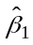± t_{α/2} (s[β₁]) = -1.12 ± 2.262 (0.1271) = (-1.408, -0.833).
- R² is given by Minitab as R-Sq = 89.7%. It means that 89.7% of the variability in maximum heart rate can be explained by the linear regression model using age as the predictor.

Practice Homework: (Please do not submit these problems): 11.35 (11.44 in 5th ed) and 11.36 (11.45 in 5th ed) .
Submit the following Homework Problems to “Dropbox for HW 12”
- You may use Minitab whenever appropriate.
- The answers to the problems will be posted on Sunday after the due date. To view the answers, click on the Homework Solutions link in the menu bar to the left.
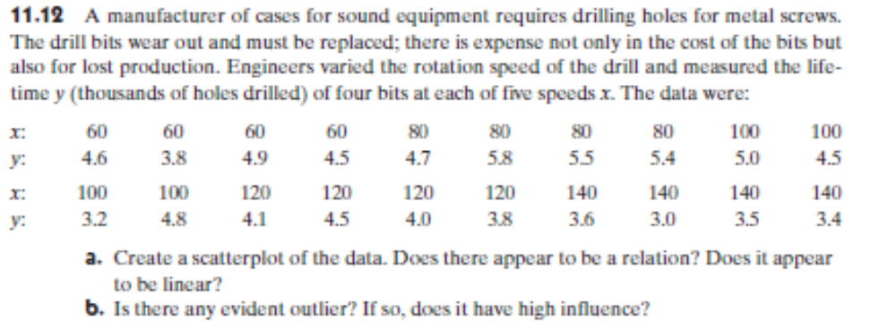
1(a). Problem 11.12(a) (11.21(a) in 5th ed)
1.(b) Use Minitab to obtain estimates of the regression parameters. Interpret the value of the estimated slope in this context

- The scatterplot:
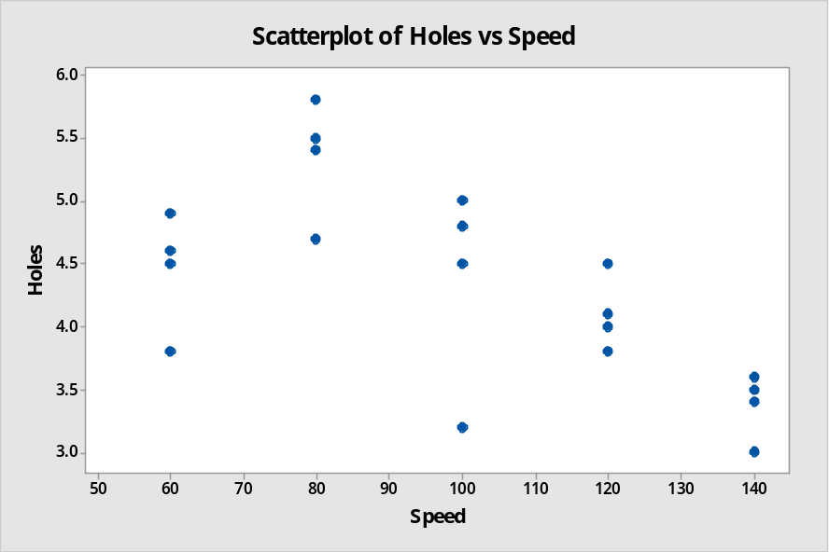

The relationship looks approximately linear. There is some variation at small x (x=60) but for values beyond x=60, the relationship does look linear.

- The minitab output for regression is:
Regression Analysis: Holes versus Speed

Analysis of Variance

Source DF Adj SS Adj MS F-Value P-Value
Regression 1 4.624 4.6240 11.56 0.003
Speed 1 4.624 4.6240 11.56 0.003
Error 18 7.198 0.3999
Lack-of-Fit 3 3.463 1.1543 4.64 0.017
Pure Error 15 3.735 0.2490
Total 19 11.822

Model Summary

S R-sq R-sq(adj) R-sq(pred)
0.632368 39.11% 35.73% 25.46%

Coefficients

Term Coef SE Coef T-Value P-Value VIF
Constant 6.030 0.520 11.61 0.000
Speed -0.01700 0.00500 -3.40 0.003 1.00

Regression Equation

Holes = 6.030 - 0.01700 Speed

Fits and Diagnostics for Unusual Observations

Obs Holes Fit Resid Std Resid
2 3.800 5.010 -1.210 -2.08 R

R Large residual

The slope or the coefficient of X is the coefficient of speed, which is -0.01700. This is the slope of the regression equation which means: for every one unit increase in speed, the estimated increase in holes is:
-0.01700 * 1000 (equivalently, the estimated decrease in number of holes is 17.)

2. Problem 11.65 (11.35 in 5th ed)
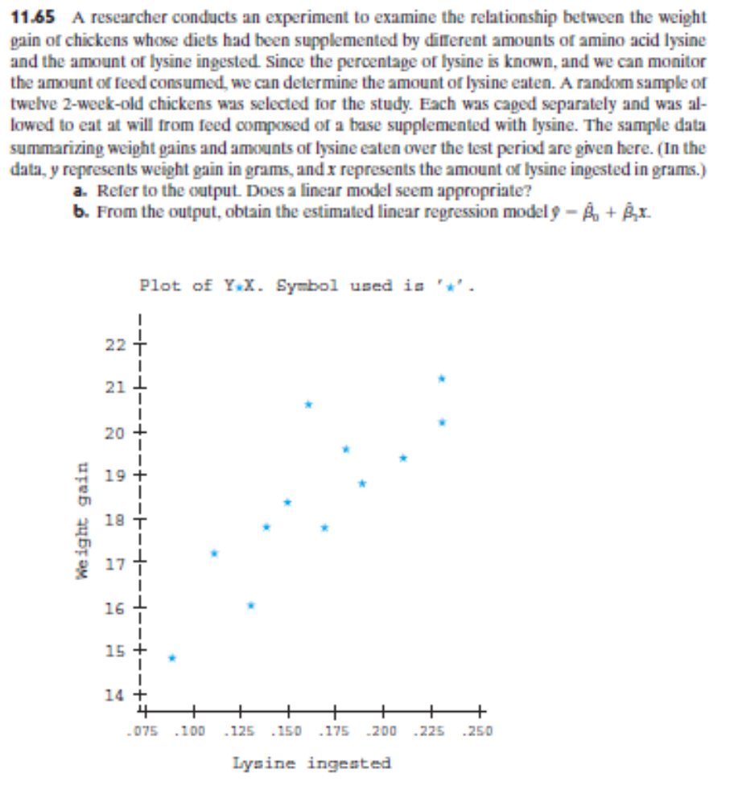
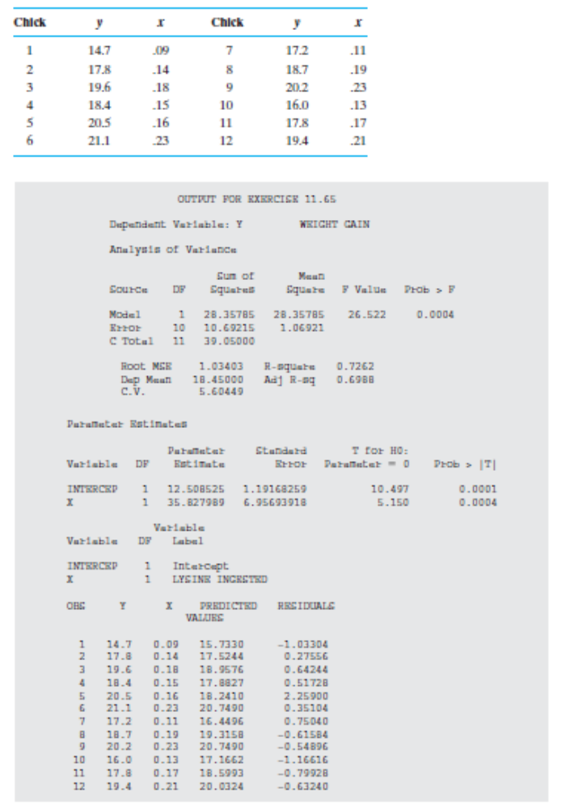

- Looking at the plot, we can say that a linear model seems appropriate. Therefore it does not appear to be any difficulty with using a linear regression model. The use of a linear regression model is appropriate.
- The estimated linear model from the output is:

y^ = 12.508525 + 35.827989 * x
OR
Weight_Gain = 12.508525 + 35.827989 * LYSINE_INGESTED

3. Problem 11.66 (11.36 in 5th ed) (when reporting the p-value, pay attention to whether this is a one-tailed test or a two tailed test.)
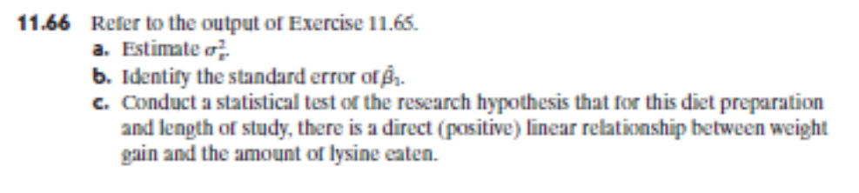

- σ_{ε}² = MSE = 1.06921
- SE of β₁^ = 6.95693918
- The hypothesis testing is different than the one presented in the output. The question asks:
H0: β₁ <= 0 ; Ha: β₁ > 0; DF = 12-2 = 10
The p-value = 0.0004 / 2 = 0.0002 is less than 0.01 (assumed) so we can reject the null hypothesis and find that there is sufficient evidence of a direct relationship

According to output, t =5.15, and p=0.0004, so for a one tailed test the p value is 0.0004/2 = 0.0002 which is small for all reasonable level of significant. This means that I can reject the null hypothesis and conclude the alternative that there is a positive linear relationship between weight gain and amount of lysine eaten

4. For the data given in 11.65, give a 95% interval for the mean response of weight gain when x=0.22 and a 95% interval for the weight gain of a chick with x=0.22.

The minitab output for prediction at x=0.22 is:
Prediction for Y

Regression Equation

Y = 12.51 + 35.83 X

Variable Setting
X 0.22

Fit SE Fit 95% CI 95% PI
20.3907 0.480734 (19.3195, 21.4618) (17.8499, 22.9315)

- 95% interval for the mean response of weight gain when x=0.22 is 95% CI = (19.3195, 21.4618)
- 95% interval for the estimate of weight gain when x=0.22 is 95% PI = (17.8499, 22.9315)

5. In Problem 11.65, will you use the regression equation to predict the weight gain or mean weight gain of a chick with x=0.84? Explain briefly.

No, because LYSINE INGESTED = 0.84 is out of scope of the X-values in the data that are used to obtain the regression equation. It would be inappropriate to extrapolate the weight gain using the regression equation for a chick whose LYSINE INGESTED = 0.84

6. 11.74 (11,74 in 5th ed)

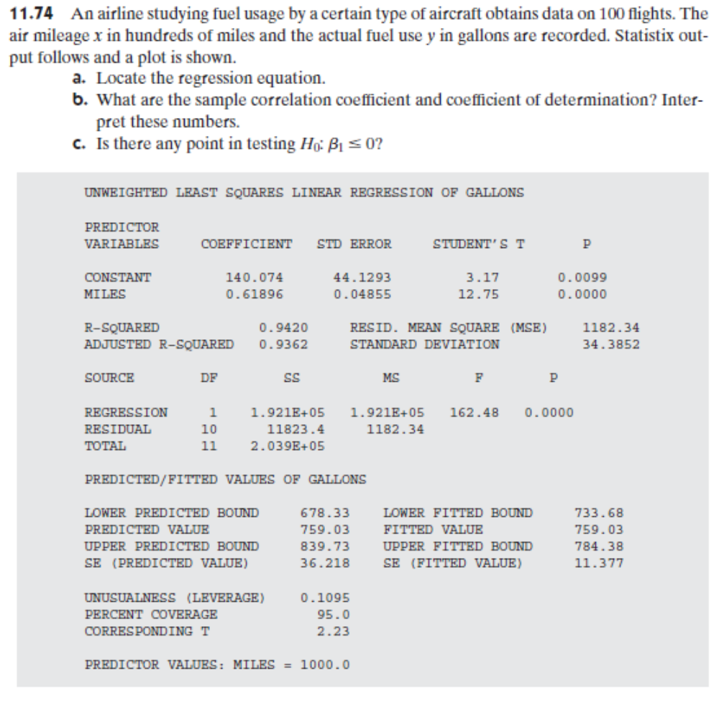

- Regression equation is:
y^ = 140.074 + 0.61896 * x
OR
fuel use = 140.074 + 0.61896 * MILES

- The output gives R^2 () directly as: 0.9420
However we know that for the specific case when there is only one independent variable x (simple linear regression), one can show that R2 = r2 where r is correlation coefficient between X and Y.
Therefore r = sqrt(R2) = sqrt(0.9420) = 0.9706
- The direct relation from the observation also makes intuitive sense - the longer flights will have higher fuel usage. The p-value is very small and leads us to reject the null of β₁ ≠ 0. So there isn’t much value in further testing β₁ <= 0

