STAT500 HW#12 Solution

- Problem 11.12 (25 pts)
    - The scatter plot from Minitab.

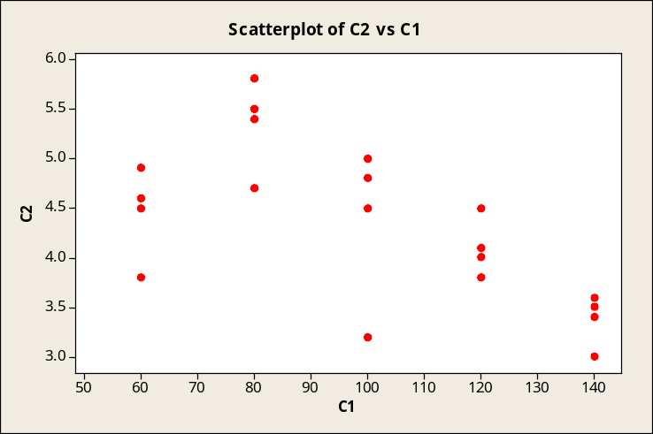

The relationship is approximately linear.

    - From the output (shown below)
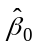 = 6.03, 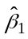 = -0.017.

Regression Analysis: C2 versus C1
The regression equation is
C2 = 6.030 - 0.01700 C1

S = 0.632368 R-Sq = 39.1% R-Sq(adj) = 35.7%

Analysis of Variance
Source DF SS MS F P
Regression 1 4.624 4.62400 11.56 0.003
Error 18 7.198 0.39989
Total 19 11.822

= -0.017 indicates that for each unit of increase in rotation speed, the lifetime of the drill decreases by 0.017 units (thousands of holes drilled) on average.

- Problem 11.65(15 pts)

  - Based on the scatter plot of the data, the data appear to be linear. Therefore it does not appear to be any difficulty with using a linear regression model. The use of a linear regression model is appropriate.
  - ŷ = 12.51 + 35.83x. You should get the correct values from Minitab.

3) Problem 11.66 (15 pts)
- Variation of error s² = MS error = 1.06921
b) Standard error for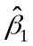 is 6.96
c) Testing if: H₀: β₁ = 0; Ha: β₁ > 0
According to output, t =5.15, and p=0.0004, so for a one tailed test the p value is 0.0004/2 = 0.0002 which is small for all reasonable level of significant. This means that I can reject the null hypothesis and conclude the alternative that there is a positive linear relationship between weight gain and amount of lysine eaten.

4) Problem in Handout (15 pts)
By using Minitab, we get
Predicted Values for New Observations

New
Obs Fit SE Fit 95% CI 95% PI
1 20.391 0.481 (19.320, 21.462) (17.850, 22.931)
Values of Predictors for New Observations
New
Obs x
1 0.220
Therefore, the 95% interval for the mean response of weight gain when x=0.22 is 95% CI =(19.320, 21.462); The 95% interval for the weight gain of a chicken with x=0.22 is 95% PI =(17.850, 22.931).

5) Problem in Handout (15 pts)
No. Because when x=0.84, it is out of the range of observed values. According to Remark 1, it is incorrect to use the regression equation to predict values of the predictor variable outside the range of the observed values.

- Problem 11.74(15 pts)

- Locate the regression equation.
Fuel burned = β₀ + β₁* miles + ε
The estimated regression equation is
Fuel burned = 140.074 + 0.61896 miles

- What are the sample correlation coefficient and the coefficient of determination?
The sample correlation coefficient r = .970
The coefficient of determination, R² = 0.942 and represents the percentage of variability explained by the regression model.
c) No. Since represents air mileage in hundreds of miles and indicates the actual fuel use in gallons they are positively related.

